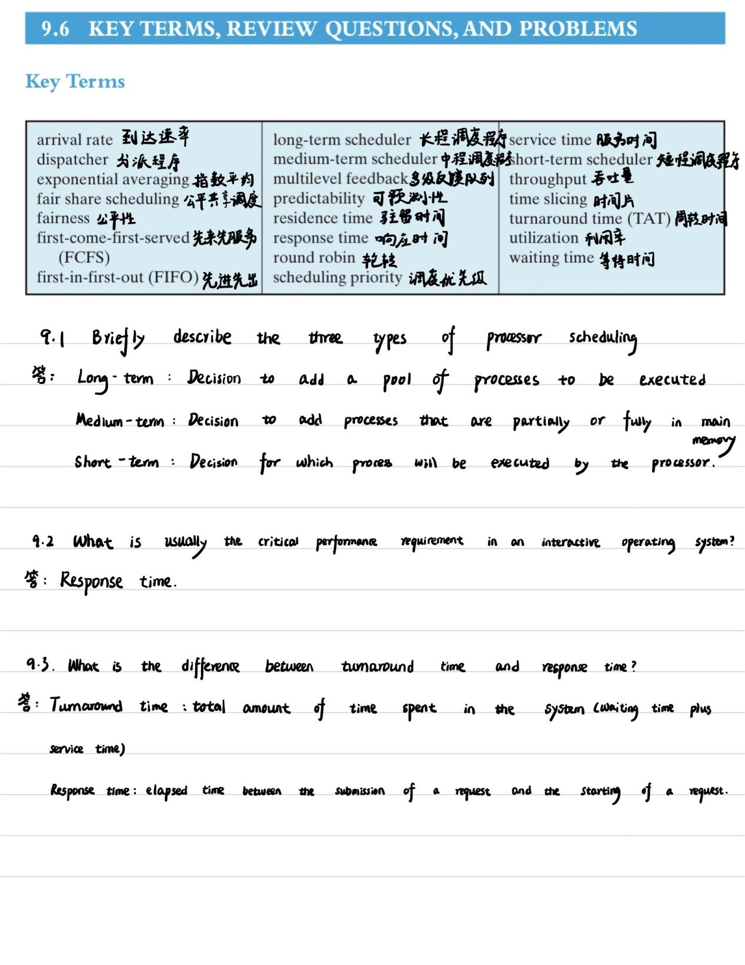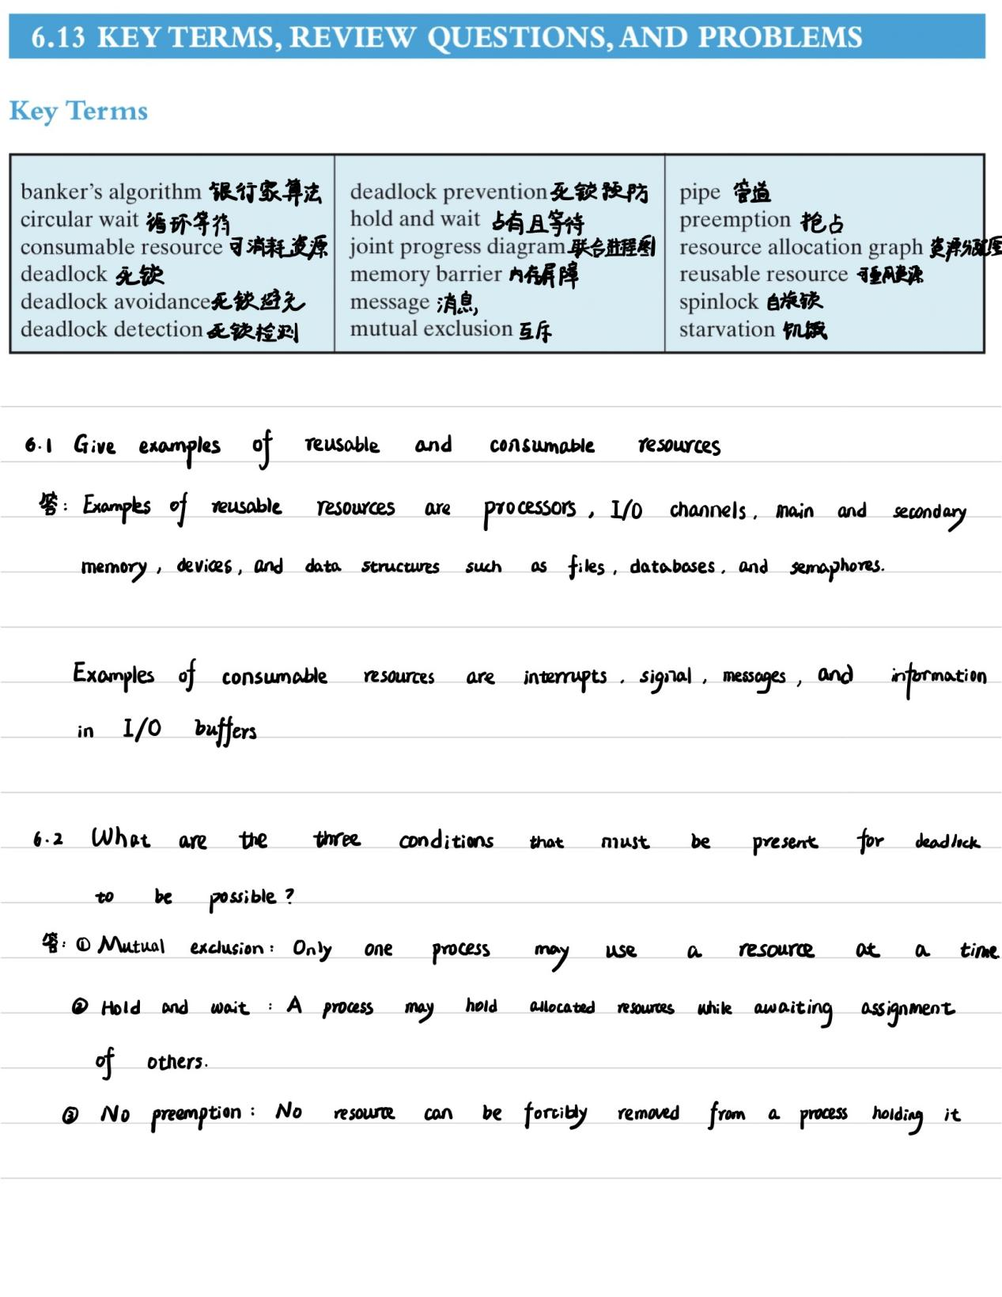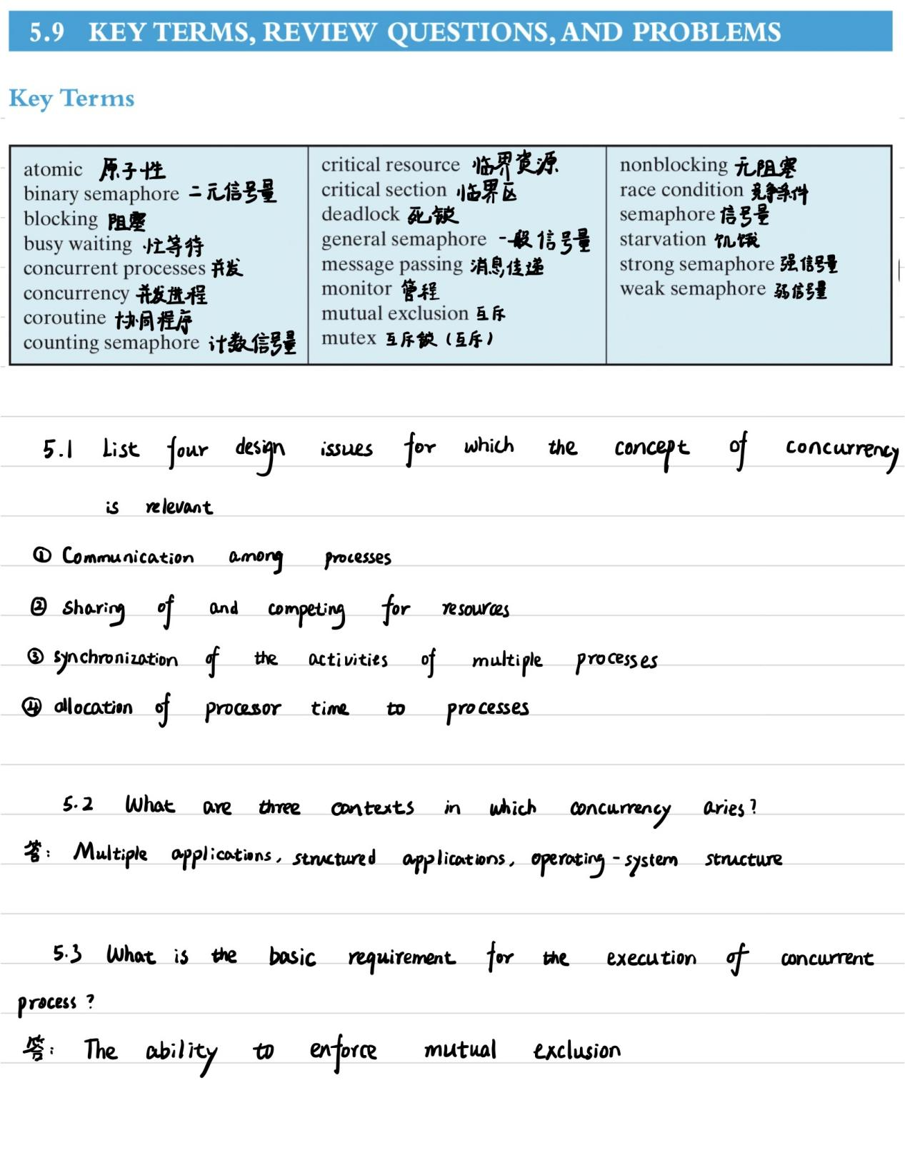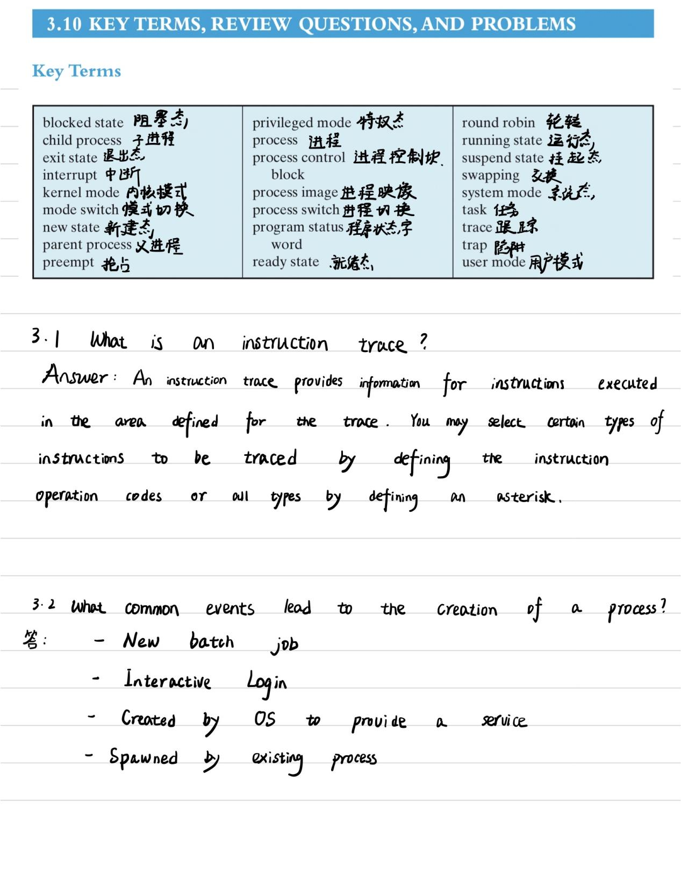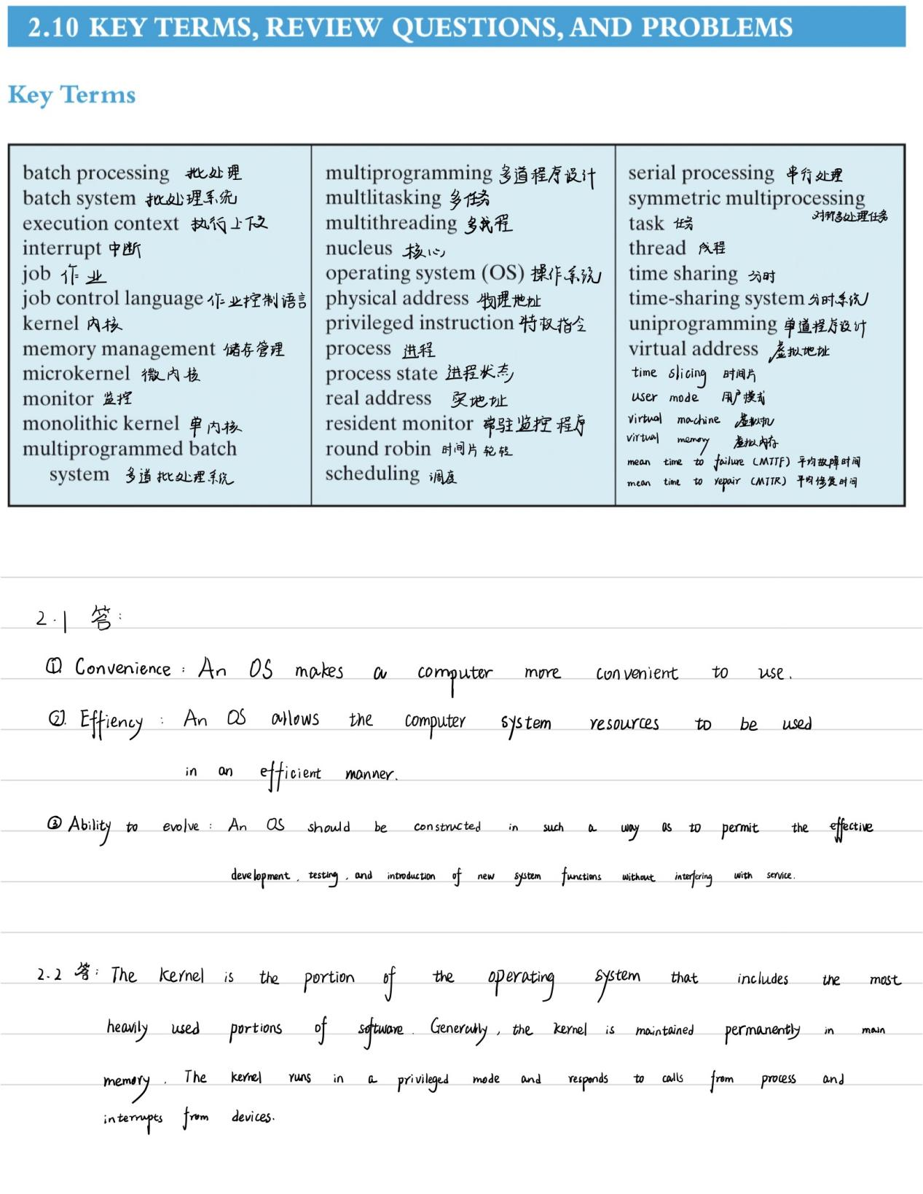

进程控制块的英文全称

1. Process Control Block

分派器的英文是

1. Dispatcher

Activate的中文是

1. 激活

进程映像的英文

Process image

整型信号量缺点：不遵循“让权等待”原则，会出现忙等现象

The Conditions for Deadlock are ( ),( ),( ),( ).

(1) Mutual exclusion

(2) No preemption

(3) Hold and wait

(4) Circular wait

Three common approaches to dealing with deadlock are ( ),( ),( ).

(1) Prevent Deadlock

(2) Avoid Deadlock

(3) Detect Deadlock

串行处理的英文全称是serial processing

内核级线程的英文是Kernel level thread

银行家算法：[操作系统——银行家算法（Banker's Algorithm） - 王陸 - 博客园 (cnblogs.com)](https://www.cnblogs.com/wkfvawl/p/11929508.html)