1. 全称

TCP：Transmission Control Protocol

UDP：User Datagram Protocol

HTTP:Hyper Text Transfer Protocol

FTP:file transfer protocol

ISP:Internet Service Provider

API:Application Programming Interface

FDM:frequency division multiplexing

TDM:time division multiplexing

RTT:round trip time

二、简答题

(1)What is the instantaneous throughput? What is the average throughput? What does end-to-end throughput depend on?.

The instantaneous throughput at any instant of time is tlie rate (in bits/sec) at which Host B is receiving the file.(Many applications, including many P2P file sharing systems, display the instantaneous throughput during downloads in the user interface— perhaps you have observed this before!)

If the file consists of F bits and the transfer takes T seconds for Host B to receive all F bits, then the average throughput of the file transfer is F /T bits/sec

1. What is the difference between TCP and UDP?

TCP提供的是面向连接的、可靠的数据流传输；

UDP提供的是非面向连接的、不可靠的数据流传输。

TCP提供可靠的服务，通过TCP连接传送的数据，无差错、不丢失，不重复，按序到达；UDP尽最大努力交付，即不保证可靠交付。

TCP面向字节流；

UDP面向报文。

TCP连接只能是点到点的；

UDP支持一对一、一对多、多对一和多对多的交互通信。

TCP首部开销20字节；

UDP的首部开销小，只有8个字节。

TCP的逻辑通信信道是全双工的可靠信道；

UDP的逻辑通信信道是不可靠信道。

TCP定义

TCP（Transmission Control Protocol 传输控制协议）是一种面向连接的、可靠的、基于字节流的传输层通信协议，由IETF的RFC 793定义。

UDP定义

UDP （User Datagram Protocol 用户数据报协议）是OSI（Open System Interconnection开放式系统互联） 参考模型中一种无连接的传输层协议，提供面向事务的简单不可靠信息传送服务。

(3)What is the difference between circuit switching and packet

switching?

分组交换的优点：

    它提供了比电路交换更好的带宽共享；

    它比电路交换更简单、更有效、实现成本更低；

分组交换的缺点：

    分组交换不适合实时服务，因为端到端的时延是可变、不可预测的，这和整个网络的情况相关；

电路交换的优点：

    提供了端对端传输数据的速率保证；

电路交换的缺点：

    电路交换存在静默期，这是指专用电路空闲时，其占用的资源并没有得到充分的利用；

    建立连接的过程比较复杂；

总体上来说，分组交换的性能要好于电路交换的性能，但是不同类型的分组交换方式有不同的应用场景；比如一些对最低速率有着严格要求的应用，比如实时服务等，为了获得速率保证，牺牲网络的效率也是可以接受的。趋势向着分组交换发展

(4)What is the 5-layer protocol stack?

Application layer

Transport layer

Network layer

Link layer

Physical layer

-------------------------------------

When taken together, the protocols of the various layers are called the protocol stack. The

Internet protocol stack consists of five layers: the physical, link, network, transport, and

application layers, as shown in Figure.

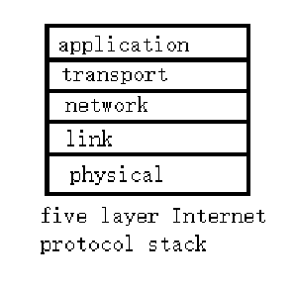

(5)how does the http work?

How does HTTP work? As a request-response protocol, HTTP gives users a way to interact with web resources such as HTML files by transmitting hypertext messages between clients and servers. ... POST adds content, messages, or data to a new page under an existing web resource.

第二次过程性考核

一、英译汉

A third approach is for the sender simply to resend the current data packet when

it receives a garbled ACK or NAK packet. This approach, however, introduces

duplicate packets into the sender-to-receiver channel. The fundamental diffi-

culty with duplicate packets is that the receiver doesn't know whether the ACK

or NAK it last sent was received correctly at the sender. Thus, it cannot know a

priori whether an arriving packet contains new data or is a retransmission!

第三种方法是发送方在收到乱码的 ACK 或 NAK 数据包时简单地重新发送当前数据包。然而，这种方法将重复的数据包引入到发送方到接收方的通道中。重复数据包的根本困难在于接收方不知道它最后发送的 ACK 或 NAK 是否在发送方正确接收。因此，它无法先验地知道到达的数据包是包含新数据还是重传！

二、简答

(1) What is multiplexing? What is demultiplexing?.

This job of delivering the data in a transport-layer segment to the correct socket is called demultiplexing. The job of gathering data chunks at the source host from different sockets, encapsulating each data chunk with header information (that will later be used in demultiplexing) to create segments, and passing the segments to the network layer is called multiplexing.

(2)What are the differences between flow control and congestion control?

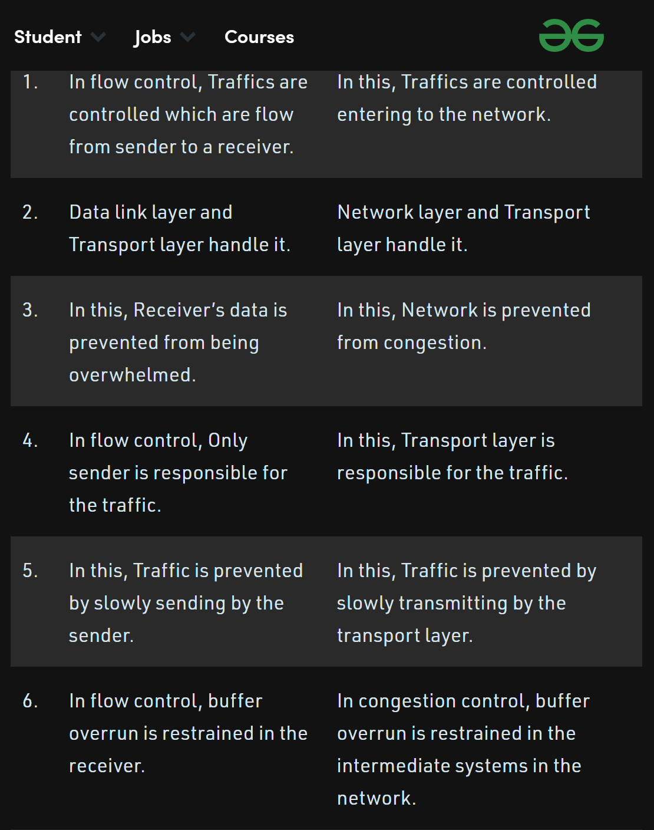

(3) What is the reliable data transfer? How to implement it?.