Design Document

Guidelines
- Technical guidelines
- Development will be done using the Xcode IDE and iPhone SDK 3.1.
- The programming language that will be used is Objective-C.
- We will use iPhone SDK simulator, which is based on Objective-C, for testing.
- The SQL Query API will be used for the database related programming.
- Audio files are played using the Xcode AVFoundation framework.
- For implementing graphical and event-driven applications in iPhone OS, Cocoa
Touch comprising UIKit and Foundation frameworks will be used.
- The image of Professor Monkey was made using Microsoft Power Point.
- Images will be taken from Microsoft clip art and found the internet with Google.
- Google code SVN will be used as the source code control system. All code and versions will be released into the team’s Subversion repository.
- Tortoise SVN will be used to access the project’s Google code database.
- Gantt Chart was drawn using Microsoft Project.
- All coding must be accompanied by comments.
- We will write our source code to comply with the Cocoa Style coding standard and conventions.

- Ethical and Legal Issues
- All code is original, written by Team Awesome, with the exception of the open source code libraries.
- The application will make use of source code and binary libraries created by third-party developers however, to respect intellectual property rights, the application will be developed using libraries under open source licenses. Documents and source code comments will give credit to the original authors of the code libraries used.
- This application is designed for children and will not contain any violence, coarse language or nudity.
System Diagrams

Class Diagram:

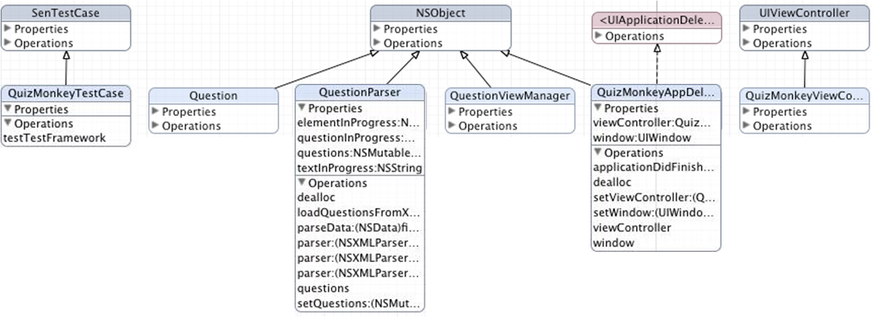

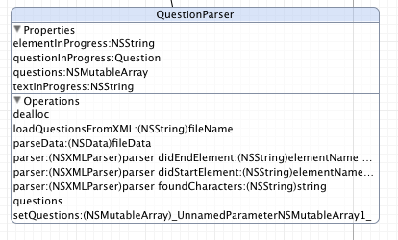
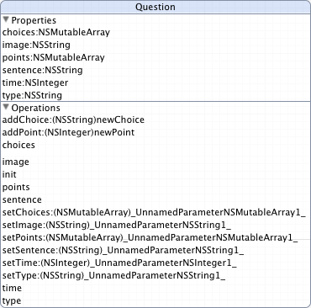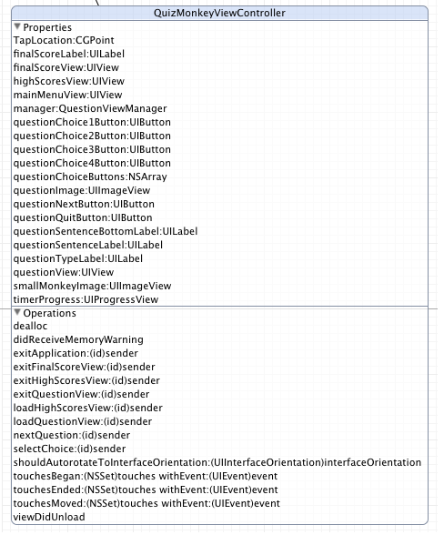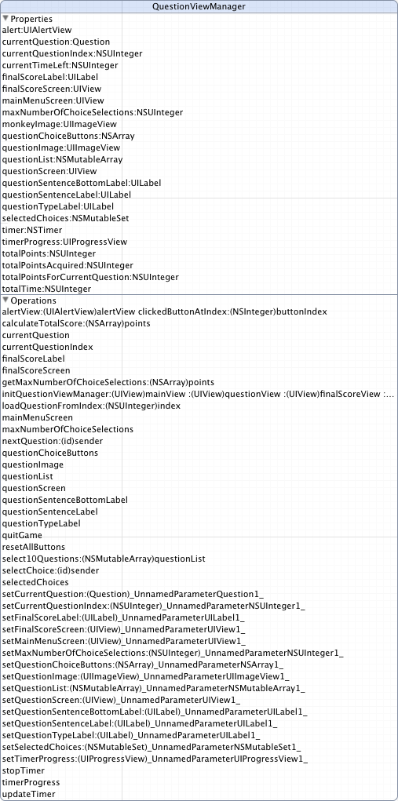
System Sequence Diagram of QuizMonkey Application:
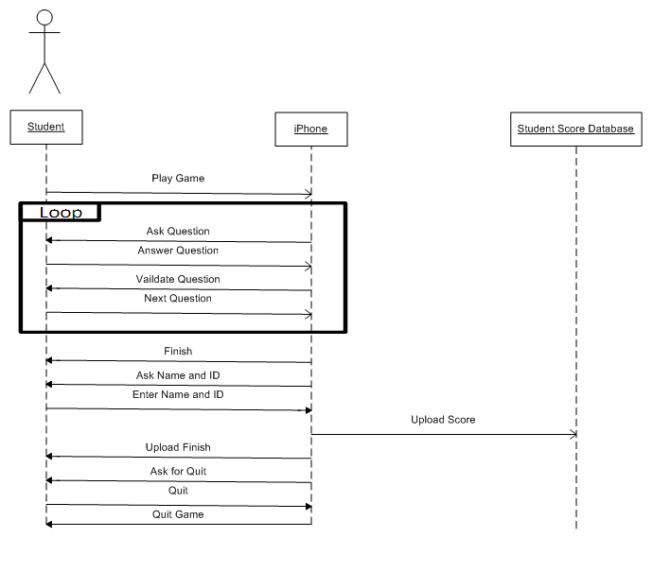
System Sequence Diagram of the Online Student Monitoring System
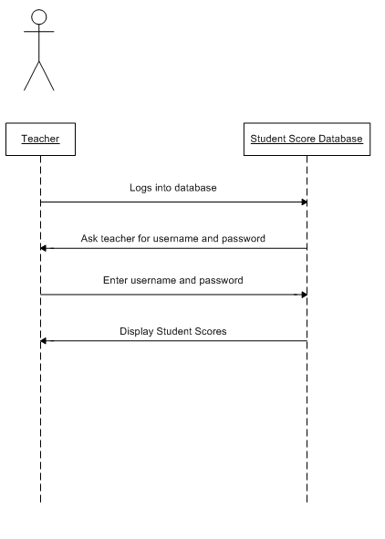

Data Requirements
About the IPhone:
The IPhone has a multi-touch screen that is able to sense the presence of one or many fingers. It also supports audio formats such as AAC, Protected AAC, MP3, MP3 VBR, Audible (formats 2, 3, and 4), Apple Lossless, AIFF, and WAV.

Input:
To get a user’s answer out a given number of choices, the tap screen will be used.
The application will use “.jpg” files for displaying graphical aspects of the application
The application will use “.mp3” files for sound effects during the game
The application will use “.xml” files for loading quiz questions, answers, and choices.

The “.xml” files will have the following format:

<questions>
<question>
<type>Question Type</type>
<image>imageIfRequired.png</image>
<sentence>The text asking the question or providing the
sentence.</sentence>
<choice>option A</choice>
<choice>option B</choice>
<choice>option C</choice>
<choice>option D</choice>
<point>possible points for A(integer)</point>
<point>possible points for B(integer)</point>
<point>possible points for C(integer)</point>
<point>possible points for D(integer)</point>
<time>number of seconds this question contributes to the
total allotted time(integer)</time>
</question>
<question>
Another question
</question>
...
...
...
</questions>

Output:
The application will use “.xml” files for saving user names and scores.
Send scores to an SQL server through the internet
External Systems:
Scores will be sent to a server and the scores will uploaded to an external database that is viewable by a dynamic webpage coded using PHP.

Feature Priority

Feature | Priority
Main menu | Crucial
First three game modes:  “Find the nouns, adjectives, or verbs” | Crucial
Question loader from the xml documents | Crucial
In-game display of personal, high scores stored locally | Nice to have
Other three game modes:  “Fill in the blank”  “Match the picture”  “Find the misspelled word” | Medium
Uploading scores to the internet | Crucial
Saving game state, for multitasking | Nice to have
Web interface for teachers | High
Resize screen on rotation | Nice to have

Versions | Features
Version1 | A working prototype which will have main menu functionality, loading questions from XML files with the 3 question types (“Find the word type”, “Fill in the blank”, “find the misspelled word”)
Version2 | Enter your info for saved high scores. Online high score database. Save state for continuation on re-opening of the app.
Version3 | Web interface for teachers to view progress of students. Additional question types. Support for integrating downloaded question packs.

