Requirements and Design

Introduction

QuizMonkey is an interactive iPhone game designed to test a student’s grammar and spelling abilities at the 2nd or 3rd grade level. The game is played by answering a series of questions on the topic of spelling and grammar. Once completing the series of questions, the student’s score will be uploaded to an external score database that is viewable only by the student’s teacher. The scores posted on the server will provide the teacher with an accurate assessment of the student’s spelling and grammar skills and will indicate whether the student needs improvement. Also, there will be a character on the screen named Professor Monkey who will provide detailed information on the student’s performance and guide the student throughout the game.

The application is also designed to be very simple and easy to use since during a game session the user will only be required to tap answers displayed on the screen. When starting the game, a series of 10 questions will randomly be selected from a larger question pool. The student will have several minutes (depending on the randomly selected questions) to finish a game session otherwise, the score gained will not be recorded in the personal high scores. Points will be awarded for each question, and the amount of points awarded will depend on the question since some questions may have more than one answer.

Once a student has answered all 10 question in that game, the student will be asked for their name and student ID. Once the student has entered that information the student’s score for that game will then be uploaded to a private score server known as the
“Student Progress Monitoring System”. This is a website that will be accessible only by the student’s teacher and will display the student’s game play history. After submitting their score the student can choose to play again. Since the questions are randomized the game will be different every single time.

Intended Audience

This iPhone software is exclusively intended for students of grade 2-3.
The application will assume that its audience has a basic understanding of grammar, possess basic language skills and who are seeking to put those skills to the test.

The web-based student-score database is intended for the teachers who are responsible for monitoring the students’ progress in the game.

Features

The application will be simple and intuitive. The game will have several question types to test the students’ spelling and grammar skills. Users will use the touch-screen to identify correct answers rather than typing out the answers by hand. This will make the game easy-to-use and provide the student with a fun way of learning outside of class.

Main Menu

The main menu will be the first screen the user will see upon starting QuizMonkey. The main menu will display just two options for simplicity; “Play Game” and “Quit”. When the user selects “Play Game” the user will immediately be directed to the game-play screen which will display the first question of a sequence of 10 randomly selected questions from a larger question pool. Each question will have a time limit associated with it. The individual time limits for each of the 10 questions will be added together to create the total quiz time limit. Upon starting the game the student may see the following question types displayed on the screen.

Question Types

- Find the nouns - A sentence will be displayed onscreen and the user will identify the nouns by tapping the correct words on the screen.
For example, the sentence could be “The rat ran into its cave”. Then the user, in order to get both points, will have to tap the words “rat” and “cave”. If the user only correctly taps one of those two words then he or she will only gain 1 of the two available points.
Upon tapping a correct word, the word will turn green. While if an incorrect word is tapped, the word will turn red.
After tapping two words, a pop-up message will appear on the screen displaying the number of points gained.
To continue to the next question the user must tap a “next” button, displayed on the pop-up message. The user will only have one try to select the correct answers.
- Find the adjectives - A sentence will be displayed onscreen and the user will identify the adjectives by tapping the correct words on the screen.
For example, the sentence could be “There has never been a sky as blue as this one”. Then the user, in order to get a point for the question, will have to tap the word “blue”. After tapping the correct word, the user will gain 1 point. Upon tapping a correct word, the word will turn green. While if an incorrect word is tapped, the word will turn red.
After the word, a pop-up message will appear on the screen displaying the number of points gained.
To continue to the next question the user must tap a “next” button, displayed on the pop-up message.

- Find the verbs - A sentence will be displayed onscreen and the user will identify the verbs by tapping the correct words on the screen.
For example, the sentence could be “The cow likes to eat fresh grass”. Then the user, in order to get a point for the question, will have to tap the word “eat”. After tapping the correct word, the user will gain 1 point. Upon tapping a correct word, the word will turn green. While if an incorrect word is tapped, the word will turn red.
After the word, a pop-up message will appear on the screen displaying the number of points gained.
To continue to the next question the user must tap a “next” button, displayed on the pop-up message.
- Fill in the blank – The user will be given a sentence or a word that may or may not contain a picture. The user will have a set of options to choose from and will have to touch the correct option on screen to complete the sentence or the word.
For example, a sentence could be “Sue ____ tired of running on the beach”. The choices displayed are “are”, “am”, and “is”. In order to gain the points for this question, the user must tap the choice “is”.
If the user taps the correct choice, then the choice will turn green and a pop-up message will notify if the answer was “correct” or “wrong”.
If however, the user taps an incorrect choice, then the choice will turn green and a pop-up message will notify the user whether the answer was “correct” or “wrong”.
Another example of fill-in-the-blank question
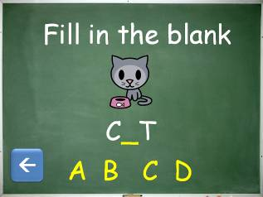

- Match the Picture – The user will be displayed a picture of an object. And will also be given a set of options, the user can tap the choice that he or she thinks is the correct one. For example, an image of a bird is displayed on the screen and under it will be the four choices. These choices can be “House”, “Car”, “Bird”, and “Nurse”. Then the user, to gain points for the question, will have to tap the word “Bird”. If the choice tapped is correct, then the choice will turn green and a pop-up message will notify the user whether the answer was “correct” or “wrong”. If the choice tapped is incorrect, then the choice will turn red and a pop-up message will notify the user whether the answer was “correct” or “wrong”.
Students will see a picture and will have to choose the correct word that identifies that particular animal, vehicle or object.
- Find the misspelled word – The user will be given a list of words, were one of the words will be slightly misspelled (the word "choice" could be spelled "shoice" as an example). Conversely they may be given a list of misspelled words and be asked to identify the correctly spelled one.
For example, the choices may be "Cook", "Fun", "Yellow", and "Leter". then the user, to gain the points for this question, will have to tap the word "Leter" since the correct spelling of this word is "Letter". Then if the choice is tapped, then the word chosen will turn green and a pop-up message will notify the user that the choice was "correct". However, if an incorrect word is tapped, then it will turn red and a pop-up message will notify the user that the choice was "wrong".
If the user is unable to complete the quiz, within the total time period allowed for the 10 random questions, then a pop-up message will appear to notify the user that time has run out. Then they must tap a next button to go back to the main menu.
When a student ends one game session, the student will then be asked for his or her name and their student ID (possibly given by a teacher). Upon filling in those details, the game score will then be uploaded to an external server viewable by a teacher from a website. If an internet connection is not available, the score will then be saved on the student’s iPhone to be uploaded once a connection becomes available.

Non-functional requirements
Product Requirements | Usability | Students (aged 6-7) shall be able to navigate games and menus without requiring any further assistance from reference material such as user manuals as the interface will be intuitive.
Product Requirements | Speed | Questions and menus should load and display seemingly instantaneously; should loading take more than 1 second, the program will notify the user to wait.
Product Requirements | Space(memory and HDD) | Program size on the iPhone should be less than 10MB. Memory usage shall be no more than 90% of free space while iPhone is idle.
Product Requirements | Reliability | The student should be able to finish an entire round of quiz questions regardless of whether an internet connection is available. The game should not crash under any circumstances.
Product Requirements | Robustness | Should the iPhone lose its internet connection during a score upload, the student will then be asked whether he/she wants to save the score locally on the iPhone’s memory.
Product Requirements | Portability | This application is designed to run only on an iPhone/iPod Touch, so portability is not an issue.
Organizational Requirements | Delivery | Application versions and all documentation are to be delivered on time as specified in the assignment page on WebCT.
Organizational Requirements | Implementation | Application code shall be developed in Objective-C using Xcode.
Organizational Requirements | Standards Requirements | The application will be created using iterative development.
External Requirements | Interoperability | Application must be able to access an SQL database, to update and pull high scores.
External Requirements | Ethical | This application is designed for children and will not contain any violence, coarse language or nudity.
External Requirements | Safety | This application shall not put the user in danger, nor will it encourage any dangerous behaviour.
External Requirements | Privacy | This application will not ask for any personal information. The user’s full score history will be available through a web page accessible only by the student’s teacher. Non-authenticated users will not have access to the score page.

Example Tutorials

Upon starting the game on your iPhone you should now see this screen in Figure 1.
Press “Play Game” to start a new game session.
Press “Quit” to return to your iPhone dashboard.
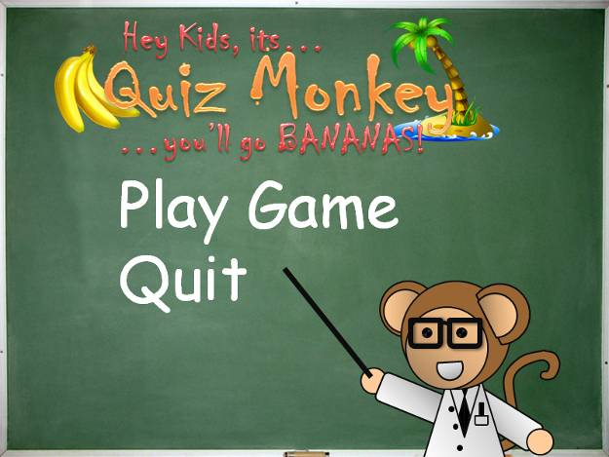
Figure 1

Gameplay
Here are 2 examples of the questions you may encounter:
Select one of the following options in yellow to progress to the next question. A question such as “Find the adjectives” may require the student to select multiple answers.
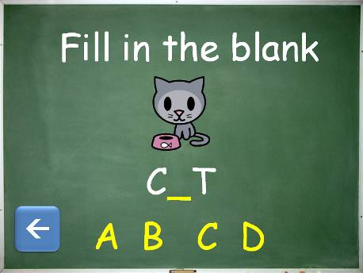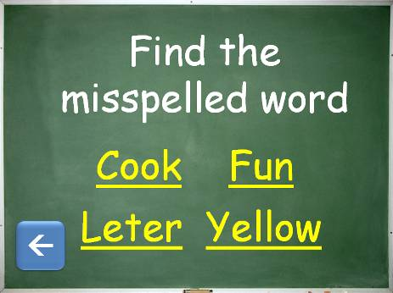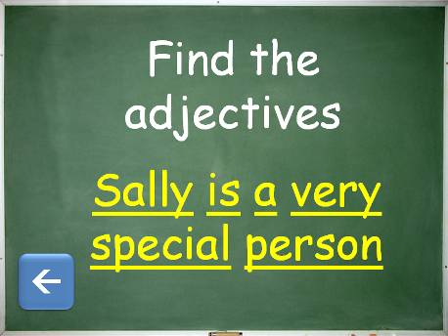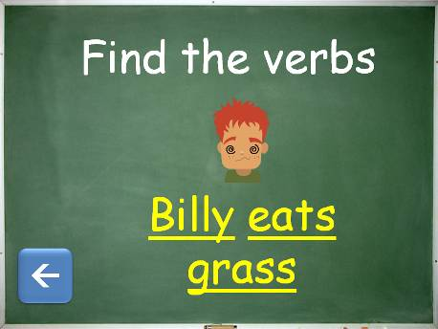
Figure 2

Press the blue arrow button and the game will ask you whether you want to quit.
(Shown in Figure 5)

After selecting your answer, the game will tell you if your answer was correct or incorrect. Questions with multiple answers will display how many answers the student answered correctly for example “You answered ½ correctly!”
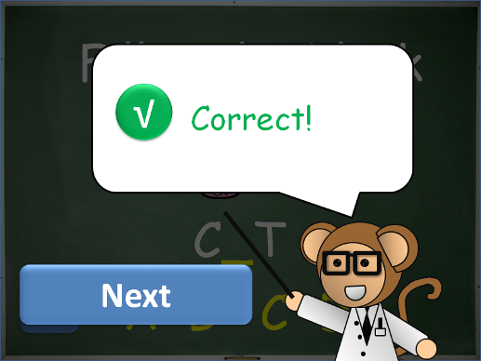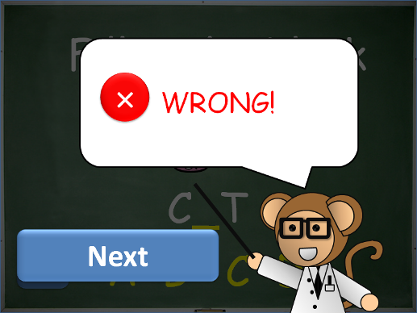
Figure 3 Figure 4

If you have pressed the blue arrow you will be brought to the screen shown in Figure 5
Select “Yes” and the game will display the student’s score.
Select “No” and the game will continue.
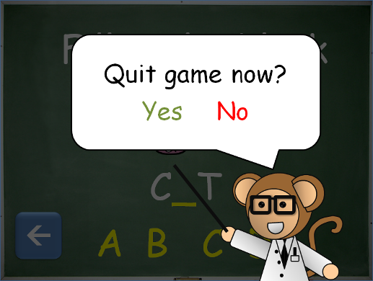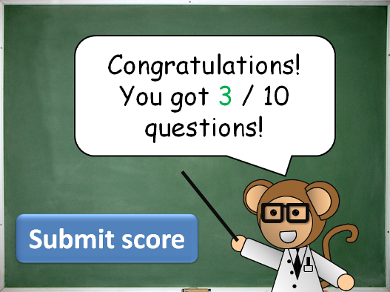
Figure 5 Figure 6

After pressing “Submit Button” on the game score screen (Figure 6) the student will then be prompted for their name and Student ID (Shown in Figures 7 and 8)
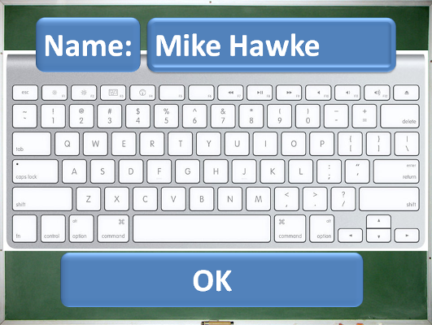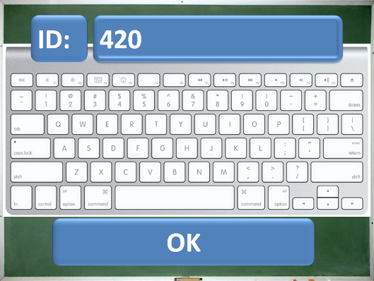
Figure 7 Figure 8

After pressing “OK” on the screen shown in Figure 6, the game will confirm
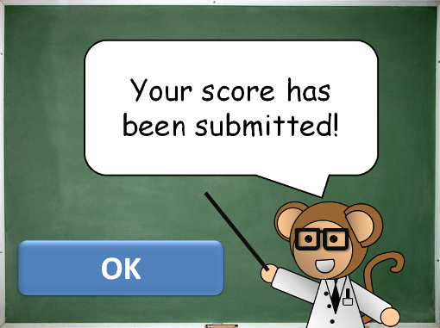
Figure 9

Once the scores have been submitted, the student’s scores are viewable on the
Student Progress Monitoring System, which is accessed by the student’s teacher.

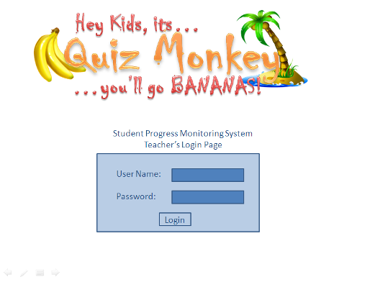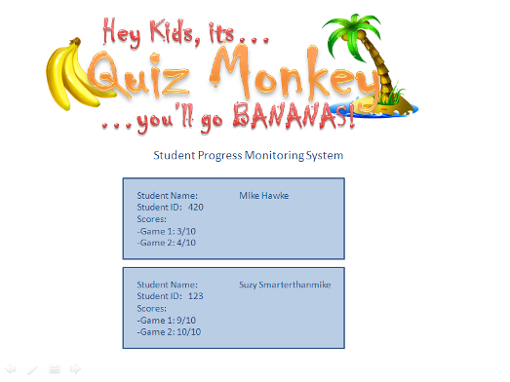
Figure 10 Figure 11

Glossary

Student ID – A number that uniquely identifies the student playing the game. This is what is displayed in the high score website.

Score/Marks – A number that represents how many questions a student has answered correctly

Database – Contains a record of the students’ score and is viewable through a computer web browser (not through the iPhone) by a teacher

iPhone - A line of Internet and multimedia enabled smart phones designed and marketed by Apple Inc.

User/Student – Students in Grades 2-3 playing our game, the word user and student both refer to the same person and are used interchangeably throughout this document

Touch-Screen - A touch-sensitive display screen: touching different portions of the screen with a finger will cause the computer to take actions determined by a program.

Objective-C – The programming language used to build iPhone and Macintosh applications.

XCode – A software development tool that assists programmers in the development of iPhone and Macintosh applications

SQL – A database query language used for manipulating table entries in a relational database

Database – A computer application tasked with the storage and manipulation of data, this may also refer to the computer that contains a database server

Server – A computer that is accessible through a network that “serves” information to other computers

