CMPT 414: Model Based Computer Vision
Term Project
Character Recognition Using a Neural Network
Cley Tang - #
Jeff Hunter – 301128503
Introduction:

The goal of this project is to implement a neural network that learns through the backpropagation technique. While a neural net can be used to recognize many general things, ours will be developed towards discrimination and recognition of various glyphs; in our case, the english alphabet. Our networks will be further constrained by having only layer based, as opposed to more general, topologies.
The network simulations were first built as simple two input neurons. We then had many stages of generalization and re-implementation of the higher levels: neurons to layers, layers to networks, etc... At these intermediate stages, our networks were tested not to recognize glyphs, but to segment various hyper-planes (x,y in particular).
(NOTE: REDO BELOW BASED ON NEW INFO)
The final product was capable of recognizing small, noise-free images of characters. More complex datasets (databases of handwritten characters) were tested, but the learning rates and results of the networks under these conditions were less than desired.

Development:

The development of our project was geared towards a layer based neural network from the beginning. This allowed us to make many design simplifications at various levels. The two final objects we developed towards were a network capable of calculation and learning, and a trainer capable of teaching a network on various datasets.

Neuron:

The simplest object was developed first; a single neuron, first built with two inputs. Regardless of the number of inputs, a neuron in our model has four public functions: construction, calculation, learning and the returning of weights. While we considered having a selectable activation function, we decided that only a sigmoid function was necessary, as the backprop method for learning we had chosen required it.
Construction is quite simple, required only three of four arguments. Argument that need to be specified are the number of inputs, the learning factor or “gain”, and the “inertia factor”. The optional argument gives a range of values that the neuron's weights and bias can be randomly selected from, the default being from 0.0 to 1.0.
Calculation is also quite simple, requiring only a list of inputs of proper length for this neuron (Ex: a four input neuron with complain when presented with five inputs for calculation). The inputs are then multiplied by their corresponding weights and summed together. A bias is then added to this subtotal, and the result is put through a sigmoid function. The result of the sigmoid then finally returned.
Learning is the only function that we had to redesign. Initially we had planned for two arguments, the inputs and desired outputs of that neuron. This design proved impossible to implement, as calculating the error terms for hidden neurons would require more information. It seemed necessary to use error term instead of desired output; testing revealed that it would be simple to calculate error terms outside of the neuron. Once an array of inputs and the corresponding error term are presented to the neuron, the weights and bias are adjusted in the standard way. For each input and associated weight, the input is multiplied by the error term and our gain factor, the weight is then adjusted by this amount. If a non-zero “intertia factor” was specified, then the weights are further adjusted by that intertia multiplied by the last change in weights. The bias is adjusted in an identical way, the only exception being that the bias' “input” is always considered to be one.
These simple neurons can make simple decisions, splitting an N dimensional space with an N-1 dimensional hyper-plane where N is the number of inputs. Some of the first tests of our project were attempting to get a single neuron to split the x, y plane across various lines. The following images represent decision boundaries for two tests, dividing the plane along the lines: x = 5 and y = (x / 4) + 5.
Colours correspond to decision boundaries after a number of training steps: Violet = 10 training points, Red = 100 points, Yellow = 1000, Green = 10,000, Blue = 100,000. The thick grey lines are decision boundaries after the network has achieved 99.5 percent accuracy.
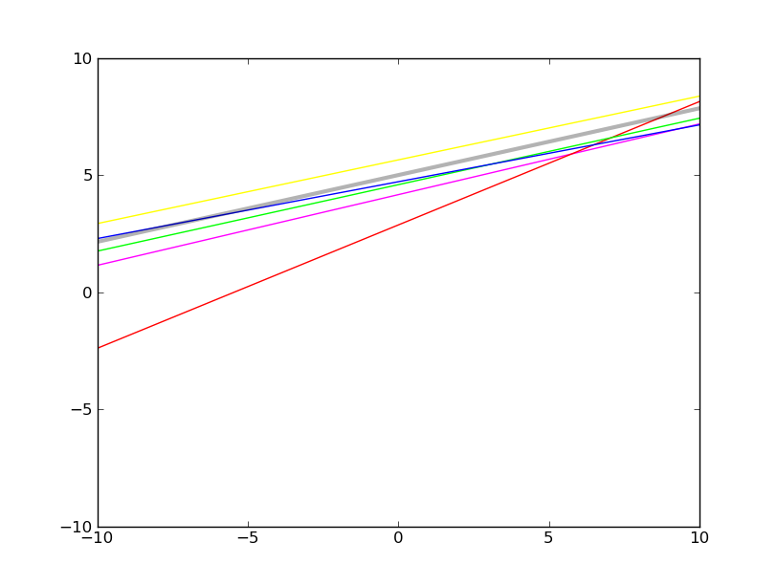
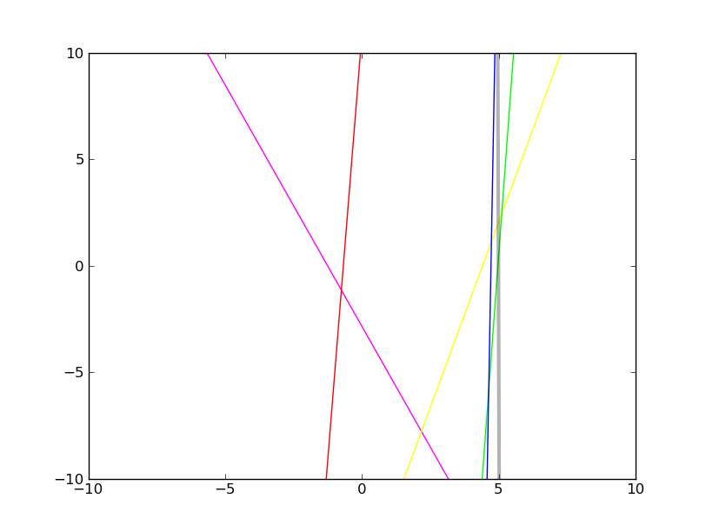
Layers:

After our neurons were complete, we began to construct our layer object. A layer of neurons represents exactly what you would expect, a collection of neurons corresponding to a single layer of a possibly multi-layered neural network. Like a neuron, a layer can calculate, learn, be constructed, and return the weights of it's constituent neurons.
Construction of a layer required the number of inputs, the number of neurons, as well as gain and inertia factors. While a neuron can accept a range for weigh starting values, the layers use the default values. The gain and inertia factors are specified as floats, not as lists, ensuring that all neurons have these same factors. We tested small (2x2) networks with non-uniform factors, but found that results were not acceptable.
Calculation for a layer is incredibly simple. A list of inputs is passed in to the layer, if the size of the input list is inappropriate, the software complains. If the list is acceptable, then each neuron in the layer append it's calculation for the given input to a result list, which is returned after all neurons have contributed.
When asking a layer to learn, one must pass in a list of inputs and a list of error terms, one error for each neuron. The layer then passes those arguments down to the neurons individual learn functions. The choice to have error terms calculated outside the layer class arose from having to calculate error terms differently for hidden and output layers. We decided to have a more general layer class as opposed to differentiating between hidden and output layers.
While on it's own, a layer could be considered to be a simple form of neural network, we never implemented any testing of a layer on it's own. Having constructed the network and layer classes at the same time, we ended up testing layers through the proxy of networks.

Networks:

The

