Implementation

Overview

There are various approaches to solving the problem of optical 2D character recognition; one such approach involves creating a neural network that can be trained in order to identify characters with a great deal of accuracy. Our program implements a simple feed forward network which utilizes the back-propagation algorithm for network training in order to recognize characters. Although neural networks can be trained to solve almost any problem, we decided that optical character recognition would be the best way to demonstrate the power of neural networks visually.

Our network is a single-layer perceptron with N number of output nodes. N is the number of training images used to train the network. Our current image library consists of 5 images ranging from A to E. Each training image is 5x5 pixels in resolution with each image corresponding to 1 desired output (versus many images corresponding to 1 desired output)

The main reason why our system has only a single layer and processes 5x5 images is because, after much testing, that the system can be trained much faster and quite accurately given the size of our images. Also, since any image inputted through our program is automatically converted to a 5x5 binary image, our system is more resistant to small differences in images when determining a suitable match.

Our image library is then used to train our network. Once the training has been completed, an image (of any size) can be serialized into a 1 dimensional vector and feed through our network. The network will output a list of percentages or confidence values indication the most likely match from the library.

For example:

Input Image: E
Library: [ A, B, C, D, E ]
Output: [0.02, 0.03, 0.02, 0.01, 0.98]
Binary Output: [ 0, 0, 0, 0, 1 ]

The “natural” output is then rounded to produce the binary output thus, indicating that E is the most likely match from the image library or training set.

Basic Testing Process

→ Serialized to [0, 1, 1, 1, 1,..] → Feed through →
25 element array Network

Output matched image

Program Architecture
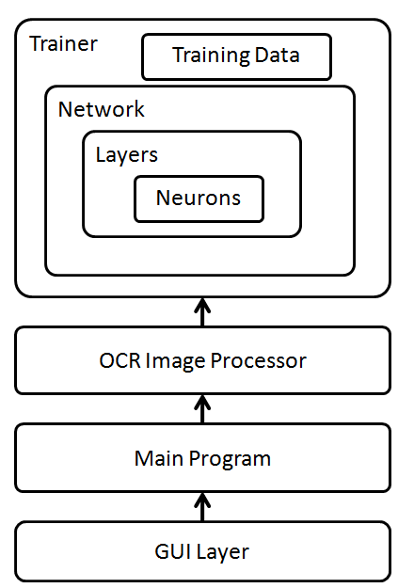

Training Data

Our training data is a set of training inputs each corresponding to one desired output

Inputs Desired Output
[1, 0, 0, 0, 0, 1, 1, 0, 0.... 1] [1, 0, 0, 0, 0]
[1, 0, 0, 1, 0, 0, 1, 0, 0.... 1] [0, 1, 0, 0, 0]
...

Our inputs are an array or vector of 25 binary values which represent a 5x5 image. Before any image can be run through our system, they need to be re-sized into a 5x5 image. If the images are in colour, they are then convert to a grey-scale image in which each pixel will be rounded to either 1 or 0 to produce a binary image.

Once our array of training images has been put into the form shown above they are then used to train the system.

Trainer, Network, Layers and Neurons

This layer contains the basic structure for our neural network. This class is composed of a list of layers. These layers are composed of a list of neurons which contain a list of weights for each input going into them. Each of these classes have a learn() function which is called at each training step from the Trainer class.

It is the trainer class that runs the main loop of the back propagation algorithm by calling the train() function.

Basic Process:
- Initialize network with random weights
- Feed each training input through the system and store their outputs
- Compare the desired output from each training input to the desired output
- Adjust the weights for each node in each layer starting from the top layer
- Re peat steps 2 to 4 until the outputs for each training input match their corresponding desired output to a certain degree

Once the training process is complete, we are ready to feed images directly through the network to determine a match. Since the weights are randomly assigned throughout the network upon initialization it is still possible to feed inputs through our network without training however, this most-likely yields incorrect results for large training sets.

Network Topology

The network is can be represented as a bipartite graph. “x” represents your inputs and y represents your outputs.

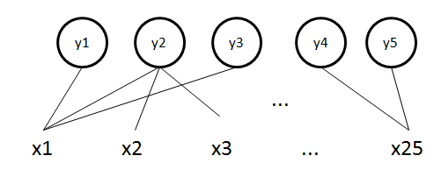

Program Usage and Findings

Upon starting the program you will see our main program’s GUI. You will notice that sample training data has already been added for you. This training data is a list of images that you will use to train your network. Immediately if you load an image for comparison, you may not get correct matched image outputted since the network is not trained at this point.

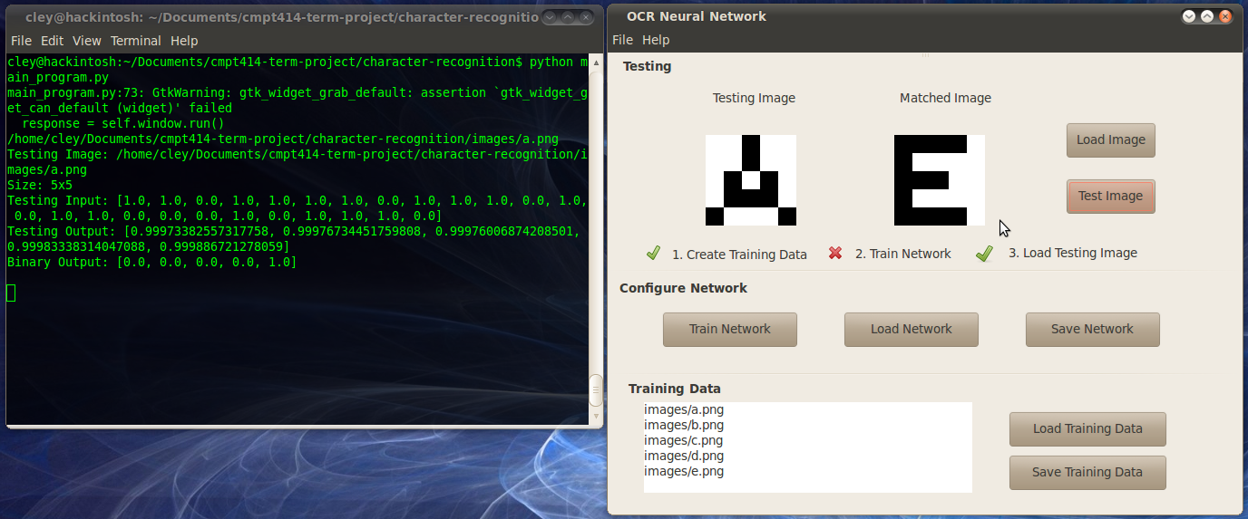

After training the network you will see your terminal output information from each training step. It displays each inputted image in binary form, the raw output as a list of floats representing confidence values for each training image, the output at that step and the desired output.

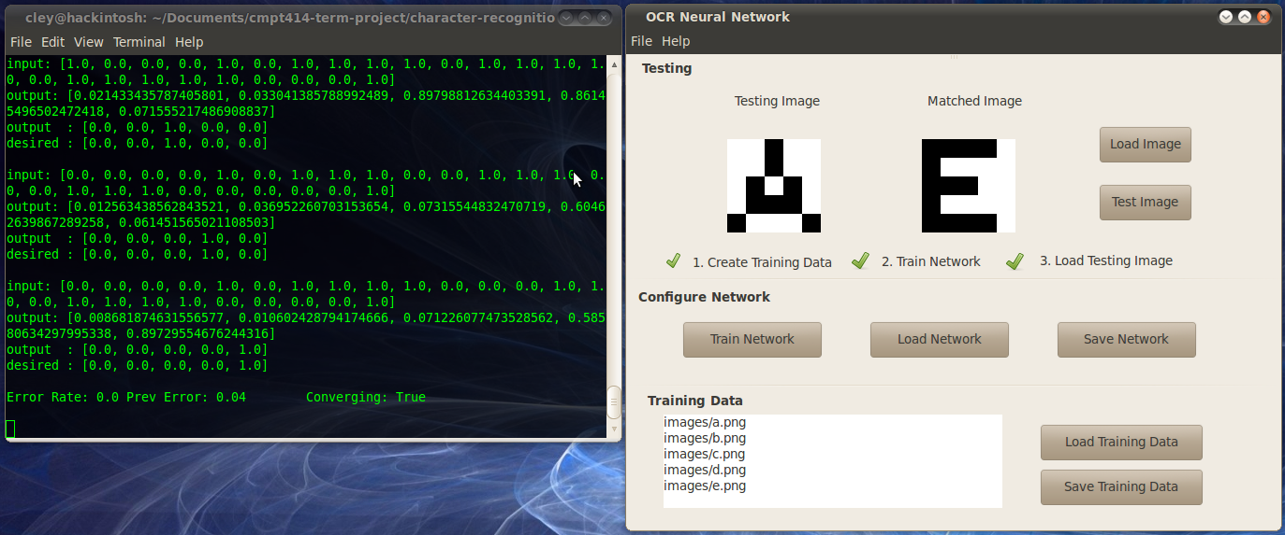

Now if we test the system again we find that the system is now able to determine the correct letter.

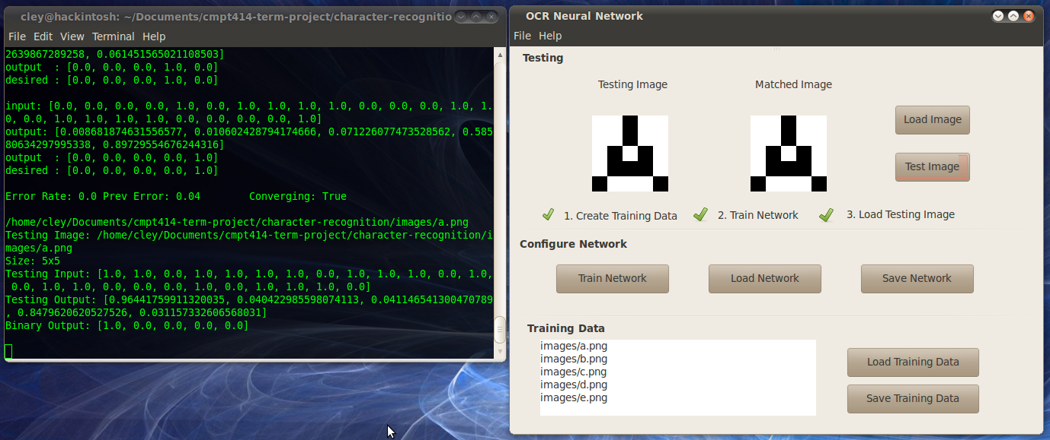

If we take a closer look at the terminal output we can see that our system is 96% confident that the image tested is the letter A.

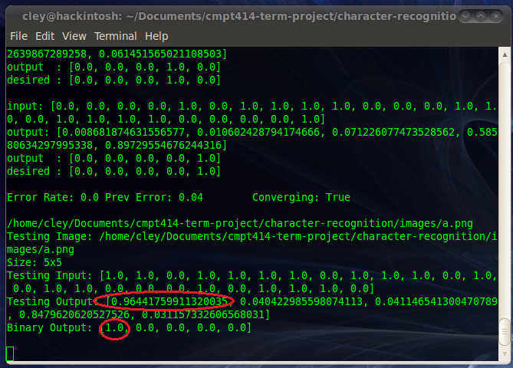

What about images that resemble the C not in our library? We input a 30x30 image for comparison resembling the letter C. Since this image is scaled down to a 5x5 image, our program is able to make a comparison and correctly identify the letter.

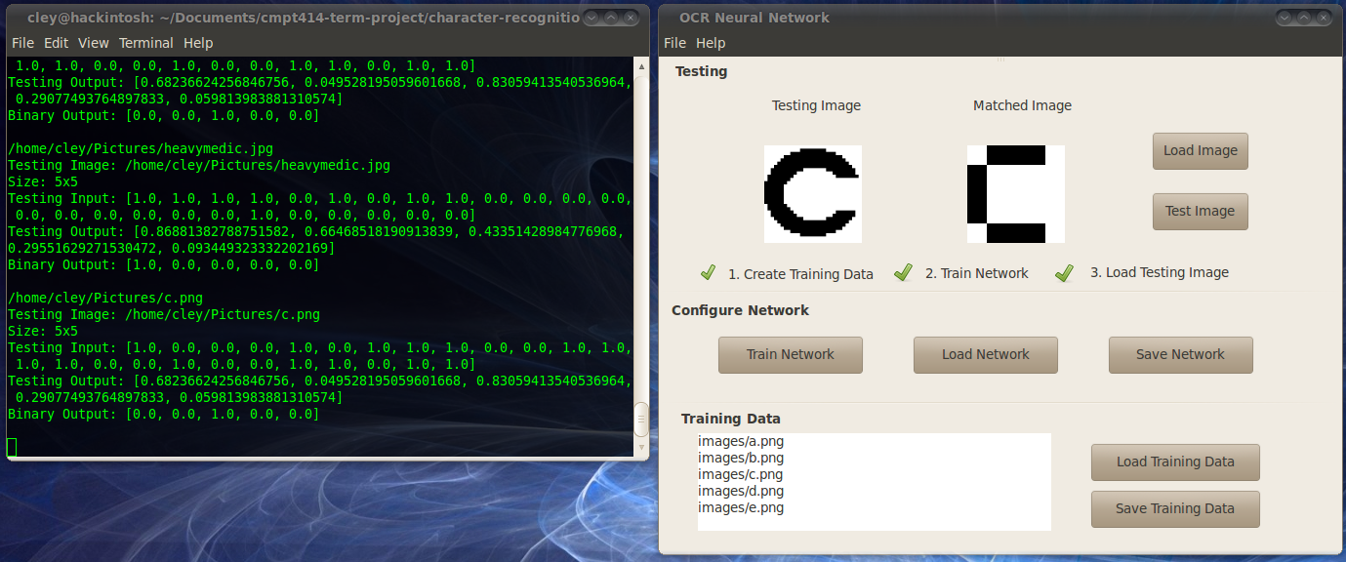

Now we can try a color image and finds that the matched image could be any from the library.

