CMPT 475 Assignment 2
Evergreen Line SkyTrain Specification

Authors:
- Cley Tang
- James Wall
Overview

The goal of this project is to construct a control system for the new SkyTrain Evergreen Line. This document will contain a high level design and requirements specification, as well as, a more detailed description about the software architecture. The high level requirements specification will contain a simplified diagram of the overall system and the software architecture description will contain information about the classes and objects to be implemented in the software.

The SkyTrain Evergreen Line is a new extension of the existing SkyTrain rail system. However, this line will be completely disjoint as the existing system will not share any railways with the new system. To connect the two systems, the Lougheed Skytrain station will be extended so that passengers can transfer from one line to another as was done for the Canada Line. This means that the current control system for the current SkyTrain line will not affect the new line.

Safety is of the utmost importance of this software as this system will be regarded as a mission-critical system that should not and cannot fail under any circumstances. Sensors will be placed on the track so that the system knows when a train is coming or going. It will also let the system know whether the train is fully stopped so that the train can open its doors. The trains also contain sensors that signal whether the doors are open or closed. The doors must not open before the train is fully stopped and the train must wait at least two seconds after the doors close before departing.

While the train must wait to safely open and close the doors, the liveness of the system requires that the system set deadlines so that the train leaves within around 12 seconds of stopping and opening the doors. It closes the doors within 10 seconds, waits at least 2 seconds after doors are closed until it leaves. There is often a trade off between liveness and safety and this system is no different in that it prioritizes safety over response time. However, while the system will not sacrifice safety over liveness, it will have boundaries that create a balance between the two.

The Evergreen Line is a new rapid transit line will connect the Coquitlam, Port Coquitlam and Port Moody Areas to the existing SkyTrain Lines. Travel to Port Moody from Lougheed SkyTrain Station should take approximately 15 minutes.

Requirements

The system operates as follows:
- There are two tracks on which trains travel in opposite directions.
- There are sensors on each of the tracks that can detect if a train is coming, currently halting, stopped at the station, or leaving the station.
- There is also a sensor on each track that detects when a leaving train has left the scope of this skytrain station.
- Once a train completely stops, the system should open the doors within 2 seconds (liveness)
- After 10 seconds the doors should be closed, if it is safe to do so.
- Note that it is important that at least 2 seconds before a train starts moving the system closes the doors (safety).
- Should passengers interfere with the doors closing; the system will wait 5 seconds. If the doors are still not closed when the 5 seconds has elapsed, the track will order all trains to stop
- The moment someone falls into the track area, the “Man on the Track” sensor will activate causing the tracks to cut power to the trains
- Tracks have their own built-in environmental obstruction sensor which indicates whether track flooding or snow is obstructing the track. If there is an obstruction, the tracks will then cut power to the trains causing them to stop
- Trains should indicate whether or not they are suffering engine problems, if the track detects that a train has halted in the middle of the track due to mechanical failure, the track will then cut power to all other trains causing them to stop.
- Stations should contain information about whether they are closed. Trains will not stop at closed stations
- High-Level Design

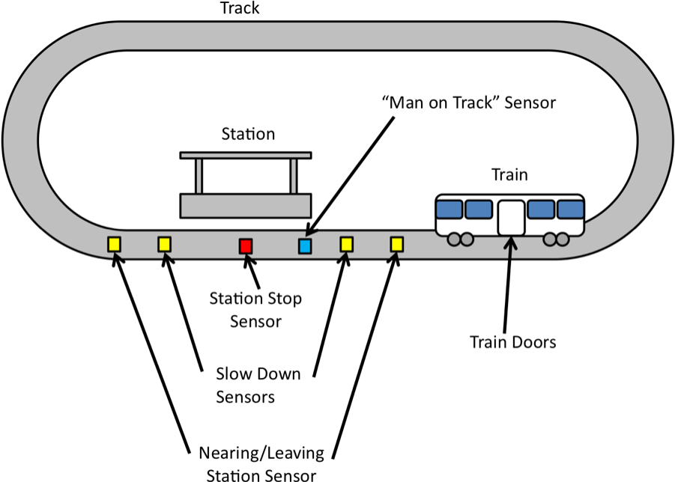

Tracks
The track controller deals with both liveliness and safety by setting deadlines and wait times while signalling the doors to open or close. The track controller ensures that the doors open immediately after the train stops, that they close ten seconds after the train stops, and that the train waits at least two seconds after the doors close before taking off. Tracks are also aware of station sensors and the trains that are currently running on them. So the track controller is responsible for knowing what state the trains are in, determining when to open or close the train doors as well as telling the train when to leave. If any of the sensors report an obstruction on the track, the track will automatically and immediately issue a stop signal to all trains causing them to slow-down and stop. Power can be cut off to these tracks in the event of an emergency. In a high level technical discussion, the track controller sets the time that the doors should close by (should close ten seconds after opening), sets the time the train should leave after (after waiting two seconds), signals the doors to open or close by changing the direction of the doors to ‘opening’ or ‘closing’ and clears the deadline and waitTime if need be.
Trains
These unmanned train cars are controlled by track sensors. They can be ordered to start, speed-up, slow-down and stop. They contain information about their status which can be “Running” or “Broken”. Information about the train door status is recorded with the rest of the train information. Train doors can be either open, opening, closed or closing. Trains can also report their speed as well.
Doors
The door controller simply opens and closes the doors when it is signalled to do so. Although the track determines and signals when the doors should be opened or closed, the door controller actually does the opening and closing. Basically it just changes the doors to ‘open’ and ‘closed’. In an actual implementation, the doors would tell the doors to close, then wait until the doors are actually closed before changing the doorState to ‘closed’ in case a person is obstructing the doors. It would also signal errors to the TrackController so that power can be cut from the tracks and a skytrain attendee signalled to fix the problem.
“Man on Track” Sensors
These sensors work detect whether a person has stepped onto a track; which is exactly what the name implies. When this occurs, the tracks issue a stop signal to all trains.
Stations
Stations only contain information about whether they are closed or open. Trains will not stop at closed stations.
Environment
The environment simply simulates trains approaching the skytrain station at random times. It also simulates the sensors that are placed on the track that display the different states of the train from empty, coming, stopping, stopped, and leaving.
The nearing station sensors are placed just outside of the station. They let the system know when a train is arriving at the station or departing from the station. The slow down sensors are used only for incoming trains that tell the system when the train needs to start slowing down. When an incoming train passes a “Slow Down Sensor”, it changes from ‘coming’ to ‘stopping’.
Observer
The observer is a simple interface to view or log the state of each track, the state of the doors and the time after starting the program. It simply prints out whether a train is coming, stopping, stopped, leaving or the tracks are empty, and if the train is between the slow down sensors it also prints out whether the doors are open or closed.
High-Level Design (cont.)
Class Descriptions
Track
- Stations - Tracks contain a list of stations
- EnvironmentSensor – Boolean sensor that indicates whether an obstruction is detected, true for obstruction detected, false for no obstruction detected

Station
- LeavingStationSensor – Boolean sensor, true for leaving, false for not leaving
- ArrivingAtStationSensor – Boolean Sensor, true for arriving, false for not arriving
- StationStopSensor – Boolean sensor, true for train stopped, false for train has not stopped
- ManOnTrackSensor – Boolean sensor, true for man on track, false for no man on track

Sensor
- Type – Indicates type of sensor
- IsActivated() – True if activated, false if not

Train
- Door – Indicates whether it is open, opening, closed or closing
- Status – either OK or BROKEN
- GetSpeed() – This gets the speed of the train
- Stop() – This stops the train
- Start() – This starts the train at low speed
- SpeedUp() – Returns the train to normal speed
- SlowDown() – Slows down the train upon station approach
- The Prototype
- The CoreASM prototype is a simplified version of the system that simulates the environment and deals with the handling of trains and their doors.
- The prototype does not account for all of the safety features listed in the above high level design, but is meant as a proof of concept model.
- Prototype liveness:
  - The train doors open within 2 seconds of stopping.
  - The train doors close within 10 seconds of opening.
- Prototype safety:
  - The train doors do not open until the train is completely stopped.
  - The train does not begin moving until the doors have been closed for 2 seconds.

