Proof of Dijkstra’s Distributed Termination System

In order to grasp why this system works for all cases we must again refer back to the 6 basic rules of the system.

- Rule: When active, machine i+1 keeps the token; when passive, it hands over the token to machine i.

- Rule: A machine sending a message makes itself black.

- Rule: When machine i+1 propagates the probe, it hands over a black token to machine i if it is black itself, whereas while being white it leaves the color of the token unchanged.

- Rule: After the completion of an unsuccessful probe, machine 0 initiates a next probe.

- Rule: Machine 0 initiates a probe by making itself white and sending a white token to machine i-1.

- Rule: Upon transmission of the token to machine i, machine i+1 becomes white. (Note that its original color may have influenced the color of the token.)

There are 2 cases that this system must handle:
- No machines are sending or receiving messages (all machines are passive)
- Machines are sending messages (or become active) during the probing

Keep in mind this algorithm runs in real-time. The algorithm probes the system by propagating a white token through the system. If the token is propagated through the system and remains white, we know that all machines are inactive and we can terminate the entire distributed system.

Case 1

For this example we will consider a simple system with 5 machines as seen below.

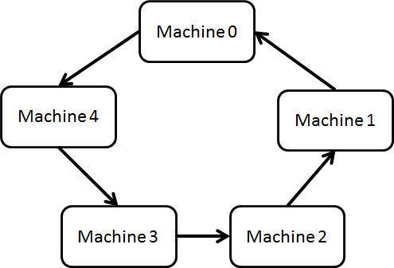

From the diagram it is quite easy to see that passing a white token through the system will reach the end white (Rule 3). Provided that no machines send any messages, the system will terminate. We will examine this in more detail.

We start with Rule 5. Machine 0 initiates the probe by making itself white. Since the every machine is passive we can assume that all machines are white. The white token is passed from Machine 0 to Machine 4.

Since Machine 4 is white, it passes on the white token to Machine 3 as stated in Rule 3. Similarly this will happen for each subsequent machine until the token reaches Machine 0. Since each machine cannot change the colour of the token, the token remains white. Machine 0 receives the white token and then the whole system can be terminated.

In summary, the white token passes through the white machines without changing colours. When it reaches the end, the system terminates.

Case 2

How about the case where messages are sent during the probing?

We consider again the same diagram as shown above, suppose that Machine 4 sends a message. Rule 2 would make this machine then turn black. When the token is passed from Machine 0 to Machine 4 (Rule 2), Machine 4 holds the token until it becomes passive and turns white (Rule 1). Rule 3 would make the token Black. At this point the token will not become white until it reaches Machine 0. The system will not terminate.

Now Rule 4 comes in to effect, the system is probed again. Let’s also suppose the white token reaches Machine 3 and Machine 2 decides to send a message before the token reaches it.

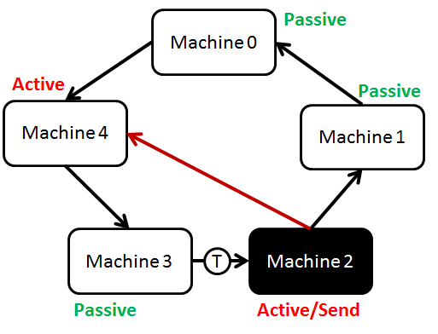

Again, the token will turn black after Machine 2 passes it along, turns white (Rule 6) and the whole process is repeated again.

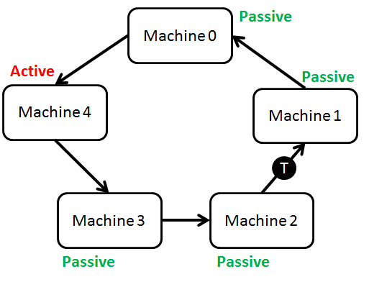
Notice how Machine 4 is active but did not turn black. The token will eventually reach
Machine 4. As long as Machine 4 does not send a message, the token will remain white and reach Machine 0 again thus terminating the whole system.

But what if we have this situation?
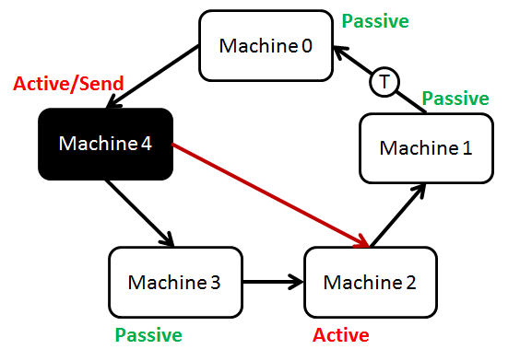
Machine 0 will theoretically receive a white token but and terminate with Machine 4 still active! However, this situation is impossible because of Rule 1 and Rule 6. The system would have to become passive and white in order to pass the token along.

Furthermore, only active machines can send messages. So only machines in the token’s path will be able to send messages and turn black.

Therefore the system works for all cases.

