CMPT 475 Assignment 2
Evergreen Line SkyTrain Specification

Authors:
- Cley Tang
- James Wall
Overview

The goal of this project is to construct a control system for the new SkyTrain Evergreen Line. This document will contain a high level design and requirements specification, as well as, a more detailed description about the software architecture. The high level requirements specification will contain a simplified diagram of the overall system and the software architecture description will contain information about the classes and objects to be implemented in the software.

The SkyTrain Evergreen Line is a new extension of the existing SkyTrain rail system. However, this line will be completely disjoint as the existing system will not share any railways with the new system. To connect the two systems, the Lougheed Skytrain station will be extended so that passengers can transfer from one line to another as was done for the Canada Line. This means that the current control system for the current SkyTrain line will not affect the new line.

Safety is of the utmost importance of this software as this system will be regarded as a mission-critical system that should not and cannot fail under any circumstances. Sensors will be placed on the track so that the system knows when a train is coming or going. It will also let the system know whether the train is fully stopped so that the train can open its doors. These sensors could also let the system know whether or not a person has accidentally fallen on to the track so that power can be shut off to the trains.

The Evergreen Line is a new rapid transit line will connect the Coquitlam, Port Coquitlam and Port Moody Areas to the existing SkyTrain Lines. Travel to Port Moody from Lougheed SkyTrain Station should take approximately 15 minutes.

Requirements

The system operates as follows:
- There are two tracks on which trains travel in opposite directions.
- There are sensors on each of the tracks that can detect if a train is coming, or if a train is currently halting at the station.
- Once a train completely stops, the system should open the doors within 2 seconds (liveness), and after some period of time (say between 10 and 12 seconds), the doors should be closed, if it is safe to do so.
- Note that it is important that at least 2 seconds before a train starts moving the system closes the doors (safety).
- Should passengers interfere with the doors closing; the system will wait 5 seconds. If the doors are still not closed when the 5 seconds has elapsed, the track will order all trains to stop
- The moment someone falls into the track area, the “Man on the Track” sensor will activate causing the tracks to cut power to the trains
- Tracks have their own built-in environmental obstruction sensor which indicates whether track flooding or snow is obstructing the track. If there is an obstruction, the tracks will then cut power to the trains causing them to stop
- Trains should indicate whether or not they are suffering engine problems, if the track detects that a train has halted in the middle of the track due to mechanical failure, the track will then cut power to all other trains causing them to stop.
- Stations should contain information about whether they are closed. Trains will not stop at closed stations

High-Level Design

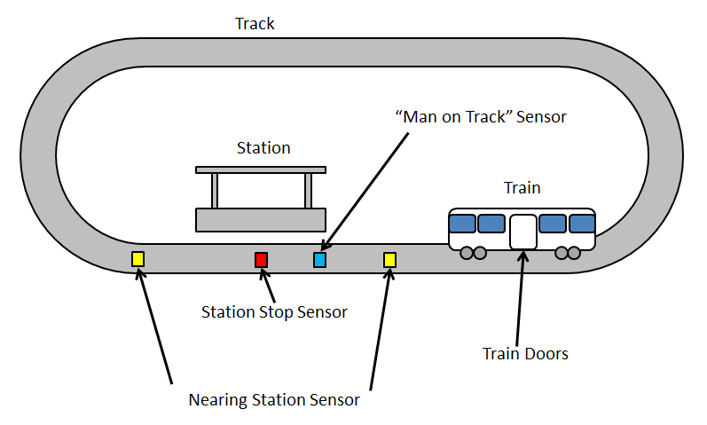
Tracks
Tracks contain environmental information on potential obstructions such as flooding or excessive snowfall. Tracks are also aware of station sensors and the trains that are currently running on them. If any of the sensors report an obstruction on the track, the track will automatically and immediately issue a stop signal to all trains causing them to slow-down and stop. Power can be cut off to these tracks in the event of an emergency.

Nearing Station Sensors
These sensors are placed just outside of the station. They let the system know when a train is arriving at the station or departing from the station. Nearing Station Sensors will cause the trains to slow down when approaching a station. They can also cause trains to speed up when leaving the station.
High-Level Design (cont.)

Trains
These unmanned train cars are controlled by track sensors. They can be ordered to start, speed-up, slow-down and stop. They contain information about their status which can be “Running” or “Broken”. Information about the train door status is recorded with the rest of the train information. Train doors can be either open, opening, closed or closing. Trains can also report their speed as well.

“Man on Track” Sensors
These sensors work detect whether a person has stepped onto a track; which is exactly what the name implies. When this occurs, the tracks issue a stop signal to all trains.

Stations
Stations only contain information about whether they are closed or open. Trains will not stop at closed stations.

Class Descriptions

Track
- Stations - Tracks contain a list of stations
- EnvironmentSensor – Boolean sensor that indicates whether an obstruction is detected, true for obstruction detected, false for no obstruction detected

Station
- LeavingStationSensor – Boolean sensor, true for leaving, false for not leaving
- ArrivingAtStationSensor – Boolean Sensor, true for arriving, false for not arriving
- StationStopSensor – Boolean sensor, true for train stopped, false for train has not stopped
- ManOnTrackSensor – Boolean sensor, true for man on track, false for no man on track

Sensor
- Type – Indicates type of sensor
- IsActivated() – True if activated, false if not

Train
- Door – Indicates whether it is open, opening, closed or closing
- Status – either OK or BROKEN
- GetSpeed() – This gets the speed of the train
- Stop() – This stops the train
- Start() – This starts the train at low speed
- SpeedUp() – Returns the train to normal speed
- SlowDown() – Slows down the train upon station approach

