There are various ways to identify a LLM presence -:
1. Check If Response Comes Word-by-Word (Streaming)
Watch how the answer appears:
- Does it appear slowly word by word?
- Or does the full answer appear at once?
Most LLMs generate tokens one by one.
You can see this in:
- Browser Network tab
- Response loading pattern
If it streams gradually → strong LLM sign.
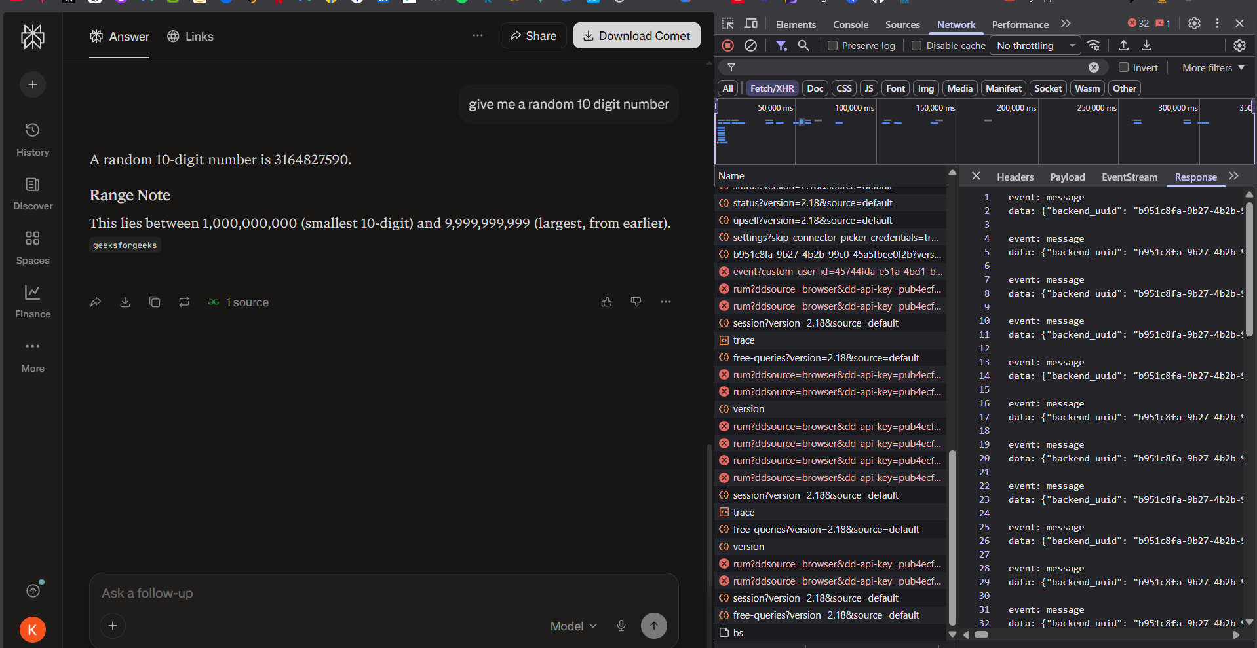
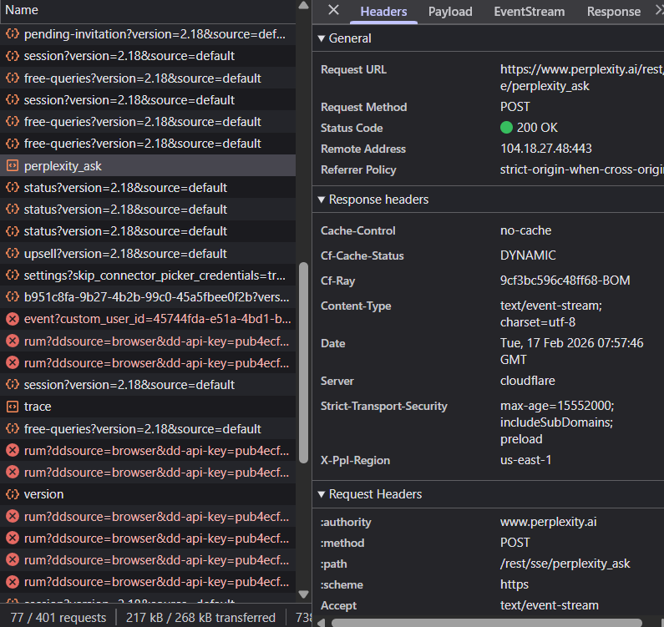
- If the response is word by word, we will be able to know in 3 tabs Header tab, Response tab, Timing tab
- In Header tab if we see these things -:
Look for any of these:
- Transfer-Encoding: chunked
- Content-Type: text/event-stream
- Cache-Control: no-cache
- Connection: keep-alive
If you see chunked or event-stream →
This alone proves streaming at the HTTP level.
Why?
Chunked responses exist specifically to send data piece by piece before completion.

- In Response tab: As we know the LLM understand things in token and give response also in token format so in the response tab
Now do this carefully:
- Click Response
- Re-send a new prompt
- Watch the Response panel live
Streaming looks like:
- Text keeps growing
- New chunks appear without closing the request
- Sometimes you’ll see partial JSON or repeated blocks
Example patterns:
data: {"answer":"The"}
data: {"answer":"The model"}
data: {"answer":"The model explains"}
or incremental text appended over time.
⚠️ If the Response panel updates while the request is still “Pending”, that is real streaming.

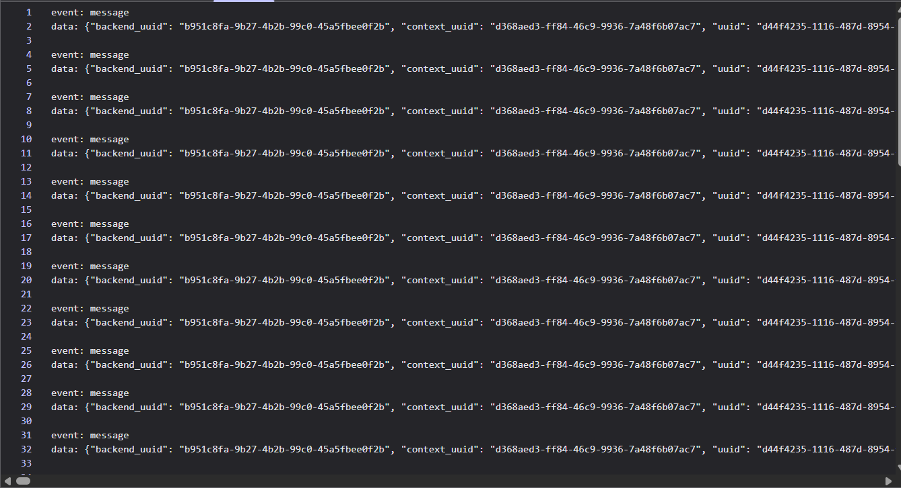
- In Timing tab:
Open Timing for perplexity_ask.
Streaming signature:
- Waiting (TTFB) → small
- Content Download → long (several seconds)
This means:
- Server started responding early
- Continued sending data gradually
Non-streamed APIs show:
- Huge Waiting
- Tiny Content Download
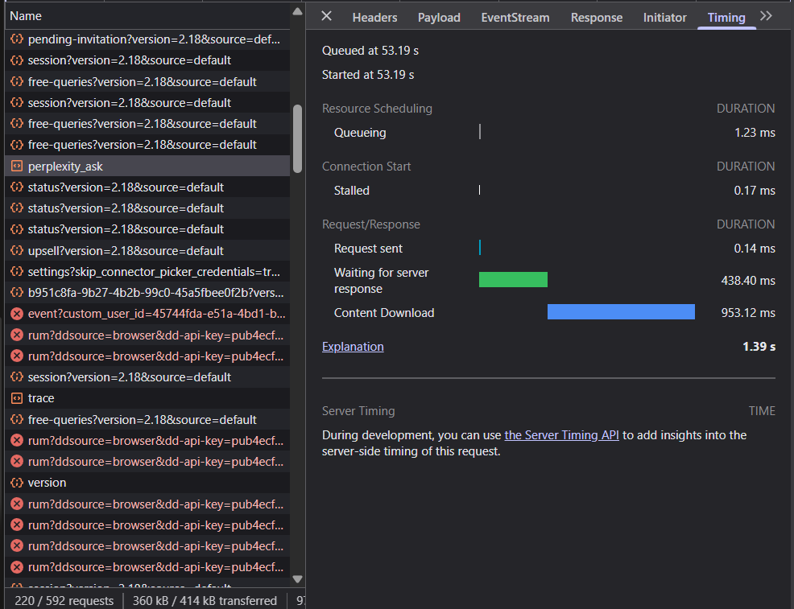

These are some ways which have some validation regarding knowing about LLM presence

We do have some more other method which can be also used to know about LLM presence

2.Ask Same Question Multiple Times
Ask same question 5 times.
If answers:
- Slightly different each time
- Different wording
- Same meaning but variation
That’s probabilistic behaviour → LLM sign.
Normal rule-based bots usually give same answer every time.

3.Check Response Delay Pattern
Try this:
- Send a short prompt → measure time.
- Send a very long prompt → measure time.
If longer prompt = longer thinking time
That’s typical LLM behaviour.
Normal APIs usually respond almost same speed regardless of text size.

4.Send Very Large Prompt
Keep increasing prompt size.
At some point you may see error like:
- “Maximum context length exceeded”
- “Token limit reached”
That’s a classic LLM sign.

