**WEEK-3**

**AIM:**

*Write a program to implement K-means clustering algorithm.*

**Description:**

K-Means Clustering is an unsupervised learning algorithm that is used to solve the clustering problems in machine learning or data science. In this topic, we will learn what is K-means clustering algorithm, how the algorithm works, along with the Python implementation of k-means clustering. K-Means Clustering is an [Unsupervised Learning algorithm](https://www.javatpoint.com/unsupervised-machine-learning), which groups the unlabeled dataset into different clusters. Here K defines the number of pre-defined clusters that need to be created in the process, as if K=2, there will be two clusters, and for K=3, there will be three clusters, and so on.

It is an iterative algorithm that divides the unlabeled dataset into k different clusters in such a way that each dataset belongs only one group that has similar properties. It allows us to cluster the data into different groups and a convenient way to discover the categories of groups in the unlabeled dataset on its own without the need for any training.

It is a centroid-based algorithm, where each cluster is associated with a centroid. The main aim of this algorithm is to minimize the sum of distances between the data point and their corresponding clusters.

The algorithm takes the unlabeled dataset as input, divides the dataset into k-number of clusters, and repeats the process until it does not find the best clusters. The value of k should be predetermined in this algorithm.

The k-means [clustering](https://www.javatpoint.com/clustering-in-machine-learning) algorithm mainly performs two tasks:

* Determines the best value for K center points or centroids by an iterative process.
* Assigns each data point to its closest k-center. Those data points which are near to the particular k-center, create a cluster.

Hence each cluster has datapoints with some commonalities, and it is away from other clusters.

**Code:**

import matplotlib.pyplot as plt

from sklearn.cluster import KMeans

x = [1, 1.5, 3, 5, 3.5, 4.5, 3.5]

y = [1,2,4,7,5,5,4.5]

plt.scatter(x, y)

plt.show()

data = list(zip(x, y))

kmeans = KMeans(n_clusters=2)

kmeans.fit(data)

plt.scatter(x, y, c=kmeans.labels_)

plt.show()

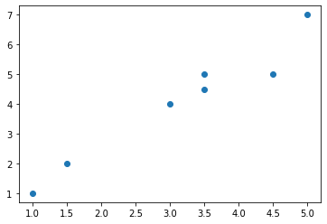plt.legend()

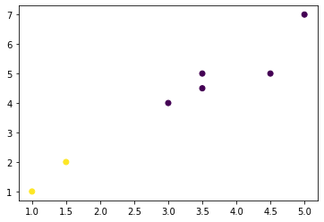

WARNING:matplotlib.legend:No handles with labels found to put in legend.

<matplotlib.legend.Legend at 0x7f8494666810>

