**WEEK-4**

**AIM:**

Write a program to extract SURF/SIFT feature descriptors from a sample image.

**Description:**

The SURF method (Speeded Up Robust Features) is a fast and robust algorithm for local, similarity invariant representation and comparison of images. The main interest of the SURF approach lies in its fast computation of operators using box filters, thus enabling real-time applications such as tracking and object recognition.

SIFT, which stands for Scale Invariant Feature Transform, is a method for extracting feature vectors that describe local patches of an image. Not only are these feature vectors scale-invariant, but they are also invariant to translation, rotation, and illumination. Pretty much the holy grail for a descriptor.

**Code:**

from google.colab import drive

drive.mount('/content/drive')

**Output:**

Mounted at /content/drive

**Code:** !pip install mahotas

**Output:**

Looking in indexes: <https://pypi.org/simple>, <https://us-python.pkg.dev/colab-wheels/public/simple/>

Collecting mahotas

Downloading mahotas-1.4.13-cp37-cp37m-manylinux_2_12_x86_64.manylinux2010_x86_64.whl (5.7 MB)

|████████████████████████████████| 5.7 MB 7.7 MB/s

Requirement already satisfied: numpy in /usr/local/lib/python3.7/dist-packages (from mahotas) (1.21.6)

Installing collected packages: mahotas

Successfully installed mahotas-1.4.13

**Code [SURF];**

import skimage

import numpy as np

import pandas as pd

import matplotlib.pyplot as plt

from skimage import io

%matplotlib inline

cat = io.imread('/content/drive/MyDrive/Academics/5th sem/ml lab/cat.jpg')

dog = io.imread('/content/drive/MyDrive/Academics/5th sem/ml lab/dog.jpg')

df = pd.DataFrame(['Cat', 'Dog'], columns=['Image'])

from mahotas.features import surf

import mahotas as mh

dog_mh = mh.colors.rgb2gray(dog)

dog_surf = surf.surf(dog_mh, nr_octaves=8, nr_scales=16, initial_step_size=1,

threshold=0.1, max_points=54)

fig = plt.figure(figsize = (10,4))

ax2 = fig.add_subplot(1,2, 1)

ax2.imshow(surf.show_surf(dog_mh, dog_surf))

**Output:**

<matplotlib.image.AxesImage at 0x7f54573994d0>

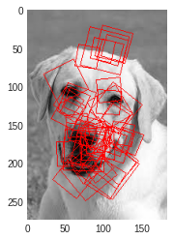

**Code[SIFT]**

cat_mh = mh.colors.rgb2gray(cat)

cat_surf = surf.surf(cat_mh, nr_octaves=8, nr_scales=16, initial_step_size=1,

threshold=0.1, max_points=54)

fig = plt.figure(figsize = (10,4))

ax1=fig.add_subplot(1,2,1)

ax1.imshow(cat)

ax2 = fig.add_subplot(1,2,2)

ax2.imshow(surf.show_surf(cat_mh, cat_surf))

matplotlib.image.AxesImage at 0x7f5455be10d0>

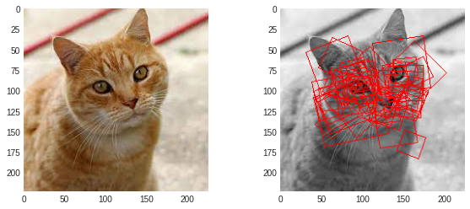

dog_mh = mh.colors.rgb2gray(dog)

dog_surf = surf.surf(dog_mh, nr_octaves=8, nr_scales=16, initial_step_size=1,

threshold=0.1, max_points=54)

fig = plt.figure(figsize = (10,4))

ax1=fig.add_subplot(1,2,1)

ax1.imshow(dog)

ax2 = fig.add_subplot(1,2,2)

ax2.imshow(surf.show_surf(dog_mh, dog_surf))

matplotlib.image.AxesImage at 0x7f5454328410>

