User Guide

March 2014

Version 1.0

This project was inspired by [Blindsquare's](http://blindsquare.com/" \t "_blank) need for entrance-location data, and it was built in the scope of the course GIS Application Development in [Aalto University](http://www.aalto.fi/en/) by Aditya Raju, Anna Gorodetskaya, Kamyar Hasanzadeh and Marco Martins.

Document Revisions

|  |  |  |
| --- | --- | --- |
| Date | Version Number | Document Changes |
| 29/03/2014 | 1.0 | Initial Draft |
|  |  |  |
|  |  |  |
|  |  |  |
|  |  |  |
|  |  |  |
|  |  |  |
|  |  |  |
|  |  |  |

Table of Contents

1 Introduction 5

1.1 Scope and Purpose 5

1.2 Features 5

2 Adding building entrance 6

2.1 Viewing existing entrances 7

2.1.1 Procedure to view existing entrance in the map 7

2.1.2 Adding entrance attributes 8

# Introduction

## Scope and Purpose

Beosmapper is a web based application that can be used to collect information about various attributes of the user’s location. Presently, in the scope of our project, only the information about entrances in various buildings could be collected. However, the application could be extended easily to facilitate collection of various other details like stairs etc. This application is easy to use and very quick in adding entrance information and even available for mobile devices.

The purpose of this document is to guide the users in using the Beosmapper web application for adding entrance information to the OpenStreetMap. This document elaborates the different features that are available with the Beosmapper application and step by step instructions to collect entrance data. This user guide is intended for ordinary users with basic knowledge of using web browsers and web maps. However, to collect the entrance information, users are expected to have Open Street Map account.

## Features

Beosmapper web application provides users with a platform to view existing entrance information present in the OpenStreet Map, add new entrance details along with their description and information regarding suitability of the entrance for physically disabled people. The application is designed in such a way that it needs very few clicks to add the entrance details. Currently, it features only entrance location collection. However, the application is planned to accommodate lot of new attributes in future. The subsequent sections describe the steps to collect the user’s entrance location.

The application could be accessed from <http://beosmapper.sytes.net/> in a web browser. The browsers that are currently supported are

1. Internet Explorer 8 and above
2. Mozilla Firefox
3. Google Chrome
4. Safari 7
5. Android 4.x and above
6. Apple iOS 7.x

The application offers flawless support and user friendly interface in mobile devices. Fig. 1 shows the layout of the application

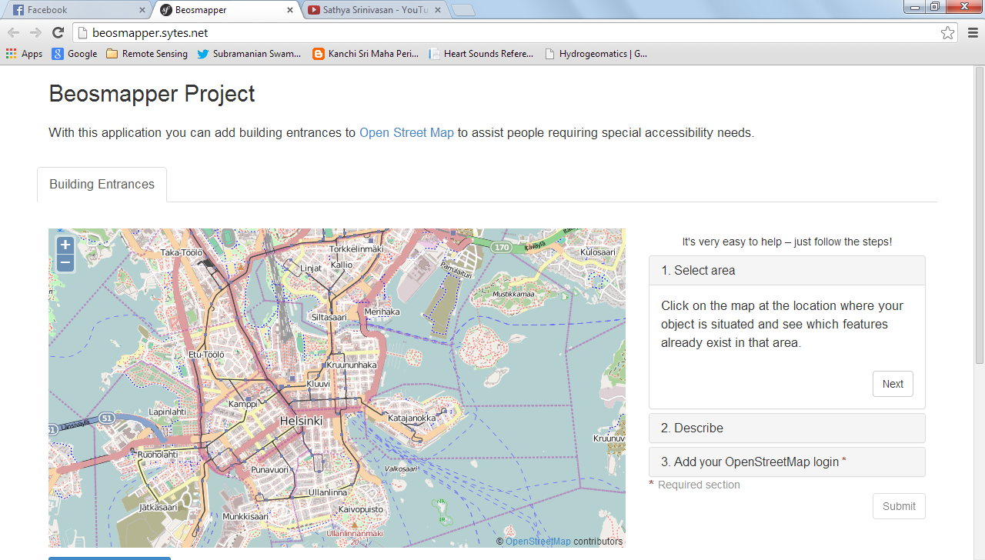

Figure 1 Layout of beosmapper

# Adding building entrance

Adding the building entrance to the Open Street Map requires three steps. Firstly, user can view the entrance already available in the OpenStreetMap just by clicking a point on the map. In the second step user can add entrance details at any point just by clicking the point on the map. The user specifies the entrance descriptions in this step. Lastly, user can submit the entrance details from the previous steps to the Open Street Map after signing in with a valid OpenStreetMap account.

Figure 2 Steps to add entrance information to Openstreetmap

## Viewing existing entrances

The first step in adding the entrance details, the user can verify if the entrance information already exists in the OpenStreetMap.

### Procedure to view existing entrance in the map

1. Left click on the map at any area of users choice
2. A  icon appears on the point where user has clicked on the map and a Brown box as shown in the Figure 3 appears
3. Inside the brown square box, an  icon appears indicating the existing entrance information.
4. Once user has confirmed the absence of entrance information in intended location, he can proceed with the next step to add entrance data.
5. To proceed to next step, click on the intended entrance location on the map to add new entrance data so that an  icon appears in the intended location.
6. Click on NEXT in the select area panel to add entrance attributes.

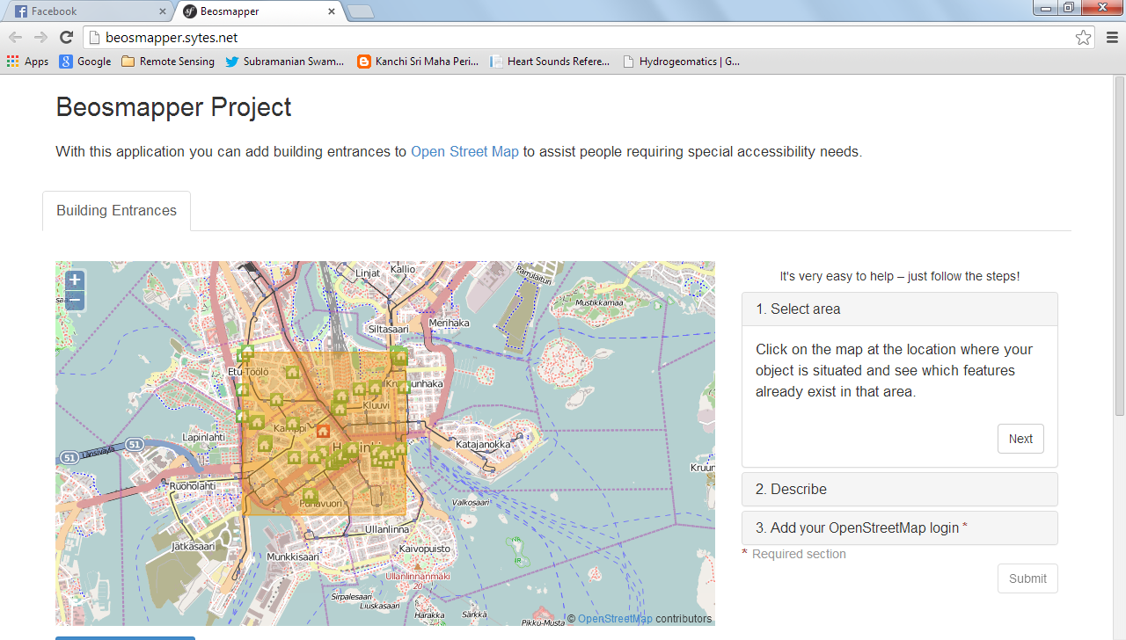

Figure 3 Viewing existing entrance information

### Adding entrance attributes

The user has an option to add additional information such as accessibility information and address information for the entrance door. Table 1 summarizes the description of various accessibility parameters.

|  |  |
| --- | --- |
| Accessibility parameter | Description |
| **Importance or Type of use** | Describes the type of entrance and suitability for different applications- Can take values to indicate the main entrance or exits, stairs, private homes, emergency exits, or entrance only for service delivery such as postal services. |
| **Allowed to enter** | Indicated to mark if the door is usable for general people or specifically open only for delivery agents or the employees. Could also be used to mark the door is unusable. |
| **Wheelchair access** | User can mark the presence or absence of entrance suitability for wheelchair users |
| **Automatic door** | When enabled, it could be used to warn wheelchair users and blind users for the presence of automatic doors |

Table 1 Accessibility parameters for entrance descriptions

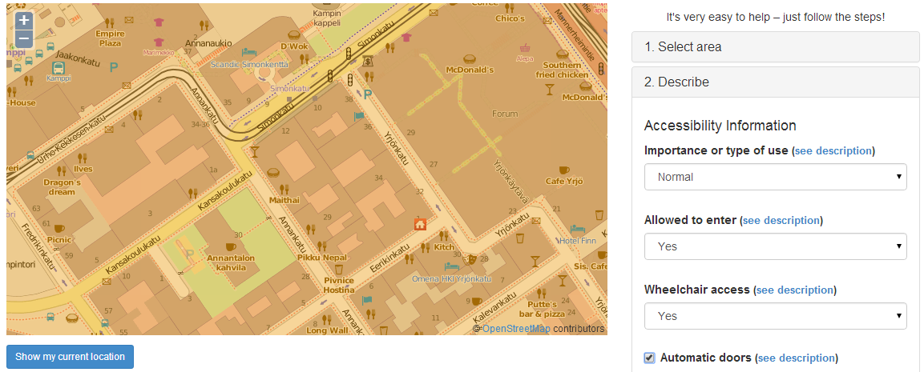

Figure 4.a Adding accessibility information

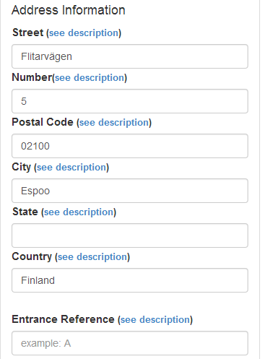

Figure 4.b Adding address information

1. To select the accessibility parameters:
2. User can select the appropriate values for the different attributes for the selected entrance. In Figure 4.a, the entrance location is highlighted with red circle for reference.
3. Once user selects the accessibility information, the address details, shown in Fig. 4.b, can also be added along with a entrance reference or landmark.
4. Left click on NEXT button in Describe panel to submit the added details
5. To submit the entries, you need a valid OpenStreetMap account. Users can sign up for free account by clicking the ‘Sign up here’ on the ‘Add your open street map login’ panel. It is shown in Figure 5 using a red circle

**Figure 5 Signing up for OpenStreetMap account**

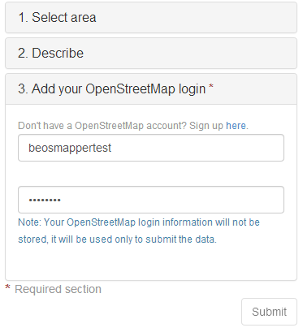

* If the user has a valid accound already, user can enter the user name and password in text box and click on Submit button.

1. On successful submission, a notification as shown in Figure 4 appears that the submission was successful. The notification message is highlighted in red circle in Figure 6.a

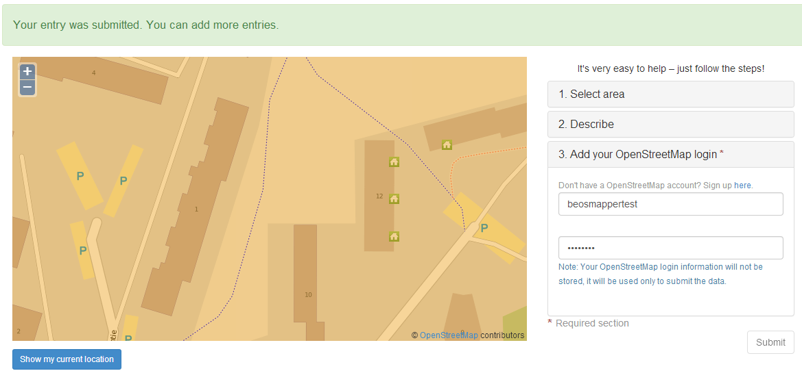

**Figure 6.a Successful entry**

1. On unsuccessful submission, an error message as shown in Figure 6.b appears

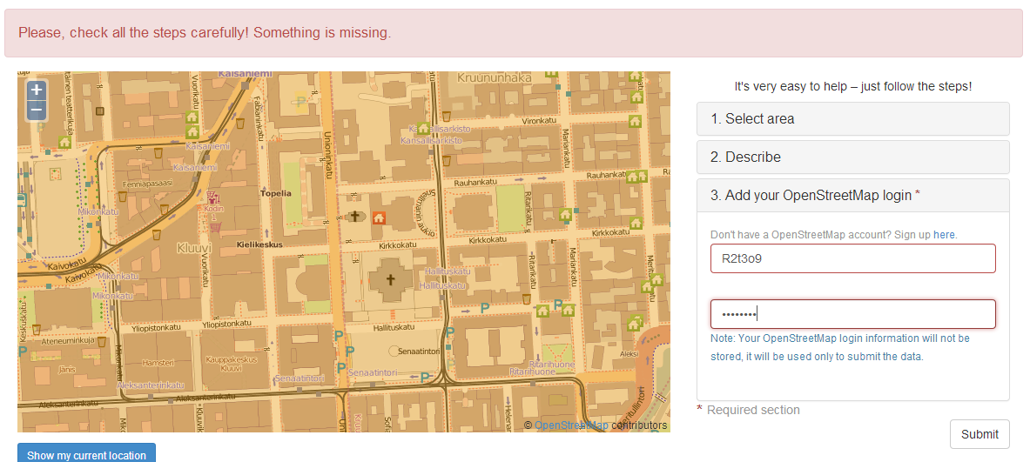

**Figure 6.b Unsuccessful entry**