# Creation of Interval Type-2 Fuzzy System and Decision- Making using Interval Approach

Online Summer Internship

*IN*

**Centre for Cognitive Computing**

**IIIT Allahabad**



*BY*

**Nikhil Bansal SRIP_2020_R03**

*UNDER THE SUPERVISION OF*

Prof. U. S. Tiwari

Professor

Mr. Rohit Mishra

Mentor

IIIT-ALLAHABAD

**INDIAN INSTITUTE OF INFORMATION TECHNOLOGY, ALLAHABAD**

(A UNIVERSITY ESTABLISHED UNDER SEC.3 OF UGC ACT, 1956 VIDE NOTIFICATION NO. F.9-4/99-U.3 DATED 04.08.2000

OF THE GOVT. OF INDIA)

A CENTRE OF EXCELLENCE IN INFORMATION TECHNOLOGY ESTABLISHED BY GOVT. OF INDIA

**15th July 2020**

**CANDIDATE’S DECLARATION**

I hereby certify that the work which is being presented in the Final Report, entitled “Creation of interval type-2 fuzzy system and decision-making using interval approach” being submitted as a part of Summer Research Internship Programmed, 2020; Centre for Cognitive Computing, Indian Institute Of Information Technology, Allahabad, is an authenticated record of my original work, thus far, under the guidance and supervision of Prof. U.S. Tiwari from 15.05.2020 – 15.07.2020. I have adequately cited and referenced the original sources and have adhered to all principles of academic honesty and integrity.

Date: July 15, 2020

Nikhil Bansal

(SRIP_2020_R03)

**CERTIFICATE FROM SUPERVISOR**

This is to certify that the statement made by the candidate is correct to the best of my knowledge and belief. The project entitled “Creation of interval type-2 fuzzy system and decision-making using interval approach” is a record of the candidates’ work carried out by them under my guidance and supervision. I do hereby recommend that it should be accepted in the fulfilment of the requirements of the Summer Research Internship Programme, 2020; Centre for Cognitive Computing, Indian Institute of Information Technology, Allahabad.

Prof. U.S. Tiwari,

IIIT-Allahabad.

July 15, 2020.

**ACKNOWLEDGEMENT**

I would like to acknowledge and extend our heartfelt gratitude to Prof. U.S. Tiwari, Indian Institute of Information Technology Allahabad, who guided us through this project. His keen vital encouragement, superb guidance, and constant support are the motive force behind this project work. I would also like to extend my warm thanks to Mr. Rohit Mishra, who has been there to guide me as well, through thick and thin. I also thank my group mate for the enriching discussions we have had in the course of this project.

Nikhil Bansal

(SRIP_2020_R03)

**Table of Contents**

Creation of Interval Type-2 Fuzzy System and Decision- Making using Interval Approach 1

CHAPTER-1 1

INTRODUCTION 1

1.1 INTRODUCTION 1

CHAPTER-2 3

OBJECTIVE 3

2.1 Problem Description and Objective 3

CHAPTER-3 4

Literature Survey 4

CHAPTER-4 5

Dataset 5

4.1 Dataset 5

CHAPTER-5 6

Workplan 6

5.1 Flow diagram 6

5.2 Week Plan 6

CHAPTER-6 7

Methodology 7

6.2 Software used 11

CHAPTER-7 12

References 12

# CHAPTER-1

## INTRODUCTION

### 1.1 INTRODUCTION

Decision making refers to making choices among alternative courses of action—which may also include inaction. While it can be argued that management is decision making, half of the decisions made by managers within organizations fail. Therefore, increasing effectiveness in decision making is an important part of maximizing your effectiveness at work. This chapter will help you understand how to make decisions alone or in a group while avoiding common decision-making traps.

Individuals throughout organizations use the information they gather to make a wide range of decisions. These decisions may affect the lives of others and change the course of an organization. For example, the decisions made by executives and consulting firms for Enron ultimately resulted in a $60 billion loss for investors, thousands of employees without jobs, and the loss of all employee retirement funds. But Sherron Watkins, a former Enron employee and now-famous whistleblower, uncovered the accounting problems and tried to enact change. Similarly, the decisions made by firms to trade in mortgage-backed securities is having negative consequences for the entire U.S. economy. Each of these people made a decision, and each person, as well as others, is now living with the consequences of his or her decisions.

Because many decisions involve an ethical component, one of the most important considerations in management is whether the decisions you are making as an employee or manager are ethical. Here are some basic questions you can ask yourself to assess the ethics of a decision.

* Is this decision fair?
* Will I feel better or worse about myself after I make this decision?
* Does this decision break any organizational rules?
* Does this decision break any laws?
* How would I feel if this decision was broadcast on the news?

Decision making is vitally important activity that lies at the center of every business, mind of person. Many business decisions can be complicated but, regardless of the complexities, there are fundamental steps and techniques which decision makers should follow to ensure a robust decision-making process so that there should be always profit. All decisions are made under the degree of uncertainty. There is always the possibility of a bad outcome arising irrespective of the quality of the decision-making process. Even if the decision was considered ‘good’ at a particular point in time, there is still a chance of an unfavorable result due to uncontrollable factors. Consequently, it is difficult to judge the quality of a decision based solely on its outcome. As a result, it is necessary to distinguish between good and bad decisions be evaluating the process undertaken- such as how the decision was actually made and who was involved. To solve the decision making there are several processes which are used in today’s competitive market but here we are using **fuzzy logic.**

# CHAPTER-2

## OBJECTIVE

### 2.1 Problem Description and Objective

To learn anything new life, firstly we should see what problem it solves. In our scenario Fuzzy logic is an extension of the classical logic that allows the modeling of data imperfections and to a certain extent approaches the flexibility of human reasoning. The fuzzy logic thus presents many concrete applications, ranging from video games (programming of bots) to automatic pilots via the microwave. Yes, often we apply in the daily without our knowing the concept of the fuzzy choice, so this notion surrounds us!

The example elucidating this vague concept will be the decision of the amount of the tip after a meal in the restaurant, depending on the quality of service experienced and the quality of food.

Among the objectives sought when applying this concept, we can note:

- Application of fuzzy logic to risk assessment and decision making (used to analyze risks when knowledge is uncertain)

- The use of a fuzzy logic model for identification, evaluation and control from the expertise of the human operator.

-The modeling and control of complex systems uses the theory of fuzzy sets.

-The non-linear structure of the fuzzy regulator makes it possible to improve the performances in terms of accuracy and robustness of the non-linear system with respect to the structured and unstructured uncertainties.

# CHAPTER-3

## Literature Survey

|  |  |  |  |  |  |  |
| --- | --- | --- | --- | --- | --- | --- |
| **S no.** | **Title** | **Year** | **Journal/**  **Conference** | **objective** | **Method** | **Future Scope** |
| 1. | Interval Type-2 Fuzzy Logic Systems Made Simple | 2006 | IEEE TRANSACTIONS ON FUZZY SYSTEMS, VOL. 14, NO. 6 | To implement the decision making and get the output according to the input using interval type-2 fuzzy system | Interval type-2 fuzzy logic system | To implement the logic on some e-commerce sites and in some businesses. |
| 2 | The Role of Fuzzy Logic in Decision Making Process | 2014 | 2nd International Conference on Management Innovation and Business Innovation (ICMIBI 2014), At Bangkok, THAILAND, Volume: 44 | How fuzzy logic are used in the decision making and what steps are used while getting desired output | Fuzzy logic |  |
| 3 | Encoding Words into Interval Type-2 Fuzzy Sets  Using an Interval Approach | 2008 | TRANSACTIONS ON FUZZY SYSTEMS, VOL. 16 | How fuzzy system is created using the dataset and dataset pruning and filtering | Mathematical model and technique |  |

# CHAPTER-4

## Dataset

### 4.1 Dataset

The dataset can be varying according to the implementation of example. As I implement the example of hotel rating according to the quality and service of the hotel. So, to implement the fuzzy system we have to create the membership function. To get the output properly the membership function needs to be correct so there is need to collect the dataset according to the implementation. Now to create the it2fs we are provided with excel file in which the values are provided through survey. In this, according to them how much range should be given for each input like very low, medium, high etc. in the range of (0,10)

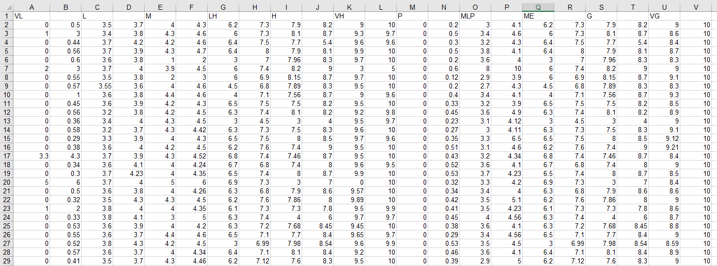

# CHAPTER-5

## Workplan

### 5.1 Flow diagram

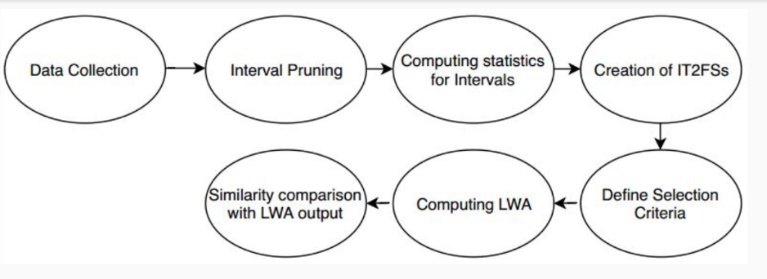

Figure Flow Diagram

### 5.2 Week Plan

Through these 2 months, we have done every work with a target of 1 week and here is week plan so what we have done every week

**● Week 1: Type-1 Fuzzy Set Inference System**

**● Week 2: Study Interval Type-2 Fuzzy set**

**● Week 3: Data Collection and Interval Pruning**

**● Week 4: Computing Statistics and Creation IT2Fs**

**● Week 5: Define Decision Criteria and Computing LWA**

**● Week 6: Similarity Comparison**

**● Week 7: ← Improvement →**

**● Week 8: Final Code and Report Submission**

# CHAPTER-6

## Code Implementation

### 6.1 Methodology

First, we make the membership function for two inputs i.e. **Quality** and **Price** using the dataset that I mentioned earlier.

We do Bad data processing by using the equations:

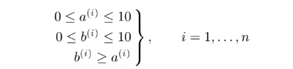

Then the outlier processing is done

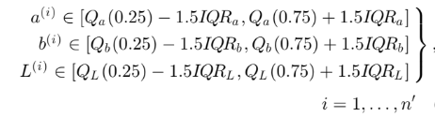

Now tolerance limit processing is done by using mean and standard deviation of that column

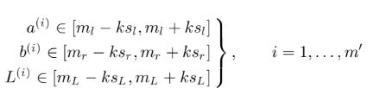

Reasonable interval processing is done so that there is no overlapping of data

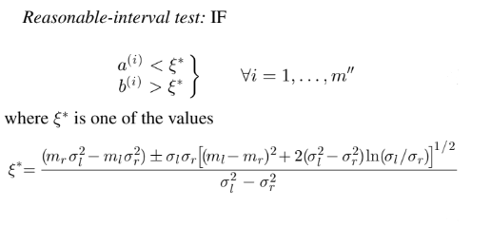

In summary, data preprocessing starts with all n data intervals and ends with m data intervals, i.e.



Now the data is filtered and now for particular variable we check whether it is lying in left, interior, right shoulder by using the equation which is listed below

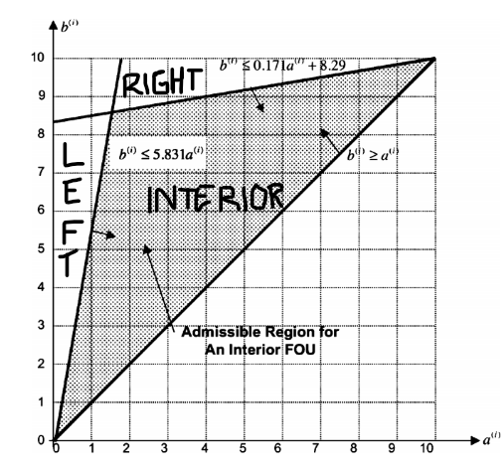

Now we get each membership function for each linguistic parameter now we will implement the it2fs on these membership function

Rules we have implemented in the code:

|  |  |  |  |  |  |
| --- | --- | --- | --- | --- | --- |
| Price  Quality | VL | L | M | VG | VH |
| VL | VL | VL | VL | VL | VL |
| L | L | L | L | VL | VL |
| M | M | M | M | M | L |
| VG | VG | VG | VG | VG | M |
| VH | VH | VH | VH | VH | VH |

### 6.2 Software used

**Pycharm ide of pyhton is used for coding and implementation.**

### 6.3 Github link for code

### <https://github.com/coolestbnslz/IT2FS>

# CHAPTER-7

## References

**[1] Tutorials on fuzzy system** <https://www.tutorialspoint.com/fuzzy_logic/fuzzy_logic_decision_making.htm>

**[2] Fuzzy Control Systems: The Tipping Problem**

<https://pythonhosted.org/scikit-fuzzy/auto_examples/plot_tipping_problem_newapi.html>

**[3] Matplotlib package implementation**

<https://matplotlib.org/api/pyplot_api.html>

**[4] openpyxl package implementation**

<https://openpyxl.readthedocs.io/en/stable/>

**[5] pandas package implementation**

<https://pandas.pydata.org/>

**[6] excel file reading**

<https://www.geeksforgeeks.org/reading-excel-file-using-python/>