Analysing feedback

The feedback received for the procedural generation was positive in relation to how the dungeon was generated with most participants positively reacting to the amount of parameters they could modify. One negative that most participants said was the reliance on tooltips for some parameters that rely on other parameters such as max axis is reliant on the size of the dungeon axes. Another complaint was the box like nature of the rooms and how the generation currently only allows one tile per a level.

Participants were also asked if any parameters were poorly explained and the results were the Fraction parameters and the min/max room axis. Some suggestions by testers suggest that the fraction parameters should be renamed to MinSizeForTrap/Item as these names better describe the purpose of the parameter. One participant suggested verbally adding if statements to change variables if they break the rules described to the designer. This would be useful to limit any errors occurring and by adding a debug log when it occurs, it would indicate to testers during testing that the designer needs to modify the current set parameters.

When asked if any of the parameters felt unnecessary all participants stated that they all felt relevant which suggests that while there are many parameters that can be modified, they did not overwhelm and give too much choice to the designer.

When asked about what feature people wanted added I got many different parameters/features people wanted added. Some major ones that I was also personally considering as important next features: move to tilemap to increase the amount of tiles per a level, making the generation not reliant on tool tips and enemy spawner. Likely if I added an enemy spawner I will fuse the trap and item spawner into one to prevent them spawning on top of each other as there is no real use for them to be apart. One participant also suggested adding deadend paths which could be set up by creating 1x1 rooms after the generation of the initial rooms.

Some other additions suggested include giving the option for some rooms to be predefined such as a shop room or treasure room, creating a toggle option for increasing the size of corridor, creating more variation in room shapes and improving the trap/item spawning to follow certain rules (such as no traps on entrance to room) and have the option to set the amount of rooms. Another suggestion was adding support for other types of tile such as hexagons was suggested however this will likely be hard to implement without significantly modifying the generator.

Sample output analysis

The first outputs are from a dungeon of 50 by 50 with a min axis size of 5 and a max axis size of 20.

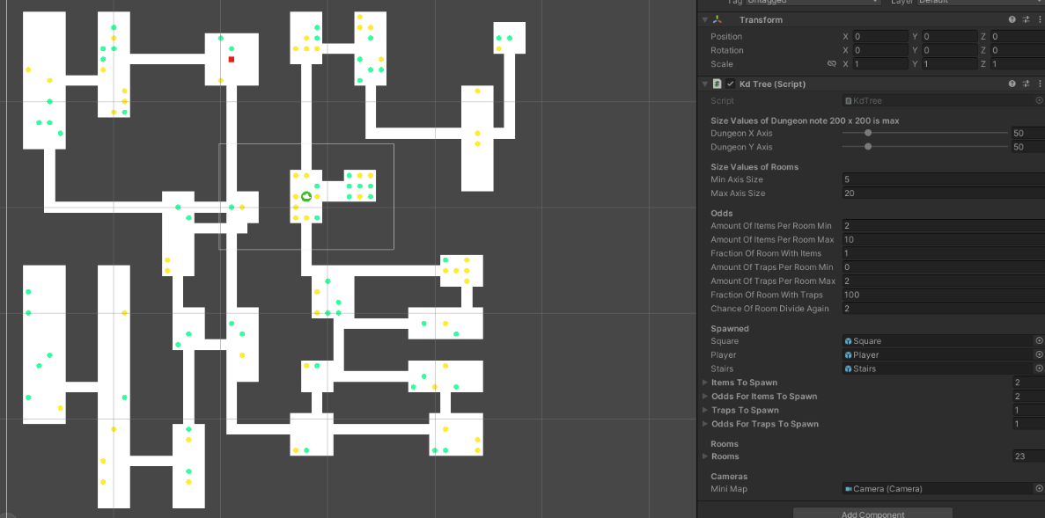

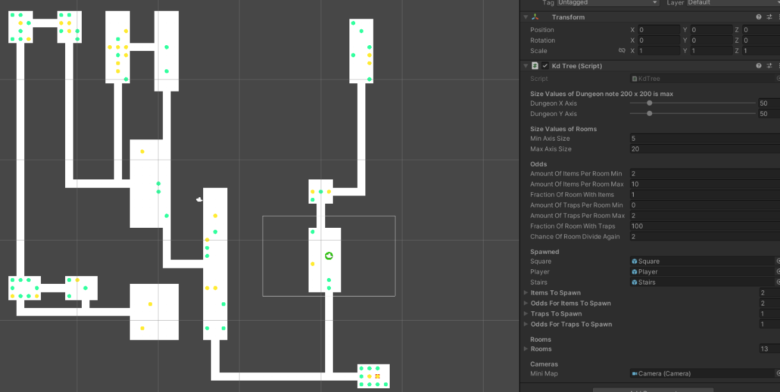

When looking at the sample output one major change that would improve the experience designer could create is changing the item generation to be based proportional to the size of the room along with considering the min and max item amount. This is mainly in smaller rooms where it is not ideal to have the max amount be chosen such as in the sample above max items per a room is 10 and either 9 or 10 was chosen for a room of size 9. This would improve player experience as items would be better distributed. The other issue with generation is the long room which is not an intended feature. Rooms axis size should be limited to max axis size however there is a bug which causes rooms to be too long vertically or horizontally.

The second outputs are from a dungeon of 100 by 100 with a min axis size of 5 and a max axis size of 20.

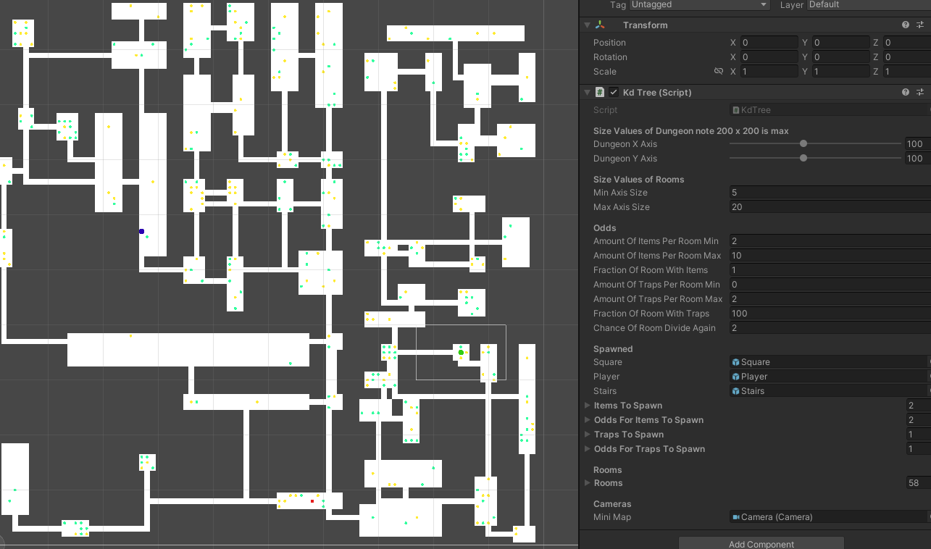  
  
  
  
  
  
  
  
  
  
  
  
  
  
  
  
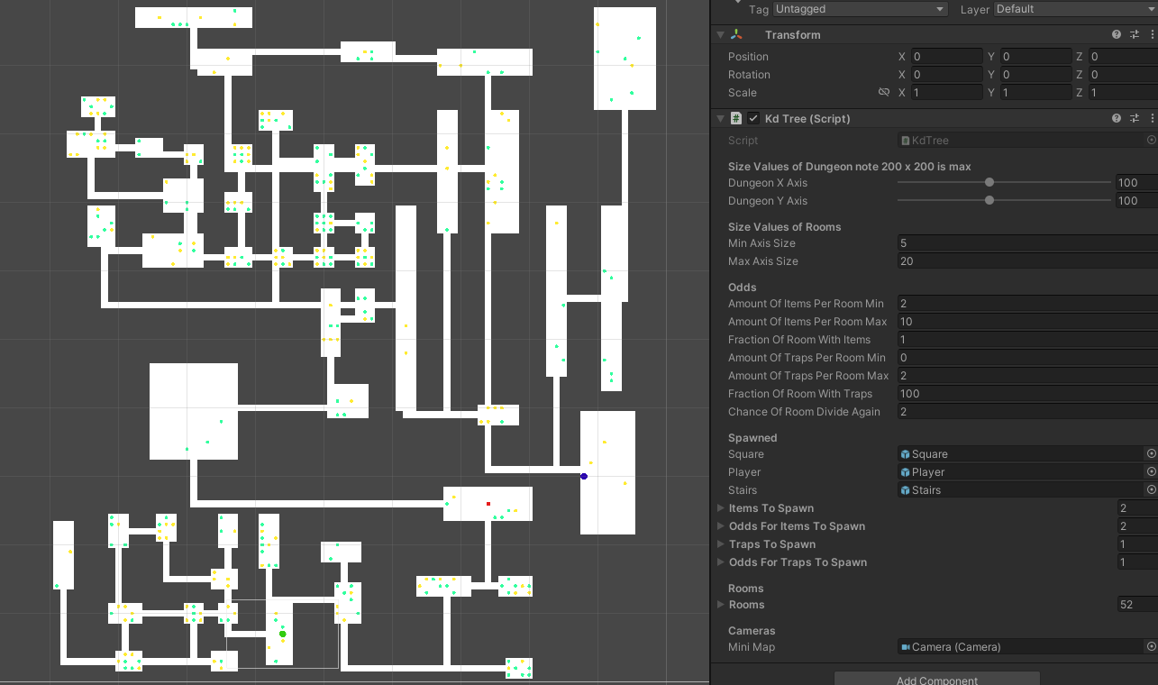

These output really highlights the issue mentioned before where nearly all the rooms of size 9 are filled with items. This highlights the importance of modifying item spawning to be proportional to the room size. These sample outputs also highlight the interesting paths that can be generated.

The third outputs are from a dungeon of 100 by 100 with a min axis size of 10 and a max axis size of 20.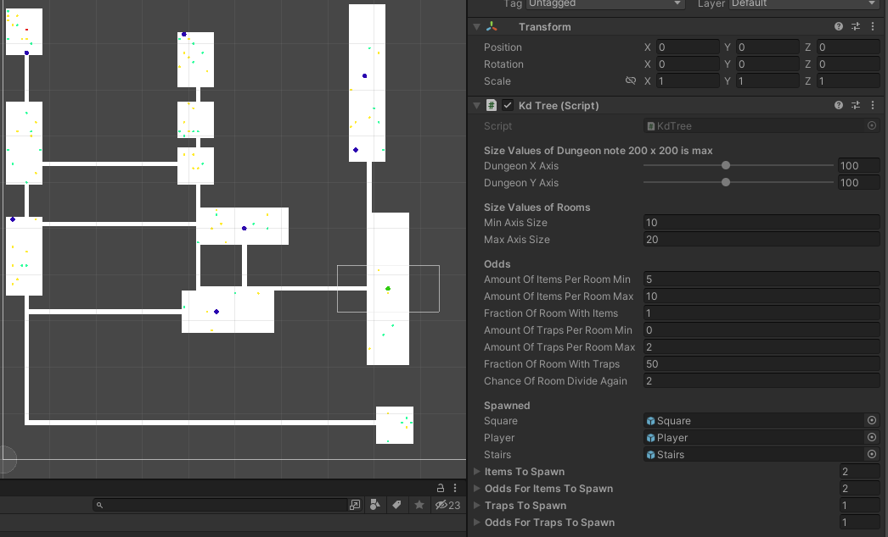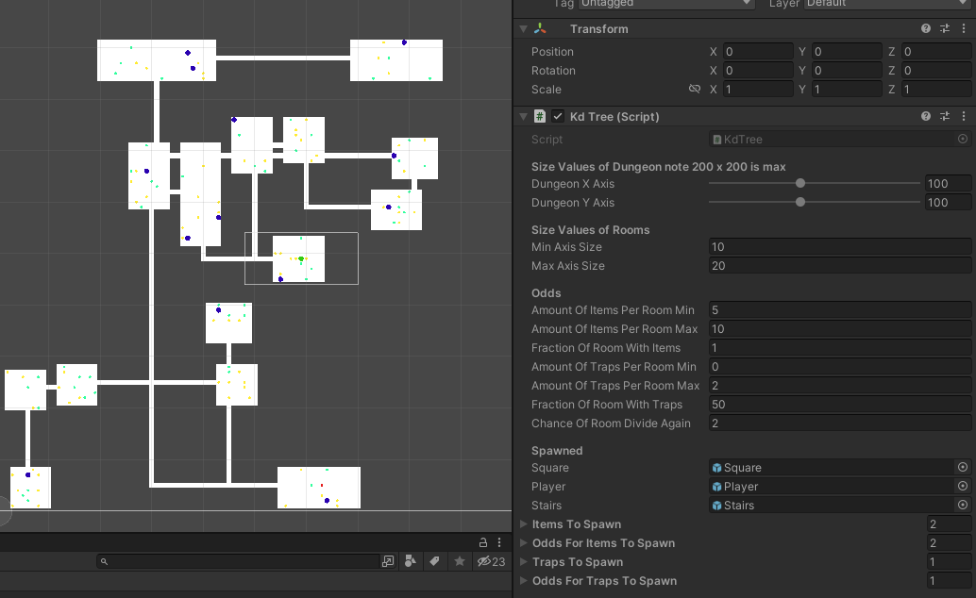

When comparing between min axis 5 and min axis 10, the main difference to note is the amount of rooms generated. When rooms are set to be bigger, there is a higher chance of less rooms as rooms which go below the min axis size will be deleted. This can be useful for making more spread out rooms with more empty space in the dungeon. This is one issue for smaller rooms as there are a greater number of places the player needs to explore.

The fourth outputs are from a dungeon of 100 by 100 with a min axis size of 10 and a max axis size of 50.

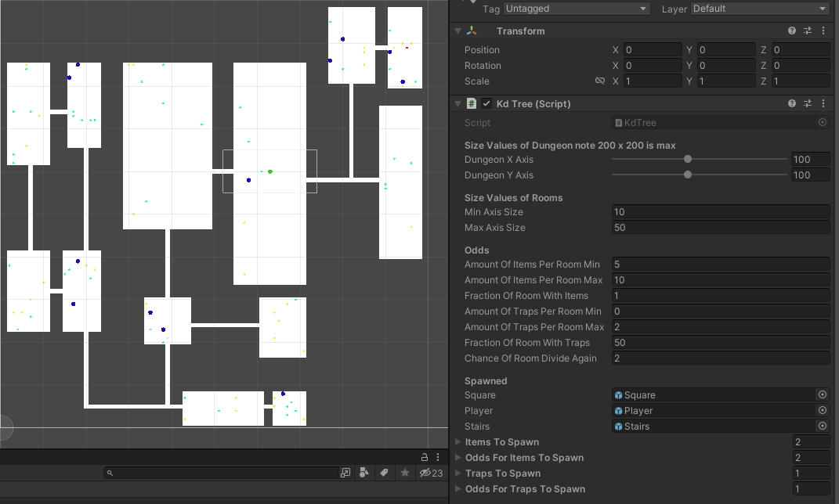

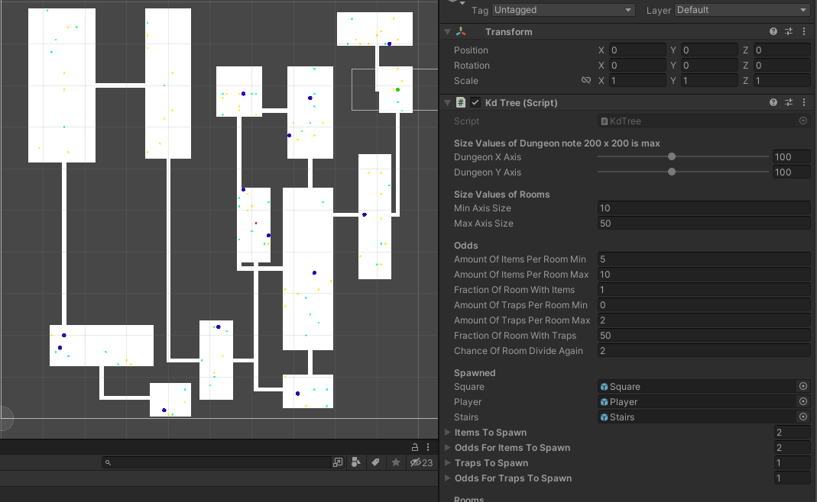

When comparing min axis 10 max axis 20 with min axis 10 max axis 50, one thing that is very noticeable is the reduction in empty spaces within the dungeon.

Depending on the use the designer wants will depend on the type parameters they will use. For a dungeon exploring game likely the third output set would be the ideal setup with the first and second being useful for more maze type exploration.