Math 3800 - A1

Nick Cooley

101021174

Date: 14 Jan 2024

Question 1.

We can just pass in the output arguments [L, U] and we can set P to identity. I don’t think we want to do that here.

Suppose we want to find a matrix PA = LU where P may not be the identity matrix. Given to us in MATLAB with the [L, U, A] = lu(A) function, we have:

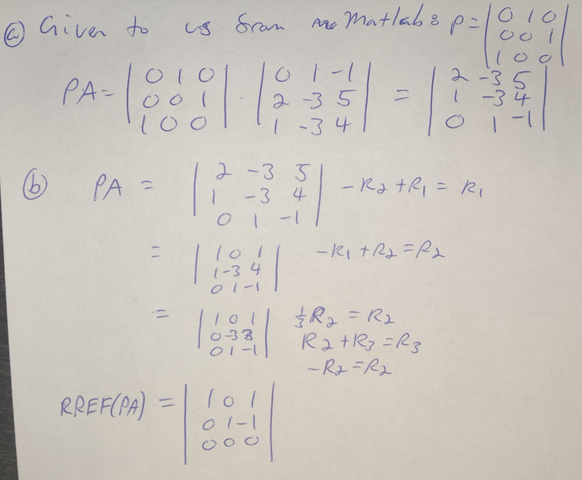

Figure 1. RREF(PA) without row swapping.

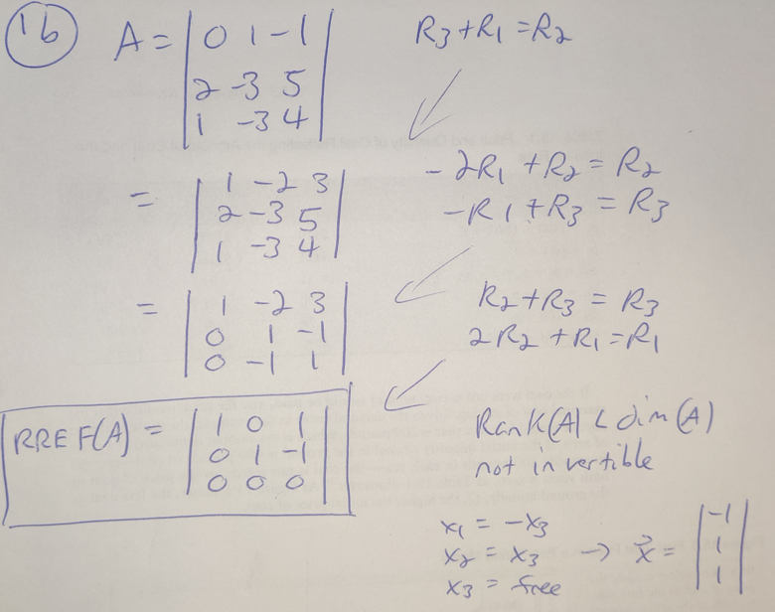

Figure 2. RREF(A) without row swapping.

Testing a suspicion. We find that RREF(A) = RREF(PA) even when P is not equal to the identity matrix and explicit row swap operations are not performed.

Question 2.

References:

lu() usage.

[1] https://www.mathworks.com/help/matlab/ref/lu.html