Sarah Cooley  
CS480 - Winter 2011  
Jan 5, 2011

Homework 0

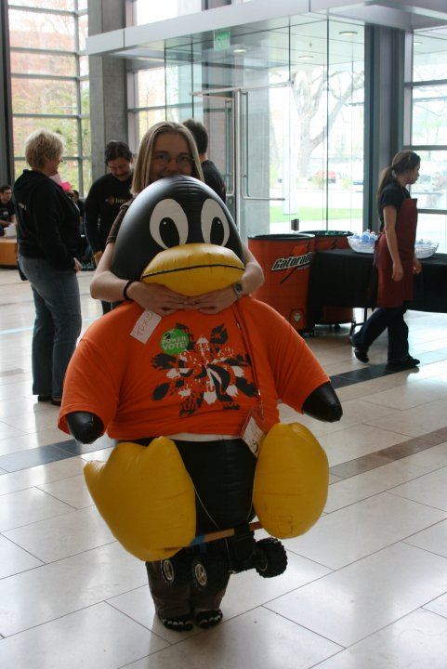Hola, since you already know me and know my academic background, I'll try to include new and interesting information.

I was born in Crawfordsville, Indiana and lived there for three years. While I was too young to remember much, I visit often and spent many summers in Crawfordsville with my grandparents. In 1992, my family moves to McAllen, Texas to start up a printing plant for RR Donnelley. My mom speaks fluent Spanish and Greek so she was an ideal human resources employee while my dad was the head engineer. Their plant was the first to move away from token rings and mainframes. I had a live in babysitter, Patty, who's family owned a pastry shop and wedding cake business; as a result, I had three tiered birthday cakes with cool themed party favors. I loved to read and my mom brought home misprinted children's books so I read a lot. We also took in a stray cat. The cat then had kittens, beginning my love of cats. In 1998, my mom transferred to Sun Microsystems and we moved to Pleasanton, California.

While in California, I discovered open source on a whim. My dad mentioned Linux as an interesting alternative to Windows and I began running Mandrake 3.0 (Mandrake became Mandreeva and I believe is now defunct). While I ran Linux, I didn't learn how to program until my junior year of high school. I had an incredible introduction to computer science class taught in C with an emphasis on data structures and string manipulation (which teaches you a lot about pointers) followed by AP Computer Science in Java. Meanwhile, my dad started getting involved in renewable energy and installed a 6kWh photovoltaic array on the roof of our house. As it turns out, he overshot our energy consumption by 30%. To use some of the extra power, we bought a Corbin Sparrow (a three wheeled electric car). I got involved in the electric car community. Lastly, I took AP environmental science in high school and nearly majored in environmental science in college. I especially enjoyed my science fair project, "The effectiveness of coagulants in the secondary process of waste water treatment". I thought it would be boring but the people who work at wastewater treatment plants are great scientists and generally have a fantastic sense of humor.

After extensive college visits all over California, I decided to go to Oregon State because OSU has the Open Source Lab and offered undergraduate paid research opportunities as well as interesting tech jobs. Accordingly, I applied to the OSL winter term freshman year. Freshman and sophomore year, I worked at the OSL and on the OSU Solar Challenge team. Junior year I began doing non-technical open source work for the OSEL and started TAing for CS161. I have also intermittently worked with the college of engineering ambassador program. This year unpredictable my own health problems and family illness marred my life, making it hard to continue my usual routine.

Academically, I am quite interested in languages and microprocessor design, though I am not good at remembering terminology and syntax. I am also interested in science and math education. My least favorite topics are electronics and signal analysis. Mostly, I enjoy high-level concepts and clever, scriptable, programs. I really enjoy problems that have a story. During my internship with Microsoft this summer, I enjoyed working with problems in cloud computing and in large data.

I’m going to work for Microsoft when I graduate this year. I will work with the same team I worked with this summer and will continue working on cloud computing and large data processing. As things stand, I think I plan to work for Microsoft for a few years then switch emphasis to education. I think I will continue living in the pacific northwest and would like to build a hobbit hole come day.