Sarah Cooley & Rob McGuire-Dale
cs/ece472
4 November 2009

Project 3

Testing the base processor model
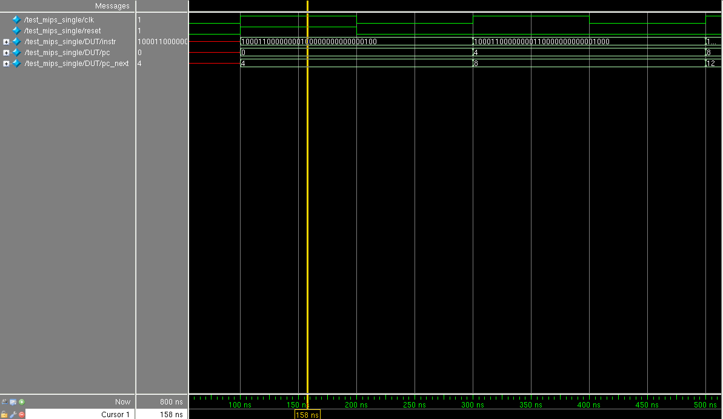
Reset pulled up for one clock cycle
PC and PC next incremented by 4 each clock cycle
Instruction changing every clock cycle

