Alexandre Lamy

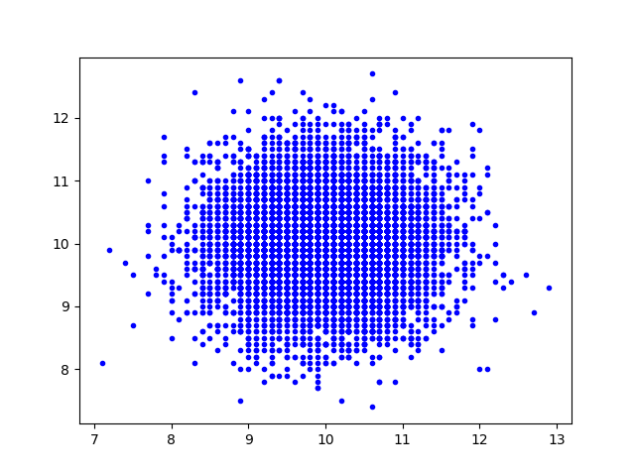
Data Generation and Continuous Buhmbox Goal Description

Independent snps
[100, 0, 0, 100]

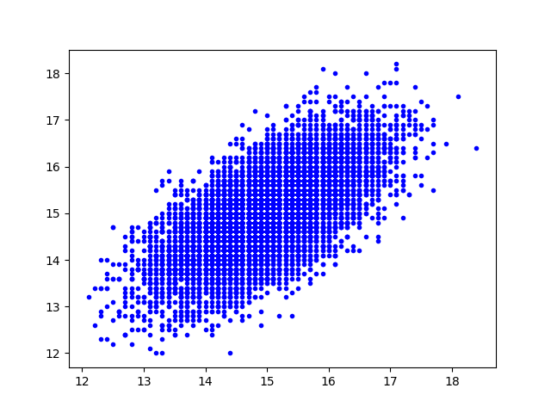

Shared SNPS
[50, 100, 0, 50]

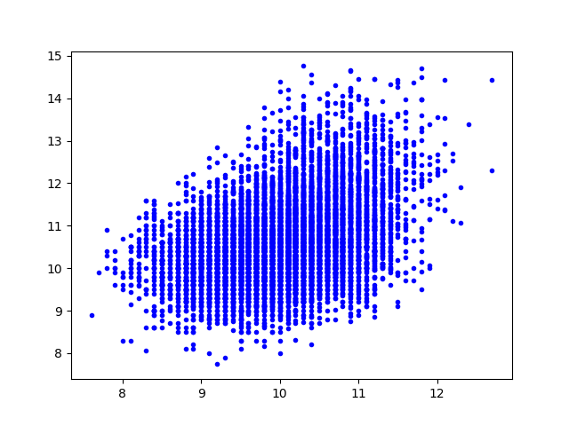

Heterogeneous individuals

Independent SNPs [100, 0, 0, 100]

But with individuals whose phenotype 2 is:
max(phenotype2, phenotype1 with random noise)

Below blue is individuals who have phenotype2=reg phenotype2, red is phenotype2 = phenotype1 with random noise.
