Exp no: |  | Date:
Title:
Aim:
Theory:
Prpblem:
Conclusion:
Result:

Exp no: 02 |  | Date: 23-09-2020
Title: | Introduction to activation functions and implementation of an Artificial Neuron
Aim: | To observe the outputs of varius activation functions with the help of implementation of an Artificial Neuron
Code: | '''  implementation of neruron and activation functions  '''  import numpy as np  class Neuron:  '''McCulloch pitts neuron model'''  def __init__(self,activation_fn, weights, bias=0):  self.weights = np.array(weights)  self.inputs = np.empty_like(self.weights)  self.act_fn = activation_fn  self.bias = bias  def calc_out(self):  '''calculates neuron output using specified activation function'''  return self.act_fn(self.weights.T @ self.inputs + self.bias)  def signum(net):  '''signum activation function'''  return net >= 0  def bipolar_step(net):  '''bipolar step activation function'''  return 2 * int(net > 0) -1  # def softmax(net):  # '''softmax activation function'''  # return np.exp(net) / np.np.xp(net))  def u_peicewise_linear(net):  '''unipolar peicewise linear activation function'''  return min(1, max(0, net))  def b_peicewise_linear(net):  '''bipolar peicewise linear activation function'''  return min(1, max(-1, net))  def u_sigmoidal(net):  '''unipolar sigmoidal activation function'''  lam = 1  return 1 / (1 + np.exp(-1 * lam * net))  def b_sigmoidal(net):  '''bipolar sigmoidal activation function'''  lam = 1  return 2 / (1 + np.exp(-1 * lam * net)) - 1  def hyperbolic_tan(net):  '''hyperolic tan activation function'''  return np.tanh(net)  def arctan(net):  '''arctan activation function'''  return np.arctan(net)  def relu(net):  '''relu activation function'''  max(0, net)  def leaky_relu(net):  '''leaky relu activation function'''  max(0.01 * net, net)  #code for observing activation function outputs  import numpy as np  import matplotlib.pyplot as plt  from neuron import *  plt.style.use('Solarize_Light2')  fig, axs = plt.subplots(nrows=3, ncols=3)  ax = axs.flatten()  # plt.figure(constrained_layout=True)  x = np.linspace(-10, 10, 1000)  y = signum(x)  ax[0].set_title('signum')  ax[0].plot(x, y)  y = bipolar_step(x)  ax[1].set_title('bipolar signum')  ax[1].plot(x, y)  y = u_sigmoidal(x)  ax[2].set_title('sigmoidal')  ax[2].plot(x, y)  y = b_sigmoidal(x)  ax[3].set_title('bipolar\nsigmoidal')  ax[3].plot(x, y)  y = hyperbolic_tan(x)  ax[4].set_title('hyperbolic\ntan')  ax[4].plot(x, y)  y = arctan(x)  ax[5].set_title('arctan')  ax[5].plot(x, y)  y = relu(x)  ax[6].set_title('relu')  ax[6].plot(x, y)  y = leaky_relu(x)  ax[7].set_title('leaky relu')  ax[7].plot(x, y)  y = b_peicewise_linear(x)  ax[8].set_title('bipolar\npeicewise linear')  ax[8].plot(x, y)  fig.tight_layout()  plt.show()
Conclusion: | The working of various activation functions were studied and outputs observed
Result: | 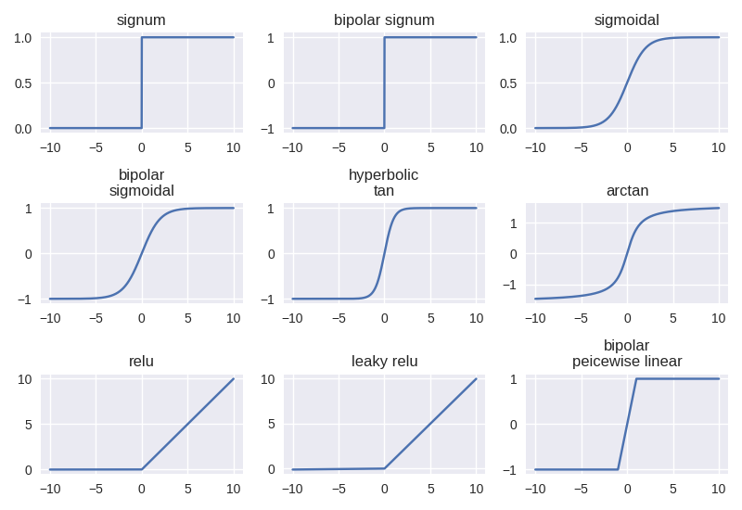
Exp no: 03 |  | Date: 30-09-2020
Title: | Implementation of Logic Gates using Artificial Neurons
Aim: | To implement boolean logic gates using simple McCulloch-Pitts Model of Artificial Neuron
Code: | '''  logic gates  '''  import numpy  from neuron import Neuron, signum #Neuron class written in practical 3  def show_output(gate, gate_inputs_list):  '''  helper function to display output  '''  for gate_input in gate_inputs_list:  gate.inputs = numpy.array(gate_input)  print(f'x1:{gate_input[0]} x2:{gate_input[1]} O:', gate.calc_out())  gate_inputs = [[0,0],[0,1],[1,0], [1,1]] #inputs to test the gates against  # and gate  print("\nand gate")  and_gate = Neuron(lambda x: x > 1, weights=[1, 1])  show_output(and_gate, gate_inputs)  #or_gate  print("\nor gate")  or_gate = Neuron(lambda x: x > 0, weights=[1, 1])  show_output(or_gate, gate_inputs)  # nand gate  print('\nnand')  nand_gate = Neuron(lambda x: x > -2, weights=[-1, -1])  show_output(nand_gate, gate_inputs)  # nor gate  print('\nnor')  nor_gate = Neuron(lambda x: x > -1, weights=[-1, -1])  show_output(nor_gate, gate_inputs)  # not  print('\nnot')  not_gate = Neuron(lambda x: x > -1, weights=[-1])  for g_inputs in [[0], [1]]:  not_gate.inputs = numpy.array(g_inputs)  print(f'x:{g_inputs} O:', not_gate.calc_out())  # xor  print('\nxor')  o1 = Neuron(signum,weights=[-2, 1], bias=-1/2)  o2 = Neuron(signum,weights=[1, -1], bias=-1/2)  xor_gate = Neuron(signum, weights=[1, 1], bias=-1/2)  def sh_xor_output(gate_inputs_list):  '''helper fuction to display xor output'''  gate_inputs_array = numpy.array(gate_inputs_list)  o1.inputs = o2.inputs = gate_inputs_array  xor_gate.inputs = numpy.array([o1.calc_out(), o2.calc_out()])  print(f'x1:{gate_inputs_array[0]} x2:{gate_inputs_array[1]} O:', xor_gate.calc_out())  for g_input in gate_inputs:  sh_xor_output(g_input)
Conclusion: | Logic gates were implemented using the McCulloch-Pitts Neuron model and outputs were observed
Result: | and gate  x1:0 x2:0 O: False  x1:0 x2:1 O: False  x1:1 x2:0 O: False  x1:1 x2:1 O: True  or gate  x1:0 x2:0 O: False  x1:0 x2:1 O: True  x1:1 x2:0 O: True  x1:1 x2:1 O: True  nand  x1:0 x2:0 O: True  x1:0 x2:1 O: True  x1:1 x2:0 O: True  x1:1 x2:1 O: False  nor  x1:0 x2:0 O: True  x1:0 x2:1 O: False  x1:1 x2:0 O: False  x1:1 x2:1 O: False  not  x:[0] O: True  x:[1] O: False  xor  x1:0 x2:0 O: False  x1:0 x2:1 O: True  x1:1 x2:0 O: True  x1:1 x2:1 O: False

Exp no: 04 |  | Date: 07-09-2020
Title: | Design of an Artificial Neuron using Hebbian Learning rule
Aim: | To study and implement the Hebbian Learning rule
Theory:
Prpblem:
Code: | '''  hebbian learning rule  '''  import numpy  from neuron import Neuron, bipolar_step  weights = [1, -1, 0, 0.5]  inputs = [[1, -2, 1.5, 0], [1, -0.5, -2, -1.5], [0, 1, -1, 1.5]]  C = 1  neuron = Neuron(activation_fn=bipolar_step, weights=weights)  for epoch in range(5):  print(f'\nepoch {epoch+1}')  for x in inputs:  neuron.inputs = numpy.array(x)  o = neuron.calc_out()  neuron.weights += C * o * neuron.inputs  print(f'weights:\t{neuron.weights}')
Conclusion:
Result: | epoch 1  weights: [ 2. -3. 1.5 0.5]  weights: [ 1. -2.5 3.5 2. ]  weights: [ 1. -3.5 4.5 0.5]  epoch 2  weights: [ 2. -5.5 6. 0.5]  weights: [ 1. -5. 8. 2.]  weights: [ 1. -6. 9. 0.5]  epoch 3  weights: [ 2. -8. 10.5 0.5]  weights: [ 1. -7.5 12.5 2. ]  weights: [ 1. -8.5 13.5 0.5]  epoch 4  weights: [ 2. -10.5 15. 0.5]  weights: [ 1. -10. 17. 2.]  weights: [ 1. -11. 18. 0.5]  epoch 5  weights: [ 2. -13. 19.5 0.5]  weights: [ 1. -12.5 21.5 2. ]  weights: [ 1. -13.5 22.5 0.5]

Exp no: 05 |  | Date: 14-10-2020
Title: | Design of an artificial Neuron using perceptron learning rule
Aim: | To study and implement the perceptron learning rule
Theory:
Prpblem:
Code: | '''  perceptron learning rule  '''  import numpy  from neuron import Neuron, bipolar_step  w = [1, -1, 0, 0.5]  C = 0.1  D = [-1, -1, 1]  X = numpy.array([[1, -2, 0, -1], [0, 1.5, -0.5, -1], [-1, 1, 0.5, -1]])  neuron = Neuron(activation_fn=bipolar_step, weights=w)  for epoch in range(5):  print(f'\nepoch {epoch+1}')  for x, di in zip(X, D):  neuron.inputs = x  o = neuron.calc_out()  neuron.weights += C * (di- o) * x  print(f'weights: {neuron.weights}')
Conclusion: | Perceptron learning rule was implemented and oututs were observed
Result: | epoch 1  weights: [ 0.8 -0.6 0. 0.7]  weights: [ 0.8 -0.6 0. 0.7]  weights: [ 0.6 -0.4 0.1 0.5]  epoch 2  weights: [4.00000000e-01 5.55111512e-17 1.00000000e-01 7.00000000e-01]  weights: [4.00000000e-01 5.55111512e-17 1.00000000e-01 7.00000000e-01]  weights: [0.2 0.2 0.2 0.5]  epoch 3  weights: [0.2 0.2 0.2 0.5]  weights: [0.2 0.2 0.2 0.5]  weights: [5.55111512e-17 4.00000000e-01 3.00000000e-01 3.00000000e-01]  epoch 4  weights: [5.55111512e-17 4.00000000e-01 3.00000000e-01 3.00000000e-01]  weights: [5.55111512e-17 1.00000000e-01 4.00000000e-01 5.00000000e-01]  weights: [-0.2 0.3 0.5 0.3]  epoch 5  weights: [-0.2 0.3 0.5 0.3]  weights: [-0.2 0.3 0.5 0.3]  weights: [-0.2 0.3 0.5 0.3]

Exp no: 07 |  | Date: 09-12-2020
Title: | Design of an artificial neuron using delta learning rule
Aim: | To study and implement the delta learning rule
Theory:
Prpblem:
Code: | '''  Delta learning rule  '''  # from pprint import pprint  import numpy  import matplotlib.pyplot as plt  from neuron import Neuron, b_sigmoidal  numpy.set_printoptions(precision=2)  W = [1, -1, 0, 0.5]  C = 0.1  D = [-1, -1, 1]  X = numpy.array([[1, -2, 0, -1], [0, 1.5, -0.5, -1], [-1, 1, 0.5, -1]])  weight_change = [W]  neuron = Neuron(activation_fn=b_sigmoidal, weights=W)  for epoch in range(250):  if epoch < 5:  print(f'\nepoch: {epoch + 1}')  for x, di in zip(X, D):  neuron.inputs = x  o = neuron.calc_out()  neuron.weights += C * (di- o) * 0.5 * (1 - o*o) * x  if epoch <5 :  print(f'weights: {neuron.weights}\tf(net): {o:.2f}')  weight_change.append(list(neuron.weights))  # pprint(weight_change)  plt.title('change of weights in 250 epochs')  plt.plot(weight_change)  plt.legend(['w1', 'w2', 'w3', 'w4'])  plt.show()
Conclusion: | Delta learning rule was implemented and outputs were observed
Result: | epoch: 1  weights: [ 0.97 -0.95 0. 0.53] f(net): 0.85  weights: [ 0.97 -0.96 0. 0.53] f(net): -0.75  weights: [ 0.95 -0.93 0.02 0.5 ] f(net): -0.84  epoch: 2  weights: [ 0.92 -0.87 0.02 0.53] f(net): 0.82  weights: [ 0.92 -0.88 0.02 0.54] f(net): -0.73  weights: [ 0.89 -0.85 0.03 0.51] f(net): -0.82  epoch: 3  weights: [ 0.85 -0.78 0.03 0.55] f(net): 0.78  weights: [ 0.85 -0.79 0.04 0.55] f(net): -0.70  weights: [ 0.82 -0.76 0.05 0.52] f(net): -0.80  epoch: 4  weights: [ 0.78 -0.67 0.05 0.56] f(net): 0.72  weights: [ 0.78 -0.69 0.06 0.57] f(net): -0.66  weights: [ 0.74 -0.65 0.08 0.54] f(net): -0.76  epoch: 5  weights: [ 0.69 -0.56 0.08 0.58] f(net): 0.64  weights: [ 0.69 -0.57 0.08 0.6 ] f(net): -0.62  weights: [ 0.65 -0.53 0.1 0.55] f(net): -0.72  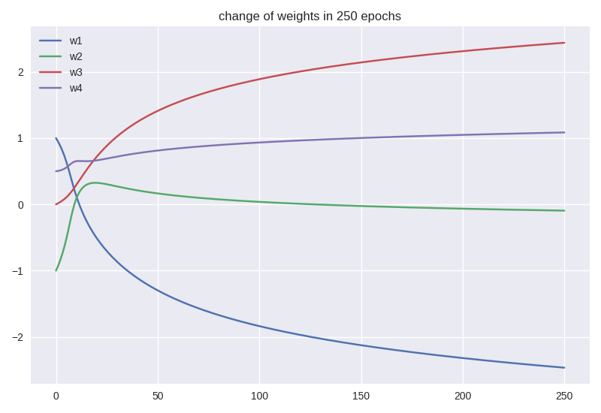

Exp no: 08 |  | Date: 10-12-2020
Title: | Implementation of roulette wheel selection
Aim: | To study and implement roulette wheel selection technique
Theory:
Prpblem:
Code: | '''  roulette wheel selection  '''  import numpy as np  import random  from pprint import pp  # initialise population  int1 = np.random.rand(10) * 10  int2 = np.random.rand(10) * 10  population = [(a, b) for a, b in zip(int1, int2)]  # goal of genetic algorithm is to maximise a*b  # fitness can be simply a*b  def fit(individual):  a, b = individual  return a * b  def rws(population):  s = 0  T = 0  for individual in population:  T += fit(individual)  r = random.uniform(0, T)  for individual in population:  # visual representation of roulette wheel selection  fitness_percent = int(fit(individual)/T * 100)  print('█' * (fitness_percent-1)+'▉', end='')  print('\n'+' ' * int(r/T * 100)+'⮝')  for p in population:  s += fit(p)  if s > r:  return p  selected = rws(population)  print('phenotype:', selected)  print('fitness:', fit(selected))
Conclusion:
Result: | 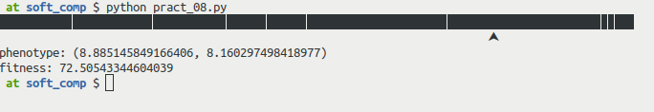
Exp no: 09 |  | Date:
Title: | Clustering using simple competitive learning
Aim: | To study and implement clustering using simple competitive learning algorithm
Theory:
Prpblem:
Code: | '''  simple competive learning  '''  import numpy as np  X = np.array([[1.1, 1.7, 1.8],  [0.0, 0.0, 0.0],  [0.0, 0.5, 1.5],  [1.0, 0.0, 0.0],  [0.5, 0.5, 0.5],  [1.0, 1.0, 1.0]])  W = np.array([[0.2, 0.7, 0.3],  [0.1, 0.1, 0.9],  [1.0, 1.0, 1.0]])  n = 0.5  for epoch in range(5):  print('\n###### epoch:', epoch+1, '######')  for x in X:  d = []  for w in W:  tmp = x-w  d.append(tmp.T @ tmp)  i = np.argmin(d)  W[i] += 0.5 * (x - W[i])  print(W, '\n')
Conclusion: | Simple competitive learning algorithm was implemented and weight change was observed
Result: | ###### epoch: 1 ######  [[0.525 0.3375 0.2875]  [0.05 0.3 1.2 ]  [1.025 1.175 1.2 ]]  ###### epoch: 2 ######  [[0.565625 0.2921875 0.2859375]  [0.025 0.4 1.35 ]  [1.03125 1.21875 1.25 ]]  ###### epoch: 3 ######  [[0.57070312 0.28652344 0.28574219]  [0.0125 0.45 1.425 ]  [1.0328125 1.2296875 1.2625 ]]  ###### epoch: 4 ######  [[0.57133789 0.28581543 0.28571777]  [0.00625 0.475 1.4625 ]  [1.03320312 1.23242188 1.265625 ]]  ###### epoch: 5 ######  [[0.57141724 0.28572693 0.28571472]  [0.003125 0.4875 1.48125 ]  [1.03330078 1.23310547 1.26640625]]

