

GOA COLLEGE OF ENGINEERING
“Bhausaheb Bandodkar Technical Education Complex”
FARMAGUDI- 403 401 GOA.
GOLDEN JUBILEE CELEBRATION
CERTIFICATE
2016 - 2017 | Roll No. | University Seat No.
This is to Certify that Shri/Kum.
of the Semester of four years Degree Course in
Engineering has completed
the term work in the subject within the four walls of GOA COLLEGE OF ENGINEERING, FARMAGUDI during the year.
Lecture In-charge Head of the Dept. Principal
CONTENTS

Exp no: 1 |  | Date: 16-09-2020
Title: | Introduction to python
Aim: | To study the basics of python language
Programs used: | Visual Studio Code, numpy, matplotlib
Theory: | Python is an interpreted, high-level and general-purpose programming language. Python's design philosophy emphasizes code readability with its notable use of significant whitespace. Its language constructs and object-oriented approach aim to help programmers write clear, logical code for small and large-scale projects.  NumPy is a general-purpose fundamental package for scientific computing with Python. It contains various features including these important ones:  - A powerful N-dimensional array object  - Sophisticated (broadcasting) functions  - Tools for integrating C/C++ and Fortran code  - Useful linear algebra, Fourier transform, and random number capabilities  Besides its obvious scientific uses, NumPy can also be used as an efficient multi-dimensional container of generic data. This allows NumPy to seamlessly and speedily integrate with a wide variety of databases.
Problem: | Exercise 1:Data = 5649. Write a "while loop" to print data variable in reverse order  Exercise 2: Write a print statement to get following result.  name: <any name> roll no: <roll no> GATE rank: <rank> percentile: <percentile>  Exercise 3: We have a list of players as follows.  players = ['abc, 'de', 'efg', 'ijk', 'lmn', 'op', 'qq', 'rr']  abc, lmn, qq, rr reached the semifinal of the tournament. Print the updated players list  Exercise 4: Write a simple program to print the first letter of your name using only asterisk '\' ( as you might have done while learning loops in 'C' language programs)  Exercise 5:  - Generate two arrays A1 and A2 of size 5 X 4 and 3 X 4 respectively using np.random()  - Join them and make an array A3 of 8 X 4. Now append random numbers ranging between from 0 to 5 to make the fourth array A4 of size 10 X 10.  - Print all the arrays and their transpose ( Transpose of 'A' can be obtained by 'A.T')  Exercise 6: Create two dictionaries.  The first dictionary 'name' will contain first name(key) of a person and its hash value(value).  The Second will contain hash value(key) and mobile no(value).  - Add 5 entries  - Delete two entries by taking the input from user as the first name.  - Add two entries by taking the input as the first name and mobile no.
Code: | '''  Introduction to python  '''  from pprint import pprint  from hashlib import md5  import numpy as np  #exe 1  DATA = 5649  ATAD = ''  while DATA > 0:  ATAD += str(DATA%10)  DATA = DATA//10  print(int(ATAD))  #exe 2  NAME = "Anirudha"  ROLL_NO = 171104008  GATE_RANK = 1  PERCENTILE = 99.99  print(f"name:{NAME} roll no:{ROLL_NO} GATE rank:{GATE_RANK} percentile:{PERCENTILE}")  #exe3  players = ['abc', 'de', 'ijk', 'efg', 'lmn', 'op', 'qq', 'rr']  for player in ['de', 'ijk', 'efg', 'op']:  players.remove(player)  print(players)  #exe4  N = 6  for x in range(N):  print(' ' * (N-x), end='')  print('*', end='')  if x ==3:  print('******', end='')  else:  print(' ' * x * 2, end='')  print('*')  #exe5  A1 = np.random.randn(5,4)  A2 = np.random.randn(3, 4)  A3 = np.concatenate((A1, A2))  A4 = np.concatenate((A3, np.random.randn(2, 4)))  A4 = np.concatenate((A4, np.random.randn(10, 6)), axis=1)  print(A4.shape)  # print(A1.T, A2.T, A3.T, A4.T)  #exe6  naava = ['Anirudha', 'Bnirudha', 'Cnirudha', 'Dnirudha', 'Enirudha']  numbers = [1234567890, 2345678901, 3456789012, 4567890123, 5678901234]  name = {naav:md5(naav.encode()).hexdigest() for naav in naava}  hashdict = dict(zip(name.values(), numbers))  for x in range(2):  x = input('names to delete:')  hashval = name[x]  del name[x]  del hashdict[hashval]  for x in range(2):  x = input('name to add:')  H = md5(x.encode()).hexdigest()  name[x] = H  num = input('mobile numbers:')  hashdict[H] = num  pprint(name)  pprint(hashdict)
Conclusion: | The basics of python programming language were studied
Result: | 9465  name:Anirudha roll no:171104008 GATE rank:1 percentile:99.99  ['abc', 'lmn', 'qq', 'rr']  **  * *  * *  ********  * *  * *  (10, 10)  names to delete:Anirudha  names to delete:Bnirudha  name to add:anirudha  mobile numbers:9999999999  name to add:bnirudha  mobile numbers:1234567890  {'Cnirudha': '29de093b14d53234b6b25e223dbbd803',  'Dnirudha': '91827ace3a7f9b18cd713daf3ae30f89',  'Enirudha': '01b61a2d4df5b005ed003fbba1751631',  'anirudha': 'c8abbaaed5311a359b008c206b6690a1',  'bnirudha': '4f6e34e1688014b10f10759cff4e1706'}  {'01b61a2d4df5b005ed003fbba1751631': 5678901234,  '29de093b14d53234b6b25e223dbbd803': 3456789012,  '4f6e34e1688014b10f10759cff4e1706': '1234567890',  '91827ace3a7f9b18cd713daf3ae30f89': 4567890123,  'c8abbaaed5311a359b008c206b6690a1': '9999999999'}

Exp no: 02 |  | Date: 23-09-2020
Title: | Introduction to activation functions and implementation of an Artificial Neuron
Aim: | To observe the outputs of various activation functions with the help of implementation of an Artificial Neuron
Theory: | 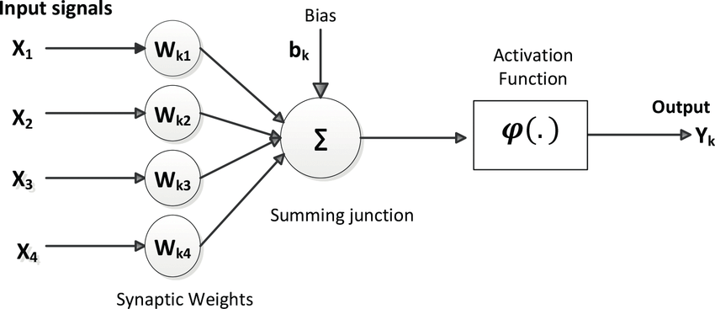  The first computational model of a neuron was proposed by Warren MuCulloch (neuroscientist) and Walter Pitts (logician) in 1943.  An artificial neuron is a mathematical function conceived as a model of biological neurons, a neural network. Artificial neurons are elementary units in an artificial neural network.  The artificial neuron receives one or more inputs (representing excitatory postsynaptic potentials and inhibitory postsynaptic potentials at neural dendrites) and sums them to produce an output (or activation, representing a neuron's action potential which is transmitted along its axon). Usually each input is separately weighted, and the sum is passed through a non-linear function known as an activation function or transfer function  It may be divided into 2 parts. The first part, g takes an input, performs an aggregation and based on the aggregated value the second part, f makes a decision.
Code: | '''  implementation of neruron and activation functions  '''  import numpy as np  class Neuron:  '''McCulloch pitts neuron model'''  def __init__(self,activation_fn, weights, bias=0):  self.weights = np.array(weights)  self.inputs = np.empty_like(self.weights)  self.act_fn = activation_fn  self.bias = bias  def calc_out(self):  '''calculates neuron output using specified activation function'''  return self.act_fn(self.weights.T @ self.inputs + self.bias)  def signum(net):  '''signum activation function'''  return net >= 0  def bipolar_step(net):  '''bipolar step activation function'''  return 2 * int(net > 0) -1  def u_peicewise_linear(net):  '''unipolar peicewise linear activation function'''  return min(1, max(0, net))  def b_peicewise_linear(net):  '''bipolar peicewise linear activation function'''  return min(1, max(-1, net))  def u_sigmoidal(net):  '''unipolar sigmoidal activation function'''  lam = 1  return 1 / (1 + np.exp(-1 * lam * net))  def b_sigmoidal(net):  '''bipolar sigmoidal activation function'''  lam = 1  return 2 / (1 + np.exp(-1 * lam * net)) - 1  def hyperbolic_tan(net):  '''hyperolic tan activation function'''  return np.tanh(net)  def arctan(net):  '''arctan activation function'''  return np.arctan(net)  def relu(net):  '''relu activation function'''  max(0, net)  def leaky_relu(net):  '''leaky relu activation function'''  max(0.01 * net, net)  #code for observing activation function outputs  import numpy as np  import matplotlib.pyplot as plt  from neuron import *  plt.style.use('Solarize_Light2')  fig, axs = plt.subplots(nrows=3, ncols=3)  ax = axs.flatten()  x = np.linspace(-10, 10, 1000)  y = signum(x)  ax[0].set_title('signum')  ax[0].plot(x, y)  y = bipolar_step(x)  ax[1].set_title('bipolar signum')  ax[1].plot(x, y)  y = u_sigmoidal(x)  ax[2].set_title('sigmoidal')  ax[2].plot(x, y)  y = b_sigmoidal(x)  ax[3].set_title('bipolar\nsigmoidal')  ax[3].plot(x, y)  y = hyperbolic_tan(x)  ax[4].set_title('hyperbolic\ntan')  ax[4].plot(x, y)  y = arctan(x)  ax[5].set_title('arctan')  ax[5].plot(x, y)  y = relu(x)  ax[6].set_title('relu')  ax[6].plot(x, y)  y = leaky_relu(x)  ax[7].set_title('leaky relu')  ax[7].plot(x, y)  y = b_peicewise_linear(x)  ax[8].set_title('bipolar\npeicewise linear')  ax[8].plot(x, y)  fig.tight_layout()  plt.show()
Conclusion: | The working of various activation functions were studied and outputs observed
Result: | 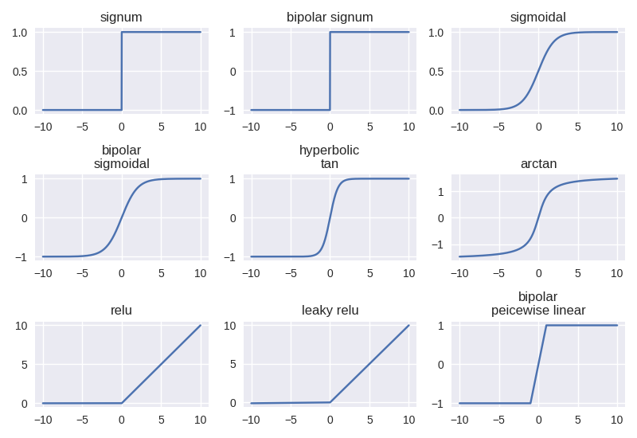
Exp no: 03 |  | Date: 30-09-2020
Title: | Implementation of Logic Gates using Artificial Neurons
Aim: | To implement boolean logic gates using simple McCulloch-Pitts Model of Artificial Neuron
Code: | '''  logic gates  '''  import numpy  from neuron import Neuron, signum #Neuron class written in practical 3  def show_output(gate, gate_inputs_list):  '''  helper function to display output  '''  for gate_input in gate_inputs_list:  gate.inputs = numpy.array(gate_input)  print(f'x1:{gate_input[0]} x2:{gate_input[1]} O:', gate.calc_out())  gate_inputs = [[0,0],[0,1],[1,0], [1,1]] #inputs to test the gates against  # and gate  print("\nand gate")  and_gate = Neuron(lambda x: x > 1, weights=[1, 1])  show_output(and_gate, gate_inputs)  #or_gate  print("\nor gate")  or_gate = Neuron(lambda x: x > 0, weights=[1, 1])  show_output(or_gate, gate_inputs)  # nand gate  print('\nnand')  nand_gate = Neuron(lambda x: x > -2, weights=[-1, -1])  show_output(nand_gate, gate_inputs)  # nor gate  print('\nnor')  nor_gate = Neuron(lambda x: x > -1, weights=[-1, -1])  show_output(nor_gate, gate_inputs)  # not  print('\nnot')  not_gate = Neuron(lambda x: x > -1, weights=[-1])  for g_inputs in [[0], [1]]:  not_gate.inputs = numpy.array(g_inputs)  print(f'x:{g_inputs} O:', not_gate.calc_out())  # xor  print('\nxor')  o1 = Neuron(signum,weights=[-2, 1], bias=-1/2)  o2 = Neuron(signum,weights=[1, -1], bias=-1/2)  xor_gate = Neuron(signum, weights=[1, 1], bias=-1/2)  def sh_xor_output(gate_inputs_list):  '''helper fuction to display xor output'''  gate_inputs_array = numpy.array(gate_inputs_list)  o1.inputs = o2.inputs = gate_inputs_array  xor_gate.inputs = numpy.array([o1.calc_out(), o2.calc_out()])  print(f'x1:{gate_inputs_array[0]} x2:{gate_inputs_array[1]} O:', xor_gate.calc_out())  for g_input in gate_inputs:  sh_xor_output(g_input)
Conclusion: | Logic gates were implemented using the McCulloch-Pitts Neuron model and outputs were observed
Result: | and gate  x1:0 x2:0 O: False  x1:0 x2:1 O: False  x1:1 x2:0 O: False  x1:1 x2:1 O: True  or gate  x1:0 x2:0 O: False  x1:0 x2:1 O: True  x1:1 x2:0 O: True  x1:1 x2:1 O: True  nand  x1:0 x2:0 O: True  x1:0 x2:1 O: True  x1:1 x2:0 O: True  x1:1 x2:1 O: False  nor  x1:0 x2:0 O: True  x1:0 x2:1 O: False  x1:1 x2:0 O: False  x1:1 x2:1 O: False  not  x:[0] O: True  x:[1] O: False  xor  x1:0 x2:0 O: False  x1:0 x2:1 O: True  x1:1 x2:0 O: True  x1:1 x2:1 O: False

Exp no: 04 |  | Date: 07-10-2020
Title: | Design of an Artificial Neuron using Hebbian Learning rule
Aim: | To study and implement the Hebbian Learning rule
Theory: | Hebbian Learning Rule, also known as Hebb Learning Rule, was proposed by Donald O Hebb. It is one of the first and also easiest learning rules in the neural network. It is used for pattern classification. It is a single layer neural network, i.e. it has one input layer and one output layer. The input layer can have many units, say n. The output layer only has one unit. Hebbian rule works by updating the weights between neurons in the neural network for each training sample.  The weights change is calculated according to the following rule:
Problem:
Code: | '''  hebbian learning rule  '''  import numpy  from neuron import Neuron, bipolar_step  weights = [1, -1, 0, 0.5]  inputs = [[1, -2, 1.5, 0], [1, -0.5, -2, -1.5], [0, 1, -1, 1.5]]  C = 1  neuron = Neuron(activation_fn=bipolar_step, weights=weights)  for epoch in range(5):  print(f'\nepoch {epoch+1}')  for x in inputs:  neuron.inputs = numpy.array(x)  o = neuron.calc_out()  neuron.weights += C * o * neuron.inputs  print(f'weights:\t{neuron.weights}')
Conclusion: | The hebbian learning rule was studied and
Result: | epoch 1  weights: [ 2. -3. 1.5 0.5]  weights: [ 1. -2.5 3.5 2. ]  weights: [ 1. -3.5 4.5 0.5]  epoch 2  weights: [ 2. -5.5 6. 0.5]  weights: [ 1. -5. 8. 2.]  weights: [ 1. -6. 9. 0.5]  epoch 3  weights: [ 2. -8. 10.5 0.5]  weights: [ 1. -7.5 12.5 2. ]  weights: [ 1. -8.5 13.5 0.5]  epoch 4  weights: [ 2. -10.5 15. 0.5]  weights: [ 1. -10. 17. 2.]  weights: [ 1. -11. 18. 0.5]  epoch 5  weights: [ 2. -13. 19.5 0.5]  weights: [ 1. -12.5 21.5 2. ]  weights: [ 1. -13.5 22.5 0.5]

Exp no: 05 |  | Date: 14-10-2020
Title: | Design of an artificial Neuron using perceptron learning rule
Aim: | To study and implement the perceptron learning rule
Theory: | Perceptron is an algorithm for supervised learning of binary classifiers. A binary classifier is a function which can decide whether or not an input, represented by a vector of numbers, belongs to some specific class.  In perceptron learning rule weight change is calculated as:
Problem:
Code: | '''  perceptron learning rule  '''  import numpy  from neuron import Neuron, bipolar_step  np.set_printoptions(precision=2)  w = [1, -1, 0, 0.5]  C = 0.1  D = [-1, -1, 1]  X = numpy.array([[1, -2, 0, -1], [0, 1.5, -0.5, -1], [-1, 1, 0.5, -1]])  neuron = Neuron(activation_fn=bipolar_step, weights=w)  for epoch in range(5):  print(f'\nepoch {epoch+1}')  for x, di in zip(X, D):  neuron.inputs = x  o = neuron.calc_out()  neuron.weights += C * (di- o) * x  print(f'weights: {neuron.weights}')
Conclusion: | Perceptron learning rule was implemented and oututs were observed
Result: | at soft_comp $ python pract_05.py  epoch 1  weights: [ 0.8 -0.6 0. 0.7]  weights: [ 0.8 -0.6 0. 0.7]  weights: [ 0.6 -0.4 0.1 0.5]  epoch 2  weights: [4.00e-01 5.55e-17 1.00e-01 7.00e-01]  weights: [4.00e-01 5.55e-17 1.00e-01 7.00e-01]  weights: [0.2 0.2 0.2 0.5]  epoch 3  weights: [0.2 0.2 0.2 0.5]  weights: [0.2 0.2 0.2 0.5]  weights: [5.55e-17 4.00e-01 3.00e-01 3.00e-01]  epoch 4  weights: [5.55e-17 4.00e-01 3.00e-01 3.00e-01]  weights: [5.55e-17 1.00e-01 4.00e-01 5.00e-01]  weights: [-0.2 0.3 0.5 0.3]  epoch 5  weights: [-0.2 0.3 0.5 0.3]  weights: [-0.2 0.3 0.5 0.3]  weights: [-0.2 0.3 0.5 0.3]

Exp no: 06 |  | Date: 7-12-2020
Title: | Design of an Adaline
Aim: | To study and implement the Widrow-Hoff learning rule
Theory: | 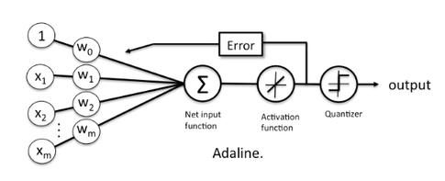  ADALINE (Adaptive Linear Neuron) is an early single-layer artificial neural network and the name of the physical device that implemented this network.  The difference between Adaline and the standard (McCulloch–Pitts) perceptron is that in the learning phase, the weights are adjusted according to the weighted sum of the inputs (the net).  In ADALINEs the weight change is calculated according to the widrow hoff learning rule given by:
Problem:
Code: | '''  hebbian learning rule  '''  import numpy as np  from neuron import Neuron  w = [1, -1, 0, 0.5]  C = 0.1  D = [-1, -1, 1]  X = np.array([[1, -2, 0, -1], [0, 1.5, -0.5, -1], [-1, 1, 0.5, -1]])  neuron = Neuron(activation_fn=lambda x: x, weights=w)  for epoch in range(5):  print(f'\nepoch {epoch+1}')  for x, di in zip(X, D):  neuron.inputs = x  o = neuron.calc_out()  neuron.weights += C * o * x  print(f'weights: {neuron.weights} f(net): {o} inputs: {neuron.inputs}')
Conclusion: | The widrow hoff learning rule was studied and ADALINE was implemented
Result: | epoch 1  weights: [ 1.25 -1.5 0. 0.25]  weights: [ 1.25 -1.88 0.12 0.5 ]  weights: [ 1.61 -2.23 -0.05 0.86]  epoch 2  weights: [ 2.13 -3.27 -0.05 0.33]  weights: [ 2.13 -4.06 0.21 0.86]  weights: [ 2.82 -4.75 -0.14 1.55]  epoch 3  weights: [ 3.9 -6.9 -0.14 0.47]  weights: [ 3.9 -8.52 0.4 1.55]  weights: [ 5.28 -9.9 -0.29 2.93]  epoch 4  weights: [ 7.49 -14.32 -0.29 0.71]  weights: [ 7.49 -17.63 0.81 2.92]  weights: [ 10.25 -20.39 -0.57 5.68]  epoch 5  weights: [ 14.79 -29.47 -0.57 1.14]  weights: [ 14.79 -36.23 1.68 5.65]  weights: [ 20.37 -41.81 -1.11 11.23]

Exp no: 07 |  | Date: 09-12-2020
Title: | Design of an artificial neuron using delta learning rule
Aim: | To study and implement the delta learning rule
Theory: | The delta learning rule is a gradient descent learning rule for updating the weights of the inputs to artificial neurons in a single-layer neural network. It is a special case of the more general backpropagation algorithm. For a neuron with weight and activation function , the change in weight is given by:
Problem:
Code: | ' ‘ '  Delta learning rule  '''  # from pprint import pprint  import numpy  import matplotlib.pyplot as plt  from neuron import Neuron, b_sigmoidal  numpy.set_printoptions(precision=2)  W = [1, -1, 0, 0.5]  C = 0.1  D = [-1, -1, 1]  X = numpy.array([[1, -2, 0, -1], [0, 1.5, -0.5, -1], [-1, 1, 0.5, -1]])  weight_change = [W]  neuron = Neuron(activation_fn=b_sigmoidal, weights=W)  for epoch in range(250):  if epoch < 5:  print(f'\nepoch: {epoch + 1}')  for x, di in zip(X, D):  neuron.inputs = x  o = neuron.calc_out()  neuron.weights += C * (di- o) * 0.5 * (1 - o*o) * x  if epoch <5 :  print(f'weights: {neuron.weights}\tf(net): {o:.2f}')  weight_change.append(list(neuron.weights))  # pprint(weight_change)  plt.title('change of weights in 250 epochs')  plt.plot(weight_change)  plt.legend(['w1', 'w2', 'w3', 'w4'])  plt.show()
Conclusion: | Delta learning rule was implemented and outputs were observed
Result: | epoch: 1  weights: [ 0.97 -0.95 0. 0.53] f(net): 0.85  weights: [ 0.97 -0.96 0. 0.53] f(net): -0.75  weights: [ 0.95 -0.93 0.02 0.5 ] f(net): -0.84  epoch: 2  weights: [ 0.92 -0.87 0.02 0.53] f(net): 0.82  weights: [ 0.92 -0.88 0.02 0.54] f(net): -0.73  weights: [ 0.89 -0.85 0.03 0.51] f(net): -0.82  epoch: 3  weights: [ 0.85 -0.78 0.03 0.55] f(net): 0.78  weights: [ 0.85 -0.79 0.04 0.55] f(net): -0.70  weights: [ 0.82 -0.76 0.05 0.52] f(net): -0.80  epoch: 4  weights: [ 0.78 -0.67 0.05 0.56] f(net): 0.72  weights: [ 0.78 -0.69 0.06 0.57] f(net): -0.66  weights: [ 0.74 -0.65 0.08 0.54] f(net): -0.76  epoch: 5  weights: [ 0.69 -0.56 0.08 0.58] f(net): 0.64  weights: [ 0.69 -0.57 0.08 0.6 ] f(net): -0.62  weights: [ 0.65 -0.53 0.1 0.55] f(net): -0.72  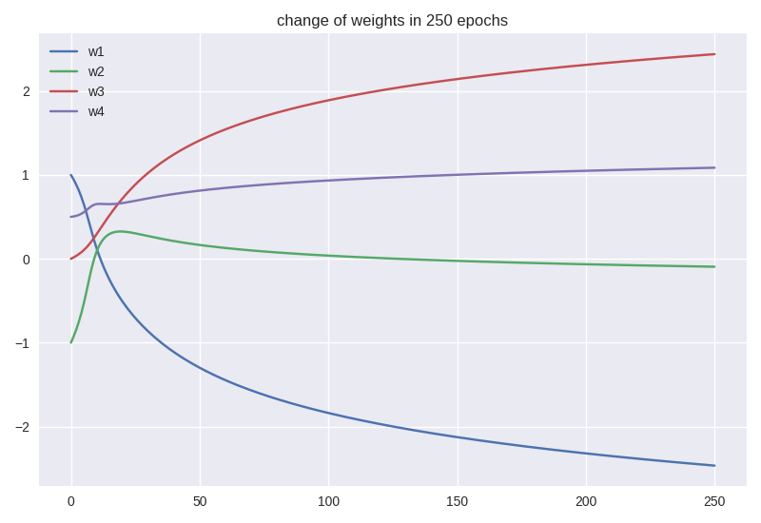
Exp no: 09 |  | Date: 14-12-2020
Title: | Clustering using simple competitive learning
Aim: | To study and implement clustering using simple competitive learning algorithm
Theory: | Simple competitive Network model accepts real valued vectors as inputs and consists of an  input layer with n nodes and output layer with n nodes. Every competitive node is described by a weight vector. A competition occurs among nodes in the outer layer, to find the winner node whose weight is  the closest to the input vector. Distance measure is usually Euclidean distance.
Problem:
Code: | ‘’’  simple competive learning  '''  import numpy as np  X = np.array([[1.1, 1.7, 1.8],  [0.0, 0.0, 0.0],  [0.0, 0.5, 1.5],  [1.0, 0.0, 0.0],  [0.5, 0.5, 0.5],  [1.0, 1.0, 1.0]])  W = np.array([[0.2, 0.7, 0.3],  [0.1, 0.1, 0.9],  [1.0, 1.0, 1.0]])  n = 0.5  for epoch in range(5):  print('\n###### epoch:', epoch+1, '######')  for x in X:  d = []  for w in W:  tmp = x-w  d.append(tmp.T @ tmp)  i = np.argmin(d)  W[i] += 0.5 * (x - W[i])  print(W, '\n')
Conclusion: | Simple competitive learning algorithm was implemented and weight change was observed
Result: | ###### epoch: 1 ######  [[0.525 0.3375 0.2875]  [0.05 0.3 1.2 ]  [1.025 1.175 1.2 ]]  ###### epoch: 2 ######  [[0.565625 0.2921875 0.2859375]  [0.025 0.4 1.35 ]  [1.03125 1.21875 1.25 ]]  ###### epoch: 3 ######  [[0.57070312 0.28652344 0.28574219]  [0.0125 0.45 1.425 ]  [1.0328125 1.2296875 1.2625 ]]  ###### epoch: 4 ######  [[0.57133789 0.28581543 0.28571777]  [0.00625 0.475 1.4625 ]  [1.03320312 1.23242188 1.265625 ]]  ###### epoch: 5 ######  [[0.57141724 0.28572693 0.28571472]  [0.003125 0.4875 1.48125 ]  [1.03330078 1.23310547 1.26640625]]
Exp no: 10 |  | Date: 16-12-2020
Title: | Design of a Brain-State-In-a-Box [BSB] Network
Aim: | To study and implement a BSB network
Theory: | A BSB network is fully connected, with as many nodes as the dimensionality n of the input space. All nodes are updated simultaneously, and the nodes take values in the continuous range from -1 to +1. The node function used is a ramp function  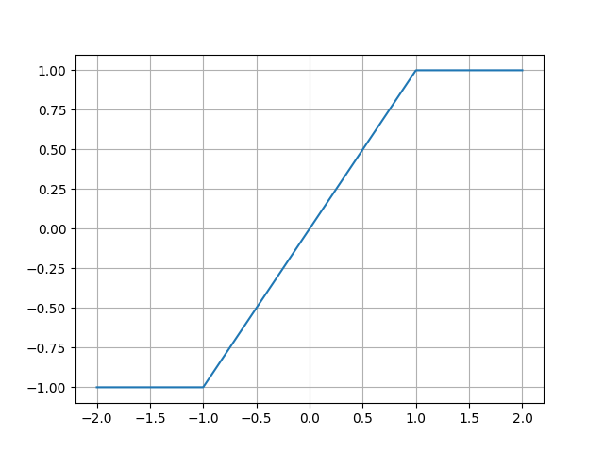  which is bounded, continuous, and piecewise linear.  In the operation of this network, each node changes its state according to the following equation.  where Xt (t ) is the state of the .eth node at time t.  Each node' s activation belongs to the closed interval [ - 1, 1], so that the state of the network always remains inside an n-dimensional “box”(hypercube), giving rise to the name of the network, “Brain-State-in-a-Box”.
Problem:
Code: | '''  brain state in a box  '''  import numpy as np  training_set = np.array([[1, 1, 1], [-1, -1, -1], [1, -1, -1]])  P = len(training_set)  W = np.empty_like(training_set, dtype=float)  I = np.array([0.5, 0.6, 0.1])  def ramp(x):  return np.maximum(-1, np.minimum(1, x))  for i in range(P):  for j in range(P):  W[i][j] = np.sum(training_set[:, i] * training_set[:, j]) / P  print('weights:\n', W)  print('\ncorrupted input:\n', I)  while(I not in training_set):  I = ramp(W.T @ I)  print('\ncorrected input:\n', I)
Conclusion: | A BSB network was studied and implemented
Result: | weights:  [[1. 0.33333333 0.33333333]  [0.33333333 1. 1. ]  [0.33333333 1. 1. ]]  corrupted input:  [0.5 0.6 0.1]  corrected input:  [1. 1. 1.]

Exp no: 11 |  | Date: 17-12-2020
Title: | Design of recurrent neural networks
Aim: | To study and implement a recurrent auto associative net store a given vector
Theory: | A recurrent neural network (RNN) is a class of artificial neural networks where connections between nodes form a directed graph along a temporal sequence. This allows it to exhibit temporal dynamic behavior. Derived from feedforward neural networks, RNNs can use their internal state (memory) to process variable length sequences of inputs.
Problem:
Code: | import numpy as np  def sign(net):  return 2 * (net >= 0) -1  inputs = np.array([[ 1, 1, 1, -1],  [-1, -1, -1, 1],  [ 1, 1, 1, 1],  [ 1, 1, -1, -1],  [ 1, -1, 1, -1],  [-1, 1, 1, -1]])  W = np.array([[0, 1, 1, -1],  [1, 0, 1, -1],  [1, 1, 0, -1],  [-1, -1, -1, 0]])  for o in inputs:  print('\ninput', o)  # for epoch in range(5):  o = sign(W @ o)  print(o)
Conclusion: | A recurrent neural netowrk was implemented and outputs were observed
Result: | input: [ 1 1 1 -1]  output: [ 1 1 1 -1]  input: [-1 -1 -1 1]  output: [-1 -1 -1 1]  input: [1 1 1 1]  output: [ 1 1 1 -1]  input: [ 1 1 -1 -1]  output: [ 1 1 1 -1]  input: [ 1 -1 1 -1]  output: [ 1 1 1 -1]  input: [-1 1 1 -1]  output: [ 1 1 1 -1]

