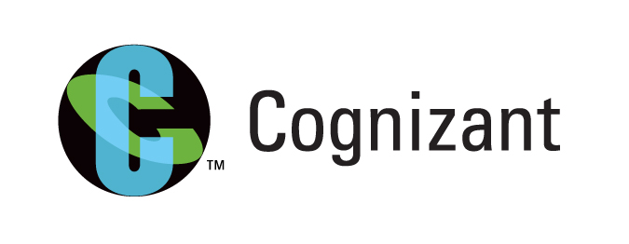
Collabera was my last on-campus drive. Now I had a gut feeling that(since it was late August), if I want to achieve something more, I have move out from your home. And information about “achieving something more” came from my friend; as I mentioned in previous experience keep connected, and I applied online to Cognizant. Call came, and opportunity called me to Pune. At this stage I was fed up with preparation for technical companies, as I was not clearing even written rounds. So I made resolution, this time I will go without preparation.
CTS consisted 3 rounds:-
- Written Test
- Technical Interview
- HR interview
It was open campus in Pune, for two days. Each day consisting of 6 batches consisting 1000+ students each. But after all those huge numbers and with my new resolution I cleared the test first time in company which was offering pure technical position.
Now it was time for technical interview. It started with formal “Describe yourself”. Every thing went great except one thing. My resume consisted of mainly open source technologies. With no “JAVA” in it, instead “PYTHON”. So he made objection and said, “Why no JAVA, will you work on it if offered?”. As I mentioned before during the time of Collabera experience be yourself during interview. I replied, “ No sir, I will prefer Python”.
After that result came, I was told that check your result with in a week on companie’s website. After few weeks I got result, in that I was rejected. It felt bad, as Diwali was coming, but as I told in my previous experience “Jo hota hai acche ke liye hota hai”. I told to myself, “ Yaa Yaa, let it be. I will find another one.”

