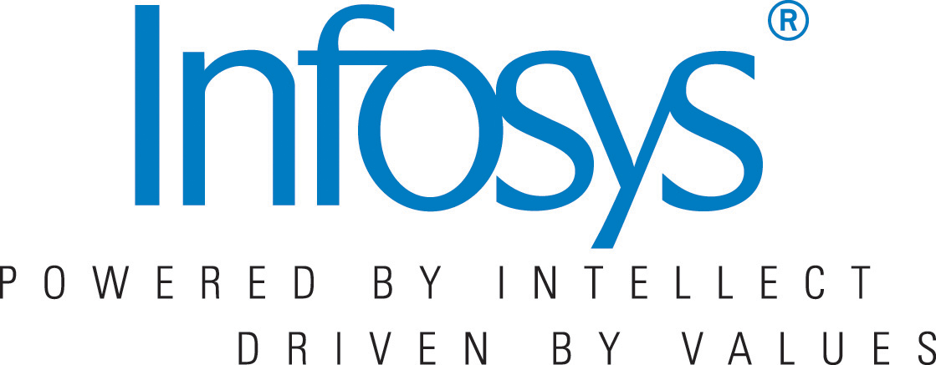
So after HCL experience I had enough of company selection procedures. It was mid-November, and nothing was happening right for me. It was happening just like “Haath ko aya mooh ko na laga”. I became nervous, annoyed and fed up with all that was happening. Also time came to make important decision between “GATE or Company preparation”, because I had realized it is extremely difficult to go with both. Same time I sent resume to Infosys and call came from Infosys in late November.
After rigorous discussion with my mother(do’s from Collabera experience) I came on discussion that I will attend written test in Pune for Infosys. But just as I was leaving form my home I got news that Hexaware was coming to Bhopal which was near my home. Again I got confused, but at last moment I made decision that I will go to Pune with my old resolution that I have taken right from Cognizant. This time I also decided anything that happens I will face it with no emotions, and was confident that whatever goes on I will definitely make my way out of it.
Infosys consist of two rounds:-
- Written
- HR interview
My that decision paid me and I cleared the written test. Next day was my interview. And I was afraid that same old “Python question” creep up. Same thing happened. Interviewer asked same “Why Python?”. But this time I was prepared I answered smartly that, “If your company don't requires Python, I will work on other open source technology like Linux”. They told me to wait for 1 month for result.
So atlast after 4 trips to Pune, 4 trips to Bhopal, 2 trips to Delhi and 1 trip to Bombay, Infosys confirmed my first technical job by mailing in mid-December.
So moral of the story or struggle or life is “Never give up, just keep trying. Until you reach where you want to be”.

