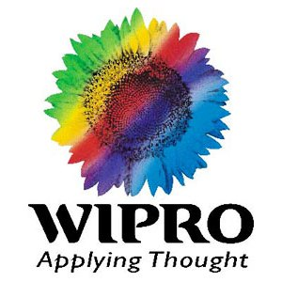

COMPANY & ROLE DETAILS
NAME: Yashlay Sinha
COMPANY THAT YOU INTERVIEWED FOR: WIPRO Technologies Ltd.
ROLE THAT YOU INTERVIEWED FOR: Project Engineer

PRE-PROCESS REQUIREMENTS (Write Yes/No)
RESUME: Yes
APPLICATION FORM: Yes
GROUP DISCUSSION: No
WRITTEN TEST: Yes
Please mention if there were any other requirements for the process.

REMARKS
Please mention your remarks on the Application Form. (Questions, Qualification details)
Application form consisted general questions related to educational qualification, Achievements, hobbies, personal details.
Eligibility Qualifications were: B.Tech in any stream (Mine was B.Tech in Production Engineering) with 55% throughout, including 10th and 12th. Only two year academic gap permitted.
Please mention your remarks on the Group Discussion process. (Topic, Duration, No. of Members)
No Group Discussion conducted.

Please mention your remarks on the Written Test process.
Online written test with different sections which included, general aptitude, English, basics of programming (Debugging of C programs). You need to clear all the sections to pass the written test.

What went right for you at different stages of the process?
My Written Test marks were good and my B.Tech marks was above 80% so the interviewer had soft side with me. People having less marks need not to worry, because most of candidates had an average score but they impressed interviewer with their answers.
During Technical round of interview I responded to all the questions well including Questions related to C, so it added an extra edge in my interview as I’m from a mechanical background.
During HR round of interview, I impressed the interviewer with my achievements in the field of presentation which included Paper Presentation at Indian Science Congress 2010.
What went wrong for you at different stages of the process?
I feel it was my day and nothing went wrong that day.

What question(s) did you ask the interview panel?
- Whether WIPRO will give me a chance to work with its R&D.
- I heard WIPRO going green in a business magazine, is it true that WIPRO buildings are also green.
Any suggestions/ dos & don’ts/ special preparation tips for your juniors:
- Try not to make fool of HR, they are very skilled in their work and have lot of experience, they may catch u.
- Go in the interview with a simple outfit.
- Don’t put ur achievements in such a way that you feel proud of them, rathe answer questions very calmly.
- Avoid messy things in the interview like sitting and shaking legs, looking here and there.
- Communicate with HR in a explanatory manner looking into his/her eyes.

