ACKNOWLEDGEMENT

I would like to express my gratitude to my trainers who helped me in framing the project and making different sources of information available. I also thank my Java Lab trainers for giving productive suggestions to execute this project.
I am sincerely grateful to my trainer, Mr. Amit Malhotra & Mr. Manish K. Bhatia for his earnest guidance and advice without which my project would have remained a fiction.

Name : HARGOVIND SINGH
Roll No. : 12
Section : IT-2(5th Semester)
Year : 2010-2011

CERTIFICATE OF ACKNOWLEDGEMENT

This is to certify that HARGOVIND SINGH of G.T.B.I.T., New Delhi has completed this project under my supervision during the academic year 2010-11.

MR. MANISH K. BHATIA

Head of the department
(Java Technology)
Ducat
Noida .

ABSTRACT

Gone are the days when we bored in front of TV’s soaps, or even dull Pc’s programs, TV’s videogames. We all are fond of having something that is new and appealing. Now is the Information-hungry age, that has become addicted to Gadgets, Internet, and other accessories & want instant gratification for their minds.

Larry Page, co-creator of Google, once said:

“You should try to do things that most people would not … There is so much leverage in science and technology, I think most people don’t really realize that. There’s so much that can be done with these new technologies. We are an example of that.”

These words were the source of inspiration that filled me with the passion to learn as much as it’s available and explore new arenas …

So by endless research and awe-inspiring training (in Java), I present you my summer training project … “Virtual Drum-set”.

This project aims at exploring the javax.sound.midi package provided in Java source code, and making an inventory GUI for exploration purposes.

CONTENTS

Title Page I
Certificate II
Acknowledgment III
Abstract IV
List of Figures V
PART 1: OVERVIEW OF PROJECT
1. Introduction 44

PART 2: OUTLINE OF DRUM-SET
2.1 What is Drum-set?
2.2 Reading Music
2.2.1 Basics

PART 3: JAVA
3.1 What is Java?
3.2 History
3.3 How does a Java program get executed?
3.4 Why MIDI package is used ?

PART 4: GUI
4.1 What is GUI?
4.2 How a GUI implemented is Java

PART 5: INTERNALS OF GUI
5.1 Used classes from javax.sound.midi explained
5.2 How does GUI play
5.3 Summing up the process involved in sound generation

PART 6: Software Requirement Specification (SRS)
6.1 Introduction
6.1.1 Purpose
6.1.2 Scope
6.1.3 References
6.2 Overall Description
6.2.1
6.3 Specific Requirements

7. Conclusion 56
8. Bibliography 58
9. Appendix
I Using classes in javax.sound.midi
II Constant fields values
III Source Code 59
IV Screen Shots 72
10. Glossary

LIST OF FIGURES

FIG 1: Integration of Virtual Drum-set idea 31

FIG 2: Labeled Drumstick 51

FIG 3: Beat pattern notations 48

FIG 4: Notes Notation 41

FIG 5: A Single-bass Drum-set 4

FIG 6: Flow of data in program execution. 41

FIG 7: Java Platform 84

FIG 8: Java’s Platform & API 54

FIG 9: AWT classes & interfaces 85

FIG 10: Inter Communication through Various ports of MIDI system,
h/w & s/w devices. 45

PART 1

OVERVIEW OF PROJECT

INTRODUCTION

Virtual Drum-set : a virtual machine capable of playing drum patterns according to our choice; a programmed percussions playable at an independent platform.

It is intended for musicians as well as layman to compose various musical pieces according to their propelling ideas. This piece of work of mine will cut down time that many people dissipate and assist them to add wings to their creativity.

It uses an easy and understandable interface to compose a maximum 16-beat pattern. The values can be assigned by the user as needed and previewed. It can also be adored by selecting the tempo.
This graceful version of drum set is designed using Java Programming Language.

The procedure followed was …
Mapping the real entity, the drum-set, with its own property & behavior. Then framing of a GUI (Graphical User Interface), using the classes provided in javax.swing package.
As the main focus was on inculcating the drum behavior for GUI, classes provided in javax.sound.midi package were also used.

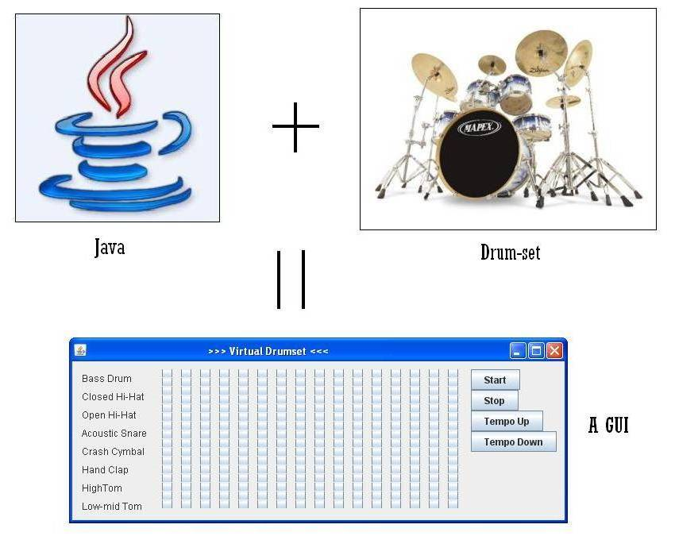

FIG 1: Integration of Virtual Drum-set idea

1.1 Instructions to use the source code:
1. Copy the compiled code (say 'code') folder to the directory from which you want to access the GUI.

2. Open the Command Prompt from System32 / run command.

3. Now type this on the cmd:
(Here, DrumBox.java is the source code file)

C:\WINDOWS\system32>cd\

C:\>cd code

C:\Code>javac DrumBox.java

C:\Code>java DrumBox

4. After executing last command the GUI opens & waits for you to respond.

1.2 Instructions to use JAVA:

1. First download the latest Java JDK (SDK containing JRE) from java.sun.com.

2. Install all its features to your system.

3. Now, go to Environment variables section in the Advanced Computer Settings.

4. Check if there is a variable named ‘path’, else create a new one and add the entire directory path (till bin folder of jdk) and save it.

5. Now check if Java is running by typing ‘java’& ‘javac’, in the command prompt.

PART 2

OUTLINE OF DRUM-SET

DRUM-SET’s INTRO

2.1 WHAT IS DRUMSET?

Drum-set is a collection of drums that produce musical note when stroked with a stick.
Some terms related to Drums …

Drum: A percussion instrument with a skin stretched across a frame, sounded by being struck with sticks or hand.

Drumbeat: A stroke or pattern of strokes on a drum.

Drum kit: A set of drums, cymbals, and other percussion instruments.

Drum roll: A rapid succession of drumbeats.

Drumstick: A stick used for beating a drum.

Drummer: A person who plays a drum or drums.

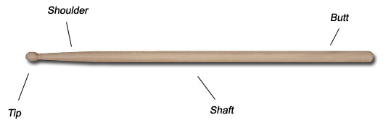

FIG 2: Labeled Drumstick

2.2 READING DRUM MUSIC

If People are unable to understand to use GUI from checkboxes, they can refer to this section for more defined solution to their problem.
Many drummers are "ear-trained". They learn to play drums by listening to music and playing to it, many times mimicking it. They also form garage bands and learn by doing. While there's nothing wrong with this type of training for the ear, many drummers never learn to read. Thus, for many, a career as a free-lance musician is denied them (particularly studio recording), unless they "make it" in a band.
Reading music is fundamental to a well-rounded musical approach. We take it for granted in this age of easy recording, but remember that recorded music is a 20th century invention. Before that, most music had to be "recorded" by writing it down on paper. We've gotten a bit lazy because of our technology.
This page hopes to give the beginning reader some of the fundamentals of reading music. It is not meant to be a final statement. A lifetime of study and practice is required to become proficient, particularly at sight-reading - the ability to play music that's put in front of you for the first time. The reader is encouraged to buy some music books and take a few lessons.

2.2.1 BASICS

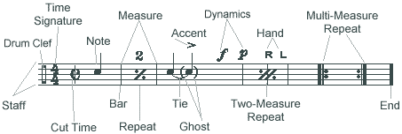
FIG 3: Beat pattern notations
The Staff
The staff is where everything happens. It consists of five lines and all the information you need is contained within it (though some notes may be above or below the staff). All the notes (values explained below) reside either on a line or in a space.

The Drum Clef
The drum clef denotes that the following music is not written for a pitched instrument; that the position of the note indicates the drum, cymbal, or other percussion instrument played (see the Notation Key). You can tailor your staff for specific instruments - just note them on a notation key.
There are other clefs which you will run into; these are for playing pitched instruments. We will not deal with them here.

Time Signature
This is one of the most important parts of the staff for a drummer. This tells you how the following notes are to be played. The top number indicates the number of beats in a measure. The bottom note indicates the note that is to get one beat.
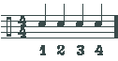
This may sound complicated, but it's not. In our example the top four indicates there are four beats in a measure: counting "1, 2, 3, 4". Four beats. The bottom number indicates which note value is getting the "one". In our example, the quarter note (hence the "4") is getting the value, so in a measure of "4/4" four quarter notes would be counted "1, 2, 3, 4" This is also called Common Time, which is sometime indicated by a large "C" in place of the "4/4" (see Cut Time below).
This will make more sense as you go along.
Cut Time
Cut time uses the large "C" discussed above with a vertical line through it, and halves both values. This basically has the effect of speeding the music up twice as fast. Don't worry about this right now.
Bar & Measure
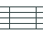
Some folks would say the bar is where you play, but they don't read music! The bar separates the measures: each measure is contained within two bars.
Note
As mentioned above, our notes will sit on various lines of the staff, indicating which drum we are to play. The type of note will indicate the duration the note will have within our measure. The table below explains the relative values of the notes.
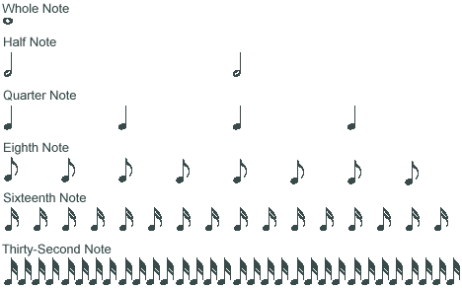
FIG 4: Notes Notation
There are two half notes for every whole note; two quarter notes for every half note; two eighth notes for every quarter note; etc.
If we are dealing with a time signature of "4/4", then the above illustration would be one measure in length. A whole note would take up four beats: "1, 2, 3, 4"; a half note would take up two beats: "1, 2, 3, 4,"; a quarter note would take up four beats: 1, 2, 3, 4".
In order to count notes smaller than quarter notes in our "4/4" example, we need to add some sounds. Four eighth notes, we add "and". Thus, counting 8 eight notes in our measure will sound like this: "1, and, 2, and, 3, and, 4, and".
Counting sixteenth notes involves adding some more sounds: "e, and, ah". Thus, counting 16 sixteenth notes in our "4/4" measure will sound like this (take a deep breath): "1, e, and, ah, 2, e, and, ah, 3, e, and, ah, 4, e, and, ah".
This comes in handy when counting mixed-note measures. I'll get into that below. Just remember that each notes halves the value of the preceeding note.
Repeats
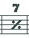
I'll explain all the repeats in the above diagram here. The first Repeat indicates that only one measure is to be played again (this is the measure immediately preceeding the repeat). The number above this indicates how many times the measure is repeated. It's not uncommon for writers to notate a simple rhythm in one measure, then put a repeat with a 7 or other number above the repeat, indicating the drummer is to play the measure seven more times. This is common in show music notation.
The second type of repeat is the Two-Measure Repeat. This works in the same way as the previous repeat, except two measures are being repeated, not one. As in the regular repeat, the number over the repeat indicates how many times the 2 measures are to be repeated.
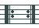
The most common type of repeat if the Multi-Measure Repeat. This is indicated by a thick bar at the end of a multi-measure phrase immediately preceeded by two dots (the one on the right of the two shown). If this is at the end of the staff and no bracketing repeat is shown (the one on the left of the two shown), the piece is repeated from the beginning. If there is a bracketing repeat, the measures repeated are those within the two repeat brackets. Unless indicated, thes repeats are taken only once. It is not uncommon to have a repeat within a longer piece of music - this saves on time writing out repeated notes.
Exercises commonly have a multi-measure repeat at the end. This indicates that the exercise can be repeated ad infinitum to build chops.
Tie

The tie indicates that the two notes tied together are played as one. Thus, two tied quarter notes would be played like a half note. This is commonly done across bar lines and when linking notes of different values.
Ghost
The ghost note indicator (parenthesis) indicates that the note is to be played very quietly, as a ghost. This is common in funk and jazz notation.
Accent

The accent mark indicates that that note is to be played louder than any of the other notes. This technique allows for rhythmic phrasing using dynamics. Very common in ethnic rhythms.
Dynamics
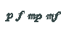
Dynamic markings indicate the volume level of a given passage. p stands for pianissimo, or "softly". f stands for forte, or "loudly". When a letter is preceeded by an m, this means the note is played "moderately softly," or "moderately loudly", thus giving values between p and f. p and f can also be doubled and tripled (pp, ppp, ff, fff), meaning "very softly," or "very, very softly," depending on the usage.

Hand

This is used specifically in drumming notation. When placed over or under a note, it indicates which hand is to strike that note. You will notice these are used in certain exercises to build independence.
End

This solid bar at the end of a staff indicates that this is the end of the piece of music. If the music continues to another staff below or on another page, there will be a regular, thin bar at the end of the staff.
Tempo
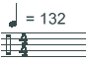
You will often run into this over the beginning of a score. This indicates that the quarter note gets 132 beats per minute. That's really pretty fast, but this is a way for the composer to tell the performer how fast to perform the music. The note indicated here is usually the bottom note of the time signature, so if we were in "6/8" time, we would see an eighth note here.
Rests
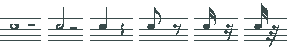
This diagram shows the rests for the given note value. A rest is just what it says: don't play. Note that the eighth, sixteenth, and thirty-second rests are alike, one is added to the previous to indicate its value. As with notes, rests usually rest on the line for the particular voice (drum).
These are the basic notations used in most drumming books.

FIG 5: A Single-bass Drum-set

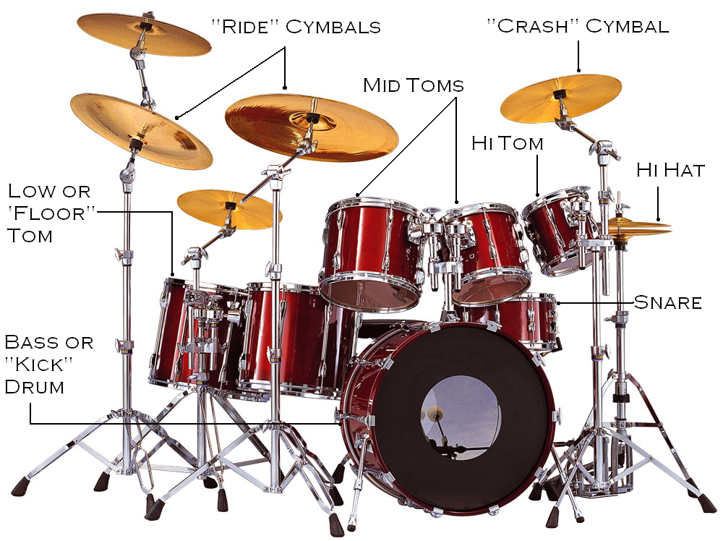

PART 3

JAVA

JAVA’s INTRO

3.1 WHAT IS JAVA?

Java Technology is both a programming language and a platform. Java is originally developed by James Gosling at Sun Microsystems (which is now a subsidiary of Oracle Corporation) and released in 1995 as a core component of Sun Microsystems' Java platform.
Java applications are typically compiled to bytecode (class file) that can run on any Java Virtual Machine (JVM) regardless of computer architecture.
It is intended to let application developers "write once, run anywhere"

Java is currently one of the most popular programming languages in use, and is widely used from application software to web applications.

3.2 HISTORY

James Gosling, Mike Sheridan, and Patrick Naughton initiated the Java language project in June 1991. Java was originally designed for interactive television, but it was too advanced. The language was initially called Oak after an oak tree that stood outside Gosling's office; it went by the name Green later, and was later renamed Java, from a list of random words.
Sun Microsystems released the first public implementation as Java 1.0 in 1995.

Versions Released…
Java = 1.0, 1.02, 1.1
Java2 = 1.2, 1.3, 1.4
Java 5.0 = 1.5 (code name = ‘Tiger’ release)
Java 6 = 1.6

The Java Programming Language is a high level language that can be characterized by following buzzwords:
* Simple
* Object Oriented
* Secure
* Robust
* Distributive
* Dynamic
* Multithreaded
* Architecture neutral
* Portable

3.3 HOW DOES A JAVA PROGRAM GET EXECUTED?

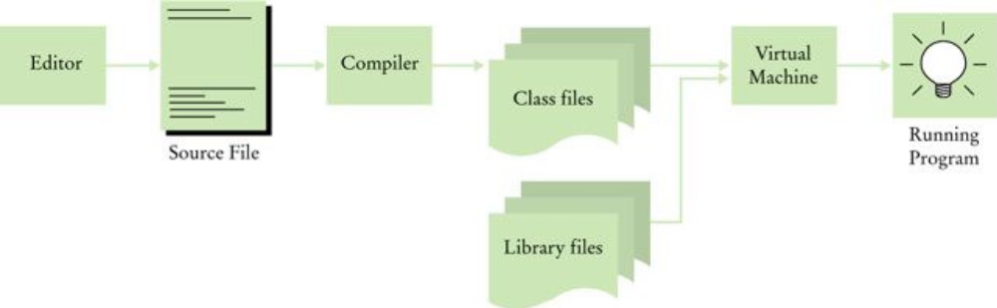

FIG 6: Flow of data in program execution.

In the Java programming Language, all source code is written in plain text files ending with the .java extension. These source files are compiled into .class files by the javac compiler. A .class file does not contain code that is native to your processor; it instead contains bytecodes, the machine language of the Java Virtual Machine (JVM). The java launcher tool then runs your application with an instance of the Java Virtual Machine.

The Java platform differs from most other platforms in that it’s software-only platform that runs on top of other hardware-based platforms.

The Java platform has two categories :
* The Java Virtual Machine
* The Java Application Programming Interface (API)

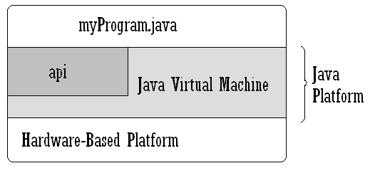FIG 7: Java Platform

NOTE:
1. A Platform is the hardware or software environment in which a program runs. Like some Operating systems.
2. API includes all the classes and interfaces provided by Java (inbuilt).

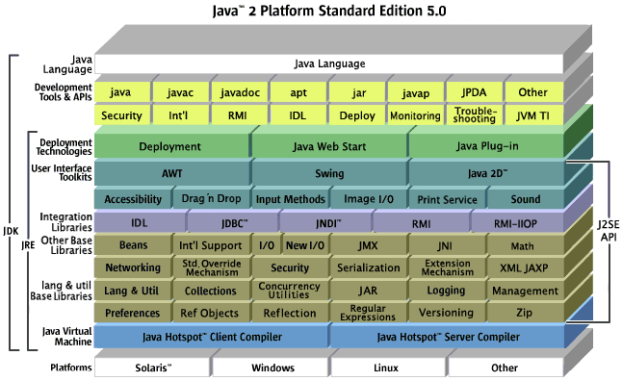

FIG 8: Java’s Platform & API

3.4 WHY I USED MIDI PACKAGE: Design Goals

The JavaTM Sound API is a low-level API for effecting and controlling the input and output of sound media, including both audio and Musical Instrument Digital Interface (MIDI) data. The Java Sound API provides explicit control over the capabilities normally required for sound input and output, in a framework that promotes extensibility and flexibility.

Who is the Java Sound API For?

Because sound is so fundamental, the Java Sound API fulfills the needs of a wide range of application developers. Potential application areas include:

Communication frameworks, such as conferencing and telephony

End-user content delivery systems, such as media players and music using streamed content

Interactive application programs, such as games and Web sites that use dynamic content

Content creation and editing

Tools, toolkits, and utilities

Packages

The Java Sound API includes support for both digital audio and MIDI data. These two major modules of functionality are provided in separate packages:

javax.sound.sampled

This package specifies interfaces for capture, mixing, and playback of digital (sampled) audio.

javax.sound.midi ( This one is used by me).

This package provides interfaces for MIDI synthesis, sequencing, and event transport.

3.4 MIDI
The javax.sound.midi package contains APIs for transporting and sequencing MIDI events, and for synthesizing sound from those events.

What Is MIDI?
Whereas sampled audio is a direct representation of a sound itself, MIDI data can be thought of as a recipe for creating a sound, especially a musical sound. MIDI data, unlike audio data, does not describe sound directly. Instead, it describes events that affect the sound a synthesizer is making. MIDI data is analogous to a graphical user interface's keyboard and mouse events. In the case of MIDI, the events can be thought of as actions upon a musical keyboard, along with actions on various pedals, sliders, switches, and knobs on that musical instrument. These events need not actually originate with a hardware musical instrument; they can be simulated in software, and they can be stored in MIDI files. A program that can create, edit, and perform these files is called a sequencer. Many computer sound cards include MIDI-controllable music synthesizer chips to which sequencers can send their MIDI events. Synthesizers can also be implemented entirely in software. The synthesizers interpret the MIDI events that they receive and produce audio output. Usually the sound synthesized from MIDI data is musical sound (as opposed to speech, for example). MIDI synthesizers are also capable of generating various kinds of sound effects.
Some sound cards include MIDI input and output ports to which external MIDI hardware devices (such as keyboard synthesizers or other instruments) can be connected. From a MIDI input port, an application program can receive events generated by an external MIDI-equipped musical instrument. The program might play the musical performance using the computer's internal synthesizer, save it to disk as a MIDI file, or render it into musical notation. A program might use a MIDI output port to play an external instrument, or to control other external devices such as recording equipment.

PART 4

GUI
(Graphical User Interface)

GUI’s INTRO

4.1 WHAT IS GUI?

Graphical User Interface (GUI) offers a profoundly environment than the step-by-step, linear world of procedural programs. The GUI presents many features all appearing to operate independently and in parallel, even though usually run with a single processor. GUIs match well with the modularity of object oriented languages since many different parts of a GUI can be created as class objects.

In the procedural world, the user simply starts a program & waits for it to churn through its algorithm and eventually stop.

In the GUI environment, the program instead waits for the user to select some task and then it carries out that selected action. (Meanwhile, the processor, which could be physical or a Virtual Machine, will switch frequently to other tasks.)

4.2 HOW A GUI IS IMPLEMENTED IN JAVA?

There are three methods to make a GUI in Java.

- AWT
- Applet
- Swing (Used In project)

AWT (Abstract Window Toolkit)

The Abstract Window Toolkit (AWT) supports Graphical User Interface (GUI) programming. AWT features include:
- A set of native user interface components
- A robust event-handling model
- Graphics and imaging tools, including shape, color, and font classes
- Layout managers, for flexible window layouts that do not depend on a particular window size or screen resolution
- Data transfer classes, for cut-and-paste through the native platform clipboard

DRAWBACK:
When a Java Programmer writes an application using the AWT, they construct the GUI using these AWT components. For example, they might request a button with the
word “Exit” written on it. The Java Virtual Machine takes that request and asks the underlying operating system to draw a native button.

This is because AWT components are called ‘heavy weight components’.
As in the background peer classes (made by Java) do the work of bringing components from the underlying OS.

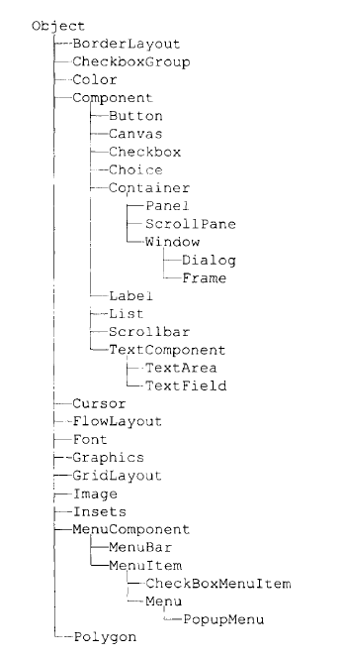FIG 9: AWT classes & interfaces

Applet

Applets can be written using any version of Java – but, the browsers only support a
limited range of Java versions. Users running Internet Explorer version 5, for example
(a very large percentage of the internet population, at the time of writing) will not be
able run Java 1.4 applets.

The solution to this problem is provided by Sun in the form of a “Java Plug In” – this
can be downloaded by the user from Sun, and the functionality of the web browser is
extended to cover the latest version of Java. The flaw in this idea is that the process
requires operator intervention (they will have to agree to the download and plug in
taking place), and worse, it will take a long time for the plug in to download.

DRAWBACK:
A web browser must be installed with Java plug-in also, before you have to run an applet.

SWING

The Swing classes build upon lower level classes of the original AWT (java.awt) graphics packages. The Swing user interface components, which always begin with “J”, extend from the container and Component classes.
The JComponent subclasses are lightweight, so they essentially run within a single heavyweight high level component, such as JFrame and JDialog, and draw and re-draw themselves within Java, no native code peer components involved. Combined with the event handling process, swing components provide a very flexible and elaborate GUI tools.

The Swing classes are built on top of the AWT architecture.

This project uses Swing classes to develop GUI.

PART 5

INTERNALS OF GUI

INTERNALS OF GUI

The Java Platform includes a powerful API for capturing, processing, and playing back audio and MIDI (Musical Instrument Digital Interface) data. This API is supported by an efficient sound engine which guarantees high-quality audio mixing and MIDI synthesis capabilities for the platform.
The provided reference implementation of this API supports the following features:
- Audio file formats: AIFF, AU and WAV
- Music file formats: MIDI Type 0, MIDI Type 1, and Rich Music Format (RMF)
- Sound formats: 8-bit and 16-bit audio data, in mono and stereo, with sample rates from 8 kHz to 48 kHz
- Linear, a-law, and mu-law encoded data in any of the supported audio file formats
- MIDI wavetable synthesis and sequencing in software, and access to hardware MIDI devices
- An all-software mixer that can mix and render up to 64 total channels of digital audio and synthesized MIDI music
The above list describes the reference implementation, not the API itself. The API permits flexible configuration of the audio and MIDI system, including ways for applications to ask the system exactly what resources are installed and available.

5.1 EXPLANATIONS for Package javax.sound.midi

Package javax.sound.midi
Provides interfaces and classes for I/O, sequencing, and synthesis of MIDI (Musical Instrument Digital Interface) data.

Interface Summary
ControllerEventListener | The ControllerEventListener interface should be implemented by classes whose instances need to be notified when a Sequencer has processed a requested type of MIDI control-change event.
MetaEventListener | The MetaEventListener interface should be implemented by classes whose instances need to be notified when a Sequencer has processed a MetaMessage.
MidiChannel | A MidiChannel object represents a single MIDI channel.
MidiDevice | MidiDevice is the base interface for all MIDI devices.
Receiver | A Receiver receives MidiEvent objects and typically does something useful in response, such as interpreting them to generate sound or raw MIDI output.
Sequencer | A hardware or software device that plays back a MIDI sequence is known as a sequencer.
Soundbank | A Soundbank contains a set of Instruments that can be loaded into a Synthesizer.
Synthesizer | A Synthesizer generates sound.
Transmitter | A Transmitter sends MidiEvent objects to one or more Receivers.

Class Summary
Instrument | An instrument is a sound-synthesis algorithm with certain parameter settings, usually designed to emulate a specific real-world musical instrument or to achieve a specific sort of sound effect.
MetaMessage | A MetaMessage is a MidiMessage that is not meaningful to synthesizers, but that can be stored in a MIDI file and interpreted by a sequencer program.
MidiDevice.Info | A MidiDevice.Info object contains assorted data about a MidiDevice, including its name, the company who created it, and descriptive text.
MidiEvent | MIDI events contain a MIDI message and a corresponding time-stamp expressed in ticks, and can represent the MIDI event information stored in a MIDI file or a Sequence object.
MidiFileFormat | A MidiFileFormat object encapsulates a MIDI file's type, as well as its length and timing information.
MidiMessage | MidiMessage is the base class for MIDI messages.
MidiSystem | The MidiSystem class provides access to the installed MIDI system resources, including devices such as synthesizers, sequencers, and MIDI input and output ports.
Patch | A Patch object represents a location, on a MIDI synthesizer, into which a single instrument is stored (loaded).
Sequence | A Sequence is a data structure containing musical information (often an entire song or composition) that can be played back by aSequencer object.
Sequencer.SyncMode | A SyncMode object represents one of the ways in which a MIDI sequencer's notion of time can be synchronized with a master or slave device.
ShortMessage | A ShortMessage contains a MIDI message that has at most two data bytes following its status byte.
SoundbankResource | A SoundbankResource represents any audio resource stored in a Soundbank.
SysexMessage | A SysexMessage object represents a MIDI system exclusive message.
Track | A MIDI track is an independent stream of MIDI events (time-stamped MIDI data) that can be stored along with other tracks in a standard MIDI file.
VoiceStatus | A VoiceStatus object contains information about the current status of one of the voices produced by a Synthesizer.

Exception Summary
InvalidMidiDataException | An InvalidMidiDataException indicates that inappropriate MIDI data was encountered.
MidiUnavailableException | A MidiUnavailableException is thrown when a requested MIDI component cannot be opened or created because it is unavailable.

Interface Sequencer
All Superinterfaces:
MidiDevice

public interface Sequencer
extends MidiDevice
A hardware or software device that plays back a MIDI sequence is known as a sequencer. A MIDI sequence contains lists of time-stamped MIDI data, such as might be read from a standard MIDI file. Most sequencers also provide functions for creating and editing sequences.
The Sequencer interface includes methods for the following basic MIDI sequencer operations:
- obtaining a sequence from MIDI file data
- starting and stopping playback
- moving to an arbitrary position in the sequence
- changing the tempo (speed) of playback
- synchronizing playback to an internal clock or to received MIDI messages
- controlling the timing of another device

Interface Soundbank

public interface Soundbank
A Soundbank contains a set of Instruments that can be loaded into a Synthesizer. Note that a Java Sound Soundbank is different from a MIDI bank. MIDI permits up to 16383 banks, each containing up to 128 instruments (also sometimes called programs, patches, or timbres). However, a Soundbank can contain 16383 times 128 instruments, because the instruments within a Soundbank are indexed by both a MIDI program number and a MIDI bank number (via a Patch object). Thus, aSoundbank can be thought of as a collection of MIDI banks.
Soundbank includes methods that return String objects containing the sound bank's name, manufacturer, version number, and description. The precise content and format of these strings is left to the implementor.

Class MidiEvent
java.lang.Object
javax.sound.midi.MidiEvent

public class MidiEvent
extends Object
MIDI events contain a MIDI message and a corresponding time-stamp expressed in ticks, and can represent the MIDI event information stored in a MIDI file or aSequence object. The duration of a tick is specified by the timing information contained in the MIDI file or Sequence object.
In Java Sound, MidiEvent objects are typically contained in a Track, and Tracks are likewise contained in a Sequence.

Class MidiSystem
java.lang.Object
javax.sound.midi.MidiSystem

public class MidiSystem
extends Object
The MidiSystem class provides access to the installed MIDI system resources, including devices such as synthesizers, sequencers, and MIDI input and output ports. A typical simple MIDI application might begin by invoking one or more MidiSystem methods to learn what devices are installed and to obtain the ones needed in that application.
The class also has methods for reading files, streams, and URLs that contain standard MIDI file data or soundbanks. You can query the MidiSystem for the format of a specified MIDI file.
You cannot instantiate a MidiSystem; all the methods are static.
Properties can be used to specify default MIDI devices. Both system properties and a properties file are considered. The properties file is "lib/sound.properties" in the JRE directory. If a property exists both as a system property and in the properties file, the system property takes precedence. If none is specified, a suitable default is chosen among the available devices. The syntax of the properties file is specified in Properties.load. The following table lists the available property keys and which methods consider them:
Property Key | Interface | Affected Method
javax.sound.midi.Receiver | Receiver | getReceiver()
javax.sound.midi.Sequencer | Sequencer | getSequencer()
javax.sound.midi.Synthesizer | Synthesizer | getSynthesizer()
javax.sound.midi.Transmitter | Transmitter | getTransmitter()
The property value consists of the provider class name and the device name, separated by the hash mark ("#"). The provider class name is the fully-qualified name of a concrete MIDI device provider class. The device name is matched against the String returned by the getName method of MidiDevice.Info. Either the class name, or the device name may be omitted. If only the class name is specified, the trailing hash mark is optional.
If the provider class is specified, and it can be successully retrieved from the installed providers, the list of MidiDevice.Info objects is retrieved from the provider. Otherwise, or when these devices do not provide a subsequent match, the list is retrieved from getMidiDeviceInfo() to contain all available MidiDevice.Info objects.

Class Sequence
java.lang.Object
javax.sound.midi.Sequence

public class Sequence
extends Object
A Sequence is a data structure containing musical information (often an entire song or composition) that can be played back by a Sequencer object. Specifically, theSequence contains timing information and one or more tracks. Each track consists of a series of MIDI events (such as note-ons, note-offs, program changes, and meta-events). The sequence's timing information specifies the type of unit that is used to time-stamp the events in the sequence.
A Sequence can be created from a MIDI file by reading the file into an input stream and invoking one of the getSequence methods of MidiSystem. A sequence can also be built from scratch by adding new Tracks to an empty Sequence, and adding MidiEvent objects to these Tracks.

Class ShortMessage
java.lang.Object
javax.sound.midi.MidiMessage
javax.sound.midi.ShortMessage

All Implemented Interfaces:
Cloneable

public class ShortMessage
extends MidiMessage
A ShortMessage contains a MIDI message that has at most two data bytes following its status byte. The types of MIDI message that satisfy this criterion are channel voice, channel mode, system common, and system real-time--in other words, everything except system exclusive and meta-events. The ShortMessage class provides methods for getting and setting the contents of the MIDI message.

A number of ShortMessage methods have integer parameters by which you specify a MIDI status or data byte. If you know the numeric value, you can express it directly. For system common and system real-time messages, you can often use the corresponding fields of ShortMessage, such as SYSTEM_RESET. For channel messages, the upper four bits of the status byte are specified by a command value and the lower four bits are specified by a MIDI channel number. To convert incoming MIDI data bytes that are in the form of Java's signed bytes, you can use the conversion code given in the MidiMessage class description.

Class Track
java.lang.Object
javax.sound.midi.Track

public class Track
extends Object

A MIDI track is an independent stream of MIDI events (time-stamped MIDI data) that can be stored along with other tracks in a standard MIDI file. The MIDI specification allows only 16 channels of MIDI data, but tracks are a way to get around this limitation. A MIDI file can contain any number of tracks, each containing its own stream of up to 16 channels of MIDI data.

A Track occupies a middle level in the hierarchy of data played by a Sequencer: sequencers play sequences, which contain tracks, which contain MIDI events. A sequencer may provide controls that mute or solo individual tracks.

The timing information and resolution for a track is controlled by and stored in the sequence containing the track. A given Track is considered to belong to the particular Sequence that maintains its timing. For this reason, a new (empty) track is created by calling the Sequence.createTrack() method, rather than by directly invoking a Track constructor.

The Track class provides methods to edit the track by adding or removing MidiEvent objects from it. These operations keep the event list in the correct time order. Methods are also included to obtain the track's size, in terms of either the number of events it contains or its duration in ticks.

5.2 How does the GUI play ?

Sequencers play >> Sequences
Sequences contain >> Tracks
Tracks contain >> MIDI Events

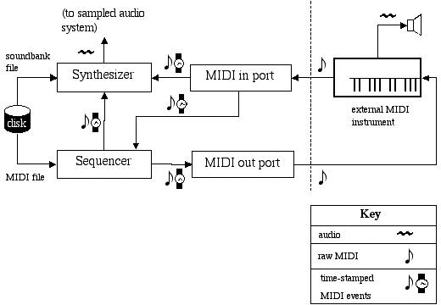

FIG 10: Inter Communication through Various ports of MIDI system, h/w & s/w devices.

5.3 SUMMING UP THE PROCESS INVOLVED IN GUI

Integrating it …

1. We’ll take access to installed MIDI system resources such as synthesizers, sequencers and MIDI i/p & o/p ports.(Through MIDI System).

2. Create a sequence, pass the track made to it (containing MIDI events).

3. Connect this sequence (through transmitter instance) to the installed sequencer, which looks up for the MIDI events from its personal soundbank (or by default get connected to default reciever).

4. Start the sequencer, it starts playing the sequence.

5. Choose to listen to it, increase/decrease tempo or send it to some network or over a file system.
6. Have Fun !

PART 6

SOFTWARE REQUIREMENT SPECIFICATION

SRS : INTRODUCTION

6.1.1 Purpose
The purpose of this document is to specify the software requirement specifications to develop the Virtual Drum-set. This document outlines a brief description about what functions are to be performed on what data to produce what results at what location for whom.

6.1.2 Scope
This document specifies software requirement specifications for Virtual Drum-set. This has been achieved through developing Use Case Diagrams for each function and for the system as a whole using Prototyping model. It is intended for musicians as well as layman to compose various musical pieces according to their propelling ideas. It uses an easy and understandable interface to compose a maximum 16-beat pattern. The values can be assigned by the user as needed and previewed.

6.1.3 References

Websites :
- http://www.wikipedia.com
- http://www.google.com
- http://www.java.sun.com

References book :
- Java 2 - The Complete Reference, Herbert Schildt

6.5Overall Descriptions

6.2.1 User Interfaces
The application will have a user-friendly interface with abilities provided for easy navigation so that :
- Users can view the various notes and hear them.
- They can go back to main screen when possible.
- User can exit application when possible.

6.2.2 Hardware Interfaces
- 1 GB RAM
- 1.8 GHz Pentium processor
- 60 GB Hard drive(including OS)
- Sound Card

6.2.3 Software Requirements
Software to be used :
- Java Development Kit (version JDK 1.5 or higher) installed.
Languages to be used
- Java
6.2.4 Memory Constraints
At least 1 GB RAM will be required for running the software on Java efficiently.
6.2.5 User Characteristics
- Education level: End user with basic musical knowledge.
- Technical expertise: Should be comfortable using a computer.

SYSTEm DESIGN

SYSTEM DESIGN
4.1. CONTEXT DIAGRAM
A context diagram is a data flow diagram, with only one massive central process that subsumes everything inside the scope of the system. It shows how the system will receive and send data flows to the external entities involved.

Chooses Values
Data Transferred
VIRTUAL DRUMSET
USER
Computer storage

Data Retrieved
Response

Fig11: Context diagram

4.2. ENTITY RELATIONSHIP DIAGRAM
An entity-relationship (ER) diagram is a specialized graphic that illustrates the interrelationships between entities in a database. ER diagrams often use symbols to represent three different types of information. Boxes are commonly used to represent entities. Diamonds are normally used to represent relationships and ovals are used to represent attributes.

4.2.1
VIRTUAL DRUMSET

Is used by

The USER

Fig4.2:ER Diagram

4.2.2.
Select a function

THE USER
CHOOSESTO LEAVE
PLAYS A RANDOM FILE

PLAYS A RANDOM FILE
CHOOSES THE VALUES FOR bEATS
Creates the FILE
PLAYS THE FILE
CHANGES IT’S TEMPO
STOPS & PLAYS IT
EDITS IT WHILE PLAYING IT
STARTS AGAIN

STOPS THE SEQUENCE

CLOSES THE WINDOW

4.4. DATA FLOW DIAGRAM
This level (level 1) shows all processes at the first level of numbering, data stores, external entities and the data flows between them. The purpose of this level is to show the major high-level processes of the system and their interrelation.

user
1
Create a drum pattern
2
Plays , Stop the sequence
D1
Temporary storage
D2
Quits

RESULTS

The results that were obtained at the end of this project were as follows
- The project works effectively at different platforms, hence platform independency is achieved.
- The patterns that have been played are accurate to 95%.
- A Sequence can be played back for the user when requested.
- The project can be used as a innovative machine that generate new ideas.
- Time of resolution (Ticks per beat) =4.
- Tempo used, BPM, Beats per minute = 120.
- Tempo based Timing uses PPQ, Pulses per Quarter note.

