Privacy Policy
Privacy Policy
- Download PDF
- Download PDF

  - 1. Information You Share With Us
  - 2. Additional Information We Recieve About You
  - 3. Information We Share and Disclose
  - 4. Managing Your Personal Information With Us
  - 5. Children and Our Services
  - 6. Our Global Operations and Privacy Shield
  - 7. Changes to This Privacy Policy
  - Download PDF
We have made revisions to this Privacy Policy, effective May 25th, 2018. You can see the new version here. By continuing to use our services after May 25th, you agree to the new Privacy Policy. A summary of changes can be found on our Help Center.

Twitter Privacy Policy
Our Services instantly connect people everywhere to what's most meaningful to them. For example, any registered user of Twitter can send a Tweet, which is public by default, and can include a message of 140 characters or less and content like photos, videos, and links to other websites.
What you share on Twitter may be viewed all around the world instantly. You are what you Tweet!
This Privacy Policy describes how and when we collect, use, and share your information across our websites, SMS, APIs, email notifications, applications, buttons, embeds, ads, and our other covered services that link to this Policy (collectively, the “Services”), and from our partners and other third parties. For example, you send us information when you use our Services on the web, via SMS, or from an application such as Twitter for Mac, Twitter for Android, or TweetDeck. When using any of our Services you consent to the collection, transfer, storage, disclosure, and use of your information as described in this Privacy Policy. This includes any information you choose to provide that is deemed sensitive under applicable law.
When this policy mentions “we” or “us,” it refers to the controller of your information under this policy. If you live in the United States, your information is controlled by Twitter, Inc., 1355 Market Street, Suite 900, San Francisco, CA 94103 U.S.A. If you live outside the United States, the data controller responsible for your information is Twitter International Company, an Irish company with its registered office at One Cumberland Place, Fenian Street, Dublin 2 D02 AX07 Ireland. Despite this, you alone control and are responsible for the posting of your Tweets and other content you submit through the Services, as provided in the Terms of Service and Twitter Rules.
Irrespective of which country you live in, you authorize us to transfer, store, and use your information in the United States, Ireland, and any other country where we operate. In some of these countries, the privacy and data protection laws and rules regarding when government authorities may access data may vary from those in the country where you live. Learn more about our global operations and data transfer here.
If you have any questions or comments about this Privacy Policy, please submit a request through our form, available at https://support.twitter.com/forms/privacy.

Information Collection and Use
We collect and use your information below to provide, understand, and improve our Services.
Basic Account Information: If you choose to create a Twitter account, you must provide us with some personal information, such as your name, username, password, email address, or phone number. On Twitter, your name and username are always listed publicly, including on your profile page and in search results, and you can use either your real name or a pseudonym. You can create and manage multiple Twitter accounts. If you use Digits by Twitter, the contact information you provide to log in is not public. Some of our product features, such as searching and viewing public Twitter user profiles or watching a broadcast on Periscope’s website, do not require you to create an account.
Contact Information: You may use your contact information, such as your email address or phone number, to customize your account or enable certain account features, for example, forlogin verification or Twitter via SMS. If you provide us with your phone number, you agree to receive text messages to that number from us. We may use your contact information to send you information about our Services, to market to you, to help prevent spam, fraud, or abuse, and to help others find your account, including through third-party services and client applications. You may use your settings for email and mobile notifications to control notifications you receive from Twitter. You may also unsubscribe from a notification by following the instructions contained within the notification or the instructions on our website. Your Discoverability privacy settings control whether others can find you on Twitter by your email address or phone number.
Additional Information: You may choose to provide us with additional information to help improve and personalize your experience across our Services. For example, you may choose to upload and sync your address book so that we can help you find and connect with users you know or help other users find and connect with you. We may later personalize content, such as making suggestions or showing user accounts and Tweets for you and other users, based on imported address book contacts. You can delete your imported address book contacts at any time by visiting your Contacts Dashboard at https://twitter.com/settings/contacts_dashboard. If you email us, we may keep your message, email address, and contact information to respond to your request. If you connect your account on our Services to your account on another service, the other service may send us information that you authorize for use in the Services. This information may enable cross-posting or otherwise help us improve the Services, and is deleted from our Services within a few weeks of your disconnecting from our Services your account on the other service.
Tweets, Following, Lists, Profile, and Other Public Information: Twitter is primarily designed to help you share information with the world. Most of the information you provide us through Twitter is information you are asking us to make public. You may provide us with profile information such as a short biography, your location, your website, date of birth, or a picture. Additionally, your public information includes the messages you Tweet; the metadata provided with Tweets, such as when you Tweeted and the client application you used to Tweet; information about your account, such as creation time, language, country, and time zone; and the lists you create, people you follow, Tweets you Like or Retweet, and Periscope broadcasts you click or otherwise engage with (such as by commenting or hearting) on Twitter. Twitter broadly and instantly disseminates your public information to a wide range of users, customers, and services, including search engines, developers, and publishers that integrate Twitter content into their services, and organizations such as universities, public health agencies, and market research firms that analyze the information for trends and insights. When you share information or content like photos, videos, and links via the Services, you should think carefully about what you are making public. We may use this information to make inferences, like what topics you may be interested in. Our default is almost always to make the information you provide through the Services public for as long as you do not delete it, but we generally give you settings or features, like protected Tweets, to make the information more private if you want. For certain profile information fields we provide you with visibility settings to select who can see this information in your profile. If you provide us with profile information and you don’t see a visibility setting, that information is public. You can change the language and time zone associated with your account at any time using your account settings, available at https://twitter.com/settings/account.
Direct Messages and Non-Public Communications: We provide certain features that allow you to communicate more privately. For example, you can use Direct Messages to have private conversations with other Twitter users. When you privately communicate with others through our Services, such as by sending and receiving Direct Messages, we will store and process your communications, and information related to them. Please note that if you interact with public Twitter content shared with you via Direct Message, for instance by liking a Tweet shared via Direct Message, those interactions may be public. When you use features like Direct Messages to communicate privately, please remember that recipients may copy, store, and re-share the contents of your communications.
Location Information: We may receive information about your location. For example, you may choose to publish your location in your Tweets and in your Twitter profile. You may also tell us your location when you set your trend location on Twitter.com. We may also determine location by using other data from your device, such as precise location information from GPS, information about wireless networks or cell towers near your mobile device, or your IP address. We may use and store information about your location to provide features of our Services, such as allowing you to Tweet with your location, and to improve and customize the Services, for example, with more relevant content like local trends, stories, ads, and suggestions for people to follow. Learn more about our use of location here, and how to set your location preferences here.
Links: We may keep track of how you interact with links across our Services, including our email notifications, third-party services, and client applications, by redirecting clicks or through other means. We do this to help improve our Services, to provide more relevant advertising, and to be able to share aggregate click statistics such as how many times a particular link was clicked on. Links, Tweets, and non-public communications like Direct Messages shared on the Services will be processed and links shortened to a http://t.co link.
Cookies: Like many websites, we use cookies and similar technologies to collect additional website usage data and to improve our Services, but we do not require cookies for many parts of our Services such as searching and looking at public user profiles. A cookie is a small data file that is transferred to your computer or mobile device. We may use both session cookies and persistent cookies to better understand how you interact with our Services, to monitor aggregate usage by our users and web traffic routing on our Services, and to customize and improve our Services. Although most web browsers automatically accept cookies, some browsers’ settings can be modified to decline cookies or alert you when a website is attempting to place a cookie on your computer. However, some Services may not function properly if you disable cookies. You can control how we personalize your Twitter experience and ads by using your Personalization and Data settings, which are available at https://twitter.com/personalization whether or not you have a Twitter account. We respond to these settings rather than the Do Not Track browser option, which we no longer support. Learn more about how we use cookies and similar technologies here.
Using Our Services: We receive information when you view content on or otherwise interact with our Services, even if you have not created an account (“Log Data”). For example, when you visit our websites, sign into our Services, interact with our email notifications, use your account to authenticate to a third-party website, application, or service, or visit a third-party website, application, or service that includes Twitter content, we may receive information about you. This Log Data may include your IP address, browser type, operating system, the referring web page, pages visited, location, your mobile carrier, device information (including device and application IDs), search terms, or cookie information. We also receive Log Data when you click on, view or interact with links on our Services, including links to third-party applications, such as when you choose to install another application through Twitter. We use Log Data to make inferences, like what topics you may be interested in, and to customize the content we show you, including ads. You can learn about the interests we have inferred about you from your activity on and off of Twitter in Your Twitter Data, available at https://twitter.com/your_twitter_data. We keep Log Data as needed for the purposes described in this Privacy Policy. We will either delete Log Data or remove any common account identifiers, such as your username, full IP address, email address, or phone number, after a maximum of 18 months, if not sooner.
Twitter for Web Data: We may personalize the Services for you based on your visits to third-party websites that integrate Twitter content such as embedded timelines or Tweet buttons. When you view our content on these websites, we may receive Log Data that includes the web page you visited. We never associate this web browsing history with your name, email address, phone number, or Twitter handle, and we delete, obfuscate, or aggregate it after no longer than 30 days. We may use interests or other information that we derive from this data to improve our Services and personalize content for you, such as suggestions for people to follow, advertising, and other content you may be interested in. You can see and control interests that we use to personalize your experience in Your Twitter Data, available at https://twitter.com/your_twitter_data. You can also control whether we keep track of your visits to websites with Twitter content by using your Personalization and Data settings, available at https://twitter.com/personalization.
Advertising: Our Services are supported by advertising. We may use the information described in this Privacy Policy to help make our advertising more relevant to you, to measure its effectiveness, and to help recognize your devices to serve you ads on and off of Twitter. We do not use the content you share privately in Direct Messages to serve you ads. Our Twitter Ads Policy also prohibits advertisers from targeting ads based on categories we consider sensitive, such as race, religion, politics, sex life, or health. Twitter adheres to the Digital Advertising Alliance Self-Regulatory Principles for Online Behavioral Advertising (also referred to as “interest-based advertising”). If you prefer, you can opt out of interest-based advertising by unchecking Personalize Ads in your Personalization and Data settings, available at https://twitter.com/personalization or through the DAA’s consumer choice tool at https://optout.aboutads.info. We will not use information from the browser (and for logged in users, the account) on which you opt out for interest-based advertising, and that browser or account will not be eligible to receive interest-based ads from Twitter. Learn more about your privacy options for interest-based ads here and about how ads work on our Services here.
Third-Parties and Affiliates: We may receive information about you from third parties, such as other Twitter users, partners (including ad partners), or our corporate affiliates. For example, other users may share or disclose information about you, such as when they mention you, share a photo of you, or tag you in a photo. Your privacy settings control who can tag you in a photo. Our ad partners and affiliates may share information with us such as a browser cookie ID, mobile device ID, or cryptographic hash of an email address, as well as demographic or interest data and content viewed or actions taken on a website or app. Our ad partners, particularly our advertisers, may enable us to collect similar information directly from their website or app by integrating our advertising technology.
Personalizing Across Your Devices: When you log into your account with a browser or device, we will associate that browser or device with your account for purposes such as authentication and personalization. Depending on your settings, we may also personalize your experience on, and based on information from, other browsers or devices besides the ones you use to log into Twitter. For example, if you visit websites with sports content on your laptop, we may show you sports-related ads on Twitter for Android. You can control whether we link your account to browsers or devices other than the ones you use to log into Twitter (or if you’re logged out, whether we link the browser or device you’re currently using to any other devices) through your Personalization and Data settings, available at https://twitter.com/personalization.

Information Sharing and Disclosure
We do not disclose your private personal information except in the limited circumstances described here.
User Consent or Direction: We may share or disclose your information at your direction, such as when you authorize a third-party web client or application to access your account or when you direct us to share your feedback with a business. When you use Digits by Twitter to sign up for or log in to a third-party application, you are directing us to share your contact information, such as your phone number, with that application. If you’ve shared information, like Direct Messages or protected Tweets, with another user who accesses Twitter through a third-party service, keep in mind that the information may be shared with the third-party service.
Service Providers: We engage service providers to perform functions and provide services to us in the United States, Ireland, and other countries. For example, we use a variety of third-party services to help provide our Services, such as hosting our various blogs and wikis, and to help us understand and improve the use of our Services, such as Google Analytics. We may share your private personal information with such service providers subject to obligations consistent with this Privacy Policy and any other appropriate confidentiality and security measures, and on the condition that the third parties use your private personal data only on our behalf and pursuant to our instructions. We share your payment information, including your credit or debit card number, card expiration date, CVV code, and billing address with payment services providers to process payments; prevent, detect and investigate fraud or other prohibited activities; facilitate dispute resolution such as chargebacks or refunds; and for other purposes associated with the acceptance of credit or debit cards.
Law and Harm: Notwithstanding anything to the contrary in this Privacy Policy, we may preserve or disclose your information if we believe that it is reasonably necessary to comply with a law, regulation, legal process, or governmental request; to protect the safety of any person; to address fraud, security or technical issues; or to protect our or our users’ rights or property. However, nothing in this Privacy Policy is intended to limit any legal defenses or objections that you may have to a third party’s, including a government’s, request to disclose your information.
Business Transfers and Affiliates: In the event that we are involved in a bankruptcy, merger, acquisition, reorganization or sale of assets, your information may be sold or transferred as part of that transaction. This Privacy Policy will apply to your information as transferred to the new entity. We may also disclose information about you to our corporate affiliates in order to help provide, understand, and improve our Services and our affiliates’ services, including the delivery of ads.
Public Information: We may share or disclose your public information, such as your public user profile information, public Tweets, or the people you follow or that follow you. Remember: your privacy and visibility settings control whether your Tweets and certain profile information are made public. Other information, like your name and username, is always public on Twitter, unless you delete your account, as described below.
Non-Personal, Aggregated, or Device-Level Information: We may share or disclose non-personal, aggregated, or device-level information such as the total number of times people engaged with a Tweet, the number of users who clicked on a particular link or voted on a poll in a Tweet (even if only one did), the characteristics of a device or its user when it is available to receive an ad, the topics that people are Tweeting about in a particular location, or aggregated or device-level reports to advertisers about users who saw or clicked on their ads. This information does not include your name, email address, phone number, or Twitter handle. We may, however, share non-personal, aggregated, or device-level information through partnerships with entities that may use data in their possession (including data you may have given them) to link your name, email address, or other personal information to the information we provide them. These partnerships require that they get your consent before doing so. You can control whether Twitter shares your information under these partnerships by using your Personalization and Data settings, available at https://twitter.com/personalization.

Accessing and Modifying Your Personal Information
If you are a registered user of our Services, we provide you with tools and account settings to access, correct, delete, or modify the personal information you provided to us and associated with your account. You can download certain account information, including your Tweets, by following the instructions here. You can learn more about the interests we have inferred about you in Your Twitter Data and request access to additional information here.
You can also permanently delete your Twitter account. If you follow the instructions here, your account will be deactivated and then deleted. When deactivated, your account, including your name, username, and public profile, is not viewable on Twitter.com. For up to 30 days after deactivation it is still possible to restore your account if it was accidentally or wrongfully deactivated. Absent a separate arrangement between you and us to extend your deactivation period, after 30 days, we begin the process of deleting your account from our systems, which can take up to a week.
Keep in mind that search engines and other third parties may still retain copies of your public information, like your user profile information and public Tweets, even after you have deleted the information from the Twitter Services or deactivated your account. Learn more here.

Our Global Operations
To bring you the Services, we operate globally. Twitter, Inc. complies with the EU-US and Swiss-US Privacy Shield principles (the “Principles”) regarding the collection, use, sharing, and retention of personal information from the European Union and Switzerland, as described in our EU-US Privacy Shield certification and Swiss-US Privacy Shield certification.
If you have a Privacy Shield-related complaint, please contact us here. As part of our participation in Privacy Shield, if you have a dispute with us about our adherence to the Principles, we will seek to resolve it through our internal complaint resolution process, alternatively through the independent dispute resolution body JAMS, and under certain conditions, through the Privacy Shield arbitration process.
Privacy Shield participants are subject to the investigatory and enforcement powers of the US Federal Trade Commission and other authorized statutory bodies. Under certain circumstances, participants may be liable for the transfer of personal information from the EU or Switzerland to third parties outside the EU and Switzerland. Learn more about the EU-US Privacy Shield and Swiss-US Privacy Shield here.

Changes to this Policy
We may revise this Privacy Policy from time to time. The most current version of the policy will govern our use of your information and will always be at https://twitter.com/privacy. If we make a change to this policy that, in our sole discretion, is material, we will notify you via an @Twitter update or email to the email address associated with your account. By continuing to access or use the Services after those changes become effective, you agree to be bound by the revised Privacy Policy.
Effective: June 18, 2017
Archive of Previous Privacy Policies
Thoughts or questions about this Privacy Policy? Please, let us know by contacting us here or writing to us at the appropriate address below.
For accounts based in the United States:
Twitter, Inc.
Attn: Privacy Policy Inquiry
1355 Market Street, Suite 900
San Francisco, CA 94103
For accounts outside the United States:
Twitter International Company
Attn: Privacy Policy Inquiry
One Cumberland Place, Fenian Street
Dublin 2, D02 AX07 IRELAND

Twitter Privacy Policy
We believe you should always know what data we collect from you and how we use it, and that you should have meaningful control over both. We want to empower you to make the best decisions about the information that you share with us.
That’s the basic purpose of this Privacy Policy.
You should read this policy in full, but here are a few key things we hope you take away from it:
Twitter is public and Tweets are immediately viewable and searchable by anyone around the world. We give you non-public ways to communicate on Twitter too, through protected Tweets and Direct Messages. You can also use Twitter under a pseudonym if you prefer not to use your name.
When you use Twitter, even if you’re just looking at Tweets, we receive some personal information from you like the type of device you’re using and your IP address. You can choose to share additional information with us like your email address, phone number, address book contacts, and a public profile. We use this information for things like keeping your account secure and showing you more relevant Tweets, people to follow, events, and ads.
We give you control through your settings to limit the data we collect from you and how we use it, and to control things like account security, marketing preferences, apps that can access your account, and address book contacts you’ve uploaded to Twitter. You can also always download the information you have shared on Twitter.
In addition to information you share with us, we use your Tweets, content you’ve read, Liked, or Retweeted, and other information to determine what topics you’re interested in, your age, the languages you speak, and other signals to show you more relevant content. We give you transparency into that information, and you can modify or correct it at any time.
If you have questions about this policy, how we collect or process your personal data, or anything else related to our privacy practices, we want to hear from you. You can contact us at any time.

1

Information You Share With Us
We require certain information to provide our services to you. For example, you must have an account in order to upload or share content on Twitter. When you choose to share the information below with us, we collect and use it to operate our services.

- Basic Account Information
- Public Information
- Contact Information and Address Books
- Direct Messages and Non-Public Communications
- Payment Information
- How You Control the Information You Share With Us

- Basic Account Information
- Public Information
- Contact Information and Address Books
- Direct Messages and Non-Public Communications
- Payment Information
- How You Control the Information You Share With Us

1.1

Basic Account Information
You don’t have to create an account to use some of our service features, such as searching and viewing public Twitter profiles or watching a broadcast on Periscope’s website. If you do choose to create an account, you must provide us with some personal data so that we can provide our services to you. On Twitter this includes a display name (for example, “Twitter Moments”), a username (for example, @TwitterMoments), a password, and an email address or phone number. Your display name and username are always public, but you can use either your real name or a pseudonym. You can also create and manage multiple Twitter accounts, for example to express different parts of your identity.
pageReference: /content/twitter-com/legal/en/privacy/chapter-1/chapter-1-1
Content:

The many sides of you
Let your imagination run free. Explore your interests with a number of different identities.
Close tooltip

1.2

Public Information
Most activity on Twitter is public, including your profile information, your time zone and language, when you created your account, and your Tweets and certain information about your Tweets like the date, time, and application and version of Twitter you Tweeted from. You also may choose to publish your location in your Tweets or your Twitter profile. The lists you create, people you follow and who follow you, and Tweets you Like or Retweet are also public. Periscope broadcasts you create, click on, or otherwise engage with, either on Periscope or on Twitter, are public along with when you took those actions. So are your hearts, comments, the number of hearts you’ve received, which accounts you are a Superfan of, and whether you watched a broadcast live or on replay. Any hearts, comments, or other content you contribute to another account’s broadcast will remain part of that broadcast for as long as it remains on Periscope. Information posted about you by other people who use our services may also be public. For example, other people may tag you in a photo (if your settings allow) or mention you in a Tweet.
You are responsible for your Tweets and other information you provide through our services, and you should think carefully about what you make public, especially if it is sensitive information. If you update your public information on Twitter, such as by deleting a Tweet or deactivating your account, we will reflect your updated content on Twitter.com, Twitter for iOS, and Twitter for Android.
In addition to providing your public information to the world directly on Twitter, we also use technology like application programming interfaces (APIs) and embeds to make that information available to websites, apps, and others for their use - for example, displaying Tweets on a news website or analyzing what people say on Twitter. We generally make this content available in limited quantities for free and charge licensing fees for large-scale access. We have standard terms that govern how this data can be used, and a compliance program to enforce these terms. But these individuals and companies are not affiliated with Twitter, and their offerings may not reflect updates you make on Twitter. For more information about how we make public data on Twitter available to the world, visit https://developer.twitter.com.
pageReference: /content/twitter-com/legal/en/privacy/chapter-1/chapter-1-2
Content:

Hello, World
Your profile information is displayed under your photo and username on your profile page.
Close tooltip

Keep a low profile
Friend want to tag you in a photo? Lucky you. If you’re not into that sort of thing, you can always change your settings.
Close tooltip
Close

Think carefully
What you Tweet becomes instantly public worldwide on Twitter, and can appear on other media like websites, newspapers, or television.
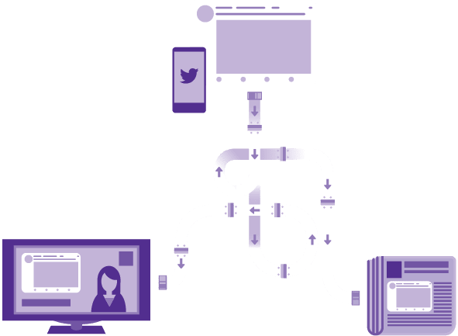

1.3

Contact Information and Address Books
We use your contact information, such as your email address or phone number, to authenticate your account and keep it - and our services - secure, and to help prevent spam, fraud, and abuse. We also use contact information to personalize our services, enable certain account features (for example, forlogin verification or Twitter via SMS), and to send you information about our services. If you provide us with your phone number, you agree to receive text messages from Twitter to that number as your country’s laws allow. Twitter also uses your contact information to market to you as your country’s laws allow, and to help others find your account if your settings permit, including through third-party services and client applications. You can use your settings for email and mobile notifications to control notifications you receive from Twitter. You can also unsubscribe from a notification by following the instructions contained within the notification or here.
You can choose to upload and sync your address book on Twitter so that we can help you find and connect with people you know and help others find and connect with you. We also use this information to better recommend content to you and others.
You can sign up for Periscope with an account from another service like Twitter, Google, or Facebook, or connect your Periscope account to these other services. If you do, we will use information from that service, including your email address, friends, or contacts list, to recommend other accounts or content to you or to recommend your account or content to others. You can control whether your Periscope account is discoverable by email through your Periscope settings.
If you email us, we will keep the content of your message, your email address, and your contact information to respond to your request.

1.4

Direct Messages and Non-Public Communications
We provide certain features that let you communicate more privately or control who sees your content. For example, you can use Direct Messages to have non-public conversations on Twitter, protect your Tweets, or host private broadcasts on Periscope. When you communicate with others by sending or receiving Direct Messages, we will store and process your communications and information related to them. This includes link scanning for malicious content, link shortening to http://t.co URLs, detection of spam and prohibited images, and review of reported issues. We also use information about whom you have communicated with and when (but not the content of those communications) to better understand the use of our services, to protect the safety and integrity of our platform, and to show more relevant content. We share the content of your Direct Messages with the people you’ve sent them to; we do not use them to serve you ads. Note that if you interact in a way that would ordinarily be public with Twitter content shared with you via Direct Message, for instance by liking a Tweet, those interactions will be public. When you use features like Direct Messages to communicate, remember that recipients have their own copy of your communications on Twitter - even if you delete your copy of those messages from your account - which they may duplicate, store, or re-share.
pageReference: /content/twitter-com/legal/en/privacy/chapter-1/chapter-1-4
Content:

Spam stinks
We scan your Direct Messages to try and prevent spam for you and on our service.
Close tooltip

Just like email
Only send Direct Messages to people you trust. Remember, even though someone can’t Retweet your Direct Messages, they still have a copy of your message.
Close tooltip

1.5

Payment Information
You may provide us with payment information, including your credit or debit card number, card expiration date, CVV code, and billing address, in order to purchase advertising or other offerings provided as part of our services.
pageReference: /content/twitter-com/legal/en/privacy/chapter-1/chapter-1-5-tooltips---overlays
Content:

Approved by you
We use your payment information to process transactions you’ve approved and for fraud detection.
Close tooltip

1.6

How You Control the Information You Share with Us
Your Privacy and safety settings let you decide:
- Whether your Tweets are publicly available on Twitter
- Whether others can tag you in a photo
- Whether you will be able to receive Direct Messages from anyone on Twitter or just your followers
- Whether others can find you based on your email or phone number
- Whether you upload your address book to Twitter for storage and use
- When and where you may see sensitive content on Twitter
- Whether you want to block or mute other Twitter accounts
pageReference: /content/twitter-com/legal/en/privacy/chapter-1/chapter-1-6-tooltips---overlays
Content:
Close

Your settings
You have options when it comes to what information you share and see on Twitter.

2

Additional Information We Receive About You
We receive certain information when you use our services or other websites or mobile applications that include our content, and from third parties including advertisers. Like the information you share with us, we use the data below to operate our services.
- Location Information
- Links
- Cookies
- Log Data
- Twitter for Web Data
- Advertisers and Other Ad Partners
- Developers
- Other Third Parties and Affiliates
- Personalizing Across Your Devices
- How You Control Additional Information We Receive

- Location Information
- Links
- Cookies
- Log Data
- Twitter for Web Data
- Advertisers and Other Ad Partners
- Developers
- Other Third Parties and Affiliates
- Personalizing Across Your Devices
- How You Control Additional Information We Receive

2.1

Location Information
We require information about your signup and current location, which we get from signals such as your IP address or device settings, to securely and reliably set up and maintain your account and to provide our services to you.
Subject to your settings, we may collect, use, and store additional information about your location - such as your current precise position or places where you’ve previously used Twitter - to operate or personalize our services including with more relevant content like local trends, stories, ads, and suggestions for people to follow. Learn more about Twitter’s use of location here, and how to set your Twitter location preferences here. Learn more about how to share your location in Periscope broadcasts here.
pageReference: /content/twitter-com/legal/en/privacy/chapter-2/chapter-2-1-tooltips---overlays
Content:
Close

Basic location data
Whenever you use Twitter, Twitter gets a general sense of your location from things like the network you’re using to access the Internet. This helps Twitter to provide you with relevant content.

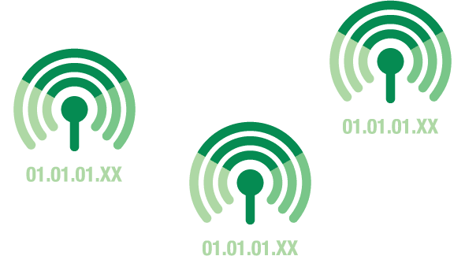

Precise location data
You can turn on Twitter’s location services, letting Twitter pinpoint your position. This enables you to use additional features on Twitter, like Tweeting with your precise location.



Tweet your location
You can choose to share your location in a Tweet publicly, letting everyone know you’re at an event, venue, or anywhere else.



2.2

Links
In order to operate our services, we keep track of how you interact with links across our services. This includes links in emails we send you and links in Tweets that appear on other websites or mobile applications.
If you click on an external link or ad on our services, that advertiser or website operator might figure out that you came from Twitter or Periscope, along with other information associated with the ad you clicked such as characteristics of the audience it was intended to reach. They may also collect other personal data from you, such as cookie identifiers or your IP address.

2.3

Cookies
A cookie is a small piece of data that is stored on your computer or mobile device. Like many websites, we use cookies and similar technologies to collect additional website usage data and to operate our services. Cookies are not required for many parts of our services such as searching and looking at public profiles. Although most web browsers automatically accept cookies, many browsers’ settings can be set to decline cookies or alert you when a website is attempting to place a cookie on your computer. However, some of our services may not function properly if you disable cookies. When your browser or device allows it, we use both session cookies and persistent cookies to better understand how you interact with our services, to monitor aggregate usage patterns, and to personalize and otherwise operate our services such as by providing account security, personalizing the content we show you including ads, and remembering your language preferences. We do not support the Do Not Track browser option. You can learn more about how we use cookies and similar technologies here.
pageReference: /content/twitter-com/legal/en/privacy/chapter-2/chapter-2-3-tooltips---overlays
Content:

Not hungry?
You can change your cookie settings in your web browser.
Close tooltip

2.4

Log Data
We receive information when you view content on or otherwise interact with our services, which we refer to as “Log Data,” even if you have not created an account. For example, when you visit our websites, sign into our services, interact with our email notifications, use your account to authenticate to a third-party service, or visit a third-party service that includes Twitter content, we may receive information about you. This Log Data includes information such as your IP address, browser type, operating system, the referring web page, pages visited, location, your mobile carrier, device information (including device and application IDs), search terms, and cookie information. We also receive Log Data when you click on, view, or interact with links on our services, including when you install another application through Twitter. We use Log Data to operate our services and ensure their secure, reliable, and robust performance. For example, we use Log Data to protect the security of accounts and to determine what content is popular on our services. We also use this data to improve the content we show you, including ads.
We use information you provide to us and data we receive, including Log Data and data from third parties, to make inferences like what topics you may be interested in, how old you are, and what languages you speak. This helps us better design our services for you and personalize the content we show you, including ads.
pageReference: /content/twitter-com/legal/en/privacy/chapter-2/chapter-2-4-tooltips---overlays
Content:
Close

Better data, better content
Using data like the Tweets and accounts you view on Twitter…


Better data, better content
...Twitter can suggest relevant content you may also like.
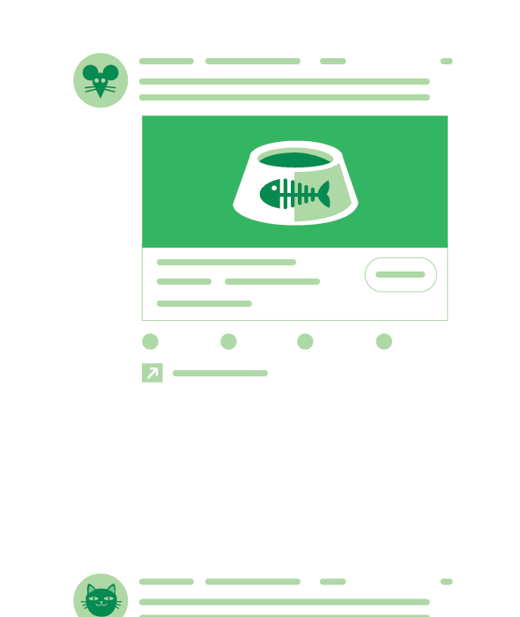

2.5

Twitter for Web Data
When you view our content on third-party websites that integrate Twitter content such as embedded timelines or Tweet buttons, we may receive Log Data that includes the web page you visited. We use this information to better understand the use of our services, to protect the safety and integrity of our platform, and to show more relevant content, including ads. We do not associate this web browsing history with your name, email address, phone number, or username, and we delete, obfuscate, or aggregate it after no longer than 30 days. We do not collect this data from browsers that we believe to be located in the European Union or EFTA States.
pageReference: /content/twitter-com/legal/en/privacy/chapter-2/chapter-2-5-tooltips---overlays1
Content:
Close

Third-party websites
You can see Twitter content on Twitter’s website and apps - but many other websites also choose to include Twitter content.


2.6

Advertisers and Other Ad Partners
Advertising revenue allows us to support and improve our services. We use the information described in this Privacy Policy to help make our advertising more relevant to you, to measure its effectiveness, and to help recognize your devices to serve you ads on and off of Twitter. Our ad partners and affiliates share information with us such as browser cookie IDs, mobile device IDs, hashed email addresses, demographic or interest data, and content viewed or actions taken on a website or app. Some of our ad partners, particularly our advertisers, also enable us to collect similar information directly from their website or app by integrating our advertising technology.
Twitter adheres to the Digital Advertising Alliance Self-Regulatory Principles for Online Behavioral Advertising (also referred to as “interest-based advertising”) and respects the DAA’s consumer choice tool for you to opt out of interest-based advertising at https://optout.aboutads.info. In addition, our ads policies prohibit advertisers from targeting ads based on categories that we consider sensitive or are prohibited by law, such as race, religion, politics, sex life, or health. Learn more about your privacy options for interest-based ads here and about how ads work on our services here.
If you are an advertiser or a prospective advertiser, we process your personal data to help offer and provide our advertising services. You can update your data in your Twitter Ads dashboard or by contacting us directly as described in this Privacy Policy.
pageReference: /content/twitter-com/legal/en/privacy/chapter-2/chapter-2-6-tooltips---overlays
Content:
Close

Data from advertising partners
Advertisers share information on Twitter…


Better ads
...so that, if your settings allow, they can show their most relevant ads.


2.7

Developers
If you access our APIs or developer portal, we process your personal data to help provide our services. You can update your data by contacting us directly as described in this Privacy Policy.

2.8

Other Third Parties and Affiliates
We may receive information about you from third parties who are not our ad partners, such as others on Twitter, partners who help us evaluate the safety and quality of content on our platform, our corporate affiliates, and other services you link to your Twitter account.
You may choose to connect your Twitter account to accounts on another service, and that other service may send us information about your account on that service. We use the information we receive to provide you features like cross-posting or cross-service authentication, and to operate our services. For integrations that Twitter formally supports, you may revoke this permission at any time from your application settings; for other integrations, please visit the other service you have connected to Twitter.

2.9

Personalizing Across Your Devices
When you log into Twitter on a browser or device, we will associate that browser or device with your account for purposes such as authentication, security, and personalization. Subject to your settings, we may also associate your account with browsers or devices other than those you use to log into Twitter (or associate your logged-out device or browser with other browsers or devices). We do this to operate and personalize our services. For example, if you visit websites with sports content on your laptop, we may show you sports-related ads on Twitter for Android.
pageReference: /content/twitter-com/legal/en/privacy/chapter-2/chapter-2-9-tooltips---overlays
Content:
Close

Personalizing across devices
To help make your Twitter experience better on one of your devices...
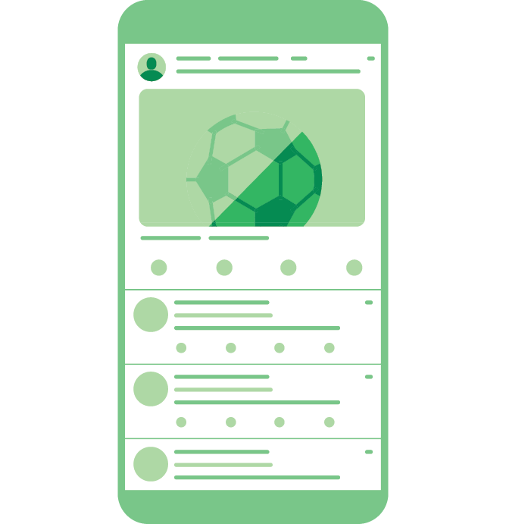

Personalizing across devices
...Twitter may use information from another device of yours.


2.10

How You Control Additional Information We Receive
Your Twitter Personalization and data settings let you decide:
- Whether we show you interest-based ads on and off Twitter
- How we personalize your experience across devices
- Whether we collect and use your precise location
- Whether we personalize your experience based on where you’ve been
- Whether we keep track of the websites where you see Twitter content
You can use Your Twitter data to review:
- Advertisers who have included you in tailored audiences to serve you ads
- Demographic and interest data about your account from our ads partners
- Information that Twitter has inferred about you such as your age range, gender, languages, and interests
We also provide a version of these tools on Twitter if you don’t have a Twitter account, or if you’re logged out of your account. This lets you see the data and settings for the logged out browser or device you are using, separate from any Twitter account that uses that browser or device. On Periscope, you can control whether we personalize your experience based on your watch history through your settings.
pageReference: /content/twitter-com/legal/en/privacy/chapter-2/chapter-2-10-tooltips---overlays
Content:
Close

Your settings
You have options when it comes to what information you share and see on Twitter.

3

Information We Share and Disclose
As noted above, Twitter is designed to broadly and instantly disseminate information you share publicly through our services. In the limited circumstances where we disclose your private personal data, we do so subject to your control, because it’s necessary to operate our services, or because it’s required by law.
- Sharing You Control
- Service Providers
- Law, Harm, and the Public Interest
- Affiliates and Change of Ownership
- Non-Personal Information

- Sharing You Control
- Service Providers
- Law, Harm, and the Public Interest
- Affiliates and Change of Ownership
- Non-Personal Information

3.1

Sharing You Control
We share or disclose your personal data with your consent or at your direction, such as when you authorize a third-party web client or application to access your account or when you direct us to share your feedback with a business. If you’ve shared information like Direct Messages or protected Tweets with someone else who accesses Twitter through a third-party service, keep in mind that the information may be shared with the third-party service.
Subject to your settings, we also provide certain third parties with personal data to help us offer or operate our services. For example, we share with advertisers the identifiers of devices that saw their ads, to enable them to measure the effectiveness of our advertising business. We also share device identifiers, along with the interests or other characteristics of a device or the person using it, to help partners decide whether to serve an ad to that device or to enable them to conduct marketing, brand analysis, interest-based advertising, or similar activities. You can learn more about these partnerships in our Help Center, and you can control whether Twitter shares your personal data in this way by using the “Share your data with Twitter’s business partners” option in your Personalization and Data settings. (This setting does not control sharing described elsewhere in our Privacy Policy, such as when we share data with our service providers.) The information we share with these partners does not include your name, email address, phone number, or Twitter username, but some of these partnerships allow the information we share to be linked to other personal information if the partner gets your consent first.
pageReference: /content/twitter-com/legal/en/privacy/chapter-3/chapter-3-1-tooltips---overlays
Content:
Close

Sharing data with advertisers
When you click on or view an ad on Twitter, if your settings allow, Twitter may send data about your device back to the advertiser to help them measure their success and improve future ads.
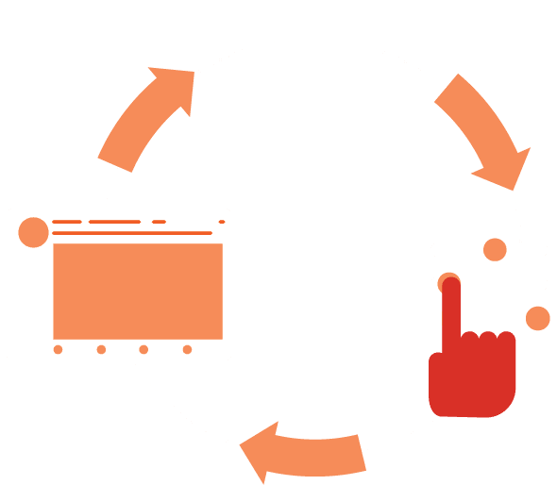

3.2

Service Providers
We engage service providers to perform functions and provide services to us in the United States, Ireland, and other countries. For example, we use a variety of third-party services to help operate our services, such as hosting our various blogs and wikis, and to help us understand the use of our services, such as Google Analytics. We may share your private personal data with such service providers subject to obligations consistent with this Privacy Policy and any other appropriate confidentiality and security measures, and on the condition that the third parties use your private personal data only on our behalf and pursuant to our instructions. We share your payment information with payment services providers to process payments; prevent, detect, and investigate fraud or other prohibited activities; facilitate dispute resolution such as chargebacks or refunds; and for other purposes associated with the acceptance of credit and debit cards.

3.3

Law, Harm, and the Public Interest
Notwithstanding anything to the contrary in this Privacy Policy or controls we may otherwise offer to you, we may preserve, use, or disclose your personal data if we believe that it is reasonably necessary to comply with a law, regulation, legal process, or governmental request; to protect the safety of any person; to protect the safety or integrity of our platform, including to help prevent spam, abuse, or malicious actors on our services, or to explain why we have removed content or accounts from our services; to address fraud, security, or technical issues; or to protect our rights or property or the rights or property of those who use our services. However, nothing in this Privacy Policy is intended to limit any legal defenses or objections that you may have to a third party’s, including a government’s, request to disclose your personal data.
pageReference: /content/twitter-com/legal/en/privacy/chapter-3/chapter-3-3-tooltips---overlays
Content:

Transparency matters
We remove content from our services when it violates our rules, like if it glorifies violence. When that content is gone, we want you to know.
Close tooltip

3.4

Affiliates and Change of Ownership
In the event that we are involved in a bankruptcy, merger, acquisition, reorganization, or sale of assets, your personal data may be sold or transferred as part of that transaction. This Privacy Policy will apply to your personal data as transferred to the new entity. We may also disclose personal data about you to our corporate affiliates in order to help operate our services and our affiliates’ services, including the delivery of ads.

3.5

Non-Personal Information
We share or disclose non-personal data, such as aggregated information like the total number of times people engaged with a Tweet, the number of people who clicked on a particular link or voted on a poll in a Tweet (even if only one did), the topics that people are Tweeting about in a particular location, or reports to advertisers about how many people saw or clicked on their ads.

4

Managing Your Personal Information With Us
You control the personal data you share with us. You can access or rectify this data at any time. You can also deactivate your account. We also provide you tools to object, restrict, or withdraw consent where applicable for the use of data you have provided to Twitter. And we make the data you shared through our services portable and provide easy ways for you to contact us.
- Accessing or Rectifying Your Personal Data
- Deletion
- Object, Restrict, or Withdraw Consent
- Portability
- Additional Information or Assistance

- Accessing or Rectifying Your Personal Data
- Deletion
- Object, Restrict, or Withdraw Consent
- Portability
- Additional Information or Assistance

4.1

Accessing or Rectifying Your Personal Data
If you have registered an account on Twitter, we provide you with tools and account settings to access, correct, delete, or modify the personal data you provided to us and associated with your account. You can download certain account information, including your Tweets, by following the instructions here. On Periscope, you can request correction, deletion, or modification of your personal data, and download your account information, by following the instructions here. You can learn more about the interests we have inferred about you in Your Twitter Data and request access to additional information here.

4.2

Deletion
We keep Log Data for a maximum of 18 months. If you follow the instructions here (or for Periscope here), your account will be deactivated and then deleted. When deactivated, your Twitter account, including your display name, username, and public profile, will no longer be viewable on Twitter.com, Twitter for iOS, and Twitter for Android. For up to 30 days after deactivation it is still possible to restore your Twitter account if it was accidentally or wrongfully deactivated.
Keep in mind that search engines and other third parties may still retain copies of your public information, like your profile information and public Tweets, even after you have deleted the information from our services or deactivated your account. Learn more here.

4.3

Object, Restrict, or Withdraw Consent
When you are logged into your Twitter account, you can manage your privacy settings and other account features here at any time.

4.4

Portability
Twitter provides you a means to download the information you have shared through our services by following the steps here. Periscope provides you a means to download the information you have shared through our services by following the steps here.

4.5

Additional Information or Assistance
Thoughts or questions about this Privacy Policy? Please let us know by contacting us here or writing to us at the appropriate address below.
If you live in the United States, the data controller responsible for your personal data is Twitter, Inc. with an address of:
Twitter, Inc.
Attn: Privacy Policy Inquiry
1355 Market Street, Suite 900
San Francisco, CA 94103
If you live outside the United States, the data controller is Twitter International Company, with an address of:
Twitter International Company
Attn: Data Protection Officer
One Cumberland Place, Fenian Street
Dublin 2, D02 AX07 IRELAND
If you are located in the European Union or EFTA States, you can confidentially contact Twitter’s Data Protection Officer here. If you wish to raise a concern about our use of your information (and without prejudice to any other rights you may have), you have the right to do so with your local supervisory authority or Twitter International Company’s lead supervisory authority, the Irish Data Protection Commission. You can find their contact details here.

5

Children and Our Services

Our services are not directed to children, and you may not use our services if you are under the age of 13. You must also be old enough to consent to the processing of your personal data in your country (in some countries we may allow your parent or guardian to do so on your behalf). You must be at least 16 years of age to use Periscope.

6

Our Global Operations and Privacy Shield

To bring you our services, we operate globally. Where the laws of your country allow you to do so, you authorize us to transfer, store, and use your data in the United States, Ireland, and any other country where we operate. In some of the countries to which we transfer personal data, the privacy and data protection laws and rules regarding when government authorities may access data may vary from those of your country. Learn more about our global operations and data transfer here.
When we transfer personal data outside of the European Union or EFTA States, we ensure an adequate level of protection for the rights of data subjects based on the adequacy of the receiving country’s data protection laws, contractual obligations placed on the recipient of the data (model clauses may be requested by inquiry as described below), or EU-US and Swiss-US Privacy Shield principles.
Twitter, Inc. complies with the EU-US and Swiss-US Privacy Shield principles (the “Principles”) regarding the collection, use, sharing, and retention of personal data from the European Union and Switzerland, as described in our EU-US Privacy Shield certification and Swiss-US Privacy Shield certification.
If you have a Privacy Shield-related complaint, please contact us here. As part of our participation in Privacy Shield, if you have a dispute with us about our adherence to the Principles, we will seek to resolve it through our internal complaint resolution process, alternatively through the independent dispute resolution body JAMS, and under certain conditions, through the Privacy Shield arbitration process.
Privacy Shield participants are subject to the investigatory and enforcement powers of the US Federal Trade Commission and other authorized statutory bodies. Under certain circumstances, participants may be liable for the transfer of personal data from the EU or Switzerland to third parties outside the EU and Switzerland. Learn more about the EU-US Privacy Shield and Swiss-US Privacy Shield here.

7

Changes to This Privacy Policy

We may revise this Privacy Policy from time to time. The most current version of the policy will govern our processing of your personal data and will always be at https://twitter.com/privacy. If we make a change to this policy that, in our sole discretion, is material, we will notify you via an @Twitter update or email to the email address associated with your account. By continuing to access or use the Services after those changes become effective, you agree to be bound by the revised Privacy Policy.
pageReference: /content/twitter-com/legal/en/privacy/chapter-7/chapter-7
Content:

You're in control
Even as Twitter evolves, you can always change your privacy settings. The power is yours to choose what you share in the world.
Close tooltip

Effective: May 25, 2018
Archive of Previous Privacy Policies
© 2018 Twitter, Inc.
Cookies
Privacy
Terms and Conditions

