**Topics: Descriptive Statistics and Probability**

1. Look at the data given below. Plot the data, find the outliers and find out $μ, σ, σ^{2}$

| **Name of company** | **Measure X** |
| --- | --- |
| Allied Signal | 24.23% |
| Bankers Trust | 25.53% |
| General Mills | 25.41% |
| ITT Industries | 24.14% |
| J.P.Morgan & Co. | 29.62% |
| Lehman Brothers | 28.25% |
| Marriott | 25.81% |
| MCI | 24.39% |
| Merrill Lynch | 40.26% |
| Microsoft | 32.95% |
| Morgan Stanley | 91.36% |
| Sun Microsystems | 25.99% |
| Travelers | 39.42% |
| US Airways | 26.71% |
| Warner-Lambert | 35.00% |

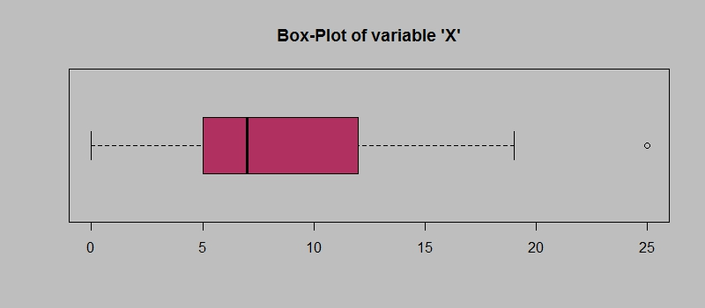

Answer the following three questions based on the box-plot above.

1. What is inter-quartile range of this dataset? (please approximate the numbers) In one line, explain what this value implies.IQ Range is 5 -10 And 1 outlier 25 is there
2. What can we say about the skewness of this dataset? Left Skewness
3. If it was found that the data point with the value 25 is actually 2.5, how would the new box-plot be affected? The Value of will change

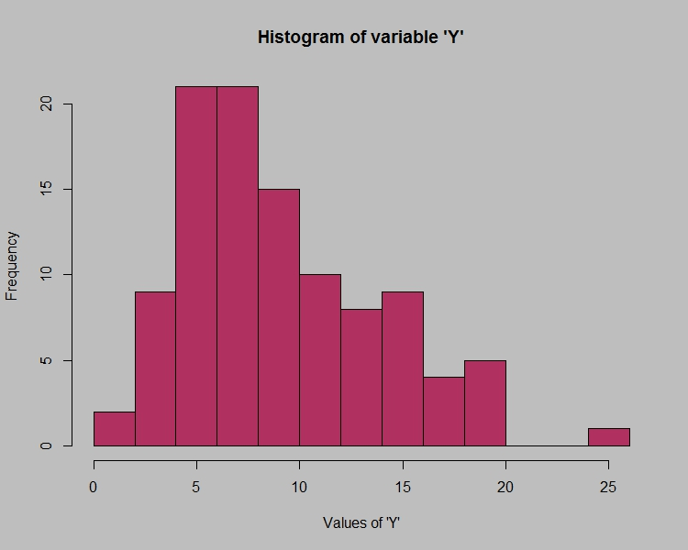

Answer the following three questions based on the histogram above.

1. Where would the mode of this dataset lie? We need to give range of Mode or Exact mode here
2. Comment on the skewness of the dataset. Left Skweness
3. Suppose that the above histogram and the box-plot in question 2 are plotted for the same dataset. Explain how these graphs complement each other in providing information about any dataset. Boxplot Can show the Number of Mode But Histogram Can show
4. AT&T was running commercials in 1990 aimed at luring back customers who had switched to one of the other long-distance phone service providers. One such commercial shows a businessman trying to reach Phoenix and mistakenly getting Fiji, where a half-naked native on a beach responds incomprehensibly in Polynesian. When asked about this advertisement, AT&T admitted that the portrayed incident did not actually take place but added that this was an enactment of something that “could happen.” Suppose that one in 200 long-distance telephone calls is misdirected. What is the probability that at least one in five attempted telephone calls reaches the wrong number? (Assume independence of attempts.)

Answer :the probability that at least one in five attempted telephone calls reaches the wrong number is

1. Returns on a certain business venture, to the nearest $1,000, are known to follow the following probability distribution

| x | P(x) |
| --- | --- |
| -2,000 | 0.1 |
| -1,000 | 0.1 |
| 0 | 0.2 |
| 1000 | 0.2 |
| 2000 | 0.3 |
| 3000 | 0.1 |

1. What is the most likely monetary outcome of the business venture? The value which is Having Highest Number of Probability 0.3
2. Is the venture likely to be successful? Explain Yes the Venture is Successful because the Average of Both the Value Multiplying each other is Giving Positive Number 800
3. What is the long-term average earning of business ventures of this kind? Explain Long term average = \sum{P(xi)*Xi} is giving positive value
4. What is the good measure of the risk involved in a venture of this kind? Compute this measure. Not able to get this question