**Start Server In IDE :**

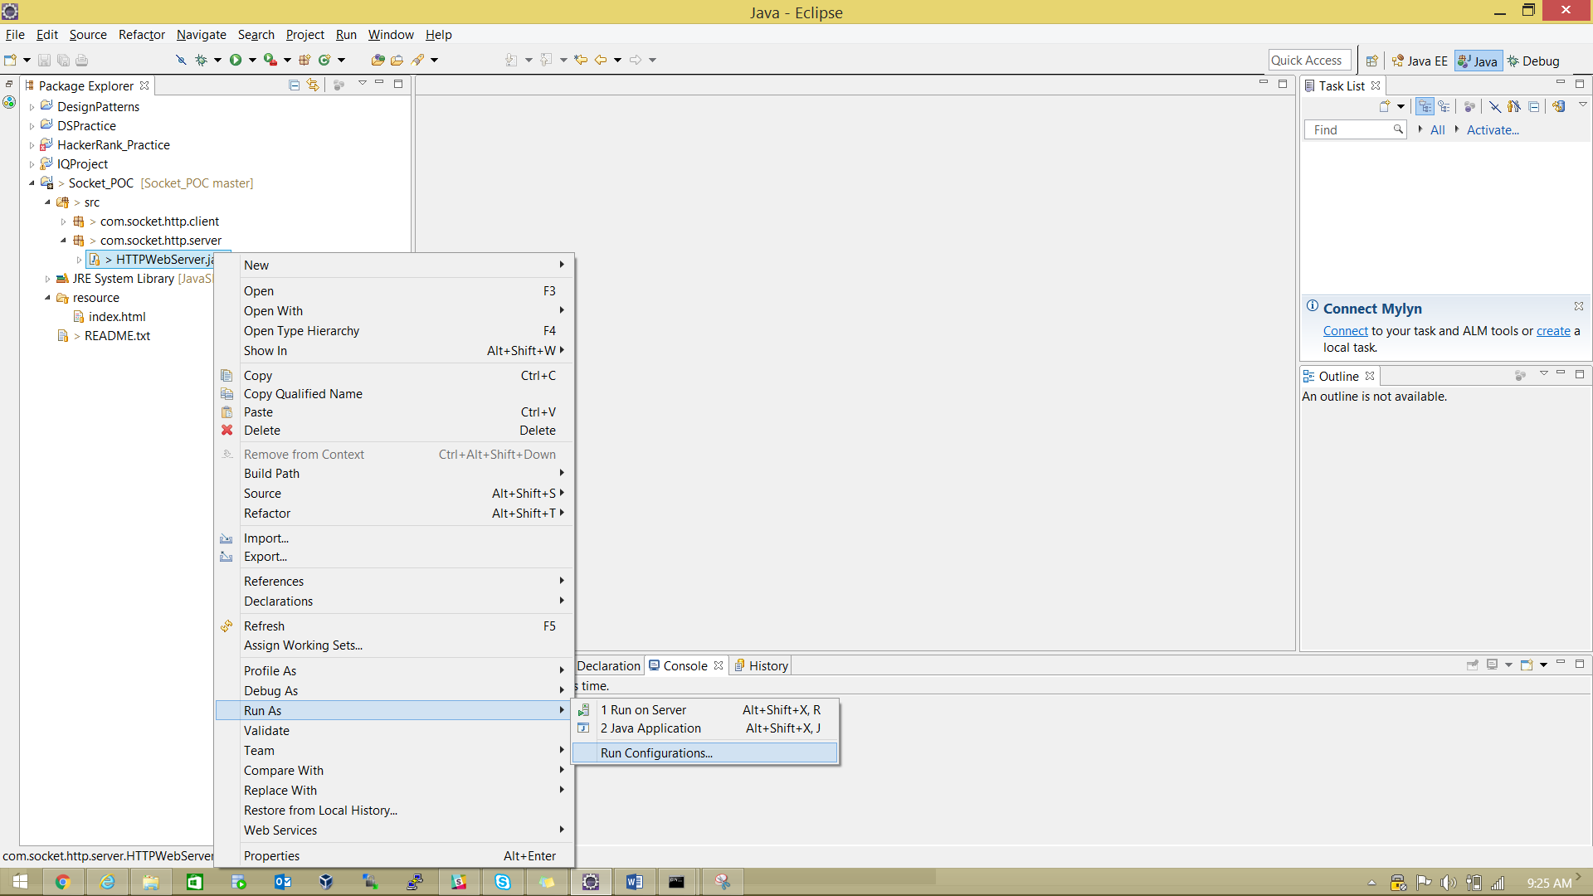

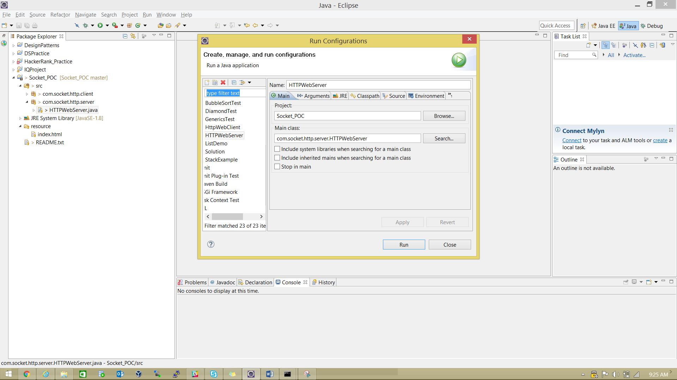

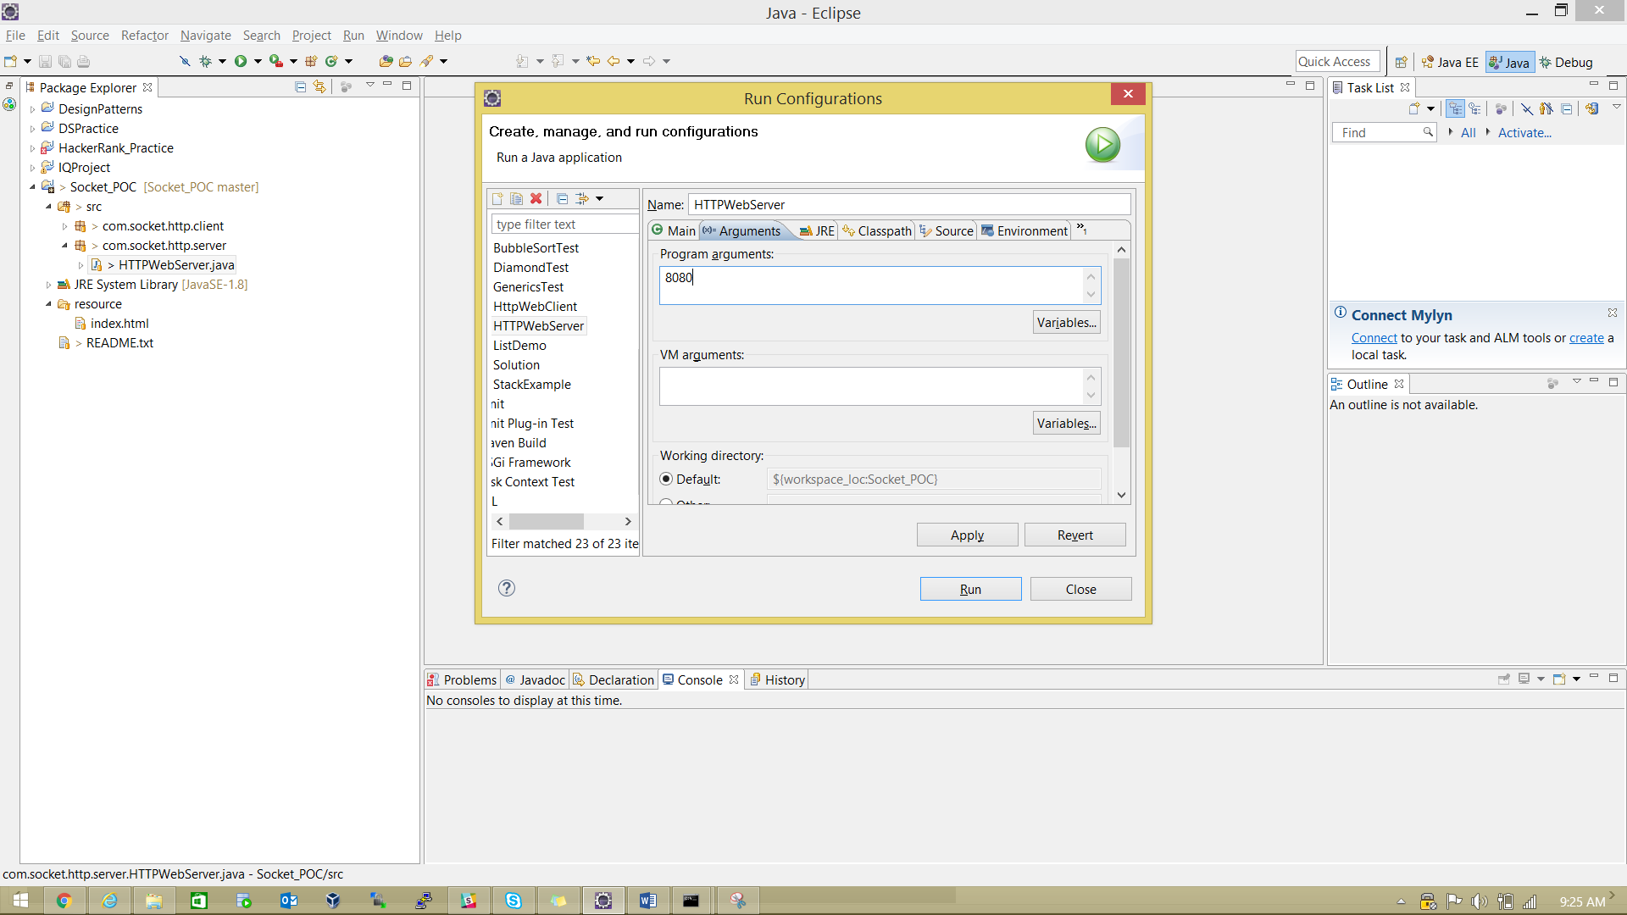

Enter Port number into Arguments and Click RUN Button.

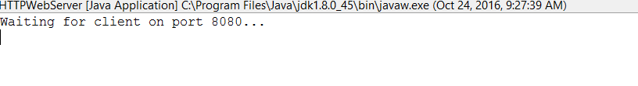

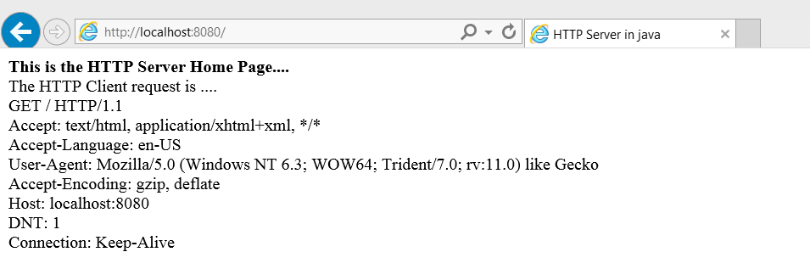

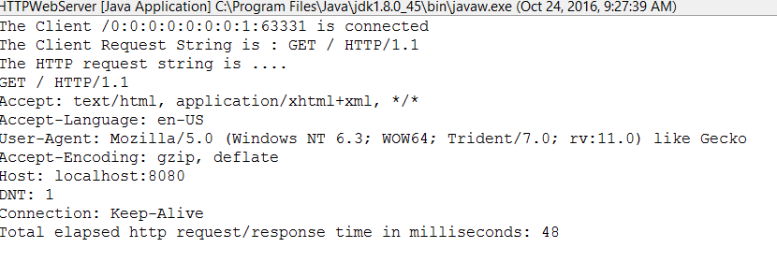

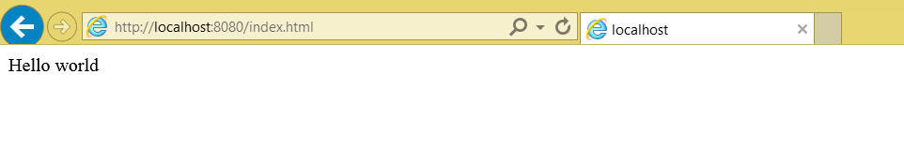

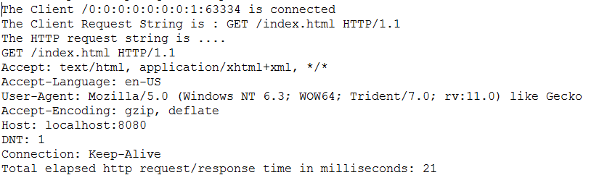

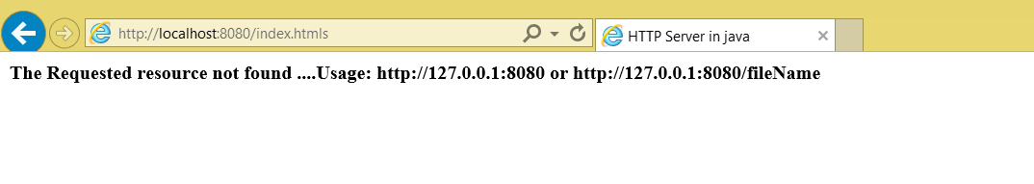

**Web client execution through command:**

**Compile:**

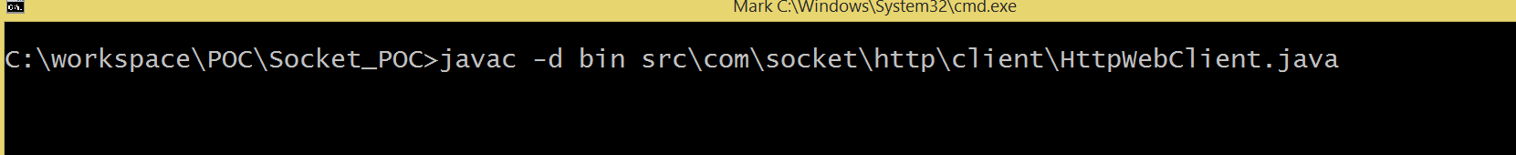

Run:





OUTPUT:

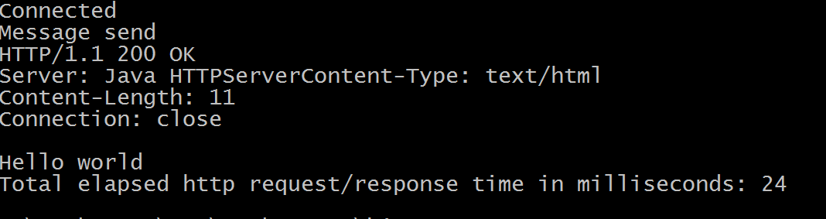

Without Port Number



OUTPUT:

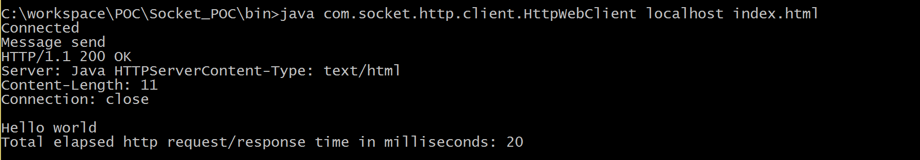

Wrong file Name

