**Practical Mock Practice**

1. Write a function to accept a list and return two numbers. A sum of positive numbers and also a sum of negative number of the input list. Example: Lst=[-1,21,-5,-9,6,-2,9,8,-9] would return 44 and -26 [5 marks]

|  |  |
| --- | --- |
| Task | Signature |
| Correct definition and call |  |
| Demo with input list  Lst=[-1,21,-5,-9,6,-2,9,8,-9] | 44  -26 |
| Demo with input list  Lst2=[-2,3,-5,7,8,3,9,7,8,-3] | 45  -10 |

Code:

Lst=[-1,21,-5,-9,6,-2,9,8,-9]

Lst2=[-2,3,-5,7,8,3,9,7,8,-3]

def sum_diff(xlist):

pos=0

neg=0

for c in xlist:

if c>0:

pos=pos+c

else:

neg=neg+c

return pos, neg

pp, nn=sum_diff(Lst2)

print(pp)

print(nn)

1. Download Beijing PM2.5 Dataset from UCI website at site [**https://archive.ics.uci.edu/ml/datasets/Beijing+PM2.5+Data#**](https://archive.ics.uci.edu/ml/datasets/Beijing+PM2.5+Data)**.** Perform the follows tasks:

|  |  |
| --- | --- |
| Task | Signature |
| Read in the csv file and show the first 5 rows of data. |  |
| Remove all rows with any NAN, null or missing data. The number of rows after removal =[ 41757 ] |  |
| Generate a DateTime Column from existing column and set as index |  |

Code:

df['DateTime']=df['day'].astype(str)+'/'+df['month'].astype(str)+'/'+df['year'].astype(str)+' '+df['hour'].astype(str)+':00'

df['DateTime']=pd.to_datetime(df['DateTime'],format='%d/%m/%Y %H:%M')

df.set_index('DateTime', inplace=True) # set the date time as index

df.head()

df=df.dropna(axis='rows')

print(df.shape)

1. Based on the process created in **Question 2**, plot a line plot of pm2.5 vs DateTime with the following attribute:

[5 marks]

|  |  |
| --- | --- |
| Attribute | Verification by Tutor |
| Chart Title: ‘Beijing pm2.5 vs Date Time and line graph is red |  |
| Label both axis properly |  |
| Legend Position: Top Left |  |

fig=plt.figure()

ax=plt.axes()

ax.plot(df['pm2.5'],c='r')

ax.set_title('Beijing pm2.5 vs date time')

ax.set_xlabel('Date Time')

ax.set_ylabel('pm2.5 values')

legend = ax.legend(loc='upper left', fontsize='x-large')

plt.show()

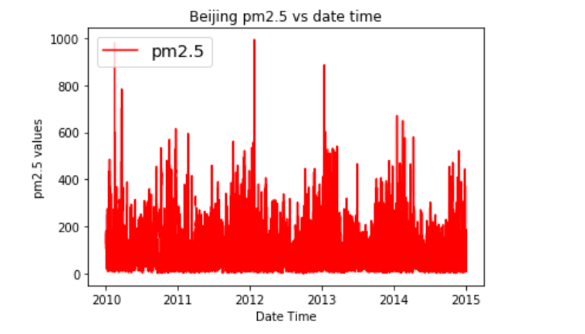

5