|  |  |
| --- | --- |
| Smart Sensors and Devices | Description: C:\Users\rajahk\AppData\Local\Microsoft\Windows\Temporary Internet Files\Content.Outlook\Z7A7LSNK\big (2).jpg |
|  | |

### Project

You can choose to work on the project individually or in a group of 2.

**Project Requirements**

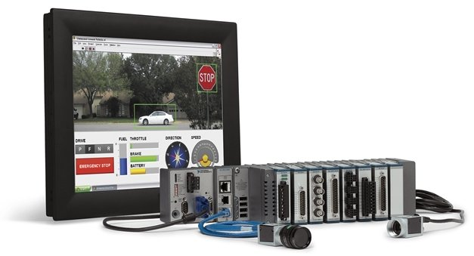

Propose a project to improve the productivity in the company that you are working. It can be a totally new project, or an enhancement to an existing project. You are allowed to work on a fictitious scenario if you like to explore something different.

The project should involve:

* Human Machine Interface using LabVIEW
* Sensors and actuators
* Processing using NI CompactRIO
* Connectivity to web infrastructure or cloud

**Project Grading Criteria**

Your project will be graded based on the scope of your proposal, implementation to meet the project specifications, project demonstration and a final report to explain your work.

* Project Proposal and Implementation (75%)
* Demonstration and Report (25%)

**Project Submission**: 8 Aug 2018