Temasek Polytechnic  Engineering Analytics |  | 
 | Group Name: |  | Class: Date:
 |  |  | Marks: / 100

Group Information

Member Name | Admin. No. | Signature

Assignment

Plan
My Goal/s (To be specific, measurable, attainable, relevant and timed, e.g., to complete the assignment and achieve a grade of at least B by the deadline of DD/MM/YY):

-

When do I start working on my assignment (Specific with the date and time):

-

Work place (e.g., home, TP/ENG/free access lab, etc.):

-

Planned resources (e.g., internet, mobile App-QR code, lecturer, classmates, etc.):

-

1. TOPIC
Motivations for data analysis, its relevance and ethical responsibility to society.

2. OBJECTIVE
i. To become proficient in component layout design of prototype circuit on a general purpose printed circuit board; Vero board (copper strips).

Fig1
ii. To construct an 8-bit shift register and timer circuits on a Vero board (copper strips).
iii. To reinforce continuity test skills (trouble shooting skills). Refer to Fig1 (QR code) demo.

1
3. TASK

Components:
Vero board (copper strips) 14.5cm X 6cm (Refer to Appendix A)
IC74HCT164 (X1)
IC555 (X1)
IC Socket, 8-pin (X1)
IC Socket, 14-pin (X1)
Resistors 1kΩ (X1), 1.2kΩ (X1), 330 Ω (X9), 300kΩ (X1)

LEDs (X9)
Electrolytic capacitor 1μF (X1)
Ceramic capacitor 10nF (X1)
Molex terminal (2-pin), Molex housing, Molex crimping pins (X1)

Procedure
a. Convert the circuit schematic diagram in Figure 1.1 to a component layout diagram in Figure 1.2 as shown. Check your placement with the schematic diagram. Components should be well spaced within the board. Good planning of the component layout will minimize the need for jumpers and produce a neat circuit.
b. Indicate on Figure 1.2 where copper tracks should be cut (X) to break circuit connections. Jumper wires are to be used for connecting components that are located on different parallel strips. Use the appropriate wire length for the jumpers.
c. The component layout on Figure 1.2 is incomplete. Students have to plan, draw and complete the component layout on Figure 1.2.

Fig2
d. Using the pliers, bend the component leads to the appropriate size before inserting them into the board. Place and solder one component at the time. Cut away the excess leads.
e. Perform a functionality test for each and every piece of LEDs before placement and solder on the board. Refer to Fig2 (QR code) demo.
2

4
- f. Check List for Performing and Monitoring:
Upon completion of your prototype circuit and before embark on-circuit board test, you must do/complete the following self-check list.

Item 1: On Board Copper Strips.

SN | Description | Yes | No | If No, what should you do?
1 | Continuity test: No metal (i.e. solder, component lead or jumper wire) contact between copper strips. Test result: OPEN CIRCUIT (OL)

Item 2: Molex Terminal.

SN | Description | Yes | No | If No, what should you do?
2 | Continuity test: The +5V and GND pins of Molex Terminal are tested OPEN CIRCUIT (OL).

Item 3: 555 Timer Circuit.

SN | Description | Yes | No | If No, what should you do?
3 | Continuity test: Between the two roll pins of IC555, the copper strips are break (X) open; Between Pins 1 and 8, 2 and 7, 3 and 6, 4 and 5. Test result: OPEN CIRCUIT (OL)
4 | Continuity test: Pins 4 and 8 of IC555 are connected to +5V point. Test result: CLOSED CIRCUIT (0Ω)
5 | Continuity test: Pin 1 of IC555 is connected to GND point. Test result: CLOSED CIRCUIT (0Ω)
6 | Continuity test: Pins 2 and 6 of IC555 are shorted together. Test result: CLOSED CIRCUIT (0Ω)
7 | Continuity test: Positive pole of 1μF electrolytic capacitor is either connected to Pins 2 or 6 of IC555 and its Negative pole to GND point. Test result: CLOSED CIRCUIT (0Ω)
8 | All the IC555 pins’ (8-pin) are inserted into the IC socket and with correct orientation.
9 | Orientation of LED9; Anode (+) lead is connected to 330Ω and cathode (-) lead to GND point.
10 | One lead of 300kΩ is connected to Pin 6 of IC555 and the other lead to Pin 7.
11 | One lead of 1kΩ is connected to Pin 7 of IC555 and the other lead to +5V point.
5
- Item 4: 74 HCT164 Shift Register Circuit.

SN | Description | Yes | No | If No, what should you do?
12 | Continuity test: Between the two roll pins of IC74HCT164, the copper strips are break (X) open; Between Pins 1 and 14, 2 and 13, 3 and 12, 4 and 11, 5 and 10, 6 and 9, 7 and 8. Test result: OPEN CIRCUIT (OL)
13 | Continuity test: Pins 9 and 14 of IC74HCT164 are connected to +5V point. Test result: CLOSED CIRCUIT (0Ω)
14 | Continuity test: Pin 7 of IC74HCT164 is connected to GND point. Test result: CLOSED CIRCUIT (0Ω)
15 | Continuity test: Pins 1 and 2 of IC74HCT164 are shorted together. Test result: CLOSED CIRCUIT (0Ω)
16 | Continuity test: the 10nF capacitor is placed close to pin 14 of IC74HCT164. One lead connected to Pin 14 and the other to GND point. Test result: CLOSED CIRCUIT (0Ω)
17 | One lead of 1.2kΩ is connected to Pin 1 or 2 of IC74HCT164 and the other lead to GND point.
18 | All the IC74HCT164 pins’ (16-pin) are inserted into the IC socket and with correct orientation.
19 | Orientation of LED1 to 8; Anode (+) lead is connected to 330Ω and cathode (-) lead to GND point.
20 | Orientation of Push Button Switch (PB); Pin 1 of PB is connected to Pin 1 or 2 of IC74HCT164 and its Pin 4 to +5V point.
21 | Pin 3 of IC555 and Pin 8 of IC74HCT164 are connected.
22 | Refer to Figure 1.2, is there a break (X) on the copper strip between Pin 9 of IC74HCT164 and Pin 2 of IC555?
22 | Why is it important?
23 | Refer to Figure 1.2, is there a break (X) on the copper strip between Pin 10 of IC74HCT164 and Pin 1 of IC555?
23 | Why is it important? |  |  | 6
24 | Refer to Figure 1.2, the anode (+) leads of all eight LEDs (LED1 to 8) are soldered on the same copper strip line. Are there any breaks (X) on the copper strip line to isolate each and every individual anode of LEDs?
24 | Why is it important?

g. Self-Test for Performing and Monitoring:
i. Set the laboratory DC power supply to 5V. Connect the 5V and Ground (GND) to the respective points as given in the circuit.
Alternatively you can use a battery (1.5V x 4 =6V or 9V) pack to power the prototype circuit.
Cautions:
- Double check, use continuity test method, to ensure that on-circuit board power points, +5V and GND, are NOT short circuit. A short circuit board will cause the batteries to heat up due to battery overload (excessive amount of electric current is drawn out from the battery) and can cause fire hazard.
- Ensure that the DC power supply/battery pack terminals are correctly oriented when apply to circuit board, (+) → +5V and (-) → GND, reversal of power connection can cause on-circuit board components damage.


ii. Does the LED9 continue flashing? Refer to Fig3 (QR code) demo.
Fig3
If NO, return to (f) Check List, repeat Items (1), (2) and (3).

If YES, continue.

iii. Step 1:
Press the push button switch (PB) once, LED1 will light up and it lights navigate to the next LED (LED2) and gradual shift down to LED8 and eventually off at LED8. Refer to Fig4 (QR code) demo.
Fig4

Step 2:
QR code

Fig6
Press the push button switch (PB) and hold, the light will propagate down from LED1 to LED8 (gradually light up one at the time). Once the PB is released, the light is gradually off one at the time from LED1 to LED8. Refer to Fig5 (QR code) demo.

If your circuit functionality COULD NOT meet the above Steps 1 or/and 2, return to (f) Check List, repeat Items (4)
Fig5

If YES, Congratulation! You have completed the assignment.

h. Demo the circuit operation to your supervisor.

Supervisor’s initial ___________________________
7

Reflect
Write a reflection on your learning using Self-Directed Learning (SDL)

Describe:
- Write about how you planned for the completion of your assignment.
- Describe how you’ve been monitoring your own progress while doing the assignment.

Examine:
- Examine how you went about doing the assignment and how you closed the gap in your learning.

Articulated Learning:
- Write about some strategies or skills you have learnt through this assignment.
- Given another assignment, what might be anything you would do differently from what you have done?

End of Paper
8
3
6
Appendix A

Molex
Terminal
(2-pin)

+5V
GND

1
2
3
8
4
5
6
7

74HCT164

555

Appendix B

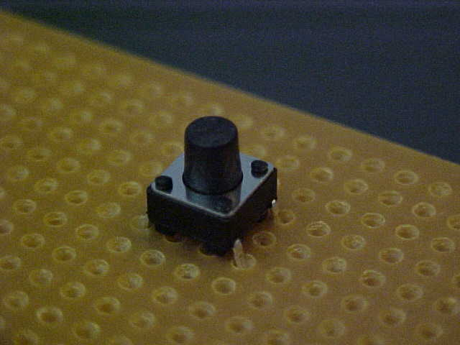
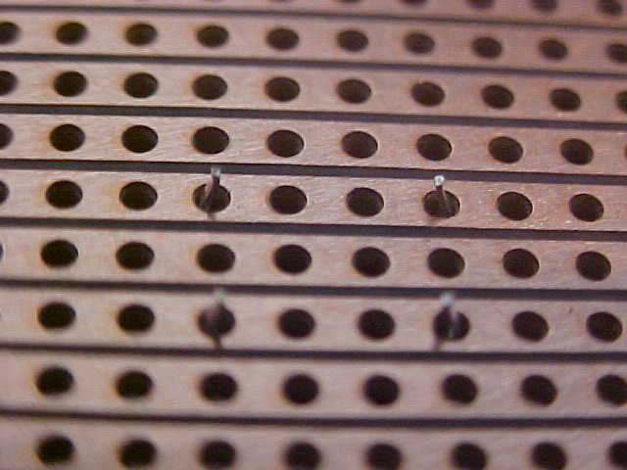
1
2
3
4
2
1
4
3

