论文一：
The 3D Skeleton Pruning for Removing Undesired Joints
方法：
Input: A set of points on the surface of model, P {P],Pb ... ,Pn}.
Output: The pruned skeleton of the given model.
Step:
- Read P and determine which p is an endpoint, a middle point, a connection point, and a branched connection point.
- Construct a branched region from p if the neighbor numbers of p is 26.
- Find the end points and the middle points that are 26-adjacent to this branched region, and mark each as ''terminator''.
- Determine the centroids in each branched region
- Compute the geodesic distance and find the shortest path from centroid to all Pi
- Delete the point that are not on the shortest path,then construct the pruned skeleton and return.
创新点：
Applying the function of geodesic distance can guarantee that the new method is invariant to a rotation and a translation, and it is also robust against the changes in the connectivity on the 3D shapes
不足：
an important challenge remaining is to find a method for generating the realistic joints that are similar to the joints of the model's anatomy.

论文二：
3D Action Recognition Based on Limb Angle Model
方法：
- Using 10 joints to create the limb angel model,which is represented by posture = {(i ,ϕi ) i =1,2,...,10}, is the angle between the limb and the direction from hip to spine while is the azimuthal angle in the plane parallel to the transversal surface of body

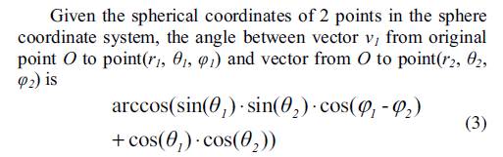
（PS：有些符号无法打出来，所以直接贴了图片....）
Each Limb Angle Model has its own angel, so the distance
between 2 LAMs is calculated as
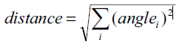
- Given training samples of skeleton sequences,extracted the posture in the form of LAM from each frame.We set a threshold to avoid saving similar postures to dataset.Then, a sequence O={o1,o2,...,oT} is got.
- Baum-Welch algorithm is applied to train the model
- The recognition result is the model of action type which has the largest probability for the observation sequence, as follow
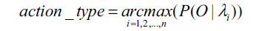
创新点：
1、The radius r of limb point is not used to represent postures so that LAM is invariant to limb length, length ratio between body parts.
2、Classified the training samples of skeleton sequences into a standard posture sequence，avoiding saving similar postures to dataset
不足：
It is only depends on the limb angle,which can confuse some postures with others , which both have similar limb angle but different position of joints.

论文三
HUMAN ACTIVITY RECOGNITION USING BODY POSE FEATURES AND SUPPORT VECTOR MACHINE
方法：
- Using the skeleton joints, body position, and velocity information to extract the features.
- Using SVM to classify:
- mapping the features into a feature space
- Using optimal hyperplanes to seperate the training dataset,then a classifier can be gotten.
- For a test data point,compute the distance between the test point and each class centroid:
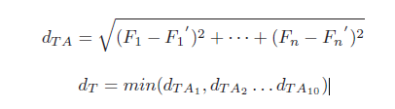

- a sample decision is made that the test data belongs to that activity group with which it has minimum distance.
创新点：
- Using classifiers based on SVM, perform best in large feature space, can better handle large classification of data and also it can handle both linear and non-linear cases by kernel choice。
- Take the velocity into candidate features,which can detect some ambiguous actions such as walking and running
不足：
- When it comes to the large scale of data, the expression may slow down the computing speed because of its complexity.
- It doesn’t come up with the exact SVM method to classify the data.

论文四
Kintense: A Robust, Accurate, Real-Time and
Evolving System for Detecting Aggressive Actions
from Streaming 3D Skeleton Data
方法：
- Get the skeleton frames from Kinect
- Use a movement detector to detect skeletal movements,if any of the values are abovesome threshold, the window is passed on to the classifiers.
- Use two types of classifier to classify the action,expert classifier will classify those pre-trained types of actions,while labeled cluster-based classifier are obtained by unsupervised learning and are labeled by a human operator.
- An action that is classified poorly by both types of classifiers corresponds to either a new action or a different way of performing an existing action.They are handed over to the action detector module.
创新点：
- Use two classifier to handle different situation.
- Those frames which cannot be classified by both classifiers will be handed over by human operator.This method can increase the accuracy of classifiers.
不足：
evolving a classifier as done in the labeled clusterbased method requires comparatively longer time to attain an acceptable recognition accuracy

论文五
Human Gait Recognition Using Depth Camera:
A Covariance Based Approach
方法：
- The trajectory for each point in the skeleton, 1<=n<=20 gives its position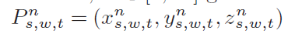,this is a function of time (or frame number) 1<=t<=Tfor the sth subject’s wth walk sequence.
- Use covariance matrix to capture the relative movement of the skeletal points,then use the covariance matrix to record the walk sequence
- The subject of the test walk sequence is identified by comparing the test covariance matrix with those in the training set.
创新点：
1、it is no longer necessary to segment and synchronize the walk sequences
2、The algorithm accommodates for changes in skeleton size as the subject moves towards the camera.
不足：
- The ignorance of some skeleton joint can bring some potential inaccuracy
- The high complexity of calculation may slow down the computing speed.

论文六
Real-Time Human Pose Recognition in Parts from Single Depth Images
方法：
- a 3D surfaceis divided into 31distinct body parts.
- The features are extracted from the body parts using the equation below:
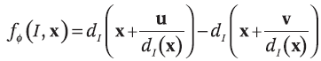
Then a single input depth image is segmented into a dense probabilistic body parts labeling.
- For training data, use the body part label to get the model.For test data, use the model to generate confidence-weighted proposals.
- A combination of these joint locations comprises the output pose.
- The classifier use the random forest to classify the dataset.
创新点：
- Only the final stage uses information from previous frames,which enhances the system’s ability to recover from tracking errors
缺点：
- The images of training dataset is synthesized by computer, which may occur some image distortion.
- It cannot run at interactive rates on consumer hardware while Handling a full range of human body shapes and sizes undergoing general body motions

