SEP #15 : Scilab Tree component

Title: Scilab tree component
Version: 1
Authors: Sylvestre Koumar – sylvestre.koumar@scilab.org
Vincent Couvert – vincent.couvert@scilab.org
Bruno Jofret – bruno.jofret@scilab.org
State: Draft
Scilab-Version: 5.2
Vote: "No: discussions and suggestions"
Created: Tuesday, 3rd February 2009

Abstract
This SEP proposes to create a generic tree component for Scilab and Scicos.
This tree will be integrated in the docking system and will be used for visualisation only.

Rationale
This tree component will be used for :
- Graphic Editor (GED) in Scilab
- Scilab Demonstrations
- Pal Tree in Scicos
- Any user's uses for tree visualisation

The tree component will be programmed in 2 parts (Scilab & Java).

In Scilab's side :

We will use the type Tree to represente trees through the use of tlist, trees will be encapsulated into the interface Tree.

ex : Tree uiCreateTree(parent, subTree1, subTree2,...,subTreeN)
(cf. Creation of a tree)

We will use the type struct to represente nodes and leaves which will be encapsulated into the interface Tree.

ex : Tree uiCreateNode('text', 'icon', 'callback')
node.text = 'Node name'
node.icon = 'Node icon'
node.callback = 'Node callback'
(cf. Creation of a node)

Later we would add other features for a node, like :

node.textPosition(at the left/right/bottom/top of the icon)
node.toolTipText(set a tool tip text message for a node)
node.iconHeight(set icon's height)
node.iconWidth (set icon's width)
of course it will make the uiCreateNode function grow.
Methods to interact with our tree :

* Creation of a node :
Tree uiCreateNode(label, [icon, [callback]])

Creation of a node (subTree).

Input : we should specify the label of the node (icon & callback are optional).
- label will be of type string
- icon will be of type string
- callback will be of type string

Output : will return a Tree.

→ myParentTree = uiCreateNode('Parent', 'imagePath\parent.jpg', 'parentCallback()')

Will create a tree node with label 'Parent', with an image 'imagePath\parent.jpg' and a callback 'parentCallback()'.

* Creation of a tree :
Tree uiCreateTree(parentTree, subTree1, subTree2,..,subTreeN)

Creation of a tree with 'N' subTrees.

Input : we should specify the parent of the created tree and all the subTrees.
- parentTree will be of type Tree
- subTree1 will be of type Tree
- subTree2 will be of type Tree

Output : will return a Tree.

Note : subTrees should be created before the tree creation.

→ myTree = uiCreateTree(myParentTree, mySubTree1, mySubTree2)

Will create a tree (myParentTree) which will have 2 children (mySubTree1 & mySubTree2).

* Insertion into the tree :
Tree uiInsertNode(tree, position, node)
Tree uiInsertNode(tree, parentNode, node)

Insertion of a node (subTree) into a tree.

Input : we should specify the tree in which we want to insert,
the insertion position OR the parent node where we want to insert,
and the node we want to insert.
- tree will be of type Tree
- position will be of type string
- parentNode will be of type Tree
- node will be of type Tree

Output : will return a Tree with the inserted node.

Note : - position formalisation : 1
|_./ 1.1
|_./ 1.1.1
|_./ 1.1.2
|_./ 1.2
[...]

- cf. warning & error messages
- insertion of a new node 'My Node' at position 1.2, will give this (node 'Node 2' will take the position 1.3 :
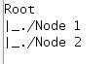
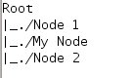
- before insertion - - after insertion -

→ myTree = uiInsertNode(myTree, '1.3', mySubTree3)
Will insert the node 'mySubTree3' into 'myTree', at the position '1.3'
→ myTree = uiInsertNode(myTree, myParentNode, mySubTree3)
Will insert the node 'mySubTree3' into the parent node 'myParentNode' of 'myTree'.

* Deletion in a tree :
Tree uiDeleteNode(tree, position)
Tree uiDeleteNode(tree, node)

Deletion of a node (subTree) from a tree.

Input : we should specify the tree in which we want to delete,
the deletion position OR the node we want to delete,
- tree will be of type Tree
- position will be of type of string
- node will be of type Tree

Output : will return a Tree without the deleted node.

Note : - if we have 3 nodes each one at position 1.1, 1.2, & 1.3, deletion of node at position 1.2 will give (position of 'Node 3' will become 1.2) :
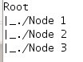
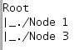
- before deletion - - after deletion -

- cf. warning & error messages

→ myTree = uiDeleteNode(myTree, '1.3')
Will delete the node 'mySubTree3' from the tree 'myTree'.
→ myTree = uiDeleteNode(myTree, mySubTree3)
Will delete the node at the position '1.3' from the tree 'myTree'.

* Printing the tree in the console or in the Graphic User Interface:
uiDumpTree(tree, [b]) {text display}
uiDisplayTree(tree) {GUI display}

Display of a tree.

Input : we should specify the tree we want to display.
- tree will be of type Tree
- b will be of type boolean

Output : nothing, will only display the given tree.

Note : - the boolean argument (optional) in uiDumpTree function will allow or not to display feature of each node (icon path, callback), default value is false.
- cf. warning & error messages

→ uiDumpTree(myTree, b)
→ uiDisplayTree(myTree)

Ex: 'b' equals %F 'b' equals %T

tree1 tree1
|_./ node1 |-- 'iconPath\iconTree1.jpg'
|_./ node1.1 |-- 'tree1Callback()'
|_./ node1.2 |_./ node1
|_./ node2 |-- 'iconPath\iconNode1.jpg'
|-- 'node1Callback()'
|_./ node1.1
|-- 'iconPath\iconNode11.jpg'
|-- 'node11Callback()'

* Concatenation of trees :
Tree uiConcatTree(tree1, tree2)

Concatenation of tree2 with tree1.

Input : we should specify the trees we want to concatenate.
- myTree1 will be of type Tree
- myTree2 will be of type Tree

Output : will return a Tree with the concatenation of tree1 & tree2.

Note : - the concatenation will took place at the parent level of tree1.
- cf. warning & error messages

→ myTree1 = uiConcatTree(myTree1, myTree2)

Will concatenate tree2 into tree1.
Ex: tree1 tree2 => tree1
|_./ node1 |_./ myNode1 |_./ node1
|_./ node1.1 |_./ myNode2 |_./ node1.1
|_./ node1.2 |_./ node1.2
|_./ node2 |_./ node2
|_./ tree2
|_./ myNode1
|_./ myNode2
* Parent of a node:
Tree uiGetParentNode(tree, node)
Tree uiGetParentNode(tree, position)

Finds the parent of a specific node.

Input : we should specify the trees we use,
the node OR the position of the node we want to get the parent.
- tree will be of type Tree
- node will be of type Tree
- position will be of type string

Output : will return a Tree which is the parent of the given node.

Note : cf. warning & error messages

→ myParentNode = uiGetParentNode(myTree, mySubTree2)
Will return the parent node of the node 'mySubTree2'.
→ myParentNode = uiGetParentNode(myTree, '1.2')
Will return the parent node of the node at position '1.2'.

* Children of a node:
children uiGetChildrenNode(tree, node)
children uiGetChildrenNode(tree, position)

Finds the children of a specific node.

Input : we should specify the trees we use,
the node OR the position of the node we want to get children.
- tree will be of type Tree
- node will be of type Tree
- position will be of type string

Output : will return a list containing children of the given node.

Note : cf. warning & error messages

→ childrenNodeList = uiGetChildrenNode(myTree, myParentTree)
Will return children node(s) of node 'myParentTree'.
→ childrenNodeList = uiGetChildrenNode(myTree, '1')
Will return children node(s) of node at position '1'.
* Find a node:
nodeList uiFindNode(tree, node)
nodeList uiFindNode(tree, position)
nodeList uiFindNode(tree, 'property', 'value')

Finds node(s) in the tree.

Input : we should specify the trees we use,
the node OR the position of the node we want to get the parent,
OR a node property and his value.
- tree will be of type Tree
- node will be of type Tree
- position will be of type string
- property will be of type string
- value will be of type string

Output : will return a list of matching node(s).

Note : cf. warning & error messages

→ myNodes = uiFindNode(myTree, mySubTree2)
→ myNodes = uiFindNode(myTree, '1.2')
→ myNodes = uiFindNode(myTree, 'text', 'Node 2')

Will return a list of matching node.
Here it will return 'myNodes = list(mysubTree2)'.

* Get the position of a node:
[position1,position2,..,positionN]uiGetNodePosition(tree,node)

Get the position of a given node.

Input : we should specify the trees we use,
the node we want to get the position
- tree will be of type Tree
- node will be of type Tree

Output : will return a matrix of string which contains node(s) position(s).

Note : cf. warning & error messages

→ myNodePosition = uiGetNodePosition(myTree, mySubTree2)

Will return myNodePosition = ['1.2'] for the matched node 'mySubTree2.
* Comparing two trees:
boolean uiEqualsTree(tree1, tree2)

Compare two trees structures.

Input : we should specify trees we want to compare,
- tree1 will be of type Tree
- tree2 will be of type Tree

Output : will return a boolean which indicate if those trees are equal or not.

Note : cf. warning & error messages

→ isEqual = uiEqualsTree(myTree1, myTree2)

Will return isEqual = true if myTree1 equals myTree2.

Warnings & error messages :

* Insertion into the tree
- if the tree doesn't exist it returns an error message.
- if the input 'parentNode' matches with more than one node of the tree,
a warning message will be returned (with all matching nodes).
- if parentNode doesn't exist it returns an error message.
- if position already exists it returns an error message.
- if last position index in the tree is 1.2, insertion of a node with the position 1.5 will return an error message (the right position to insert will be 1.1 or 1.2 or 1.3).

* Deletion in a tree :
- if the tree doesn't exist it returns an error message.
- if the node doesn't exist it returns an error message.
- if the input node matches with more than one node of the tree,
a warning message will be returned (with all matching nodes).
- if the position doesn't exist it returns an error message.

* Printing a tree :
- if the tree doesn't exist it returns an error message.

* Concatenation of trees :
- if the tree1 OR tree2 doesn't exist it returns an error message.

* Parent of a node :
- if the tree doesn't exist it returns an error message.
- if the node doesn't exist it returns an error message.
- if the position doesn't exist it returns an error message.

* Children of a node :
- if the tree doesn't exist it returns an error message.
- if the input 'node' matches with more than one node of the tree,
a warning message will be returned (with all matching nodes).
- if the node doesn't exist it returns an error message.
- if the position doesn't exist it returns an error message.

* Find a node :
- if the tree doesn't exist it returns an error message.
- if the input 'node' matches with more than one node of the tree,
a warning message will be returned (with all matching nodes).
- if the node doesn't exist in the tree it returns an empty matrix.
- if the position doesn't exist it returns an error message.
- if the input 'property' is wrong it returns an error message.
- if property's value doesn't matches with any node it returns an empty list of Tree.

* Get the position of a node :
- if the tree doesn't exist it returns an error message.
- if the input 'node' matches with more than one node of the tree,
a warning message will be returned (with all matching nodes).
- if the node doesn't exist in the tree it returns an empty matrix of string.

* Comparing two trees :
- if the tree1 OR tree2 doesn't exist it returns an error message.

In Java's side :

We will use the Jtree component.
The tree will have nodes and leaves and each of them will have :
- text
- icon (java supported image)
- callback

icon

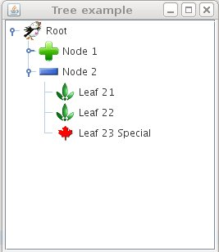
- preview of a tree -
text
node developper

User interaction description :
 | Click |  | Double-click
Node type | Leaf | Node | Leaf | Node
text | Select the node |  | Select the node | Open or close the node
text |  |  | Execute the node's callback
icon | Select the node |  | Select the node |  | Open or close the node
icon |  |  | Execute the node's callback
node developper | Open or close the corresponding node |  | The same effect of 2 single clicks

If we close and re-open a node, previously opened sub-nodes will be memorized.

Usage examples
Scilab's side
We should first create nodes before creating a tree.
Note : the icon argument could be :
  - empty string : no icon for this node
  - 'default' : according to the status of the node (node (have 2 icons : open/close) or leaf (default leaf icon))
default icons names will be into an XML file (configuration.xml)
  - 'iconPath\icon.jpg' : icon path.

Creation of the node 'root'.
root = uiCreateNode('Root', 'path\rootImage.jpg', 'rootCallback')
Creation of the node 'node1'.
node1 = uiCreateNode('Node 1', 'default', 'node1Callback')
Creation of the node 'node2'.
node2 = uiCreateNode('Node 2', 'default', 'node2Callback')
node1 & node2 don't have children so, they are considerate like leaves.

Creation of the tree with our nodes, here node 'root' has 2 children 'node1' & 'node2'.
myTree = uiCreateTree(root, node1, node2)

Display our tree (GUI display).
uiDisplayTree(myTree)
Display our tree (text display).
uiDumpTree(myTree, %f)

Java's side

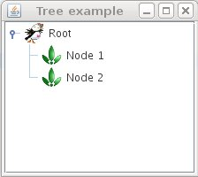
- uiDisplayTree(myTree) - - uiDumpTree(myTree, %f) -

For node1 & node2 because of their status 'default' icon is a leaf.
And we have set an icon for root.

Scilab's side
Populating node1.
Creation of the nodes 'leaf11', 'leaf12' & 'leaf13'.
leaf11 = uiCreateNode('Leaf 1.1', 'default', 'leaf11Callback')
leaf12 = uiCreateNode('Leaf 1.2 (without icon)', 'null', 'leaf12Callback')
leaf13 = uiCreateNode('Leaf 1.3 (my icon)', 'myIconPath\myIcon.jpg', 'leaf12Callback')
Insertion of leaf11, leaf12 & leaf13 into node1.
myTree = uiInsertNode(myTree, node1, leaf11)
myTree = uiInsertNode(myTree, node1, leaf12)
myTree = uiInsertNode(myTree, node1, leaf13)

Display our tree (GUI mode).
uiDisplayTree(myTree)
Display our tree (text display).
uiDumpTree(myTree, %f)

Java's side
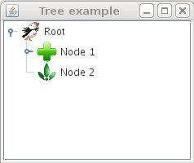
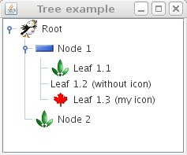
GUI display
- node 1 closed - - node 1 opened -

Text display
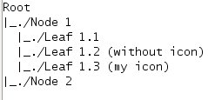
- node 1 closed - - node 1 opened -

We have populate node1, so node1 is no more a leaf, it has become a node.
A node has 2 default images (node open (minus icon) & node close (plus icon)).

Scilab's side
Deletion of a node.
myTreeDel = uiDeleteNode(myTree, node2)
Display our tree (GUI mode).
uiDisplayTree(myTree)
uiDisplayTree(myTreeDel)
Display our tree (text display).
uiDumpTree(myTree, %f)
uiDumpTree(myTreeDel, %f)

Java's side
GUI display
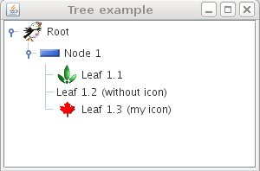
- myTree - - myTreeDel -

Text display
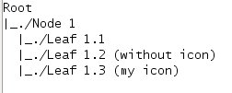
- myTree - - myTreeDel -

node2 has been deleted.

Scilab's side
Concatenation of a tree.
We have to create myTree2 like we have created myTree.
myTree = uiConcatTree(myTree, myTree2)
Display our tree (GUI mode).
uiDisplayTree(myTree)
Display our tree (text display).
uiDumpTree(myTree, %f)

Java's side
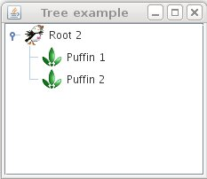
GUI display
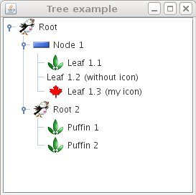
- myTree - - myTree2 -

- myTree, concatenation of myTree & myTree2 -

Text display
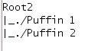
- myTree - - myTree2 -
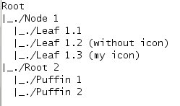
- myTree, concatenation of myTree & myTree2 -
Parent & Children nodes

Search parent node of node 'leaf13'
parentNode = uiGetParentNode(myTree, leaf13)
will return 'parentNode = node1'

Search children node(s) of node 'node1'
childrenNodeList = uiGetChildrenNode(myTree, node1)
will return 'childrenNodeList = list(leaf11, leaf12, leaf13)'

Find a node

Creation of a node
myNode = uiCreateNode('Node 1')

Find if myTree contains myNode
result = uiFindNode(myTree, myNode)
will return 'result = list(node1)'

Find node at position '1.1'
result = uiFindNode(myTree, '1.1')
will return 'result = list(node1)'

Find node where 'text' equals 'Node 1'
result = uiFindNode(myTree, 'text', 'Node 1')
will return 'result = list(node1)'

Get the position of a node

Get the position of the node 'node1'
myNodePosition = uiGetNodePosition(myTree, node1)
will return 'myNodePosition = ['1.1']'

Compare 2 trees

Creation of the node 'root'.
root = uiCreateNode('Root', 'path\rootImage.jpg', 'rootCallback')
Creation of the node 'node1'.
node1 = uiCreateNode('Node 1', 'default', 'node1Callback')
Creation of the node 'node2'.
node2 = uiCreateNode('Node 2', 'default', 'node2Callback')
Creation of trees with our nodes, here node 'root' has 2 children 'node1' & 'node2'.
myTree1 = uiCreateTree(root, node1, node2)
myTree2 = uiCreateTree(root, node1, node2)

Compare myTree1 with myTree2
isEqual = uiEqualsTree(myTree1, myTree2)

will return 'isEqual = T'

Changelog

  - – Sylvestre Koumar <sylvestre.koumar@scilab.org> Initial version
  - – Sylvestre Koumar <sylvestre.koumar@scilab.org> Update of functions names & uiEqualsTree function added

Copyright
This document has been placed under the license CeCILL-B.

