SEP # : 16

Title: anti-aliasing
Version: 1.1
Author: JB Silvy
Review:
Commented:
State: Draft
Scilab-Version: 5.2
Vote:
Created: Tuesday, 17 February 2009
Modified: Tuesday, 21 April 2009

Abstract
In this SEP, we discuss the introduction of full screen anti-aliasing (FSAA) to enhance Scilab Graphics image quality. When used in Scilab, anti-aliasing would allow to remove staircase artifacts that appears in Scilab Graphics, especially for polylines. For more information on anti-aliasing in general, see [1].

Background

All Scilab versions until Scilab 5.1 are not able to activate full screen anti-aliasing. However, most of software having visualization capabilities use it to enhance their graphics quality. They have consequently an advantage upon us. Matlab does not have such a feature by default but some toolboxes [2] provide it. Anti-aliasing has also been requested in our bug data base [3].

Rationale
FSAA enhances image quality but also decreases graphic performances. When FSAA is activated, it also comes with a quality setting. The higher the setting, the better the quality, but also the lower are the performances. Practically, there are nowadays 4 standard settings which are “2x”, “4x”, “8x” and “16x”. The “4x” and “8x” are the more commonly used settings. With “2x”, the difference with no anti-aliasing is barely noticeable. The difference between “8x” and “16x” is also barely noticeable. Consequently, “4x” represents a good compromise between speed and quality whereas “8x” stands for the best quality.

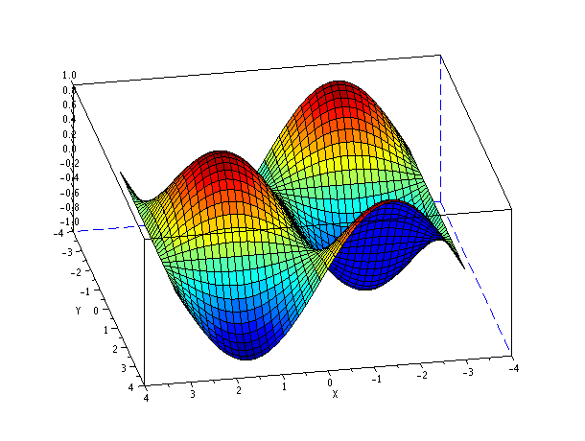
Figure 1: Result of plot3d() in Scilab without anti-aliasing.
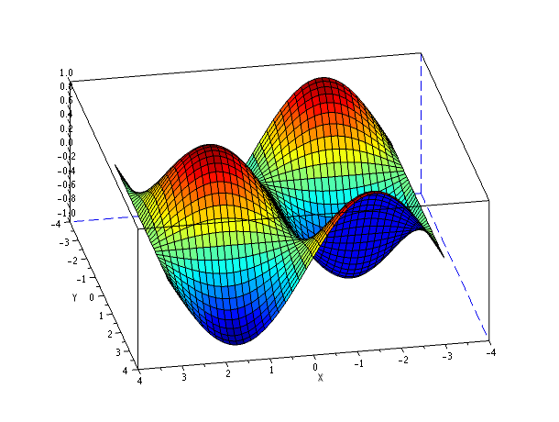
Figure 2 : Result of plot3d() in Scilab with anti-aliasing 4x.
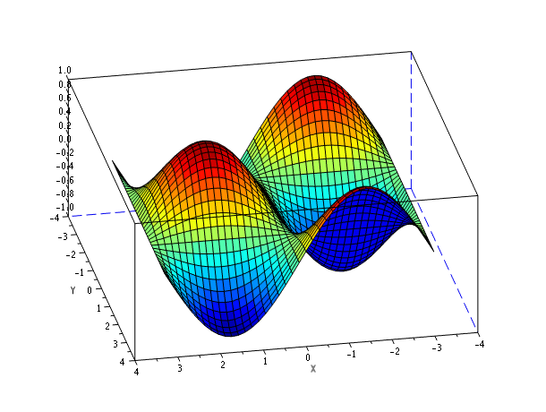
Figure 3 : Result of plot3d() in Scilab with anti-aliasing 8x.

From Scilab, the anti-aliasing will be controlled per figure. A property “anti_aliasing” will be added to figure handles. This property value can be one of the following: “off”, “2x”, “4x”, “8x”, “16x”. If the property is set to “off”, anti-aliasing is disabled. Otherwise, the value stands for the anti-aliasing quality.
An other approach would be to have only two or three possible values, more understandable by the user. The value could be chosen between “off” or “on” (current setting quality to “4x”) or between “off”, “performance” (quality “4x”) and “quality” (quality “8x”).
By default, the anti_aliasing will be turned off to avoid speed loss in already existing Scilab codes (such as Scicos). However, the default can be changed by modifying the default figure.

Limitations
As any OpenGL/JOGL development, this feature should be widely tested on different architectures. This will avoid bad surprises on low end computers.
Moreover, anti-aliasing might not be supported by a few graphic configurations. In this case a warning will be send to the user that anti-aliasing won't work on his configuration.

Implementation
In OpenGL, there is two common ways of enabling anti-aliasing: multisampling [4] or by using the Accumulation buffer [5]. Doing anti-aliasing by using accumulation buffer is an older, slower but more robust technique. Basically, in this mode the scene must be rendered as many time as the quality setting (for example 4x quality is almost twice slower than 2x quality). However, it is part of the OpenGL 1.0 specifications and is then available on all OpenGL implementations. On the contrary, multisampling is faster but not well supported by old or low-end graphic cards. It is part of the OpenGL 1.3 specifications. For instance, it is not available on Windows default OpenGL implementation. Moreover, even if Intel drivers support OpenGL 1.3 and multisampling is available, it just does not work. An other drawback of multisampling is that it does not applies on textures.

Antialiasing mode | off | 2x A | 4x A | 8x A | 16x A | 2x M | 4x M | 8x M | 16x M
Config 1 / GLJPanel / small | 57.0 | 33.3 | 23.5 | 14.5 | 8.2 | 7.3 | 49.3 | - | -
Config 1 / GLCanvas / small | 94.7 | 65.5 | 41.3 | 23.5 | 12.7 | 92.3 | 75.0 | - | -
Config 1 / GLJPanel / large | 25.9 | 15.4 | 10.8 | 6.8 | 3.9 | 21.3 | 3.5 | - | -
Config 1 / GLCanvas / large | 69.2 | 25.9 | 15.3 | 8.4 | 4.4 | 50.0 | 26.5 | - | -
Config 2 / GLJPanel / small | 90.0 | 72.0 | 55.4 | 37.5 | 22.2 | 90.0 | 94. | 83.7 | -
Config 2 / GLCanvas / small | 60.0 | 60.0 | 60.0 | 60.0 | 30,3 | 180.0 | X | X | X
Config 2 / GLJPanel / large | 43.9 | 32.7 | 25.3 | 17.1 | 10.4 | 43.4 | 40.1 | - | -
Config 2 / GLCanvas / large | 60.0 | 60.0 | 30.0 | 20.0 | 12.0 | X | X | X | X
Config 3 / GLJPanel / small | 81.9 | 47.4 | 31.9 | 19.1 | 10.7 | 67.9 | 53.7 | 37.9 | 13.0
Config 3 / GLCanvas / small | 60.0 | 59.0 | 50.1 | 29.5 | 14.8 | 59.0 | 59.0 | 59.0 | 29.3
Config 3 / GLJPanel / large | 43.4 | 24.2 | 16.3 | 9.8 | 5.5 | 35.6 | 27.1 | 14.2 | 3.6
Config 3 / GLCanvas / large | 60.0 | 29.5 | 29.5 | 14.9 | 8.5 | 59.0 | 47.4 | 29.0 | 7.0
Config 4 / GLJPanel / small | 58.0 | 39.6 | 28.3 | 18.0 | 10.3 | 53.7 | 45.6 | - | -
Config 4 / GLCanvas / small | 124.1 | 97.3 | 60.0 | 33.0 | 17.5 | 163.6 | 116.1 | - | -
Config 4 / GLJPanel / large | 29.8 | 19.3 | 14.1 | 9.0 | 5.2 | 26.5 | 21.6 | - | -
Config 4 / GLCanvas / large | 75.0 | 45.0 | 26.7 | 14.8 | 7.7 | 78.3 | 43.9 | - | -
Config 5 / GLJPanel / small | 6.3 | 5.8 | 2.9 | 1.6 | 0.70 | - | - | - | -
Config 5 / GLCanvas / small | 63.2 | 4.9 | 2.5 | 1.3 | 0.65 | - | - | - | -
Config 5 / GLJPanel / large | 2.9 | 2.0 | 0.99 | 0.48 | 0.23 | - | - | - | -
Config 5 / GLCanvas / large | 39.6 | 1.4 | 0.77 | 0.38 | 0.20 | - | - | - | -
Tableau 1: Average frame per second during a 360° rotation of the plot3d demo.

A : Accumulation buffer
M : Multisampling

- : Mode not available on the configuration
X : Mode corrupting graphic display (bug)

Config 1 : Intel Pentium D 3.4Ghz / Quadro NVS 285 / OpenSuse 11.0
Config 2 : Intel Pentium Core 2 6600 / Quadro FX 550 / Win XP64
Config 3 : Intel Pentium Core 2 T7200 / Quadro NVS 110M / Win XP
Config 4 : Intel Pentium Core 2 T7200 / Quadro NVS 110M / OpenSuse 11.1
Config 5 : Intel Pentium 4 3.0Ghz / Intel 82865 G / Win XP

small : 610 x 460 3D canvas
large : 1000 x 1000 3D canvas

Table 1 contains results of benchmarks ran on different architectures. Detailed explanations of the benchmarks protocol can be found in appendix. As expected mutlisampling is not very well supported on all configurations. On the Windows XP 64 computers, it even corrupts the display. Surprisingly, it is not always much faster than the accumulation buffer method.

Apparently, anti-aliasing with the accumulation buffer is the only method which is robust enough to be introduced in Scilab. According to the benchmarks, its activation degrades performances almost linearly with the quality setting. With a simple scene like the plot3d demo, it remains usable even with in the highest quality on most configurations. However, with Intel graphic cards or with complex plot, anti-aliasing activation is clearly not possible.

Example Usage
// setting anti-aliasing by default
df = gdf();
df.anti_aliasing = “4x”;
plot();

// changing anti_aliasing quality
f = gcf();
f.anti_aliasing = “16x”;
f.anti_aliasing = “off”;

Changelog
  - – Initial Revision
  - – Benchmarks added

Copyright
This document has been placed under the license CeCILL-B.

Bibliography

[1] Wikipedia – Anti-aliasing entry, http://en.wikipedia.org/wiki/Anti-aliasing
[2] Myaa - My Anti-Alias for Matlab, http://www.mathworks.com/matlabcentral/fileexchange/20979
[3] S. Ledru - Scilab Bug 2984 , http://bugzilla.scilab.org/show_bug.cgi?id=2984
[4] Wikipedia - Multisample anti-aliasing, http://en.wikipedia.org/wiki/Multisample_anti-aliasing
[5] Siggraph 99 – Advanced techniques course, http://www.opengl.org/resources/code/samples/sig99/advanced99/notes/node124.html

Appendix
Benchmark code:
function time = bench(axes)
tic();
for i = 1:360,
axes.rotation_angles(2) = i
end
time = toc();
endfunction
usecanvas(%t) // %t or %f depending on the test
f = gcf();
f.axes_size = [1000,1000]; // or [610, 460] depending on the test
a = gca();
plot3d();
f.anti_aliasing = "off";
disp(bench(gca()));
f.anti_aliasing = "2x";
disp(bench(gca()));
f.anti_aliasing = "4x";
disp(bench(gca()));
f.anti_aliasing = "8x";
disp(bench(gca()));
f.anti_aliasing = "16x";
disp(bench(gca()));
Configuration:
The code above was run on different configurations detailed in Table 1. To be able to switch between the two anti-aliasing methods, we used a compiled version of the Scilab master. Actually, the two methods are already included in Scilab master branch, two lines must be commented to switch between the two. Moreover, these versions were compiled with debug mode. Slightly better results can be expected on a binary version.
Depending on the configuration, the benchmarks might not be run on exactly the same Scilab revision. However, the same revision is used for all the benchmarks on a specific configuration. Moreover, it should not impact performances since only minor modifications were applied on the master branch at that time.

Protocol:
The code above was copy pasted in the Scilab console. The results were converted in frame per second by dividing the elapsed time by 360. During the benchmarks and on a specific configurations, exactly the same applications were running (anti-virus, compilation environment,..).

