SEP #48: Scilab Preferences

Title: Scilab preferences
Version: 1
Author: Sylvestre Koumar – sylvestre.koumar@scilab.org
Review:
Commented:
State: Draft
Scilab-Version: 5.X
Vote: « No: discussions and suggestions »
Created: Monday, 2nd June 2010

Abstract
This SEP proposes to create Scilab Preferences. This feature will allow the user to configure all relevant tools in Scilab through a centralized preference system.
For practical and ergonomic reasons Scilab Preferences will evolve through 2 modes:

- graphical mode
- command line mode

This SEP will be dedicated for the graphical mode. Command line mode will be handled in another SEP.

Current preferences management

The current preferences management of Scilab and its tools is dispatched. Each tool has a proper preference control window.

So, the aim of this SEP is to create a preference management system which will make possible the configuration of Scilab and its tools.
Also new settings will be added to manage parameters which are not handled in Scilab.

SCILAB PREFERENCES

General Presentation

Today Scilab configuration is done through the menu Preferences of the Scilab console and most of the other tools have their own preference window:

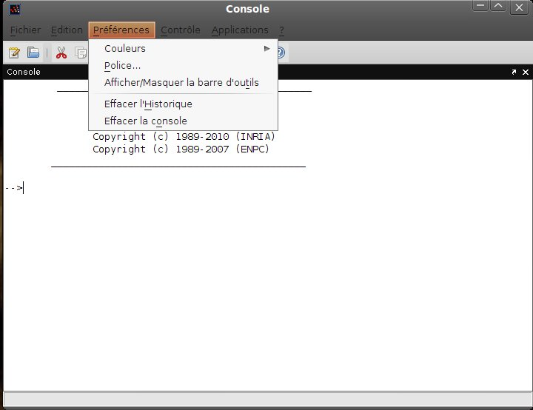

This menu will no more exist in the new Preference System. Instead a new menu item “Preferences” will be created in the menu Edit.

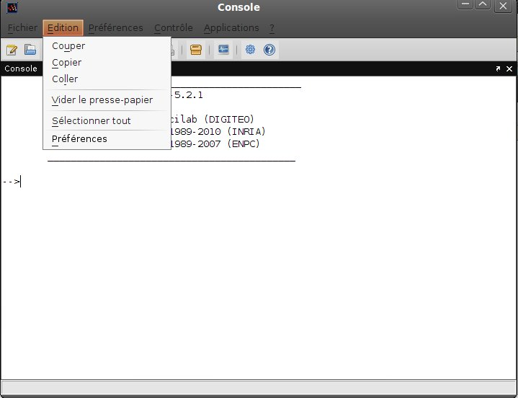

The menu item “Preferences” will open the following Scilab Preferences window.

General Preferences
General
x
Scinotes

y
Console
General Preferences Settings
a
b
c
d

...

Help
Default
Cancel
OK
Apply

As expressed previously, all the preferences will be centralized in the window above. Thus preferences for Scilab and its tools will be available through the arborescence located at the left of the Scilab Preferences window. For each element of the arborescence will correspond a settings panel.

Preferences Organization

The arborescence will be organized in the following way:

- General
- Confirmation Dialogs
- Shortcuts
- Tab Completion
- Current Directory

- Fonts

- Colors

- Console

- Command History

- Scinotes
- Display
- Tab
- Language
- Autosave

- Help

- Variable Browser

- Variable Editor

- Xcos

- Toolbars

- Toolboxes

General

- General
- Confirmation Dialogs
- Shortcuts

General Preferences

Environment
width:
10
Floating point exception:
Produces an error

Printing format:
short
Java Heap Memory

The Java Heap Memory is the memory available for Java objects (default value: 128MB).
Increasing this value may help you avoid “OutOfMemoryError: Java heap space” errors.

MB
128

128
1024
256
512
768

Environment

Floating point exception:
Points out what Scilab will return for a floating point exception.
Values:
- Produces an error
- Produces a warning
- Produces Inf or Nan
Will be represented with a combo box.

Printing format:
Selection of the printing format.
Values: short, long, short e, long e, short g, long g, variable format
Will be represented with a combo box.

Width:
Sets the width of the printing format.
Will be represented with a spinner.

General Confirmation Dialogs

- General
- Confirmation Dialogs
Allows to sort tools in alphabetical order
- Shortcuts

General Confirmation Dialogs Preferences

The following dialog boxes require user confirmation. Select a check box if you want that dialog box to appear.

State
Dialog Box Description
Tool

Warn before deleting Command History itemsCommand History
Warn before clearing the ConsoleConsole
Prompt when editing files that do not existScinotes

.
.
.

Select All
Clear All

Scilab and its tools possess a certain number of dialog boxes which requires user confirmation, so the user can choose which one to show or not. If the user want a dialog box to appear, he has to check the check box (State) for the corresponding dialog box. Otherwise the dialog box will not be displayed.

General Shortcuts

- General
- Confirmation Dialogs
- Shortcuts

General Shortcuts Preferences

Active settings:
Scilab

Shortcut keys
Shortcut
Search by action name or shortcut

Action name
Console
Execute... CTRL + E
Open a file CTRL + O
.
.
.
Scinotes
New... CTRL + N
Open... CTRL + O
.
.
.
.
.

Restore Defaults

Active Settings:
Allows the user to select a shortcut configuration.
Values:
- Scilab (default configuration)
- Emacs
- Browse... (will open a file chooser to select a shortcut configuration file)
Will be represented with a combo box.

Shortcut keys:
This text bar allows the user to search a shortcut in the belove table. Typing in the research bar will find the corresponding shortcuts (same effects of the completion).

Shortcut table:
This table displays shortcuts per Scilab tools (column “Action Name”). The column “Shortcut” is editable, the user has to click on the shortcut he wants to change and type the new shortcut.

Restore Defaults:
If an existing shortcut configuration has been changed, this button will restore the shortcut to the default one.

Fonts

- Fonts

Fonts Preferences

Desktop Font

Times New Roman
Plain
10
Use system font
Desktop text font

Sample
Puffins are cool!1234567890.

Console
Command History
Variable Browser
Help
Scinotes
Variable Editor
Font to use
Custom Font
Desktop text font

Custom:
Times New Roman
10
Plain
Sample
Puffins are cool!1234567890.

Desktop Font

Corresponds to the general font of Scilab environment. Default font is the system font.
While the “Use system font” check box is checked the “Desktop text font” parameters are disabled but they display the system font parameters.
Though the user can change the Scilab environment font (unchecked “Use system font” check box = enables “Desktop text font” parameters), by changing parameters of “Desktop text font”.

Desktop text font parameters:
- font (available fonts)
- font type (Plain, Bold, Italic, Bold Italic)
- font size (available font sizes)

With the “Sample” we can have an outline while we change Desktop text font parameters.

Custom Font

Here the user can custom font for each Scilab tools. The default font for all Scilab tools is the “Desktop text font”.
While the “Desktop text font” radio button is selected the “Custom” parameters are disabled but they display the “Desktop text font” parameters.
If the user wants to change the font for a Scilab tool, he has to select a tool from the list, then select the radio button “Custom” (will enable “Custom” parameters).

Custom parameters:
- font (available fonts)
- font type (Plain, Bold, Italic, Bold Italic)
- font size (available font sizes)

With the “Sample” we can have an outline while we change Custom parameters.

Colors

- Colors

Colors Preferences

Desktop Color

Use system color
Text
Background
Cursor

Syntax highlighting colors
Sample
Color
Default
Errors
Item
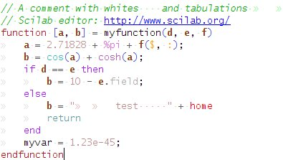
Strings
Macros

Commands

Functions
Variables

Operators

Comments
...
Restore Default Settings
Bold
Underline
Strinke Through

Italic

Desktop Color

Corresponds to the general color of Scilab environment. Default color is the system color (in general colors are: black text on white background and black color cursor).

While the “Use system color” check box is checked the “Text”, “Background” and “Cursor” parameters are disabled.
Though the user can change the color of the Scilab environment (unchecked check box = enables “Text”, “Background” and “Cursor” parameters), by changing colors of “Text”, “Background” and “Cursor”.

What happens when the user clicks on the color button?

Will appear the following panel of color allowing the user to choose a color directly from this one:

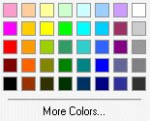

If the user do not find the color of his choice, a click on “More Colors...” will open the following window (default Java color chooser):
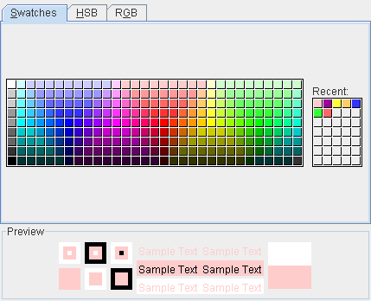

We will generalize this color selection model for all color selection of the Scilab environment.

Syntax highlighting colors

Defines the syntax highlighting colors. For the moment it concerns mainly Scilab's Scinotes but we can imagine that later we can color the text in the other tools of Scilab (Scilab Console, Command History, examples of Scilab Help,...).
Item which can be colored are organized in a list where the user can select color for each items. Add to this, the user can also define to put the selected item in bold, italic, underlined, strike through (an item can mix these different modes).

With the “Sample” we can have an outline while we change the the syntax highlighting colors. Clicking on an element of the sample will report to the item of the item list.
Example: If the user clicks on the comments of the sample, focus will be put on “Comments” of the item list.

Button “Restore Default Settings” will restore the default Scilab syntax highlighting colors.
Console

- Console

Console Preferences

Display
Wrap lines
Number of lines in console scroll buffer:
Lines to display:
Columns to display:
50
100

Tab size:
4
Accessibility
3000

To enable keyboard navigation with arrow keys, assign shortcuts to the Cursor Up and Cursor Down actions in the Shortcuts panel (for Console).

To enable or disable the completion, assign a shortcut action in the Shortcuts panel (for Console). Default shortcut for completion is Tab.

Display

Wrap line:
Enables or disables the line wrapping in the console.
Will be represented with a check box.

Lines and Columns to display:
Allows the user to select how many lines and columns will be displayed in the Console.
Will be represented with spinners.

Tab size:
Sets the tab size in the Console.
Will be represented with a spinner (allowed values: [0, 999]).

Number of lines in console scroll buffer:
Sets the number of lines in console scroll buffer.
Will be represented with a spinner.

Accessibility

The console can remember the executed statements (the number of statements to remember is defined in “Number of lines in console scroll buffer”).
Instead of rewriting statements or recalling an executed statement with the Command History, the user can get back these executed statements directly in the Console by using shortcuts.
Here through the link “Shortcuts panel” we propose to the user to define shortcuts to call back executed statements. Default shortcuts are “up” and “down” arrows respectively for previous and next statement.

In the same way completion is available with the console, and the user can set a shortcut for the completion. Here through the link “Shortcuts panel” we propose to the user to define shortcuts for the completion. Default shortcut is “Tab”.

If the user wants to write tabulations in the console, he will have to change the shortcut (example: change “Tab” to “Ctrl + Space”) so tabulations will be available in the console.

Command History

- Command History

Command History Preferences

Saving
Save after
1
command(s)
Save history file on quit

Disable history management

Settings
Save consecutive duplicate commands

History file:
/home/user/.Scilab/scilab5/history.scilab
Browse...

History lines:
1000

Saving

Sets the saving mode of the history file. Default Scilab saves after 1 command.
Will be represented with radio buttons and the selection of the number of commands will be represented with a spinner.

The user can decide if Scilab saves consecutive duplicate commands.
Will be represented with a check box.

Settings

The user can select the Scilab history file where the commands will be saved.
The text field will contain the path of the history file.
Button “Browse...”will open a file chooser.

The user can set the maximum number of line to save in the history file.
Will be represented with a spinner.

Scinotes

- Scinotes
- Display
- Syntax
- Autosave

Scinotes Preferences

Opening files in Scinotes

On restart reopen files from previous Scilab session

Automatic file changes
Reload unedited files that have been externally modified
Add line termination at end of file

Recently used file list
Number of entries:

5
File encoding
Encoding:
UTF-8

Type:

Opening files in Scinotes
End of file
Unix (LF)
All files which were not closed in Scinotes of the previous Scilab session will be reopened in the next Scilab session.
Will be represented with a check box.

Automatic file changes

Reload unedited files that have been externally modified:
If a file is opened in Scinotes and at the same moment opened elsewhere (another text editor), for all external changes made in the file Scinotes will ask to reload this file (in the form of a message box).
Will be represented with a check box.

Add line termination at end of file:
Add automatically a line termination at end of file.
Will be represented with a check box.

Recently used file list

The user can choose the size of the recently used files list to display (in menu File => Recent files).
Will be represented with a spinner.

File encoding

The user can choose files encoding (current available file encodings in Scinotes).
Will be represented with a combo box.

End of file

The user can choose the type of end of file.
Values:
- Unix (LF)
- Windows/Dos (CR + LF)
- Mac Classic (CR)
Will be represented with a combo box.

Scinotes Display

- Scinotes
- Display
- Syntax
- Autosave

Scinotes Display Preferences

General display options

Highlight current line

Show line numbers
View custom font preferences to change Scinotes font.
Wrap lines

General display options

Highlight current line:
The user can select to highlight or not the current line of Scinotes. If the check box is checked the color button is enabled and the user can select the highlight color otherwise the color button is disabled.
Will be represented with a check box and a button.

Show line numbers:
The user can select to display or not lines numbers.
Will be represented with a check box.

Wrap lines:
Enables or disables the line wrapping in Scinotes.
Will be represented with a check box.

View custom font preferences to change Scinotes font:
Through the link “custom font”, the user will be bring to the “Font preferences” window. There the user will be able to change Scinotes font in the section “Custom font”.

Scinotes Syntax

- Scinotes
- Display
- Syntax
- Autosave

Scinotes Syntax Preferences

Syntax

Enable syntax highlighting Set syntax colors

Highlight corresponding brackets
Tab key inserts spaces
Tabs & Indents
Tab size:
4
Indent size:
View Scinotes tab key preferences
4

Enable automatic indenting

Syntax

Enable syntax highlighting:
The user can enable or disable the syntax highlighting.
Will be represented with a check box.

Through the link “Set syntax colors”, the user will be bring to the “Color preferences” window and can configure the syntax color in the section “Syntax highlighting colors”.

Highlight corresponding brackets:
The user can enable or disable the highlighting on corresponding brackets.
Will be represented with a check box.

Tabs & Indents

Tab size:
The user can select the size of a Tab.
Will be represented with a text field.

Tab key inserts spaces:
The user can configure Tab, so that Tab inserts spaces instead of tabulations.
Will be represented with a combo box.

View Scinotes tab key preferences:
In Scinotes tab key can be plugged to the completion. Through the link “Scinotes tab key” the user will be bring to the “General shortcuts preferences” window. Thus the user will be able to select either tab key equals completion or tabulation.

Indent size:
The user can select the size of indent.
Will be represented with a text field.

Enable automatic indenting:
The user can enable or disable automatic code indenting.
Will be represented with a check box.

Scinotes Autosave

- Scinotes
- Display
- Syntax
- Autosave

Scinotes Autosave Preferences

Save options
Enable autosave in Scinotes

Save every:
5
minutes

Save untitled files
Close option
Automatically delete autosave files

Append filename with:
~
File name
tmp
Replace extension with:

Browse...

Source file directories
Location
Single directory:

Enable autosave in Scinotes:
The user can activate or deactivate automatic save in Scinotes. All the configuration parameters below are enable and can be changed by the user only if this option if checked.
Will be represented with a check box.

Save options

Save every X minute(s):
The user can choose in which time interval the automatic file backup will take place.
Will be represented with a spinner.

Save untitled files:
The user can activate or deactivate the save of untitled files.
Will be represented with a check box.

Close option

Automatically delete autosave files:
Select to delete or not autosave files when the user closes Scinotes.
Will be represented with a check box.

File name

The user can choose the name of the autosave files. Either to put a prefix (example: “~”) to the file name or to give a file extension name (example: “tmp”).
Will be represented with a radio button.

Location

The user can choose the location of the autosave files. Default autosave files are put in the “source file directories”. But the user can choose another place to save autosave files, this will be done through a file chooser (button “Browse...”).
Will be represented with a radio button, a text field and a button.

Help

- Help

Help Preferences

Products Help

Select the products to display in the Help Navigator:
All products
Selected products
Select All
Clear All

Installation
Scilab
“X” Toolbox
Xcos
Release Notes

...

Help Navigator

Display Tooltips

Help manual:
Use local copy

Product Help

Proposes to the user which help product will be displayed in the help navigator.

If the radio button “All products” is selected the help navigator will include all the help products. Besides the help products table and buttons “Select All / Clear All” will be disable.

If the radio button “Selected products” is selected the help navigator will include the help products which will be selected by the user in the help product table (by checking or not the check box of the respective help product). Obviously the help products table and buttons “Select All / Clear All” will be enable.

Help Navigator

Display tooltips:
Enable or disable tooltips display in the help navigator.
Will be represented with a check box.

Help manual:
The user can select which help manual to use:
- Use local copy
- Use online version
Will be represented with a combo box.

Variable Browser

- Variable Browser

Variable Browser Preferences

Variable size

500 000

Maximum array size:

Variable size

Maximum array size:
The user can set the maximum array size. The default value is 500 000 elements.
Any variable exceeding that size reports “<Too many elements>” for this variable in Variable Browser.
Will be represented with a spinner.

Variable Editor

- Variable Editor

Variable Editor Preferences

Format

Default array format:
short

Move selection after Enter

Direction:
Down

International Number Handling

Decimal separator to use when copying:
,

Editing

Format

Default array format:
The user can set the default array format.
Values: short, long, short e, long e, short g, long g, variable format
Will be represented with a combo box.

Editing

The user can enable the move of the cell focus after Enter action.

If enabled: The user can select the move direction (Down, Right, Up or Left).

If disabled: Enter action will not move the focus to the next cell. Direction selection will be disabled.

Will be represented with a check box (enable or disable move action) and a combo box (selection of the move direction).

International Number Handling

The user can select the decimal separator to use when copying. Default is “,”.
Will be represented with a text field.

Xcos

- Xcos

Xcos Preferences

Click the button below to launch the Xcos Preferences window.
Launch Xcos Preferences

Xcos Preferences will be managed in a separate window and will be the object of another SEP.
However Scilab preferences should manage the fact that Xcos is installed or not, respectively display the section “Xcos Preferences” or not.

Toolbars

- Toolbars

Toolbars Preferences

Toolbar:
Scilab

Layout:

Restore default

Launch Scinotes
Controls:
Open file
Cut
...

+

The user can customize some toolbars in Scilab through the Toolbars Preferences.
There is different possibilities, the user can show or hide toolbar's buttons (and other controls) as well as he can change their position on the toolbar.

Toolbar:
The user can select the toolbar he want to customize.
Available toolbars are: Scilab (Console), Scinotes, Command History, Variable Browser,
Variable Editor and Xcos.
Will be represented with a combo box.

Layout:
Displays the layout of the selected toolbar.
To change toolbar's buttons positions the user can directly select an item of the layout and move the item to reposition it (with drag and drop action).

Otherwise, the user can reorganize the selected toolbar through the below buttons :

Restore default
+

Move the selected item to the beginning
Move the selected item to the left or right
Move the selected item to the end
Add separator after selected item (at the end if no selection)
Remove the selected item
Restore the default toolbar layout (enable only if the selected toolbar has been changed)

Controls:
All the items of the selected toolbar will be displayed here. The user can select to show or hide these items (check or uncheck the check box of the corresponding item).

Toolboxes

- Toolboxes

Toolboxes Preferences

Launch Toolbox Preferences

...

myToolbox1
Toolbox:
myToolbox2
myToolbox3

The user can launch toolbox preferences of the installed toolbox. Indeed the selected toolbox must have preferences available.
“Launch Toolbox preferences” button is enable if a toolbox is selected from the toolbox list and if this toolbox has a preferences window, otherwise the button is disable.

However Scilab preferences should manage the fact that at least one toolbox is installed or not, respectively display the section “Toolbox Preferences” or not.

Example Usage

Changelog
1.0 – Sylvestre Koumar <sylvestre.koumar@scilab.org> Initial version

Copyright
This document has been placed under the license CeCILL-B.

