SEP # : 60

Title: CACSD response visualization tools
Version: 0
Author: Serge Steer
Review:
Commented:
State:
Scilab-Version: 5.3
Vote:
Created: April 20, 2010

Abstract
The frequency response visualization tools included in the CACSD module needs to be improved.

Rationale
The Scilab frequency response visualization tools had been developed in the earlier versions of Scilab. From this time only small code adaptations had been made, in particular to follow the evolution of the Scilab graphics.

The revisions proposed, aims to take advantage of the new facilities offered by the graphic and GUI environments to provide a better rendering of the graphs and a better interaction with the user.

Specifications
In a first stage we aims to revisit the basic visualization functions like bode, gainplot, black, nyquist, evans and the associated grids (chart, sgrid, zgrid, m_circle)
- to produce better display. Nyquist currently shows only the part associated with the positive values of the frequency while it is more usual to display positive and negative part as well, the grids rendering is often poor. The evans root locus requires a little improvement for a better view of the points where real roots splits into two complex conjugates pairs.

- to make, as far as possible, the syntax compatible with the Matlab one. The bode, nyquist functions have the same name in Matlab and Scilab so it should be difficult to make them take the Matlab syntax into account. New functions can be developped:
- nichols which is the Matlab equivalent for black (here it is a cultural problem, the full name of these curves is Black-Nichols, french people uses the Black name, while the english ones uses the nichols name)
- rlocus which is the Matlab equivalent for evans
- ngrid which is the Matlab equivalent for chart. Here I should prefer nicholschart which is more meaningful
- The m_circle function should be extended and renamed into hallchart. The Matlab equivalent is a feature of the grid function. This does not seem completely coherent with the existence of the sgrid, zgrid and ngrid functions....
To make this plots more flexible, we indent to add a later input argument, the user can use to pass a specific option data structure used to specify the units, the colors, the labels... Here again we may think to create functions similar to the bodeoptions, nyquistoptions, … Matlab functions reminding that the differences between the graphic environments will not allow a complete compatibility.
- It is also mandatory to provide a better interaction between the curve visualization and the grids. (black/nichols and chart /nicholschart, evans/rlocus and sgrid/zgrid, nyquist and hallchart)
- We also intend to have customized datatips for these plots.
In a second stage, we aims to develop an interactive application for the single input, single output dynamical system compensator design similar to the Matlab sisotool.

Example Usage
New version
s=poly(0,'s');
Plant=syslin('c',16000/((s+1)*(s+10)*(s+100)));
//two degree of freedom PID
tau=0.2;xsi=1.2;
PID=syslin('c',(1/(2*xsi*tau*s))*(1+2*xsi*tau*s+tau^2*s^2));
clf();
O=nicholsoptions();
O.grid='on';
O.grid_colors=[4,12];
O.captions=["Plant";"Plant and PID corrector"]
O.captions_location="in_lower_right";
O.frequency_labels=”on”;
nichols(Plant,'k' Plant*PID ,'b',0.01,100,O);

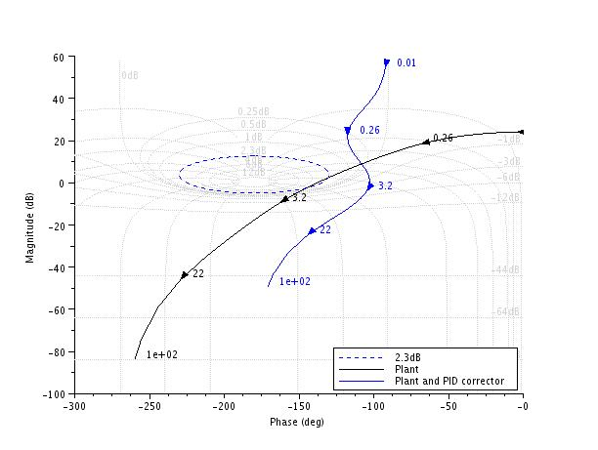
old version
s=poly(0,'s');
Plant=syslin('c',16000/((s+1)*(s+10)*(s+100)));
//two degree of freedom PID
tau=0.2;xsi=1.2;
PID=syslin('c',(1/(2*xsi*tau*s))*(1+2*xsi*tau*s+tau^2*s^2));
clf();
black([Plant;Plant*PID ],0.01,100,["Plant";"Plant and PID corrector"]);
//move the caption in the lower rigth corner
ax=gca();Leg=ax.children(1);
Leg.legend_location="in_lower_right";
chart(list(1))

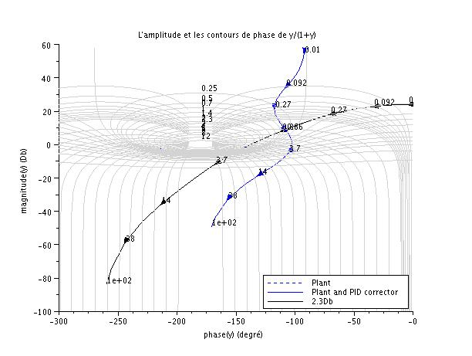
Changelog
  - – initial version

Copyright
Serge Steer INRIA

