SEP #63 : User block wizard
Title: User block wizard
Version: 1.0
Author: Bernard DUJARDIN
Review:
Commented:
State: draft
Scilab-Version: 5.4.0
Vote:
Created:

Abstract
The goal of this document is to propose a user block creation wizard,

Rationale

User blocks . The state of art.

User blocks categorization.
Actually the built-in functions are :
- SUPER_f : block defined by a diagram.
- EXPRESSION : block defined by a mathematical expression.
- MBLOCK : block Modelica generic with direct edition.
- C block: block defined by a C function specified by path.
- C block 2 : block defined by a C function with direct edition.
- Fortran_block: block defined by a Fortran function with direct edition.
- generic_block3: Generic block, the function is defined in C, Fortran or Scilab language.
- scifunc_block_m: Scilab function block.
- PDE: Partial differential equation.
These functions can be set in this main categories in function of the block set up mode:
Set up | Functions
Xcos diagram editor | SUPER_f
Text edition | C block 2, Fortran_block, MBLOCK, EXPRESSION
Dialog box | C block, generic_block3, scifunc_block_m
Specific editor | PDE

A block is defined by :
- Simulation parameters: simulation function, regular or activation input/output sizes and types.
- Appearance : title text (font color), comment text (font, color), border (color) and background (color, icon), etc.
At this state of the art the user's blocks use specific dialogs for their simulation parameters edition. The tables below shows two examples blocs:
Super_f
This block uses the Xcos editor to define its simulation parameters and the general editor appearance possibilities for appearance parameters.
Type | Description | User configuration
Simulation | input/output size | No (Defined by internal block connection)
Simulation | input/output type | No (Defined by internal block connection)
Simulation | input/output event size | No (Defined by internal block connection)
Simulation | Configuration | Yes (By mask or by opening)
Appearance | Comment text | Yes (by dialog)
Appearance | Comment text color | Yes (by dialog)
Appearance | Border color | Yes (by dialog)
Appearance | Bakground color | Yes (by dialog)
Appearance | Icon | Yes (by dialog)
Appearence (diagram) | Orientation | Yes (by dialog)
Appearence (diagram) | Event in/out orientation | Yes (by dialog)
Appearence (diagram) | Regular in/out orientation | Yes (by dialog)

C block 2
This block uses a dialog box to define its simulation parameters and the general editor appearance possibilities for appearance parameters.
Type | Description | User configuration
Simulation | input/output size | Yes (by dialog)
Simulation | input/output type | Yes (by dialog)
Simulation | input/output event size | Yes (by dialog)
Simulation | Configuration | Yes (by dialog)
Simulation | Function definition | Yes (by dialog editor)
Appearance | Comment text | Yes (by dialog)
Appearance | Comment text color | Yes (by dialog)
Appearance | Border color | Yes (by dialog)
Appearance | Background color | Yes (by dialog)
Appearance | Icon | No
Appearance (diagram) | Orientation | Yes (by dialog)
Appearance (diagram) | Event in/out orientation | Yes (by dialog)
Appearance (diagram) | Regular in/out orientation | Yes (by dialog)

Scenaris.
Xcos superbloc :
Actually, the user can create and edit a Super Block by:
- Select SUPER_f in the palette and drag it on the diagram.
- Select an area in a diagram and select Region to Superbloc.
Then, the user edit the block by the short cut Ctrl+B or by menu selection.
Other user blocs:
Select the user bloc and drag it in the diagram. Then, the user edit the block by the short cut Ctrl+B or by menu selection.

Propositions.

User block selection.
We can limit the user's choices based on the categories defined above :
- Xcos_block: classical super bloc definition (SUPER_f).
- Scilab EXPRESSION
- scifunc_block_m
- Function_block: C block 2, Fortran_block, MBLOCK, EXPRESSION, C block, generic_block3,
- PDE ?

Block user parameters (masking)
The Xcos super bloc are the only one where the block creator can define an user's block parameters configuration by masking. We propose to extend this possibility to the other blocks.

Multiple inputs/outputs.
Only the Xcos Super Block and EXPRESSION blocks supports physically independent input/output (input only for EXPRESSION block). We propose to extend this feature to the other blocks.

Scenaris.
At this time, we can give some use case based on the user actions :
Create from scratch:
- The user select a menu item in tools menu : User block project.
- A main block project wizard is presented to the user where he can select the block type, and a project save file.
Add block from palette:
- The block type is known also the main block project wizard don't allows the block type definition.
- The user can define a project save file.

Block project wizard.

Main window.
The wizard must guide the user in block definition. The first step is the definition of the main characteristics of the block: type and name. The mockups below shows a first proposition:
To simplify the user choice, the check box “Show all types” is normally unchecked and the block type selection tree is reduced to the following types: Xcos's super bloc, Project, Scilab expression, Scilab function.
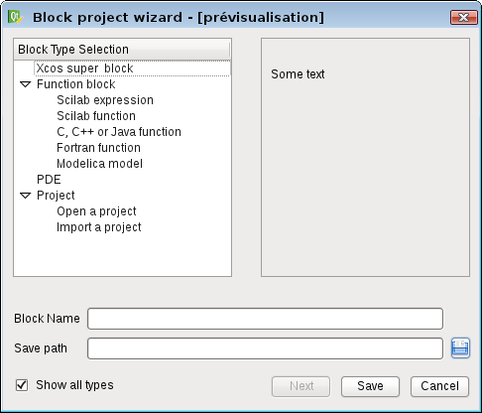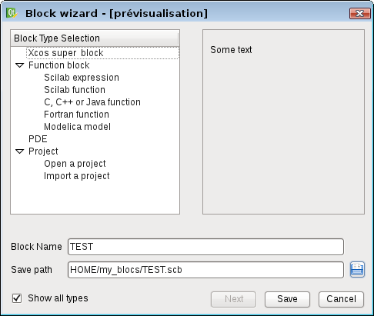
The user can import an existing project as a template of a new block or open an existing project for updating it. The selection of one of these tree items open a file's selection dialog.
The project file is a xml file which can be read with the “Import a project” or “Open a project” tree items.
Create from scratch:
- The user select a block type.
- The user gives a name and a save path for this new block project and continues the block configuration. If the user has selected Open a project, the file and the name are already wrote in edit boxes.
- After these definitions, the block configuration window is shown to the user.
Add block from palette:
- The block is already defined the user cannot change the block type but he can select to Import an existing project. The system must verified the correspondance between the project file and the block type before to accept the importation.
- At this time the user can save its project in a file.
The next paragraphs proposes the specific configuration interfaces for the block types.

Scilab expression wizard.
The mockup below show the dialog for a Scilab expression.
Here it is a simple adaptation of the existing dialog box with a possibility to the user to test its expression in Scilab.
An enhancement is the possibility for the user to test directly its expression in Scilab with a set of data and the Execute button.
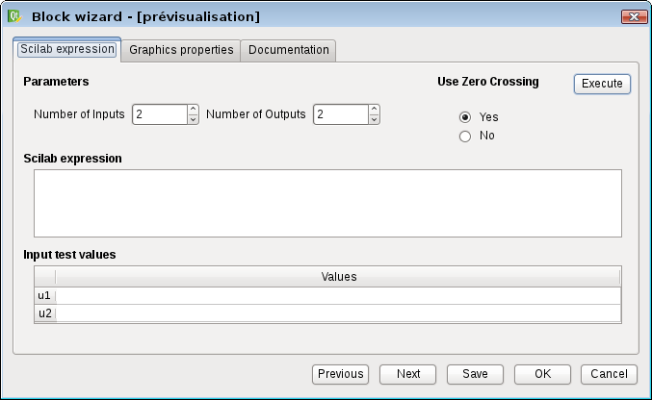
Enhancements:
- Add a “Number of outputs” parameters : the user provides outputs in the form y1= ..., y2 = …
- Add a user block parameter configuration with masking.
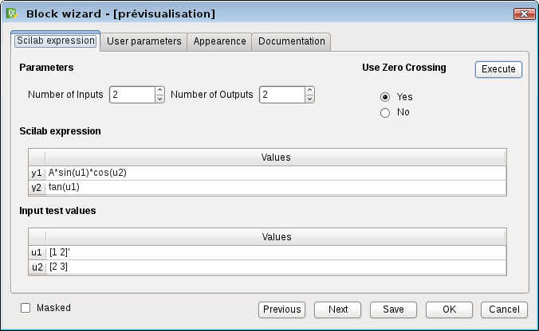

Xcos super block wizard.
The first tab allows the user to create a new diagram or import an existing diagram:
When the user click on the Next button or the little button in the bottom left, the Xcos diagram editor is opened (empty for a new diagram or with a copy of the imported diagram).
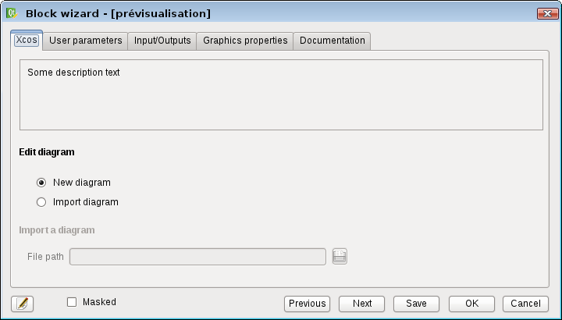
The following tab is devoted to the configuration of the bloc mask:
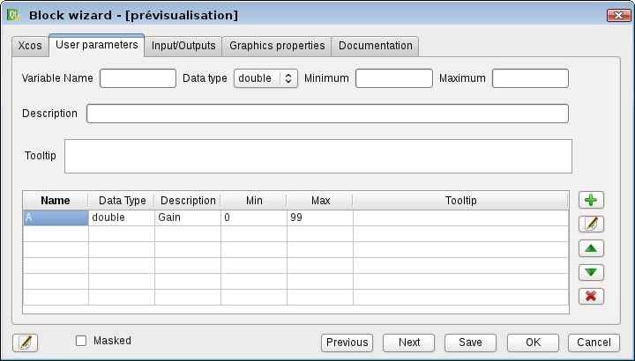
The order of appearance in the table defines the order of appearance in the user dialog box parameters.
The next tab shows a summarized view of the regular/events inputs and outputs of the super block.
In this tab the user can set or modify only the names of the inputs/outputs (input/output block comment text in the super block).

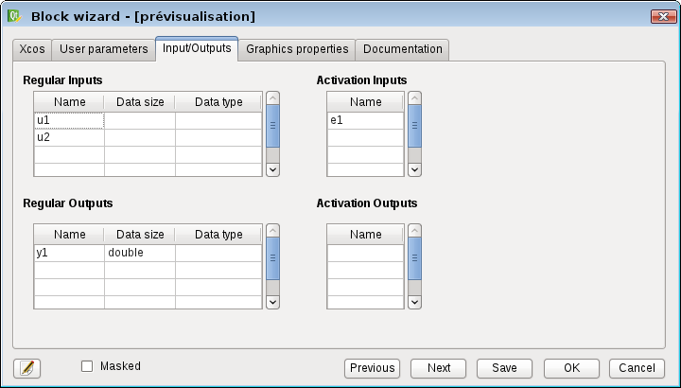
Scilab function wizard.
Initialization parameters: block.state, block.dstate, block.dep_ut(1):
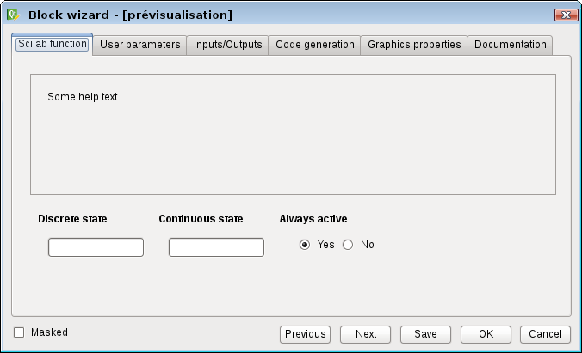
User parameters: block.rpar and block.ipar in function of the parameters types:
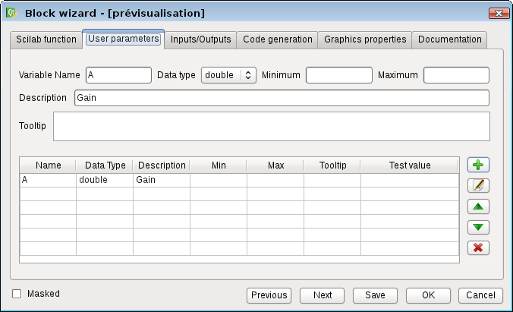
Inputs/Outputs size and types: block.in, , block.in2, block.out, block.out2, block.intype, block.outtype, block.evtin, block.evtout
block.firing
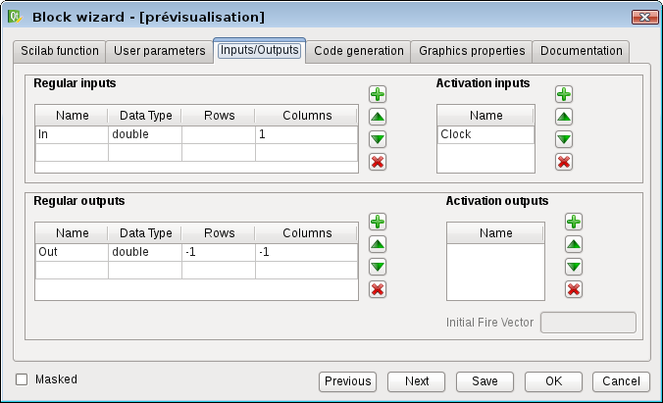
To be continued

Common tabs.

Graphic properties.
In this tab, the user can set the text and color properties of the block:
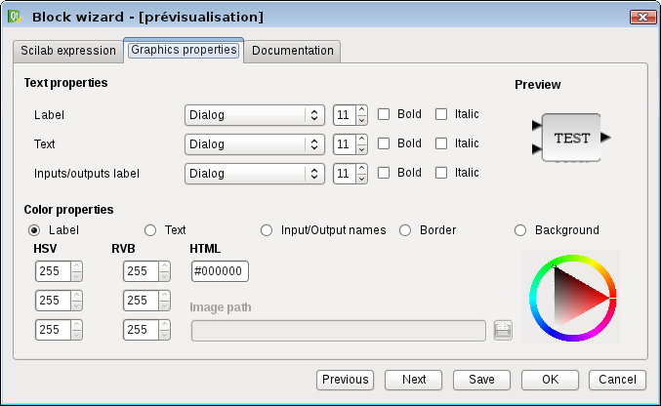

Documentation tab.
The user can give description text, example text, link to an example file and example image. These informations can be used to built the help XML squeleton.
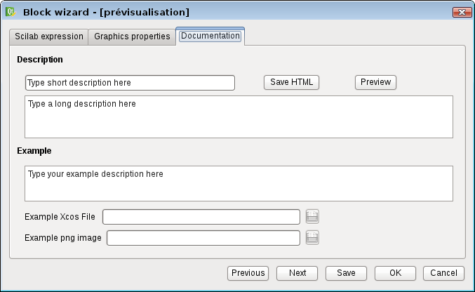

Changelog
1.0 – Bernard DUJARDIN

Copyright
?

