**ArcStat User Manual**

* The Wild Skipping Giraffes

Cole DiLorenzo, Zhe Shi, Matt Zenko

**Vision Statement:**

**For** ArgGIS Pro users

**Who** need to analyze data and find many different descriptive statistics and correlations between multiple data sources

**The** ArcStat plugin is a tool

**That** can present descriptive statistics and correlation of multiple fields in the form of chart or not to give the user as much information about the data they are attempting to analyze and give useful output to power further analysis in ArcGIS or other tools

**Unlike** individual analysis tools in the ArcGIS built-in toolboxes

**Our product** provides all these statistical analysis in one place in an intuitive way that can output information to the user or to formats that can be used in other tools

**Installation**

**Prerequisites:**

Before you proceed to install ArcStat, there are some prerequisites for ArcStat to install in your computer.

**Hardware requirements:**

Hardware is required to support ArcGIS Pro 2.7. The site below can be referenced for detail.

<https://pro.arcgis.com/en/pro-app/latest/get-started/arcgis-pro-system-requirements.htm>

**Software requirements:**

OS: Windows operating systems that support ArcGIS Pro

ArcGIS Pro

Python libraries:

* Seaborn, this is used to show heatmap of correlation for different fields

Installing the above libraries should solve any “ModuleNotFoundError”: No module named X error

**Install python libraries**

Python in ArcGIS Pro is working with ArcGIS Pro default Python environment (arcgispro-py3) after ArcGIS Pro is installed.

Install additional python libraries to the ArcGIS Pro default Python environment (arcgispro-py3) is not advisable and may result in unintended consequences. It is recommended that you only modify a cloned environment.

To create an environment, in the ArcGIS Pro, click **Project** tab on the top left, go to **Python**, then click **Manage Environments**. On the dialog box, click the **Clone Default** button. The new environment is a copy of the arcgispro-py3 environment, and only the default packages included with ArcGIS Pro will be installed. The cloning will take some time. If there is error message, sometime after you restart ArcGIS Pro, you will find that the cloning has been successful.

The active Python environment is used to run any Python functionality executed in the application, such as code executed in the Python window, script tools, and Python toolbox tools. To change the active environment, on the **Manage Environments** dialog box, select the environment (the clone one) and click **OK**. After changing the active environment, you may need to restart ArcGIS Pro to reinitialize Python and use the new environment.

For detail about Work with Python environments, the site below can be referenced.

<https://pro.arcgis.com/en/pro-app/latest/arcpy/get-started/work-with-python-environments.htm>

To install additional python packages, in the ArcGIS Pro, click **Project** tab on the top left, go to **Python**, then click **Add Packages**. Search for the package *seaborn* and click **Install** button to complete installation.

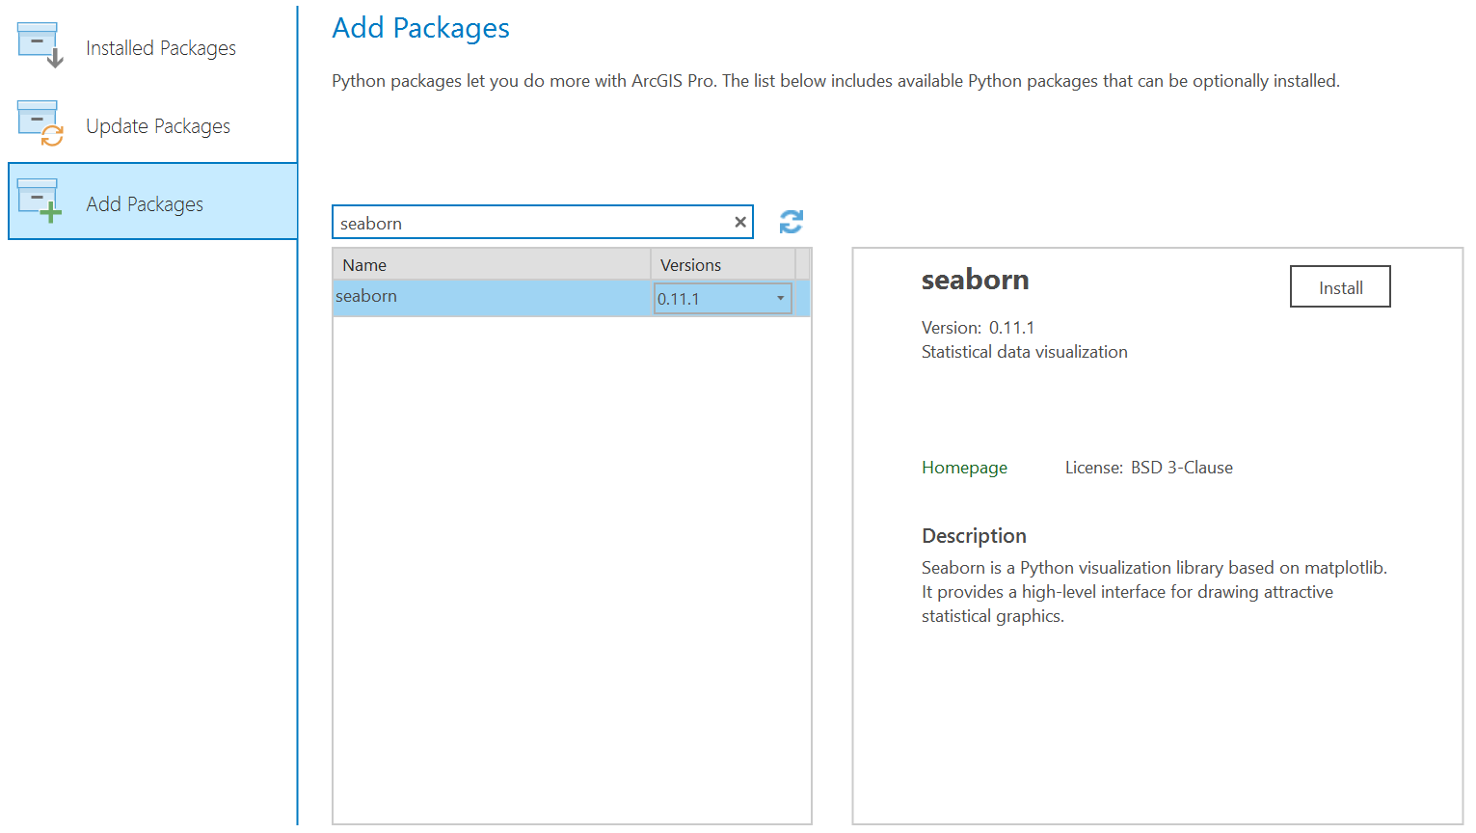

Figure1. Add Packages

For detail about Work with Python packages, the site below can be referenced.

<https://pro.arcgis.com/en/pro-app/latest/arcpy/get-started/work-with-python-packages.htm>

**Release Types**

ArcStat tool is released in gpkx package file (For example ArcStat.gpkx).

**Install ArcStat tool**

Copy ArcStat tool gpkx package file ArcStat.gpkx to ArcGIS Pro project (For example MyProject)’s folder which can be something like C:\Users\xxx\Documents\ArcGIS\Projects\MyProject

In the **Analysis** Tab, open **Tools**, search and open the **Extract Package Tool**, choose the package file as the input, and choose where you want to put the extracted tool (it is recommended to put the file in the project folder like C:\Users\xxx\Documents\ArcGIS\Projects\MyProject), then click button **Run**.

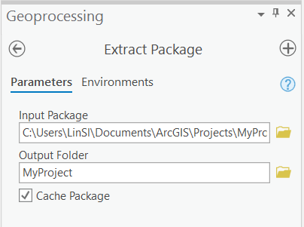

Figure2. Extract Package Tool

**Usage**

If you used **Extract Package Tool** to import the package, right click MyProject and **Refresh**, you will see something like this:

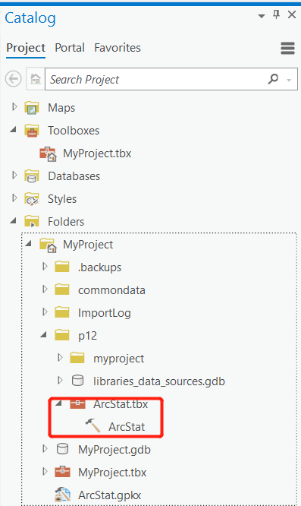

Figure3. Catalog Pane

Double Click **ArcStat** tool to open it, the tool interface should look like this:

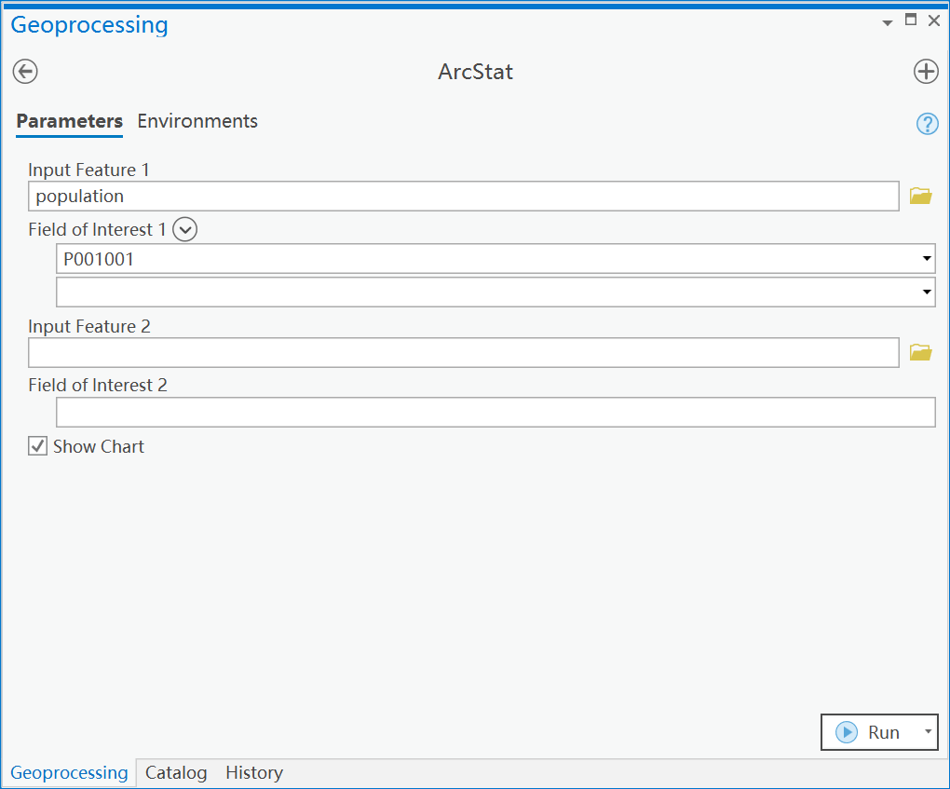

Figure4. ArcStat Interface

To run ArcStat tool, you need to either specify the inputs, which can be either the source shapefiles or the feature classes that are packaged with the tool (explore a folder like C:\Users\xxx\Documents\ArcGIS\Packages\ArcStat_XXXX\ commondata\). After the tool finishes, a new folder called scratch.gdb will be created in the MyPoject1 folder, where the intermediate feature class can be found (through ArcGIS Pro).

You should first select a feature layer or table either from the existing project or from a specific path. And then select your fields of interest. Multiple fields can be selected. However, there may be no field to select if there are no numeric field in the layer or table. If two data sources are specified and the number of their row data is different, the row data of more one will be truncated to be same as the number of row data of the less one in calculation later.

If one field is selected, ArcStat will present descriptive statistic (max, min, mean, median, std) for this field to Messages and show plot chart (Figure5) when [Show Chart] is checked.

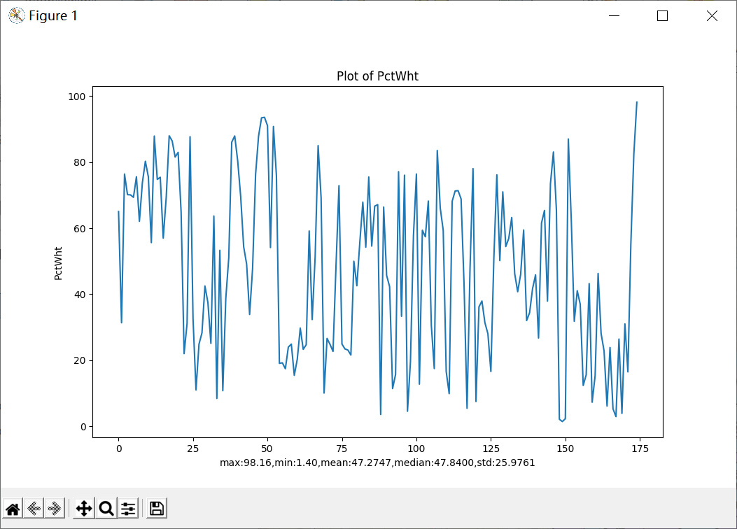

Figure5. Plot for one field

If two fields are selected, three correlation (pearson, kendall and spearman) stats will be given and output to Messages and show chart (Figure6) when [Show Chart] is checked.

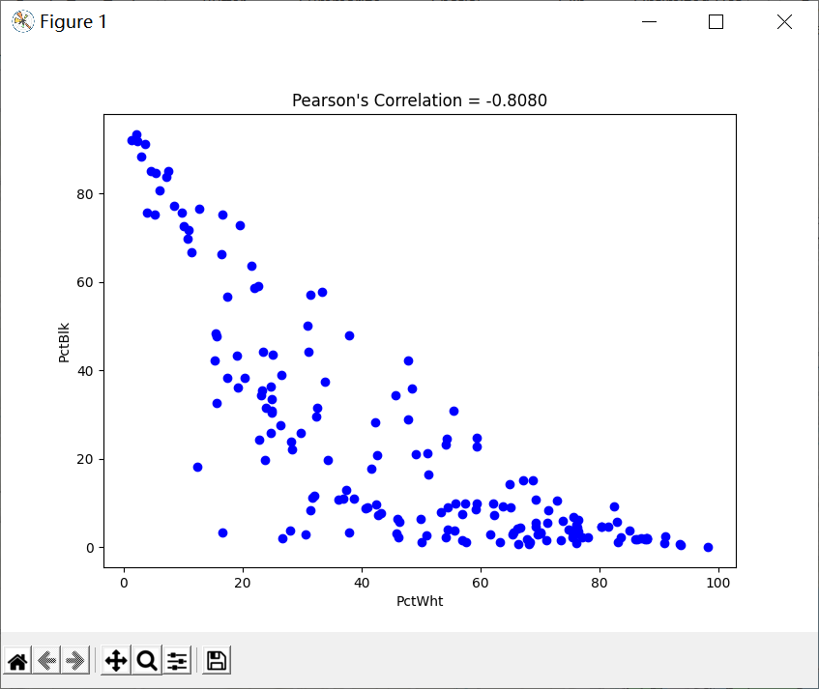

Figure6. Chart for two fields

If three or more fields are selected, three correlation (pearson, kendall and spearman) matrix will be given and output to Messages and show heatmap of correlation (Figure7) when [Show Chart] is checked.

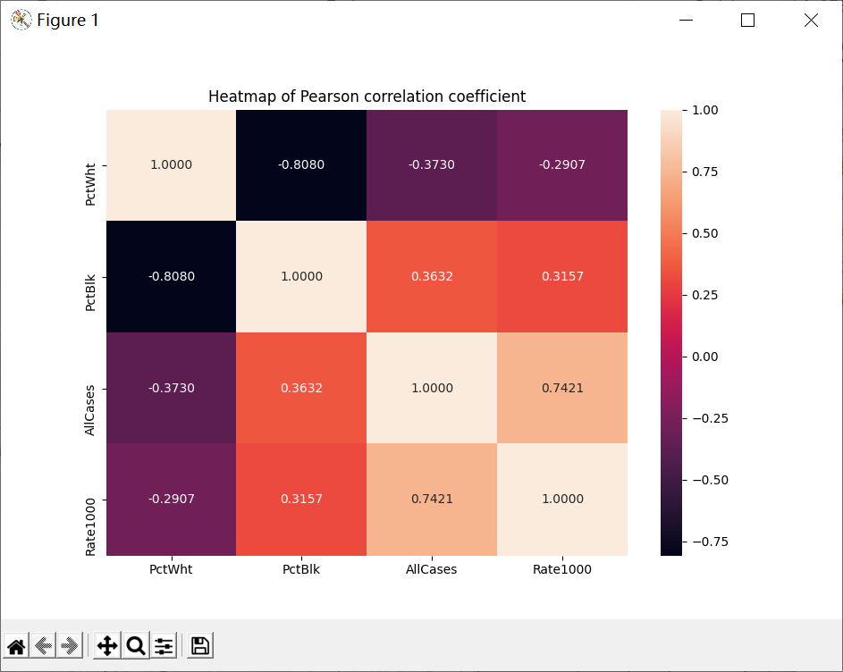

Figure7. Heatmap for correlation of four fields

**Development Discussion:**

When we first started developing the tool, we kind of have a general idea of how we are going to do this, or so we thought. After one third into the development, we are stuck on coding the “showchart” function. And we gave up most of our code because of that. We became more careful and thorough in the later development. We did not encounter such a big problem again. However, we have done some big changes to our code a few times after we did a test run, to make sure that it runs exactly like our description in the vision statement. And we have learned that this is the most important part of developing a software.