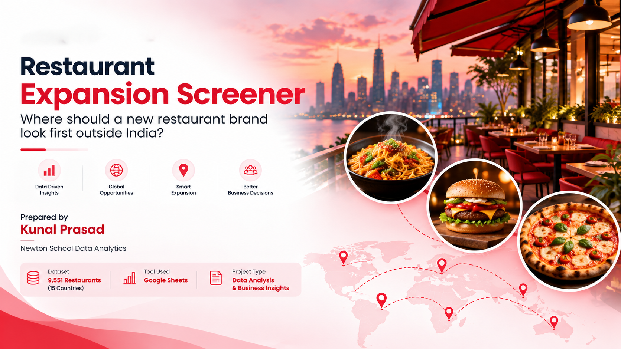

OBJECTIVE QUESTIONS

Question 1: What is the total no. of tables present in the data?

Solution:

Final Answer (if any):
There are 2 source tables in the dataset:
- Restaurant data table: 9,551 restaurant records and 20 original attributes.
- Country-code lookup table: 15 country-code records and 2 attributes.

Approach (if any):
- Identified the restaurant dataset and the country-code lookup table used to map country codes to country names.
- Treated Cleaned Data, question sheets, and pivot tables as derived analysis outputs rather than additional source tables.

Charts & Tables (if any):
Table / Chart Name: Raw Data and country description

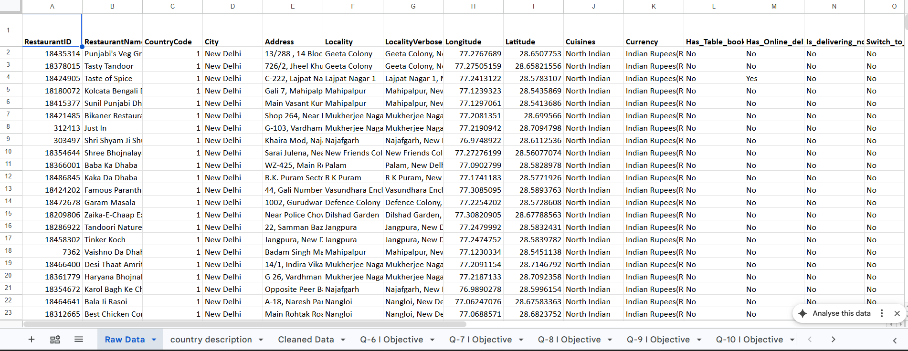

Description: The two source tables: the restaurant table (9,551 rows) and the country-code lookup table (15 rows).

Question 2: What is the total no. of attributes present in the data?

Solution:

Final Answer (if any):
22 attributes (column occurrences) across the two source tables: the restaurant dataset contains 20 original attributes, and the country-description lookup table contains 2 columns.
Approach (if any):
- Counted the original restaurant-table headers in the range Raw Data!A1:T1, which contains 20 attributes.
- Identified the 20 original restaurant attributes, from RestaurantID through Datekey_Opening.
- Included the two lookup-table attributes: CountryCode and Country Name [verify the exact second header in your sheet].
- Therefore, the combined count is 22 column occurrences across both tables. This is a combined column count, not necessarily the number of unique attribute names, because CountryCode appears in both tables.
Charts & Tables (if any):
Table / Chart Name: Raw Data (header row)

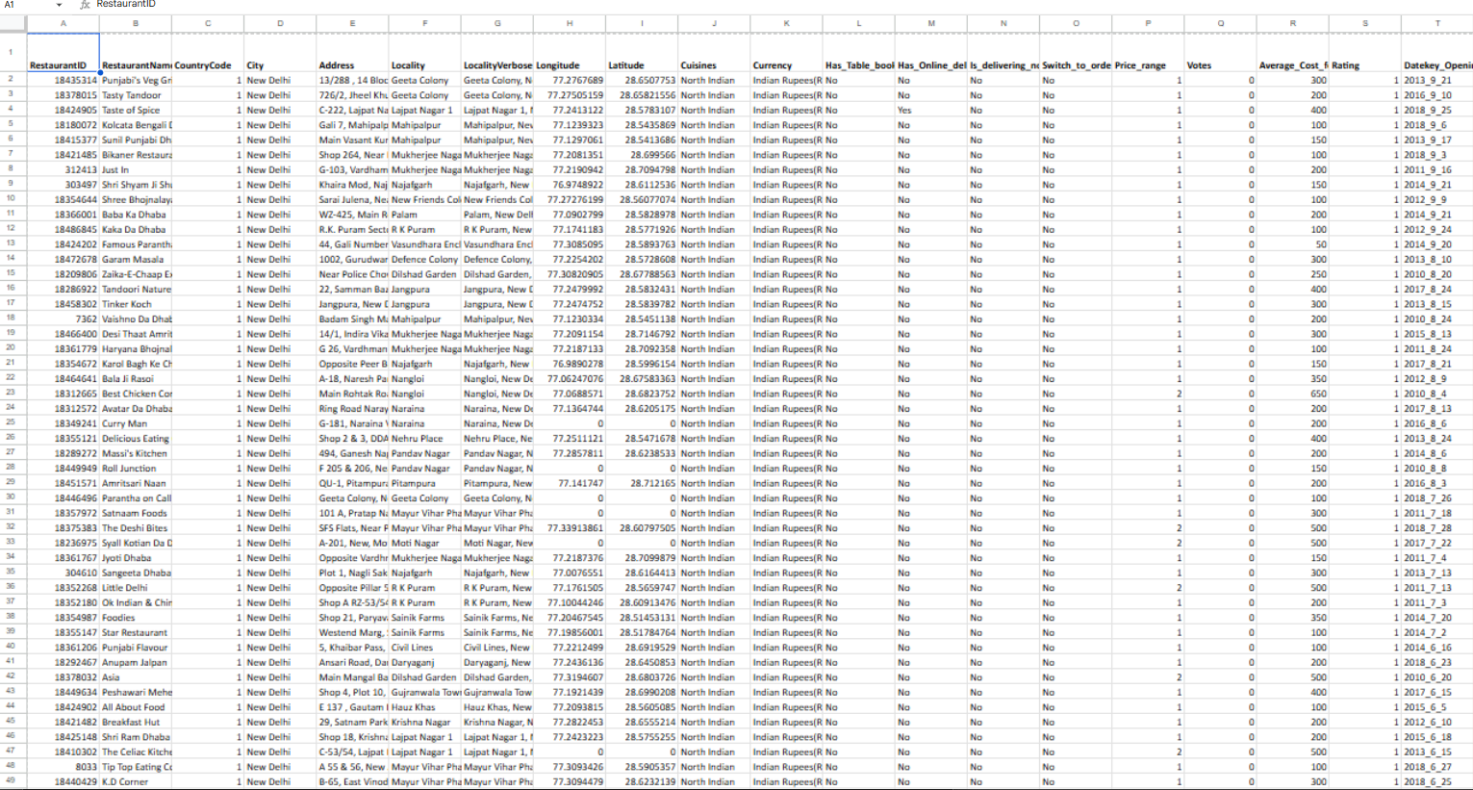

Description:
The Raw Data header row contains the 20 original restaurant attributes. The country-description lookup table contains two additional columns, giving a combined total of 22 column occurrences across the two source tables.

Question 3: How many categorical columns are there in the data?

Solution:

Final Answer (if any):
15 categorical/text-label columns, following the broader classification used for this project evaluation.
Approach (if any):
- Categorical data represents groups or labels that can be counted or grouped for analysis. Continuous data represents measurable quantities for which numerical differences and averages are meaningful.
- Following the project evaluation's broader classification, the 15 categorical/text-label attributes are CountryCode, City, Cuisines, Currency, Has_Table_booking, Has_Online_delivery, Is_delivering_now, Switch_to_order_menu, Price_range, RestaurantID, RestaurantName, Address, Locality, LocalityVerbose and Country Name.
- Price_range is treated as an ordinal categorical variable because values 1–4 represent ordered price tiers. CountryCode is categorical because it identifies a country rather than measuring a quantity.
- RestaurantID, RestaurantName, Address, Locality and LocalityVerbose are identifier or text-label fields. Although they are not all categorical variables in the strict statistical sense, they are included in the broader categorical/text-label count required by the project evaluation.
- The numerical measurement fields are Longitude, Latitude, Votes, Average_Cost_for_two and Rating. Datekey_Opening is a date field and is classified separately.
Column classification:
Type | Columns
Categorical / text-label (15) | CountryCode, City, Cuisines, Currency, Has_Table_booking, Has_Online_delivery, Is_delivering_now, Switch_to_order_menu, Price_range, RestaurantID, RestaurantName, Address, Locality, LocalityVerbose, Country Name
Numerical measurement (5) | Longitude, Latitude, Votes, Average_Cost_for_two, Rating
Date (1) | Datekey_Opening

Charts & Tables (if any)
N/A
Description: Classification of the dataset fields into categorical/text-label attributes, numerical measurement fields and date fields

Question 4: The data consists of some inconsistent and missing values so ensure that the data used for further analysis is cleaned.

Solution:

Final Answer (if any):
The data was cleaned in a separate sheet (Cleaned Data); Raw Data was left untouched and every analysis uses Cleaned Data. All 9,551 records. The cleaning process addressed missing values, duplicate identifiers, invalid or zero values, inconsistent currency labels, country names and additional analysis fields.

Approach (if any):
- Checked each column for zero values that mean 'missing', blanks, placeholder ratings, inconsistent labels and stray spaces, then fixed them in new or corrected columns so the original values stay visible.
- Rating = 1.0 is treated as 'not rated' (the lowest rating in the file is 1.0 and 2,148 restaurants have it, 2,139 of them in India), so Rating_Clean is blank for them and rating analysis uses Rating_Clean only. Zero coordinates and zero costs are blanked so they do not distort maps and averages.
- The Philippines currency label was a source error (Botswana Pula) and was corrected; it is documented here as a correction, not as an original value.

Cleaning log:
Issue | Count | Treatment
Duplicate RestaurantID | 0 | None needed; 9,551 rows kept
Longitude / Latitude equal to 0 | 498 each (497 rows with both) | Blank in Longitude_Clean and Latitude_Clean
Average_Cost_for_two equal to 0 | 18 | Blank; excluded from cost averages
Missing Cuisines | 9 | were excluded / Deleted
Rating = 1.0 placeholder | 2,148 | Rating_Clean blank; Rating_Status = Not rated (7,403 rated)
Philippines currency 'Botswana Pula(P)' | 22 | Corrected to Philippine Peso(₱) (source label error)
UK currency 'Pounds(Œ£)' | 80 | Corrected to Pounds(£) (encoding)
UAE currency 'Emirati Diram(AED)' | 60 | Corrected to Emirati Dirham(AED) (spelling)
Double spaces in text columns | 13 names, 35 LocalityVerbose | Removed
Derived columns added | n/a | Opening_Date, Opening_Year, Country name, currency-symbol price, Suggested_Flag, Rated_4plus

Known limitation: some restaurant names, addresses and localities still contain corrupted characters from the source encoding (for example Turkish and Portuguese letters). The restaurant names shown in Subjective Question 5 were corrected manually; other rows were not changed. This does not affect any count or average.

Charts & Tables (if any):
- Table / Chart Name:
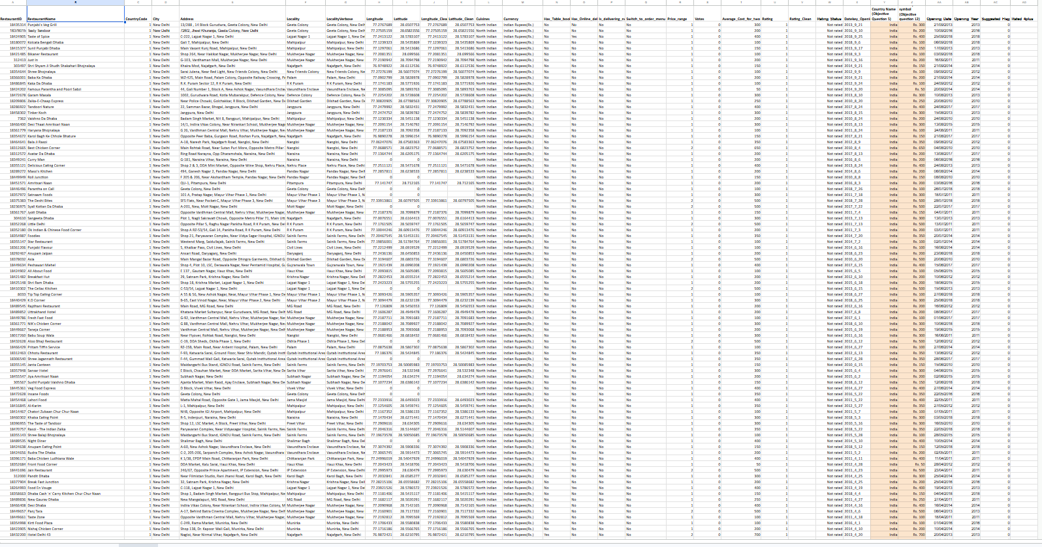- Description:
Cleaned Data holds the corrected and added columns; the log lists every issue, count and fix.

Question 5: Using the LookUp functions, fill up the countries in the original data using the country code.

Solution:

Final Answer (if any):
Country names were mapped from country codes using the country-description lookup table. The lookup table contains 15 country mappings and was applied to the restaurant records.

Approach (if any):
- Used the country-code lookup table to map each restaurant's CountryCode to its corresponding country name.
- Applied the following VLOOKUP formula:
=VLOOKUP(C2,'country description'!$A$2:$B$16,2,FALSE)
- The formula searches for an exact country-code match and returns the corresponding country name from the second column.
- Checked the resulting country-name field before using it for country-level summaries and visualizations.

Charts & Tables (if any):
- Table / Chart Name:
Country-code lookup

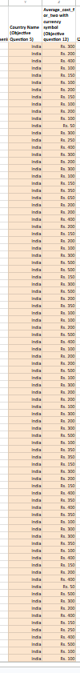
- Description:
Mapping between CountryCode and Country Name used to support country-level analysis.

Question 6: Create a table to represent the number of restaurants opened in each country.

Solution:
Final Answer (if any):

The pivot table reports 9,542 restaurant records across 15 countries in the current analysis dataset.
Country | Restaurant Count
India | 8,652
United States of America | 425
United Kingdom | 80
United Arab Emirates | 60
South Africa | 60
Brazil | 60
New Zealand | 40
Turkey | 34
Australia | 24
Philippines | 22
Indonesia | 21
Qatar | 20
Sri Lanka | 20
Singapore | 20
Canada | 4
Grand Total | 9,542

Approach (if any):

- Used the Country Name field to group restaurant records by country.
- Created a pivot table with Country Name in Rows and COUNTA of RestaurantID in Values.
- Excluded nine records with missing cuisine information from the Cleaned Data analysis dataset.
- Checked that the resulting country counts sum to 9,542.
- Used the country-level distribution to understand the geographic concentration of restaurants.
Charts & Tables (if any):

Table Name: Restaurant Count by Country
Description: The pivot table groups restaurant records by country and counts RestaurantID for each country. The resulting country counts sum to 9,542 records in the current analysis dataset.
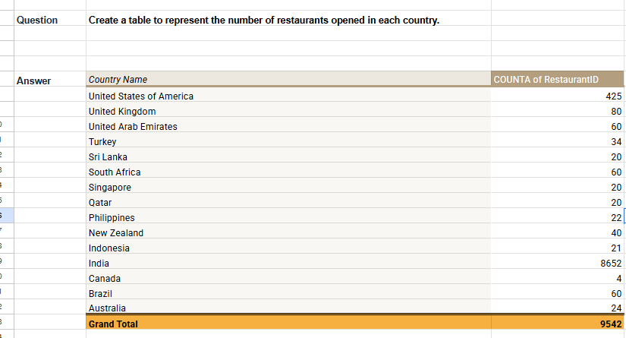

Question 7: Also, the management wants to look at the number of restaurants opened each year, so provide them with something here.

Solution:
Final Answer (if any):

A pivot table and column chart were created to summarize the number of restaurant records by opening year from 2010 to 2018 using the updated cleaned dataset.

Opening Year | Restaurant Count
2010 | 1,079
2011 | 1,096
2012 | 1,022
2013 | 1,059
2014 | 1,049
2015 | 1,023
2016 | 1,026
2017 | 1,086
2018 | 1,102
Grand Total | 9,542
Approach (if any):
- Cleaned the original Datekey_Opening field and standardized the dates in the Opening_Date column.
- Extracted the year into the Opening_Year column.
- Created a pivot table with Opening_Year in Rows and COUNTA of RestaurantID in Values.
- Created a column chart to compare restaurant counts across the years.
- Verified that the yearly counts sum to 9,542, matching the updated pivot table's grand total.
Insights
Restaurant counts ranged from 1,022 in 2012 to 1,102 in 2018. The yearly distribution was relatively stable, with no strong sustained increase or decrease across the period. The highest count occurred in 2018, while 2012 had the lowest count.
Charts & Tables (if any):
- Table / Chart Name:
Q-7 I Objective — Number of Restaurants Opened Each Year (pivot table and column chart)
Description: A pivot table and column chart showing the distribution of restaurant records by opening year from 2010 to 2018, based on the updated cleaned dataset.

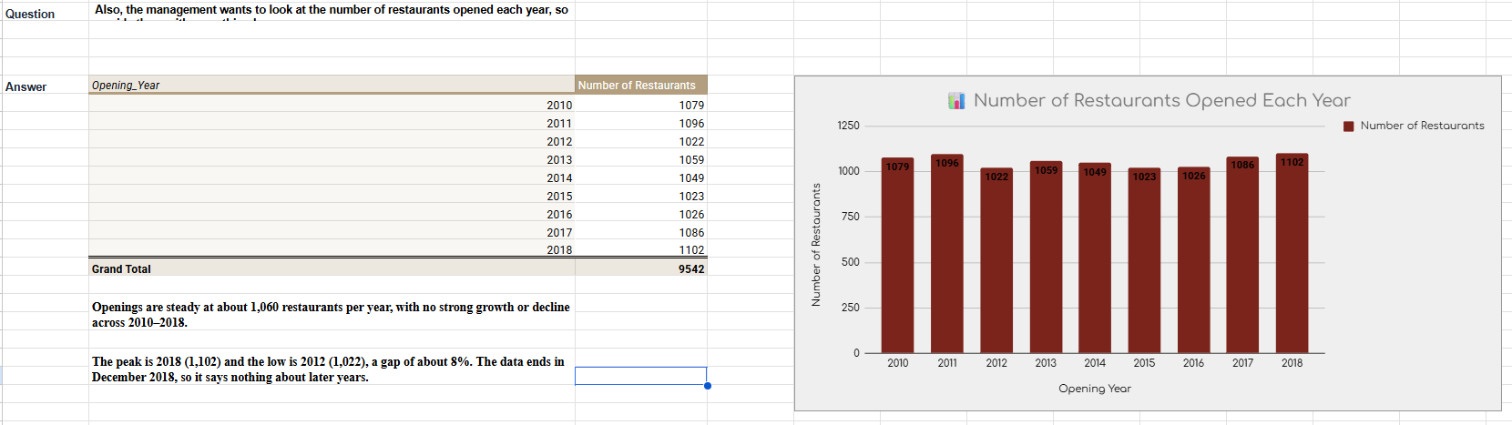

Question 8: What is the total number of restaurants in India in the price range of 4?

Solution:

Final Answer (if any):
The number of Indian restaurants with Price_range equal to 4 is 388

Approach (if any):
- Pivot on Cleaned Data with Country Name in Rows, Price_range as a filter set to 4 and COUNTA of RestaurantID in Values; India shows 388. This matches the price-range pivot used in Subjective Question 9.
- Filtered the prepared dataset for restaurants in India.
- Applied the condition Price_range = 4.
- Counted the records satisfying both conditions and compared the result with the corresponding question sheet.

Charts & Tables (if any):
- Table / Chart Name:
Objective (pivot table)
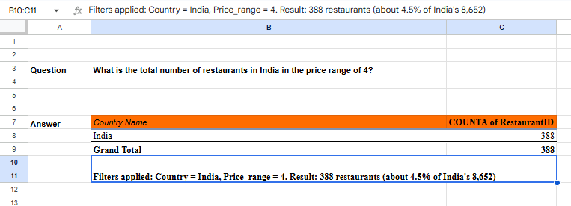
- Description:
Count of Indian restaurant records classified in price range 4.

Question 9: What is the average number of voters for the restaurants in each country according to the data?

Solution:

Final Answer (if any):
Average votes per restaurant by country: highest Indonesia (772.10), lowest Brazil (19.62); the overall average is 156.91.

Approach (if any):
Pivot on Cleaned Data with Country Name in Rows and AVERAGE of Votes in Values; the grand total gives the overall average of 156.91.

- Grouped restaurant records by country.
- Calculated the average Votes value for each country using the prepared dataset.
- Compared the country-level averages while considering the number of restaurants represented in each country.
- Interpreted average votes as an indicator of observed engagement in this dataset, not as a direct measure of market demand or revenue.

Charts & Tables (if any):
- Table / Chart Name:
pivot table
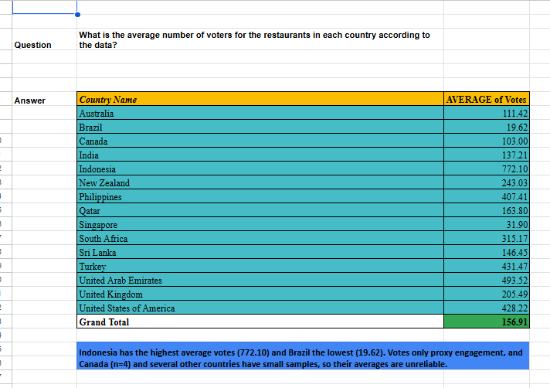
- Description:
Average number of votes for each country.

Question 10: Calculate the average rating for all the restaurants that have price_range < 4 and provide online delivery. Use only the “IF” function, Logical Operators, and Aggregation functions to solve this problem. [Note: Don’t use Conditional aggregation in this question.]

Solution:

Final Answer (if any):
3.37 (average of Rating_Clean over 2,302 rated restaurants; 96 of the 2,398 qualifying restaurants have Rating = 1.0 and are treated as not rated). Using the raw Rating column instead gives 3.27 across 2,398 restaurants.

Approach (if any):

- Formula: =ARRAYFORMULA(AVERAGE(IF(('Cleaned Data'!$R$2:$R$9552<4)*('Cleaned Data'!$O$2:$O$9552="Yes")*('Cleaned Data'!$V$2:$V$9552<>""),'Cleaned Data'!$V$2:$V$9552,"")))

- IF picks the qualifying rated rows, the logical operators (<, =, <>) combine the conditions, and AVERAGE ignores the blanks. No AVERAGEIF or other conditional aggregation is used.
- Filtered restaurant records for Price_range less than 4 and Has_Online_delivery equal to “Yes”.
- Calculated the average rating for records satisfying the conditions.
- Compared the result using the original Rating field with the result using Rating_Clean.
- Used Rating_Clean for the rated-restaurant analysis where source values of 1.0 were treated as unrated.
- Checked the number of qualifying records and the number with usable ratings to ensure the average was interpreted correctly.

Charts & Tables (if any):
- Table / Chart Name:
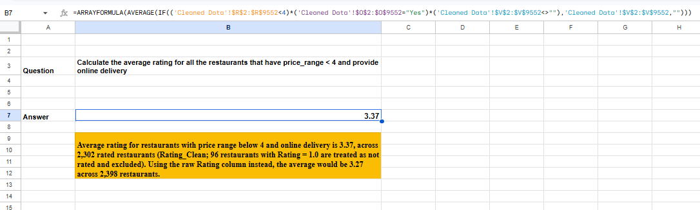
- Description:
Average rating among restaurants meeting the specified price-range and online-delivery conditions. The rating field and eligible record count should be stated alongside the result.

Question 11: Using Conditional formatting highlight the rows of restaurants that are located in the countries or cities that you’ve suggested to the management for opening new restaurants.

Solution:

Final Answer (if any):
Conditional formatting was used to highlight restaurant records belonging to the five selected countries: Canada, Singapore, Qatar, Philippines, and Indonesia. In the prepared dataset, these countries account for 87 restaurant records.
The country-wise counts are:
- Canada: 4 restaurants
- Singapore: 20 restaurants
- Qatar: 20 restaurants
- Philippines: 22 restaurants
- Indonesia: 21 restaurants

Approach (if any):
- Used the Country Name field to identify restaurants belonging to the five selected countries.
- Created a helper column named Suggested_Flag in column AC to identify matching records. The formula returns 1 for selected countries and 0 for other records.
- Applied conditional formatting to the restaurant data range using the custom formula =$AC2=1.
- Highlighted the entire row whenever the corresponding helper flag equals 1.
- Verified the highlighted rows in the Cleaned Data sheet and checked the country-wise counts.
- Interpreted the number of listed restaurants as an indication of recorded competition, rather than as direct evidence of customer demand or business success.

Charts & Tables (if any):
- Table / Chart Name:

Restaurant Counts in Selected Countries
- Description: Summarizes the number of restaurant records belonging to each selected country and the total number of highlighted records.
Visual Evidence: Screenshot of the Cleaned Data sheet showing the highlighted restaurant rows and the conditional formatting rule.
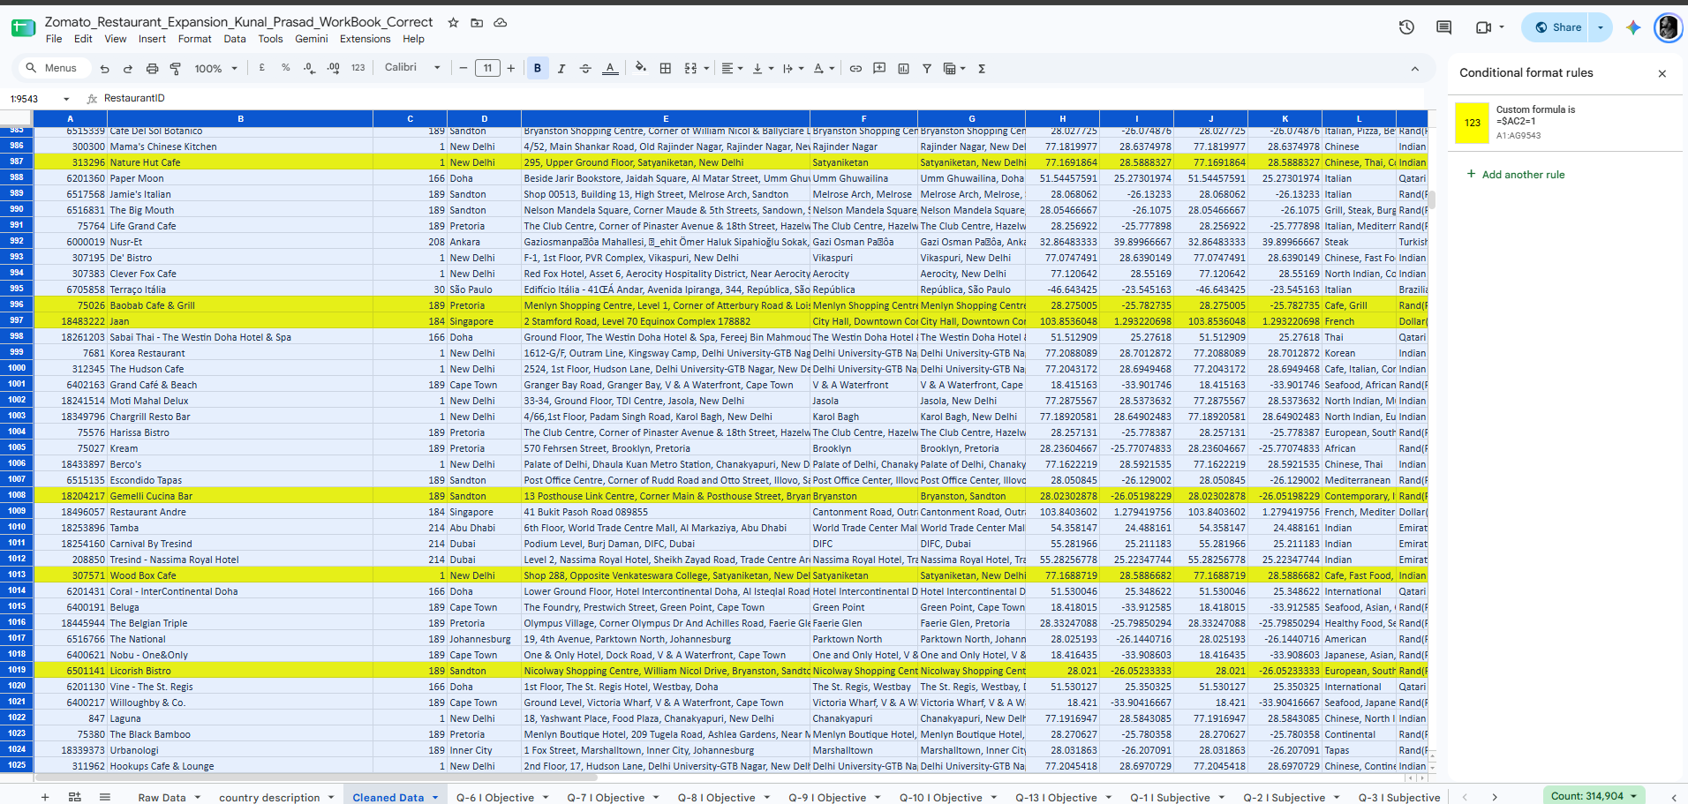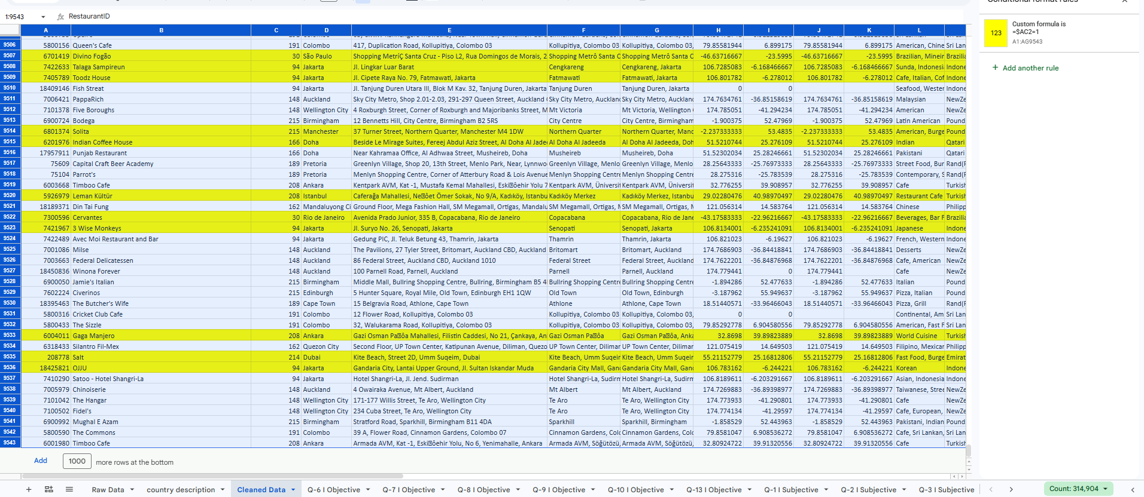
Insight
A total of 87 restaurant records are highlighted across the five selected countries. Indonesia, Qatar, and the Philippines account for most of these records, while Canada has the fewest. These counts describe the records available in the prepared dataset and should not be interpreted as complete measures of market competition.
Recommendation
Use the highlighted records to identify restaurants in the selected countries for further investigation. Before making an expansion decision, evaluate customer demand, restaurant ratings, local competition, operating costs, and market potential using additional evidence.

Question 12: Create a new customized price column that consists of the abbreviation/symbol of the currency along with the Average_cost_for_two value. [Use string operations to do this task]

Solution:

Final Answer (if any):
A formatted cost field was created to display the average cost for two with its corresponding currency symbol.

Approach (if any):
- Used the currency label to identify the appropriate symbol.
- Combined the symbol and the Average_Cost_for_two value into a readable text field.
- Used a formula that returns a blank result when the cost is missing, rather than displaying an incomplete price.
Example formula:
=IF(T2="","",MID(M2,FIND("(",M2)+1,FIND(")",M2)-FIND("(",M2)-1)&" "&TEXT(T2,"#,##0"))
- Checked that the formatted result retained the correct currency symbol and original cost.

Charts & Tables (if any):
- Table / Chart Name:
- Description:
Display of restaurant costs with currency symbols to make local-currency values easier to interpret.

Question 13: How can you create an array formula in Excel or Google Sheets to count the number of restaurants listed that do not offer online delivery, are in the lowest price range, and have an average cost for two people less than or equal to 250 Indian Rupees?

Solution:

Final Answer (if any):
The count of Indian restaurant records meeting all the stated conditions is 1,676

Approach (if any):
- Formula: =ARRAYFORMULA(SUM(('Cleaned Data'!$O$2:$O$9552="No")*('Cleaned Data'!$R$2:$R$9552=1)*('Cleaned Data'!$M$2:$M$9552="Indian Rupees(Rs.)")*('Cleaned Data'!$T$2:$T$9552<>"")*('Cleaned Data'!$T$2:$T$9552<=250)))
- Each condition returns TRUE/FALSE and multiplying them keeps only rows where all are true. The currency check keeps INR-priced restaurants only, and the <>"" test stops blank costs being counted as 0.
- Filtered records where Has_Online_delivery was “No”.
- Restricted Price_range to 1.
- Restricted Currency to “Indian Rupees(Rs.)”.
- Included only records with a nonblank Average_Cost_for_two value no greater than 250.
- Counted records satisfying all conditions simultaneously.

Charts & Tables (if any):
- Table / Chart Name: Indian restaurants satisfying the specified conditions
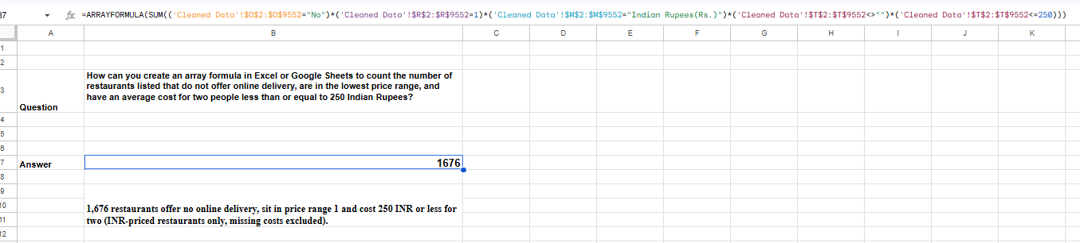

- Description:
Count of restaurant records matching the delivery, price-range, currency and cost criteria.

SUBJECTIVE QUESTIONS

Question 1: Suggest a few countries where the team can open newer restaurants with lesser competition. Which visualization/technique will you use here to justify the suggestions?

Solution:

Approach:
- Summarized restaurant count, average votes and average rating by country using a pivot table.
- Excluded India from the international comparison because it accounts for most of the restaurant records in the dataset.
- Used restaurant count as an initial indicator of the number of listed competitors and average votes as an indicator of observed customer engagement.
- Compared average ratings to understand the quality signals available in the dataset.
- Considered affordability as an additional screening dimension. Average cost for two should be converted into a common currency before comparing countries.
- Used city-level analysis as a follow-up step because country-level averages can hide substantial differences between cities.
- Treated the results as a preliminary screening exercise, not proof of market demand, profitability or low competition.
Charts & Tables:
- Table / Chart Name: Country-Level Screening Pivot Table

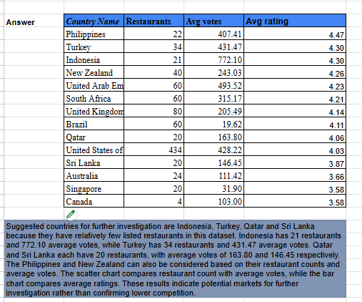
- Description: Summarizes restaurant count, average votes and average rating by country, excluding India.
Chart Name: Restaurant Count vs Average Votes by Country
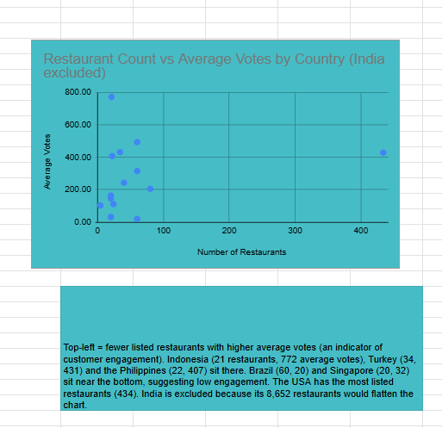

Description: A scatter chart comparing the number of listed restaurants with average votes. Countries with relatively few listings and higher engagement are candidates for further investigation.
Chart Name: Average Rating by Country

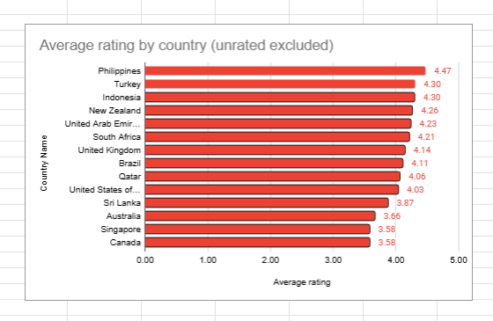
Description: A bar chart comparing average ratings across countries, excluding unrated records where applicable.
Insights:
Indonesia stands out for its relatively small listing count of 21 restaurants and the highest average votes among the displayed countries, approximately 772.10. Turkey has 34 restaurants and average votes of approximately 431.47. The Philippines has 22 restaurants, average votes of approximately 407.41 and the highest displayed average rating, approximately 4.47.
Qatar and Sri Lanka also have relatively few listings, with 20 restaurants each, but their average votes are lower at approximately 163.80 and 146.45, respectively. New Zealand has 40 restaurants and an average rating of approximately 4.26.
These findings indicate different combinations of listing count, engagement and rating quality. They do not establish which market has the greatest demand, because votes are not equivalent to customer counts and the dataset does not provide a complete measure of market size or competing restaurants.

Recommendations:
- Priority for further investigation: Indonesia, due to its relatively small number of listed restaurants and high average votes.
- Additional candidates: Philippines and Turkey, based on their combination of relatively low listing counts, customer engagement and average ratings.
- Secondary candidates: Qatar and Sri Lanka, which have relatively few listed restaurants but lower average votes.
- Compare average cost for two using a common currency before finalizing the shortlist.
- Investigate cities within the shortlisted countries and validate local competition, market size, rental costs, demand, regulations and operating expenses before making an investment decision.
Limitations
The analysis covers restaurants represented in the dataset, not every competitor in each country. Average votes indicate recorded engagement rather than total customer demand. Some countries have small samples, particularly Canada with only four restaurants, so their averages may not be representative. Restaurant count and rating alone cannot establish profitability or guarantee expansion success.

Question 2: Come up with the names of States and cities in the suggested countries suitable for opening restaurants.

Solution:
A city-level analysis was conducted for the shortlisted countries using restaurant counts, average votes, average ratings, average cost for two in INR, and average price range. Five cities were selected for further investigation: Jakarta, Istanbul, Ankara, Doha, and Colombo.

Approach:
- Created a pivot table grouped by Country Name and City, summarizing restaurant counts, average votes, and average ratings.
- Excluded cities with only one or two listed restaurants because their small sample sizes provide limited evidence for comparison.
- Used two column charts to compare restaurant counts and average votes across the five shortlisted cities.
- Created an additional cost-analysis pivot table showing average cost for two in INR, average price range, and restaurant count for each shortlisted city.
- Treated state/province information as external contextual information because the original dataset does not contain a state/province field. Such labels should be retained only when independently verified.
- Treated the results as an initial screening exercise rather than a final investment decision.

Charts & Tables:
- Table Name : City-Level Expansion Screening

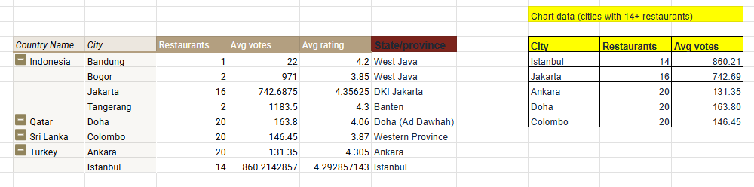

Description : Summarizes the country, city, restaurant count, average votes, and average rating for the shortlisted locations.
Chart Name: Average Votes in Suggested Cities

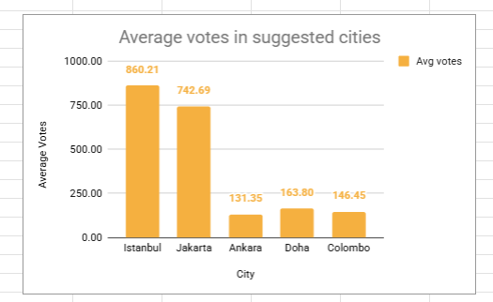
- Description: Compares average votes across the five selected cities to assess recorded customer engagement.

- Table / Chart Name: Restaurants in Suggested Cities

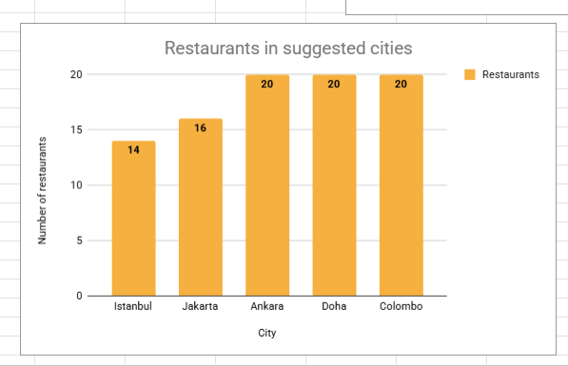

- Description: Compares the number of listed restaurants across the five selected cities.

Table Name: Cost Analysis

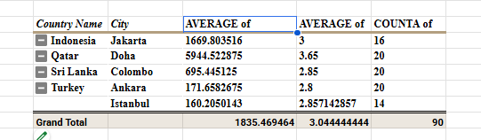

Description: Compares average cost for two in INR, average price range, and restaurant count across the five shortlisted cities.
Insights:
- Jakarta, Indonesia: 16 restaurants, approximately 742.69 average votes, and an average rating of 4.36. The average cost for two is approximately ₹1,669.80, with an average price range of 3.00.
- Istanbul, Turkey: 14 restaurants, approximately 860.21 average votes, and an average rating of 4.29. The average cost for two is approximately ₹160.21, with an average price range of 2.86.
- Ankara, Turkey: 20 restaurants, approximately 131.35 average votes, and an average rating of 4.31. The average cost for two is approximately ₹171.66, with an average price range of 2.80.
- Doha, Qatar: 20 restaurants, approximately 163.80 average votes, and an average rating of 4.06. The average cost for two is approximately ₹5,944.52, with an average price range of 3.65.
- Colombo, Sri Lanka: 20 restaurants, approximately 146.45 average votes, and an average rating of 3.87. The average cost for two is approximately ₹695.45, with an average price range of 2.85.
Several cities have exactly 20 restaurant records, suggesting that the dataset may provide only a limited view of their local restaurant markets. Average votes indicate recorded customer engagement, but they do not independently establish market demand or profitability.

Recommendations:

Prioritize Jakarta and Istanbul for further investigation because they combine relatively high average votes with fewer listed restaurants in this dataset. Keep Ankara, Doha, and Colombo as secondary candidates.
Use the cost and price-range analysis as a preliminary affordability comparison, not as a definitive ranking. The Turkish cost-conversion figures should be verified before drawing cost-based conclusions. Before making a final investment decision, validate local competition, customer demand, rental costs, market size, operating expenses, and actual local pricing through additional market research.

Question 3: According to the countries you suggested, what is the current quality regarding ratings for restaurants that are open there?

Solution:

Approach:
- Used Rating_Clean (Rating = 1.0 treated as not rated; none of the 95 suggested-country restaurants are affected). Counted restaurants in three rating bands (below 3, 3 to 3.9, 4 to 5) and the share rated 4 or above, with COUNTIFS and AVERAGEIFS, and plotted a 100% stacked column chart.
- The data has no field that says whether a restaurant is currently open (Is_delivering_now is 'No' for all 95 and Switch_to_order_menu is 'No' for every row), so all listed restaurants are treated as operating.

Charts & Tables:
- Table / Chart Name: rating-band table
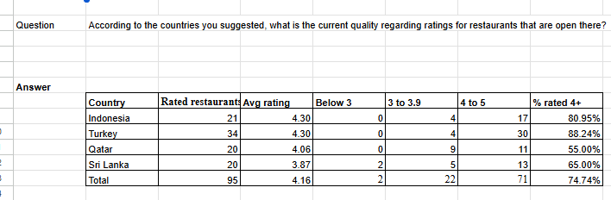
- Description: Rated restaurants, average rating, counts by band (below 3, 3 to 3.9, 4 to 5) and % rated 4+ for each suggested country.

- Table / Chart Name: Subjective: 100% stacked column chart

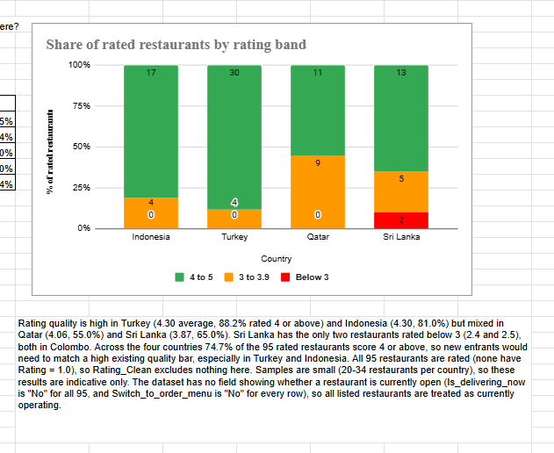

- Description: Share of rated restaurants in each rating band by country.

Insights:
- Ratings are high in Turkey (average 4.30, 88.2% rated 4 or above) and Indonesia (4.30, 81.0%), and mixed in Qatar (4.06, 55.0%) and Sri Lanka (3.87, 65.0%).
- Only two restaurants are rated below 3 (2.4 and 2.5), both in Colombo. Across the four countries 74.7% of the 95 restaurants score 4 or above.

Recommendations:
- Indonesia and Turkey: Prioritize quality differentiation because both markets have an average rating of 4.30, with 81.0% and 88.2% of rated restaurants scoring 4 or above, respectively. New restaurants should aim for a rating of at least 4.0 and monitor customer feedback regularly.
- Qatar: Focus on consistent food quality and service. Only 55.0% of rated restaurants score 4 or above, suggesting an opportunity to differentiate through a reliable customer experience.
- Sri Lanka: Investigate quality improvement opportunities before entering the market. Its average rating is 3.87, and 65.0% of rated restaurants score 4 or above.
- Next steps: Validate these opportunities with city-level competition, customer demand, pricing and operating-cost research before choosing a location.
These recommendations are preliminary because the analysis covers only 20–34 rated restaurants per country and does not establish overall market demand or profitability.

Question 4: Also, what is the current expenditure on food in the suggested countries, so we can keep our financial expenditure in control?

Solution:

Approach:
- Grouped restaurant records by country and summarized the Average_Cost_for_two field.
- Calculated the number of restaurants with available cost data, average cost, median cost, minimum cost and maximum cost for each country.
- Retained the original local-currency values to preserve the context of spending in each market.
- Converted the average and median cost for two into INR using the exchange-rate assumptions documented in the analysis, enabling direct cross-country budget comparison.
- Compared average and median values because high-cost restaurants can increase the average, while the median represents the middle observation.
- Considered the small country-level samples when interpreting the results.

Charts & Tables:

- Table / Chart Name:: Cost comparison table

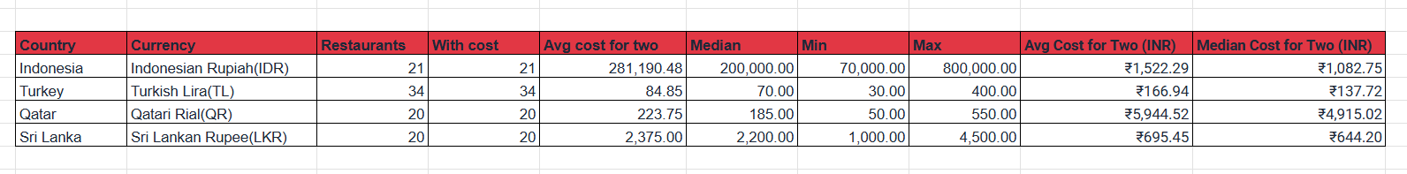

- Description: Average, median, minimum and maximum cost for two per suggested country in local currency, with average and median values additionally converted into INR for direct cross-country comparison.

Insights:
Average and median costs provide different views of the cost distribution. The average may be influenced by high-cost restaurants, while the median represents the middle observation. Price range provides additional context because it represents a relative tier rather than an equivalent monetary amount across all countries.

Recommendations:
- Use the INR-converted average and median cost for two as an initial benchmark when comparing food expenditure across the four suggested countries.
- Use the median as a practical reference for typical restaurant spending and the average to understand the broader cost level, including the influence of expensive restaurants.
- Qatar has the highest converted average cost for two at ₹5,944.52, followed by Indonesia at ₹1,522.29, Sri Lanka at ₹695.44 and Turkey at ₹166.94. These figures can help prioritize further affordability research.
- For preliminary budget planning, compare the converted median costs as well: Qatar ₹4,915.02, Indonesia ₹1,082.75, Sri Lanka ₹644.20 and Turkey ₹137.72.
- Document the exchange rates and conversion date, and validate current local prices, rental costs, staffing and other operating expenses before setting budgets or prices.
- Treat the figures as indicative benchmarks rather than definitive market budgets because the samples contain only 20–34 restaurants per country.

Question 5: Come up with the names of restaurants from the recommended states that are our biggest competitors and also those that are rated in the lower brackets, i.e. 1-2 or 2-3.

Solution:

Approach:
- Filtered the prepared dataset to the five shortlisted cities: Jakarta, Istanbul, Ankara, Doha and Colombo.
- Identified the top three competitors in each city by sorting restaurants in descending order of votes, using votes as a proxy for recorded customer engagement.
- Created a separate table of restaurants with ratings below 3 and classified them into the relevant rating bands (1–2 and 2–3).
- Built a city-level rating-band summary to compare the number of rated restaurants in each band and the percentage rated 4 or above.
- Used formula-driven summaries referencing the Cleaned Data sheet so that the results can be traced back to the source records.
- Since the dataset does not include a state/province field, used the five shortlisted cities as the geographic units for comparison.
- Interpreted vote counts as recorded engagement rather than total customer demand, and treated low ratings as signals for further investigation rather than proof of an unmet market opportunity.

Charts & Tables:
- Table / Chart Name: top competitors table
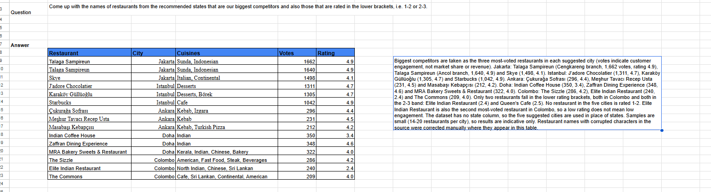
- Description: The three most-voted restaurants in each suggested city.

- Table / Chart Name: low-rated restaurants table
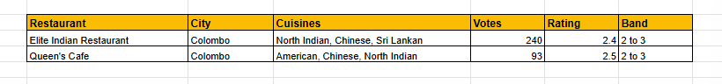
  - Description: Restaurants rated below 3, with their rating band.

- Table / Chart Name: city rating-band table
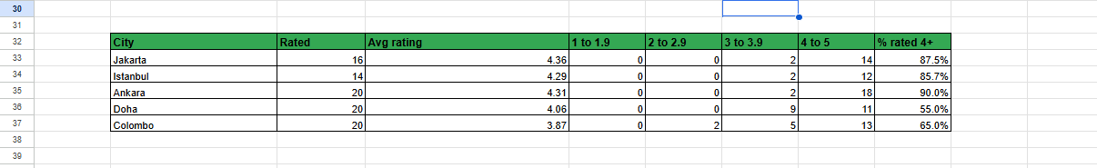
- Description: Counts of restaurants in each rating band and the share rated 4+ by city.

Insights:
- Top by votes: Jakarta: Talaga Sampireun (two branches, 1,662 and 1,640 votes, rating 4.9) and Skye. Istanbul: J'adore Chocolatier (1,311), Karaköy Güllüoğlu (1,305), Starbucks (1,042). Ankara: Çukurağa Sofrası (296), Meşhur Tavacı Recep Usta (231), Masabaşı Kebapçısı (212). Doha: Indian Coffee House (350, rated 3.4), Zaffran Dining Experience (348), MRA Bakery Sweets & Restaurant (322). Colombo: The Sizzle (286), Elite Indian Restaurant (240, rated 2.4), The Commons (209).
- Only two restaurants fall in the lower brackets, both in Colombo and both in the 2-3 band: Elite Indian Restaurant (2.4) and Queen's Cafe (2.5). No restaurant in the five cities is rated 1-2.

Recommendations:
- Prioritize Jakarta and Istanbul for competitor benchmarking. Both cities have highly voted restaurants, including Talaga Sampireun in Jakarta (1,662 and 1,640 votes across two listed branches) and J'adore Chocolatier in Istanbul (1,311 votes). Compare their menus, pricing, service quality and customer feedback before finalizing a restaurant concept.
- Investigate Colombo for potential service or quality gaps. Elite Indian Restaurant has 240 votes but a rating of 2.4, while Queen's Cafe has 93 votes and a rating of 2.5. These restaurants may help identify customer pain points, but low ratings alone do not prove an unmet market opportunity.
- Use Doha to benchmark customer experience and pricing. Indian Coffee House has 350 votes and a rating of 3.4. Compare its menu, prices and customer feedback with higher-rated competitors before deciding how a new restaurant could differentiate itself.
- Set measurable launch KPIs. As initial management targets, aim for a customer rating of at least 4.0/5, monitor monthly rating and vote trends, and review customer complaints and service feedback regularly. These are proposed targets, not results established by the dataset.
- Complete competitor validation before selecting a location. Visit shortlisted restaurants, compare menu prices and offerings, review customer feedback, and assess local demand, rent and operating costs. Use the findings to finalize the menu, pricing and service strategy.
These recommendations are preliminary because the analysis covers only the restaurants represented in the dataset and does not establish total local competition or market demand.

Question 6: Which cuisines should we focus on in the newer restaurants to get better feedback? Does the choice of cuisines affect the restaurant ratings?

Solution:

Approach:
- Filtered the cleaned dataset to the four shortlisted countries: Indonesia, Turkey, Qatar and Sri Lanka.
- Excluded records with blank Rating_Clean values from the rating analysis.
- Compared average cleaned ratings, rated-restaurant counts and average votes using cuisine summaries.
- Applied a minimum sample-size threshold of five rated restaurants to the primary-cuisine chart.
- Used the detailed cuisine-combination pivot as supporting evidence. Because restaurants may list multiple cuisines, cuisine-combination categories can overlap.
- Interpreted rating differences as associations rather than proof that cuisine choice causes higher ratings.

Charts & Tables:

Table 1: Detailed Cuisine-Combination Analysis
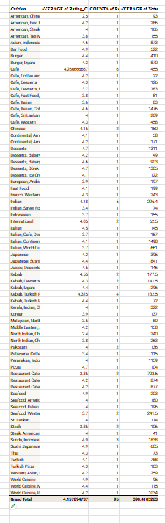
Description: Summarizes average cleaned ratings, restaurant counts and average votes for the cuisine combinations recorded in the four shortlisted countries.

Table 2: Primary-Cuisine Summary

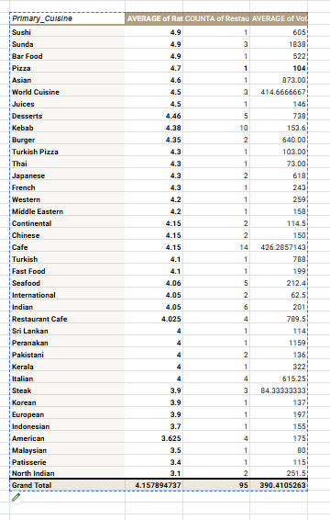
Description: Compares average cleaned ratings, rated-restaurant counts and average votes by primary cuisine.

Chart: Average Rating by Primary Cuisine — Suggested Countries

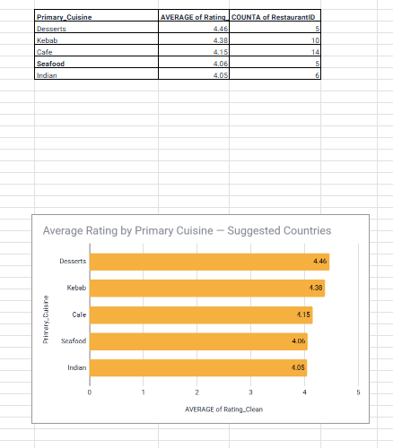
Description: Compares the five primary-cuisine categories meeting the minimum threshold of five rated restaurants.

Insights:
1. Overall customer-rating performance
The analysis covers 95 rated restaurant records across Indonesia, Turkey, Qatar and Sri Lanka. The overall average cleaned rating is approximately 4.16/5, indicating generally positive ratings within this selected group. However, these results represent the shortlisted countries in the dataset and should not be generalised to all restaurants or future restaurant openings.
2. Desserts has the highest average rating in the filtered primary-cuisine chart
Desserts has an average rating of 4.46/5, based on 5 rated restaurants. This is the highest average among the five primary-cuisine categories displayed in the filtered chart. The result makes Desserts a promising category for further investigation, although its small sample means that additional validation is needed before prioritising it for expansion.
3. Kebab also shows promising ratings
Kebab has an average rating of 4.38/5, based on 10 rated restaurants. Its combination of a relatively high average rating and a larger sample than Desserts provides another reason to investigate this cuisine. Nevertheless, ratings alone cannot establish whether the category will attract enough customers in a new location.
4. Cafe has the largest sample among the five displayed categories
Cafe has an average rating of 4.15/5, based on 14 rated restaurants. It has the largest restaurant count among the five categories in the filtered chart. Although its average rating is lower than those of Desserts and Kebab, the larger sample provides a broader basis for comparison within this group.
5. Seafood and Indian have ratings above 4.0
Seafood has an average rating of 4.06/5, based on 5 rated restaurants, while Indian has an average rating of 4.05/5, based on 6 rated restaurants. Both categories show positive average ratings, but their sample sizes are limited. They should remain secondary options for further investigation rather than being ruled in or out based on these figures alone.
6. Average rating and customer engagement are different measures
The cuisine pivots also include average votes. Votes can help indicate recorded customer engagement, while ratings indicate the average score given by customers. A cuisine with a high rating but few votes may have encouraging feedback but limited evidence of broader engagement. Therefore, ratings and votes should be considered together when evaluating potential menu options.
7. Cuisine choice may be associated with ratings, but causation is not established
The observed averages differ across cuisine categories. However, cuisine is not the only factor that may influence restaurant ratings. Country, city, pricing, service quality, restaurant reputation and customer preferences may also contribute to the differences. The current analysis identifies associations and does not prove that selecting a particular cuisine will directly improve ratings.
8. The results should be validated at the local level
The findings cover four shortlisted countries, and the number of restaurants varies across cuisine categories. The results should therefore be validated against city-level competition, local customer preferences and the performance of comparable restaurants before making expansion decisions. A small pilot with measurable customer-feedback targets would provide stronger evidence than relying on historical averages alone.
Primary cuisine | Rated restaurants | Average rating
Desserts | 5 | 4.46
Kebab | 10 | 4.38
Cafe | 14 | 4.15
Seafood | 5 | 4.06
Indian | 6 | 4.05

Recommendations:

- Investigate Desserts and Kebab first: Both show promising average ratings in the filtered primary-cuisine summary, although the samples remain small.
- Consider Cafe as an additional option: It has the largest sample among the five categories in the chart and an average rating of 4.15.
- Validate Seafood and Indian locally: Their average ratings are above 4.0, but further customer and competitor research is needed before choosing them for a new location.
- Use votes as supporting evidence: Review average votes alongside ratings rather than treating ratings alone as a measure of demand.
- Run a limited pilot: Test selected menu options, collect customer feedback and track ratings, rating counts, votes and complaints before scaling.
- Avoid causal claims: The current analysis identifies associations; it does not prove that choosing a particular cuisine will cause ratings to increase.

Question 7: According to our current data, should we go for online delivery and table booking? Does that affect the customer’s ratings?

Solution:

Approach:
- Counted delivery and booking in the suggested countries, then compared average Rating_Clean with and without each feature for the whole dataset, and again within each price range so that cheap and expensive restaurants are not mixed.
- Tables: suggested countries; whole dataset; booking by price range; delivery by price range; a column chart of booking by price range.
Charts & Tables:
- Table / Chart Name:
delivery and booking tables—
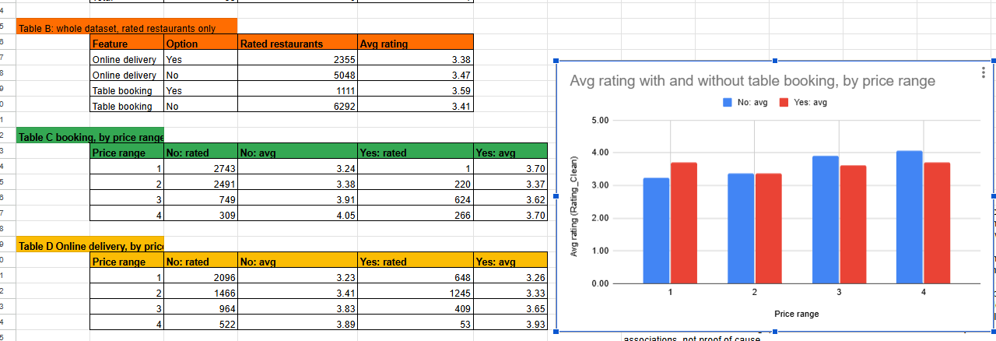
- Description:
Count of delivery and booking restaurants in the suggested countries, and average rating with and without each feature overall and by price range.

- Table / Chart Name:
price-range table and column chart--
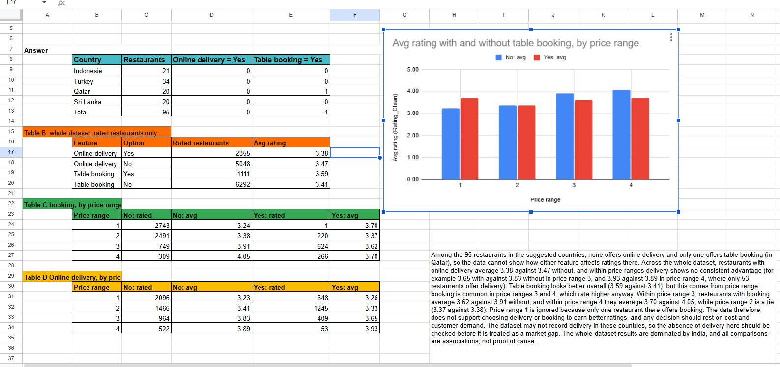

- Description:
Average rating by price range for the suggested countries and for the whole dataset.

Insights:
- In the 95 suggested-country restaurants none offers online delivery and only one offers table booking (Qatar), so the effect there cannot be measured.
- Whole dataset: delivery 3.38 with and 3.47 without. Booking looks better overall (3.59 vs 3.41), but within price range 3 booking restaurants average 3.62 vs 3.91 and in range 4 3.70 vs 4.05; range 2 is a tie (3.37 vs 3.38). The overall gap comes from price range, not booking.

Recommendations:
- Priority 1 — Validate demand before implementation: Do not introduce online delivery or table booking solely to improve restaurant ratings. First assess customer demand, expected order volume and the operating costs of each feature.
- Priority 2 — Investigate delivery feasibility: None of the 95 restaurants in the four suggested countries is recorded as offering online delivery. Verify whether this reflects actual market conditions or missing/incomplete data before treating delivery as a competitive opportunity.
- Priority 3 — Test features selectively: If local customer research indicates demand, pilot online delivery or table booking at a small number of suitable locations before rolling out the feature more widely.
- Priority 4 — Measure results: Before each pilot, record the baseline customer rating, order or booking volume, operating cost and customer feedback. After the pilot, compare these measures and use a proposed target of at least a 10% improvement in orders or bookings, without a decline in average rating or unacceptable increases in cost, to guide the next decision.
- Interpret ratings cautiously: The overall booking-rating difference changes when restaurants are compared within the same price range. Therefore, the observed association does not establish that table booking or online delivery causes better ratings.
The final decision should balance customer demand, operating costs and service feasibility rather than ratings alone.

Question 8: Should the team keep the rate of cuisines higher? Will that affect the feedback? According to our data are the rates of cuisines and ratings, correlated?

Solution:
Approach:
- 'Rate of cuisines' is read as the price of meals, measured by price range (1-4) and, within each country only, average cost for two (currencies differ).
- Used CORREL with FILTER on Rating_Clean for each suggested country, for all four pooled, for the whole dataset, India and outside India, plus a table and chart of average rating by price range.

Charts & Tables:
- Table 1: Price and Rating Correlation Table
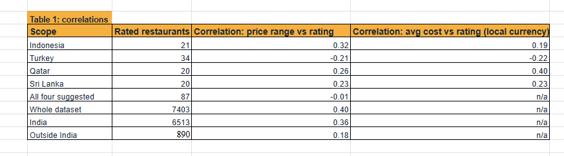
- Description:
Shows the correlation between price range and restaurant ratings for each suggested country, all suggested countries combined, the whole dataset, India and locations outside India. It also includes sample sizes and within-country correlations between average cost for two and ratings where applicable.
Table 2: Average Rating by Price Range
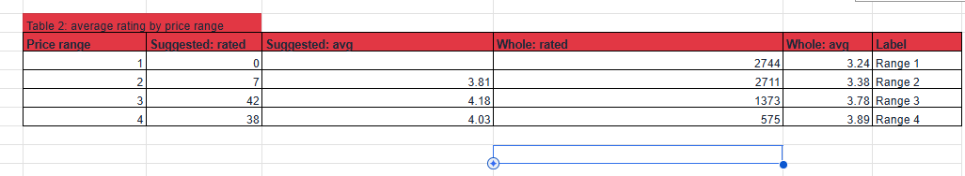
Description: Compares the number of rated restaurants and average ratings for price ranges 1–4 across the suggested countries and the whole dataset.
Chart 1: Average Rating by Price Range — Suggested Countries vs Whole Dataset
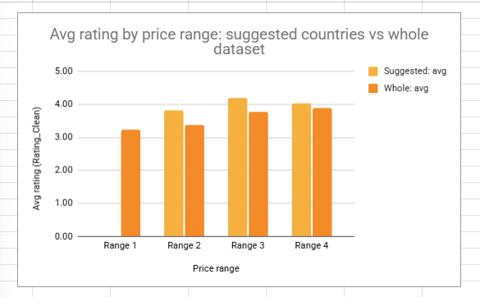
Description: A grouped column chart comparing average restaurant ratings across price ranges 1–4 for the suggested countries and the whole dataset. It helps show whether higher price ranges are associated with higher average ratings.

Insights:
- In the suggested countries price and rating are essentially unrelated: correlation 0.02 pooled, with ratings of 4.17, 4.14 and 4.20 in price ranges 2, 3 and 4. By country the sign differs (Indonesia 0.32, Qatar 0.26, Sri Lanka 0.23, Turkey -0.21) and such values cannot be told apart from chance with 20 to 34 restaurants.
- Whole dataset 0.40 (3.24 in price range 1 to 3.89 in range 4) but mainly India (0.36); outside India 0.18.

Recommendations:
- Do not expect higher prices to produce better feedback; set prices from cost and local competition (see Question 4).
Correlation shows association, not cause.

Question 9: What is the distribution of the number of restaurants of different price ranges in all the countries?

Solution:

Approach:
Pivot on Cleaned Data with Country Name in Rows, Price_range in Columns and COUNTA of RestaurantID in Values, a second pivot showing % of row, and a 100% stacked bar chart.
Charts & Tables:
- Table / Chart Name:
two pivot tables and 100% stacked bar chart—
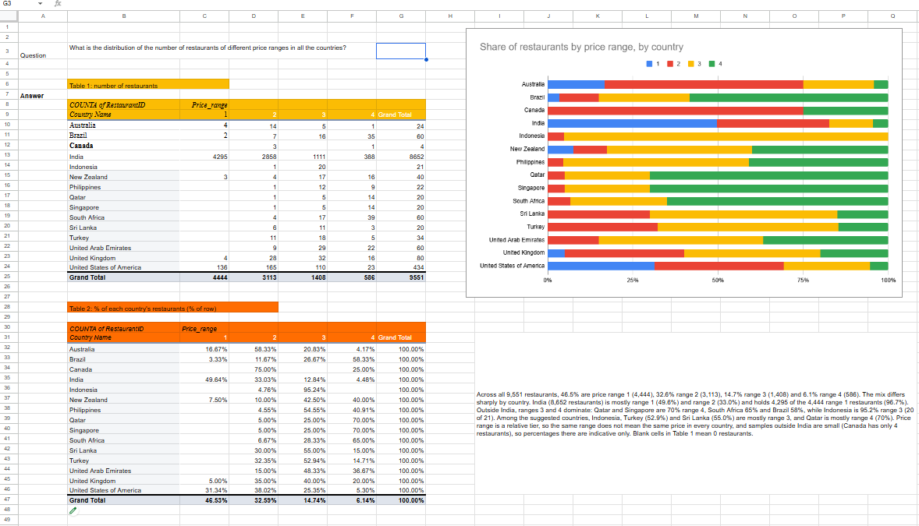
- Description:
- Number of restaurants in each price range by country.
- Share of each country's restaurants in each price range.
- : Price-range mix by country.

Insights:
- Overall 46.5% are price range 1 (4,444), 32.6% range 2 (3,113), 14.7% range 3 (1,408) and 6.1% range 4 (586). India holds 4,295 of the 4,444 range-1 restaurants (96.7%).
- Outside India ranges 3 and 4 dominate: Qatar and Singapore are 70% range 4, South Africa 65%, Brazil 58%; Indonesia is 95.2% range 3. Among suggested countries Indonesia, Turkey (52.9%) and Sri Lanka (55.0%) are mostly range 3 and Qatar is mostly range 4.

Recommendations:
- Prioritize mid-priced positioning for initial investigation in Indonesia, Turkey and Sri Lanka, where price range 3 represents the largest share of restaurant listings in the respective markets or is a prominent tier. Validate the appropriate price point against local competitors and customer affordability before finalizing prices.
- Consider a premium positioning in Qatar, where 70% of the listed restaurants are in price range 4. Assess whether a new restaurant can offer sufficient quality and value to compete in this segment.
- Use the country-level price-range percentages to guide the initial menu and pricing strategy rather than applying one price tier across all countries.
- Validate before launch: Compare local menu prices, food costs, rent, customer preferences and competitor offerings. Test the proposed price tier with a small menu or pilot before committing to a wider rollout.
- Interpret the findings cautiously: Price range is a relative category, not a common monetary value across countries. Several international markets also have small samples, so the observed distribution may not represent the full market.

Question 10: Explain your approach in brief for suggesting countries/cities in order to open new restaurants, if the objective and subjective questions would have not been given to assist you. [you have to give bullet pointers in order to answer this question]

Solution:

Approach:
- Data preparation: Cleaned the restaurant dataset by addressing missing and inconsistent values, standardizing currency labels, creating helper columns and mapping country codes to country names.
- Country screening: Excluded India from the international screening and compared countries using restaurant counts and average votes to identify markets for further investigation.
- Quality assessment: Compared average cleaned ratings, rating bands and the percentage of rated restaurants scoring 4 or above, while considering sample sizes.
- City-level analysis: Investigated shortlisted countries at the city level using restaurant counts, average votes and average ratings to identify potential locations.
- Affordability assessment: Compared average and median costs for two in local currencies, INR-converted cost benchmarks and price-range distributions.
- Competitor analysis: Identified highly voted restaurants and lower-rated competitors to understand existing customer engagement and possible service or quality gaps.
- Product and service assessment: Examined cuisine ratings, price–rating relationships, online delivery and table booking, controlling for price-range differences where relevant.
- Dashboard development: Presented key metrics and charts in an interactive Google Sheets dashboard with Year and Country slicers.
- Prioritization: Ranked candidate markets for further investigation based on recorded competition, customer engagement, ratings and affordability rather than restaurant counts alone.
- Final validation: Before investment, verify local demand, market size, rental and operating costs, licensing requirements, and political and regulatory stability. Use a limited pilot with measurable customer-rating, order or booking, and cost targets before considering expansion.
Limitation: The dataset does not provide revenue, footfall, rent or reliable confirmation that every listed restaurant is currently open. Therefore, the analysis supports preliminary market screening, not a definitive investment decision.

Charts & Tables:
- Table / Chart Name: Restaurant Expansion Screener Dashboard

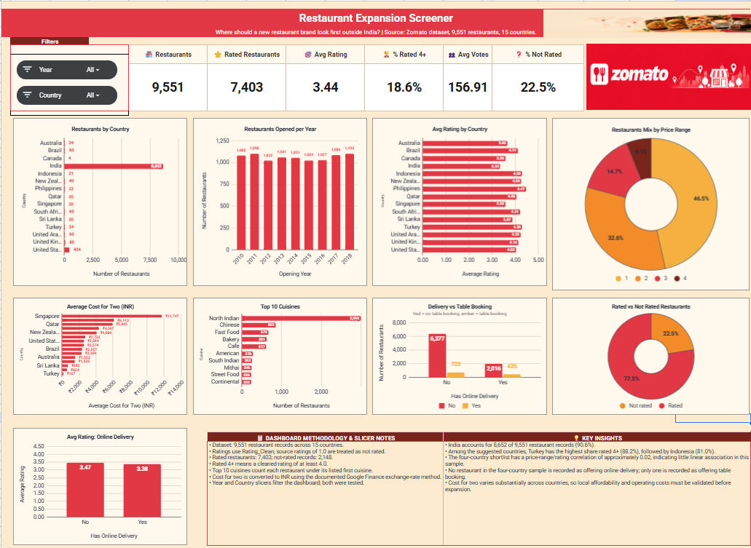
- Description: Interactive Google Sheets dashboard containing six KPI cards and nine charts covering restaurant distribution by country and opening year, average ratings by country, price-range distribution, average cost for two in INR, top cuisines, delivery and table-booking comparisons, rated versus not-rated restaurants, and average rating by online-delivery status. Year and Country slicers allow management to filter and explore the dashboard.
Insights: The initial screening identifies Indonesia, Turkey, Qatar and Sri Lanka as countries for further investigation, with the Philippines and New Zealand as additional candidates. Jakarta, Istanbul, Ankara, Doha and Colombo are candidate cities for further research. These are preliminary screening results, not confirmed investment recommendations.

Recommendations:
- Validate the shortlisted markets using current city-level competition, customer demand, local affordability, rent, operating costs and licensing requirements.
- Assess political and regulatory stability before committing capital.
- If a market passes feasibility checks, run a limited pilot and track customer ratings, orders or bookings, customer feedback and operating costs against a documented baseline.
- Expand only when the pilot meets pre-agreed business targets. The dataset alone cannot establish revenue growth or profitability.

