RAMDisk Concept

121027

Kunjan Patel

6th Semester, Operating Systems

Institute of Engineering and Technology, Ahmedabad University

# What is a RAMDisk?

A block of RAM that an OS is treating as a disk drive. It is also called as virtual RAM Drive, or Software RAM Drive. First of its kind, RAM Drive was invented and written by JERRY KARLIN in UK in 1979/80. The name of the software he developed was: Silicon Disk System.

In Linux, RAMDisk is nothing but a memory based file system. It creates a storage area directly in a RAM as if it were a partition on a disk. We can perform read and write operations as such we do on a regular disk drive in the RAM Disk.

The principal benefit of RAM Disks is they are 10s of times faster than modern SSD drives in terms of reading and writing speed. These types of fast storage areas are ideally suited for applications which need repetitively small data areas for caching or using temporary space.

RAM, we all know, is volatile. Hence, when the system restarts, or crashes, file system is lost along with all its data. Hence before restarting or shut down, one should take back up of the data or the data will be lost. In Windows, options are available that the data in the RAMDisk will be copied to the hard drive automatically when it shuts down or restarts and then it is copied back again from hard drive to ramdisk on boot up. But this can cause a substantial time delay in booting of the system.

# Types of RAMDisk

Principally in Linux, there are two main types of RAMDisk file systems,

1. ramfs
2. tmpfs

## ramfs

The ramfs uses same mechanism for storage space as Linux file system cache. The ramfs file system cannot be limited in size like a disk base file system which is limited by its capacity.

Ramfs will continue using memory storage until the system runs out of RAM and crashes or becomes unresponsive. This can be a problem if the application writing to the file system cannot be limited in total size.

Moreover, you cannot see the size of the file system & it can be only estimated by looking at the cached entre from ‘free’ command.

## tmpfs

tmpfs is a more recent RAM file system which overcomes many of the drawbacks with ramfs. You can specify the size limit in tmpfs & will give a ‘disk full’ error when the limit is reached. The tmpfs behaves same as partition of a physical disk.

One drawback with tmpfs is, if the system runs out of the physical RAM, files in the tmpfs partitions may be written to disk based SWAP partitions and will have to be read from disk when the file is not accessed. The same draw back can be termed as a benefit in some environment

# Creating a RAMDisk in Linux

Create a folder to use as a mount point for your RAM disk.

mkdir /mnt/ramdisk

Then use the **mount**command to create a RAM disk.

mount -t [TYPE] -o size = [SIZE] [FSTYPE] [MOUNTPOINT]

Substitute the following attributes for your own values:

* [TYPE] is the type of RAM disk to use; either **tmpfs** or **ramfs**.
* [SIZE] is the size to use for the file system. Remember that ramfs does not have a physical limit and is specified as a starting size.
* [FSTYPE] is the type of RAM disk to use; either **tmpfs**, **ramfs**, **ext4**, etc.

For Example,

mount -t tmpfs -o size=512m tmpfs /mnt/ramdisk

The above line will create a 512 mb RAMDisk in the file system.

# Creating a RAMDisk in Windows

In windows, there are many software available that can create a RAMDisk for you as per your given specifications. The software will itself create the RAMDisk on your given inputs. Some of the software are Gizmo Drive 2.7.9, Bond Disc, SuperSpeed RAMDisk, Primo RAMDisk Standard Edition, SoftPerfect RAMDisk etc. The read and write speed of the software is variable. The following are some speeds of read and write in RAMDisk.

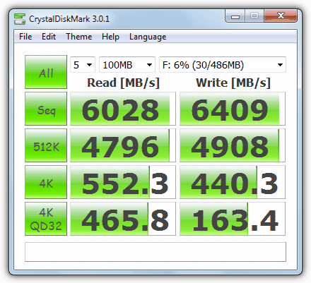🡨SuperSpeed RAMDisk

# 🡨 Bond Disk 🡨 Gizmo 🡨 Softperfect RAMDisk 🡨Passmark OSF

# References:

1. <https://www.raymond.cc/blog/12-ram-disk-software-benchmarked-for-fastest-read-and-write-speed/> (for images)

2. <http://www.jamescoyle.net/knowledge/951-the-difference-between-a-tmpfs-and-ramfs-ram-disk>

3. <http://www.jamescoyle.net/how-to/943-create-a-ram-disk-in-linux>