S3 CONFIGURATIONS

SETTING UP THE S3 BUCKET

Note that the S3 bucket is set to to default be private

Cloud front was used make the static sight available over the internet, the cloud front distribution was created and linked to the root of the S3 bucket

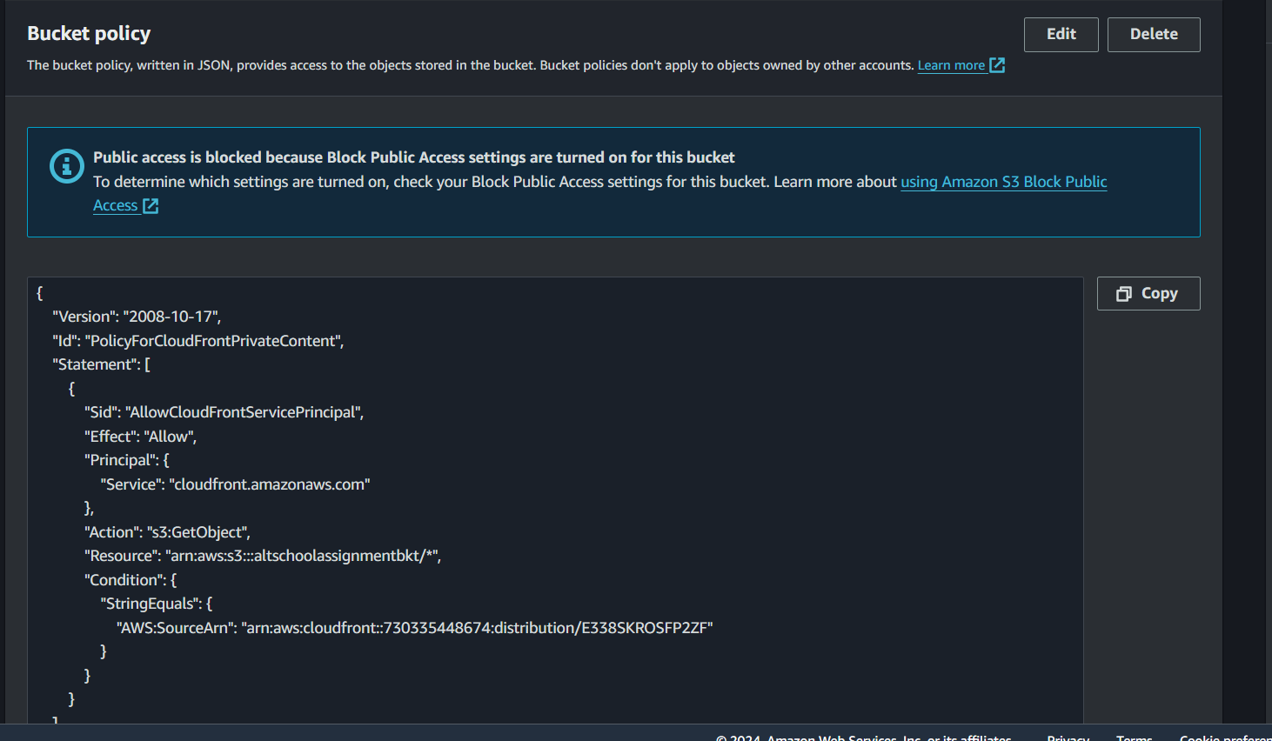

Using the domain URL of the Cloud front I was able to display the s3 bucket

