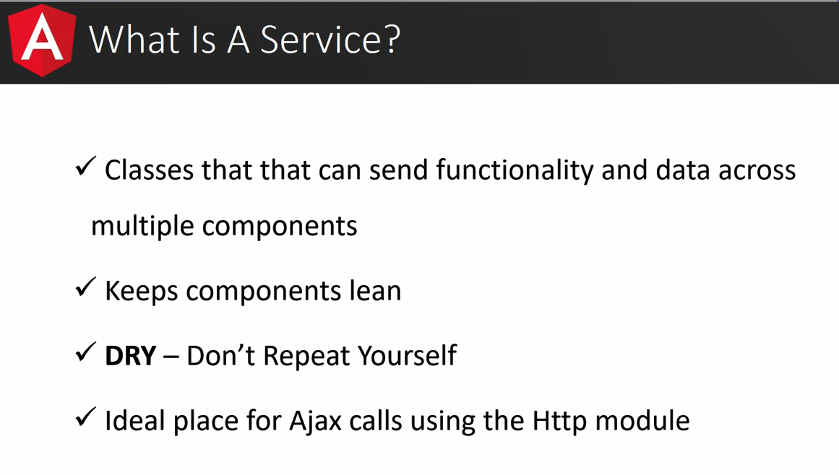

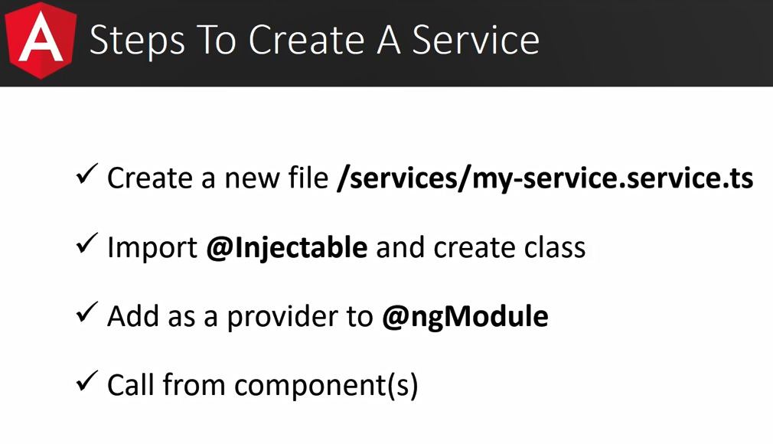

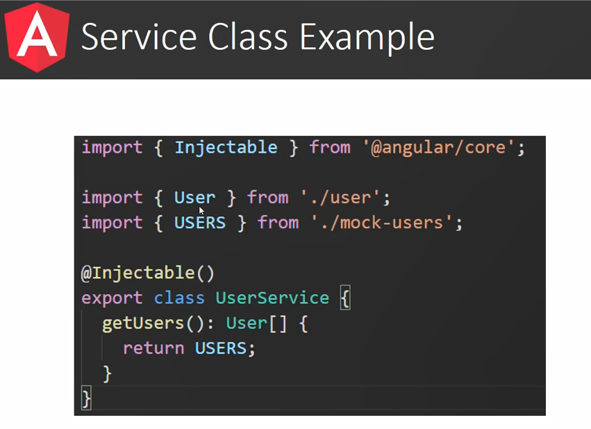

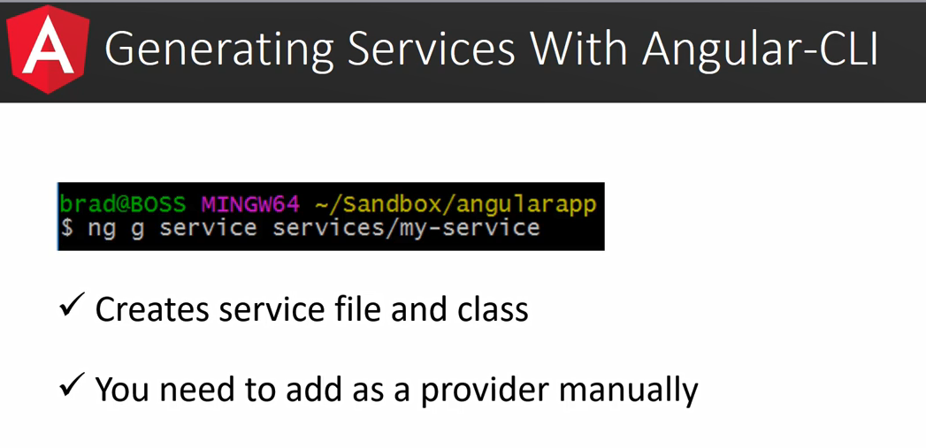

**So, what are observables?**

In the [Angular docs](https://angular.io/docs/ts/latest/guide/glossary.html#!#O), they are described as a sort of array:

You can think of an observable as an array whose items arrive asynchronously over time. **Observables help you manage asynchronous data**, such as data coming from a backend service. Observables are used within Angular itself, including Angular’s event system and its http client service. To use observables, Angular uses a third-party library called Reactive Extensions (**RxJS**). Observables are a proposed feature for ES 2016, the next version of JavaScript.

07 Angular Router: 041 Section 7 Introduction

