London Housing Case Study

Mohammed Ayub Shaik

Table of Contents

Summary………………………………………………………………………………… 3
Introduction……………………………………………………………………………………… 4
Analysis………………………………………………………………………………………….. 5
Challenges and Data Processing…………………………………………………………………. 7
Conclusion………………………………………………………………………………………. 8

Summary

The main purpose of this report is to find out the top 10 boroughs in London which have seen the greatest increase in housing prices, on average, over the last two decades?

This report will also focus on the challenges faced when processing the raw data collected from
london.gov.uk

Introduction
A borough is just a fancy word for district. There are 32 Boroughs Within Greater London. The Data on the average prices of housing in the Borough is downloaded from London Datastore
Following tools are used for the Data processing and analysis
- Pandas
- Matplotlib
- Seaborn
- NumPy

Data is acquired from here.
Pandas is used the load the data set using
The pipeline that is followed in this case study are:
- Sourcing and loading
- Cleaning and Transforming
- Analyzing
- Evaluating and concluding

Analysis
The Data set downloaded from the London datastore has the London borough’s average housing prices from Jan 1995 to Oct 2020. The data not only had that information it also has a lot of information which was not essential for this case study which was dropped for this analysis.
From the information we can say that Kensington & Chelsea at present (as of Oct 2020) is the most expensive with an average price of 1.3M Euros. Below is a bar plot of the Top 5 expensive Boroughs at present.
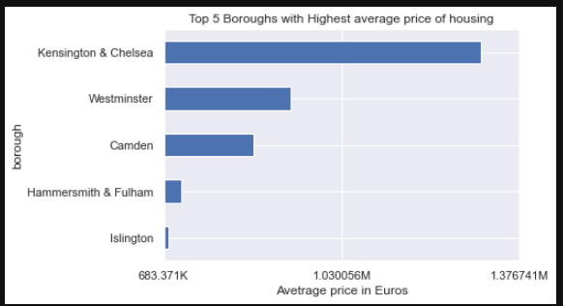

We can also say that Barking & Dagenham is the least expensive Borough to buy a house with an average price of 308.58K Euros. Below is a bar plot that shows the Top 5 least boroughs with least average housing prices.
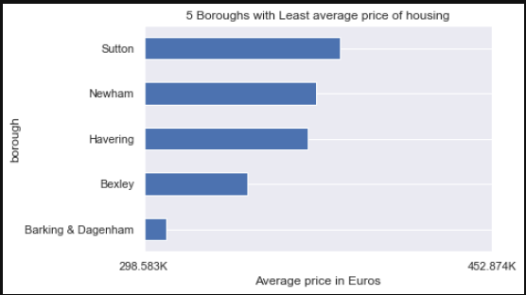
Also, from the data we can observe that from the year 1995 to 2020 Hackney has the highest increase in average price. Below plot shows the top 5 boroughs that had the highest increase in the average price of housing.

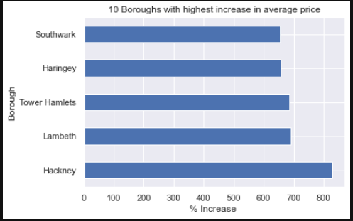
Challenges and Data Processing

The main challenges faced during processing the data was during cleaning the data are:
- The data that was downloaded from the London data store consisted of not only the data on London boroughs but also some other information not relevant to this study.
- There was also the columns and rows that were out of order and needed proper naming
- There were some missing values in the data which needed to be dropped.
- The data was not aligned properly so there was some transformation that was needed to get to the correct data frame with the information needed for easy analysis.
- The data was not of appropriate data type.

As mentioned earlier pandas was used to process the dataset, we stored the data in a data frame and after cleaning noisy data this is the outlook of the data frame.

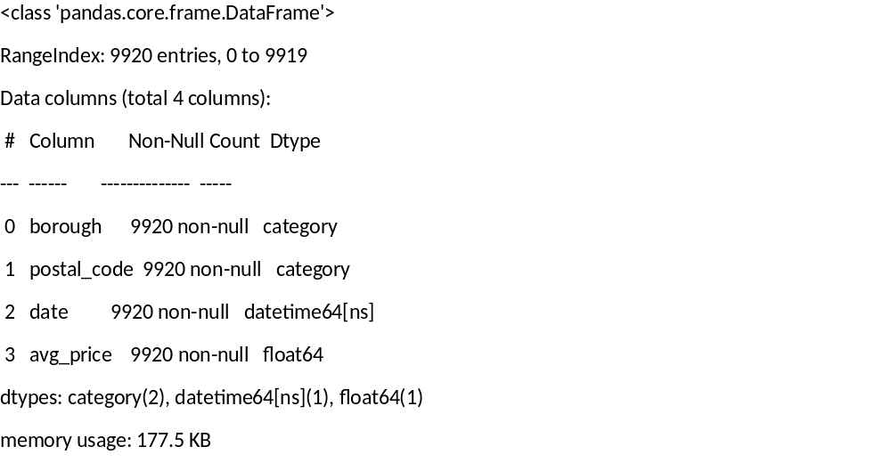

Another Data frame was created based on the initial data frame with borough’s data. this data frame consisted of some statistical information to summarize the data we have on the Boroughs
Below is the image on how the new data frame looked
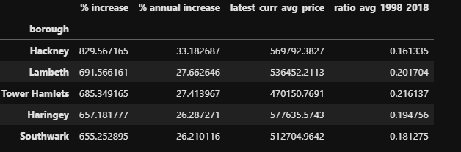
Conclusion

From the analysis of the data following can be concluded.

- Hackney had seen the greatest increase in housing prices, on average, over the last two decades.
- Barking & Dagenham is the least expensive Borough to buy a house with an average price of 308.58K Euros.
- Kensington & Chelsea at present (as of Oct 2020) is the most expensive with an average price of 1.3M Euros.

