
Leoni, North Middlesex Regional High School, Townsend MA, US

GAME SUMMARY DOCUMENT
Technical Requirements:
- You must use the Game Design Summary Template.
- The summary must be a minimum of 600 characters including spaces.
- You must provide a name for your game. The name must be in the English language.
- The file format must be either a .DOC, .DOCX or .PDF, .RTF or .TXT file. This option does not allow .JPEG submission files.
- The content of the Game must address a social cause connected to the 2012 Theme: “Imagine a world where technology helps solve the toughest problems”.
- The Game Design Summary Document must be submitted in the English language. If a translator is needed, you are responsible to procure and to make use of one.

Leoni is a RPG (Role-playing game) that will feature angels coming from the heavens to restore peace after the human race destroys their mother-planet. The intent of the game is to make the user aware of what could happen to our planet if it is not taken care of in a serious and dark way. Our hopes is by the end of the game that the mood will change from dark and serious to joyful and bright as the planet becomes more sustainable and lively.
The game will be in first person and 3D, with the user playing as multiple angels. Our game will target environmental sustainability, and will focus on the aftermath of what happens if we don't take care of our environment. Some unique game play that the game will feature is 'angel-vision', an ability to see the world in a different way, such as seeing smoke stacks that might blend in with the scenery as rotten metal turn into something more vibrant and noticeable. Angel vision will also entail ways of gaining energy and acts as a 'portal' into a different world. However, if the user decides to interact with oil or something harmful, the user will start to lose health and slowly die if not taken care of.
Something else that is unique to our game play is the way everything works within the game to create a challenge. The game acts as a role playing game, with puzzle-like games within them. For instance, the first challenge of the game is to find a power source that can be used to power objects. In order to do so, you must find 2 things: an energy source and then a battery to hold a charge. However, it should be noted that there will not be just one solution, there could be many. Some could use a generator as the energy source, while others might make use of solar panels, and others may find a car engine. This method will allow people to be creative with their game play.
Improvements from Round 2
After feedback from the round 2 judges, we improved our game play significantly. To improve feedback to the user, we added in a scoring system, a more in depth health notifications, and immediate feed back to the user after the angel dies. The scoring system includes a way for the player to know how well or bad he/she is doing by tallying points as he/she performs actions, as with most games. Health is easily shown with a red tint around the screen. As the screen becomes more red, the player knows that he/she is become weaker and closer to death. After the angel dies, the player can see how well he/she did by a quick summary like “Good Job! You did awesome” or “You did okay, but you could have done better”. To make the game more exciting, we made the smoke stack monster a much bigger part of the game. Using the plasma gun, the player can shoot smoke stack monsters down. The player also loses health 8x faster when “in range” of a smoke stack monster. The user will know if he/she is the in range when their screens starts to smoke up. To show some some ideas that would come in the future, we made it only possible to shoot down a smoke stack monster if the player is within the range of the smoke stack monster. By doing this, a trade off would be forced to happen. For the player to gain points and kill the smoke stack monster, he/she would have to sacrifice some health. This game play would become essential in concepts like “smoke-stack monster wars”.
Team Members:
Justin Marple – Lead Programmer/Modeler
Bryan Caputo – Lead Designer/ Programmer
Aaron Taylor – Writer/Artist/Voices
Marc Rudkowski – Manager
Copyright information:
All code, except for the BEPUphysics engine has been programmed by Justin and Bryan. The licensing information can be found here: http://bepuphysics.codeplex.com/license .

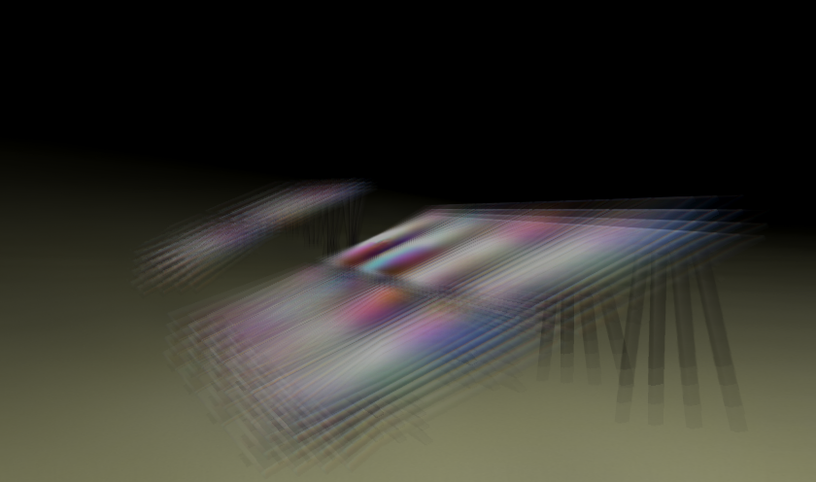
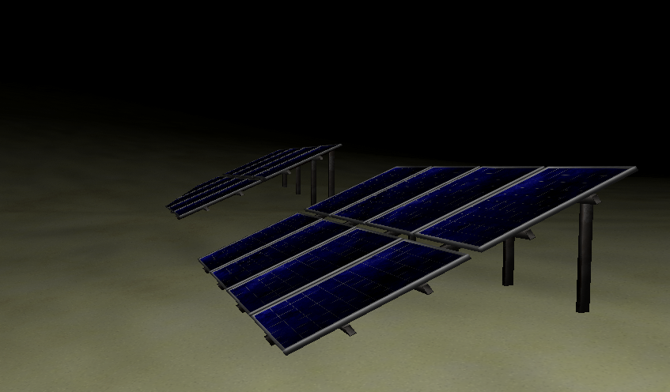
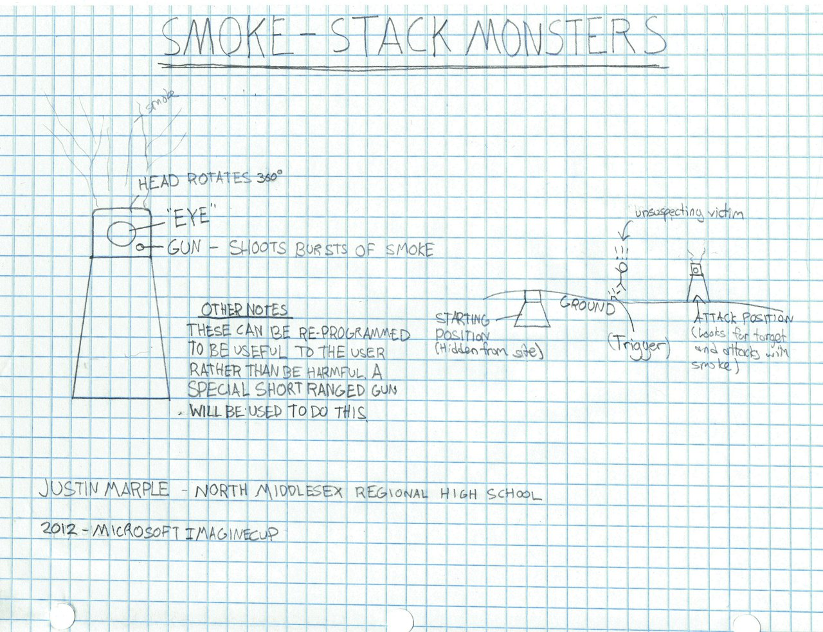
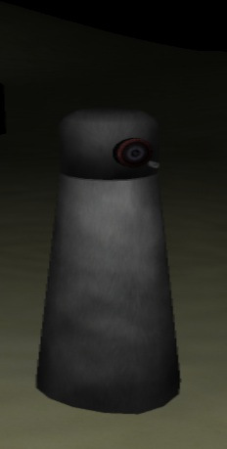
All models were made by Justin.
Aaron, our writer, created our storyline.
Our friend Joe, also from North Middlesex, wrote the music, and gave us permission to use it.
The font used, “Foglihten” can be found here(license is in a folder with the font): http://www.dafont.com/foglihten.font and is licensed under the Open Font License. “LED Real” was made by Matthew Welch, which can be downloaded from
http://www.fontspace.com/category/led?p=7 (Read me has the file lists permissions)

All textures were made by Justin, Aaron and Bryan.
Voice-overs were by Aaron.

Examples
'Angel-Vision' – Solar Panels
Smoke Stack Monsters

