MuleSoft Classic Release
Production Branch Synchronization Approach
Team architecture and rollout overview
Purpose: separate ongoing development from the production snapshot, while ensuring the production branch always represents the exact code version successfully deployed to PROD.

1. Target State
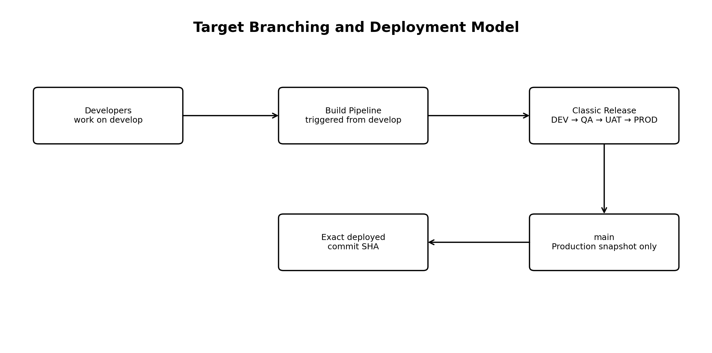
- develop becomes the working branch for ongoing developer changes.
- The build pipeline is triggered from develop instead of main.
- main is no longer the day-to-day development branch; it becomes the production snapshot branch.
- After a successful PROD deployment, main is moved directly to the exact commit SHA of the deployed artifact.
- A rollback is handled the same way: if an older artifact is deployed, main moves back to that older deployed commit.

2. One-Time Migration / Preparation
Step | Action | Reason
1 | Temporarily protect/lock main during migration | Avoid changes while branch structure is being changed.
2 | Create PROD-Code from the latest deployed PROD tag/commit | Preserve the current production snapshot before repurposing main.
3 | Remove the old develop branch if required | Clean up the previous branch arrangement.
4 | Create develop from the current main | Give developers a continuation point containing the current code.
5 | Update build pipeline triggers: remove main, add develop | CI/CD builds should follow the development branch.
6 | Apply the former main branch policies to develop | Keep normal PR/reviewer protections on the developer branch.
7 | Roll out the new PROD synchronization task | Automate main so it always reflects the successfully deployed PROD commit.

3. What Happens During Every PROD Release
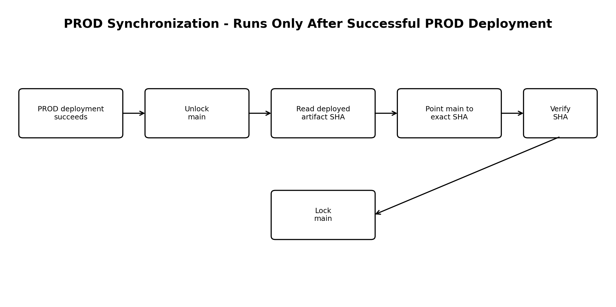
The synchronization step is placed after the actual PROD deployment and is gated on deployment success. The deployed artifact's source commit SHA is the source of truth; the script does not merge, rebase, or cherry-pick.
Step | Runtime action | Result
1 | PROD deployment succeeds | No branch synchronization should happen for a failed deployment.
2 | Unlock main | Allows the automation identity to update the protected production snapshot.
3 | Read the exact deployed commit SHA | Uses release/build artifact metadata rather than the current branch tip.
4 | Update main directly to that SHA | Makes the Git branch represent exactly what was deployed.
5 | Verify remote main | The task confirms remote main equals the deployed SHA.
6 | Re-lock main | Returns the production snapshot branch to its protected state.

4. Forward Deployment and Rollback
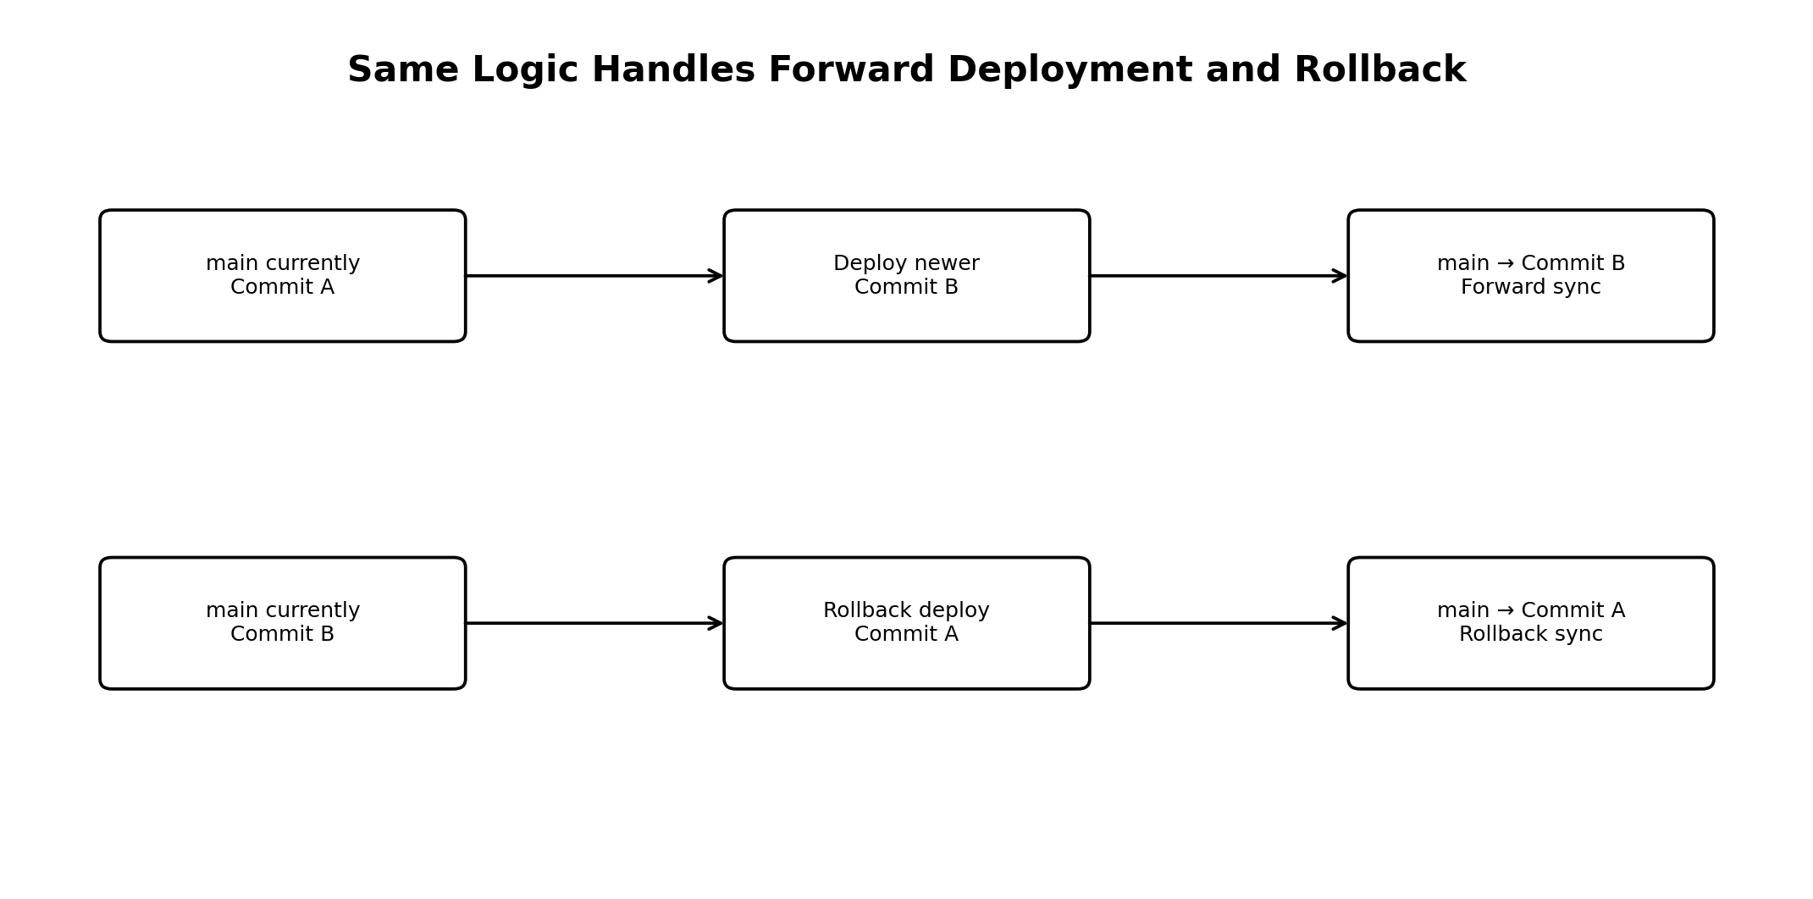
Because the branch is pointed directly at the deployed SHA, the same mechanism supports both directions. This is why changes such as a parent POM version, Mule XML, properties, or application code require no special handling: the complete Git snapshot at that commit becomes the branch state.

5. Controlled Rollout to All Classic Release Pipelines
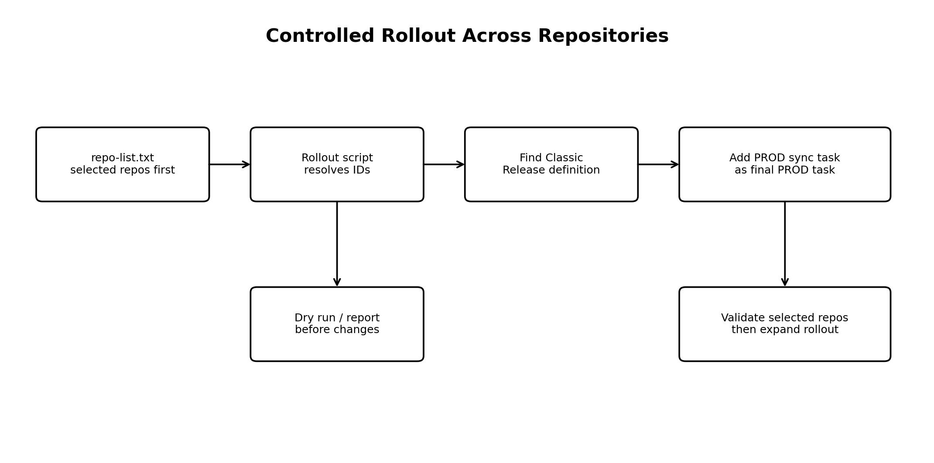
The rollout is intentionally list-driven so the team can start with a small set of repositories, validate behavior, and then expand.
- repo-list.txt contains the repositories selected for the current rollout wave.
- The rollout script resolves repository/build/release identifiers rather than requiring IDs to be maintained manually.
- It finds the matching Classic Release definition and adds the synchronization PowerShell task to the PROD environment.
- The task is placed after the successful PROD deployment so a failed deployment does not update main.
- Use dry-run/reporting first, validate the selected repositories, and only then increase the repo list.

6. Shared Automation Repository
The synchronization logic is stored centrally in the shared MuleSoft pipeline repository. Classic Release does not execute the script merely because that repository is cloned; the release definition must contain an explicit PowerShell task that invokes it.

7. Safety Controls
Control | Why it matters
Successful deployment gate | main changes only after PROD deployment succeeds.
Exact SHA | The deployed artifact commit—not a branch name or latest commit—is authoritative.
No merge | No merge commit, rebase, or cherry-pick is introduced.
Verification | The remote branch is read again after the update and must equal the deployed SHA.
No-op handling | If main already equals the deployed SHA, no unnecessary update is required.
Automation permissions | Elevated branch permissions are granted to the automation identity, not broadly to developers.
Rollback support | Deploying an older release intentionally moves main backward to the older deployed snapshot.

8. Simple Team Explanation
In one sentence: Developers work from develop, while main is automatically maintained as an exact snapshot of the code that is actually running in Production.
Release flow: develop → build artifact → Classic Release → successful PROD deployment → synchronize main to deployed commit → verify → lock main.

