**Application**

**Web app** file created Webapp1.py

**Infrastructure**

Infrastructure will look like below in Azure

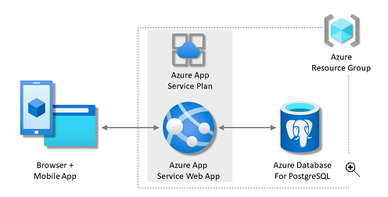

Azure Web App < --- > Azure PostgreSQL

|

|

Visitor App

|

|

Tf Deployment

|

|

Create Azure Resources

Web App, DB

|

| link to

(Azure PostgreSQL)

**main.tf** has been created for Iac

Bash : - terraform init and terraform apply

**Containerization**

docker-compose.yml and Dockerfile are in same file location in Git

Bash: -

docker-compose up –build

docker-compose down

**CI/CD**

I Used Jenkins for Pipe line for build and Deploy

**Build :-** docker-compose build

Deploy: - docker-compose up –d

Create a New Pipeline Job

Run the Pipeline 🡪 Build Now

**2.5 Monitoring**

For Monitoring I will use Nagios open source tool monitoring vsdb01-web with <Ipaddress>

Checks for Checks:

Checks will be done on cfg file vsdb-check.cfg and vsweb-check.cfg placing hostname on HOSTS for DNS mapping.

Nagios is application and Infra Monitoring Tools with Alert notification sent to Dashboard and Email.

2.6 Documentation

1. Technologies tools here are Python 3.12 , Nagios, Vs code, Jenkins, Terraform, Azure Cloud, Postgres SQL.
2. I used GitHub for repository for code storage. We can clone the file and change the hardcoded Parameters.
3. For Azure Monitoring Events and Auto-Scaling with Load Balancer to Scale up with DB server.

We usually monitor CPU usage, response time, Storage space, long running transaction.

1. Scale Down can be maintained using Cool-down period.
2. I will Use Akamani DNS to point to Loadbalance DNS for CDN and Security.