Step1：put 999-hostapd-2.10-lar.patch in OpenWrt../hostapd/patches , then make bewlow two \*.ipk

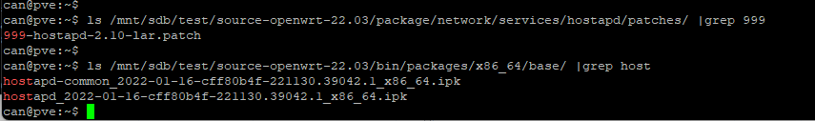

Step2: Install hostapd and configure the /etc/config/wireless

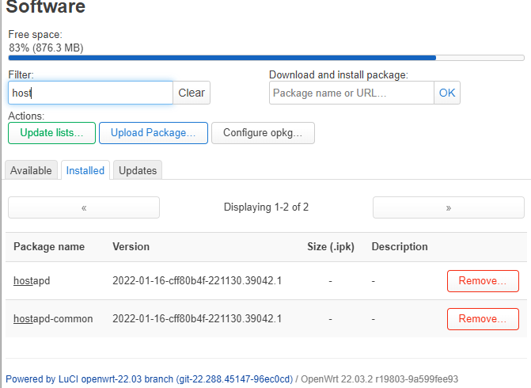

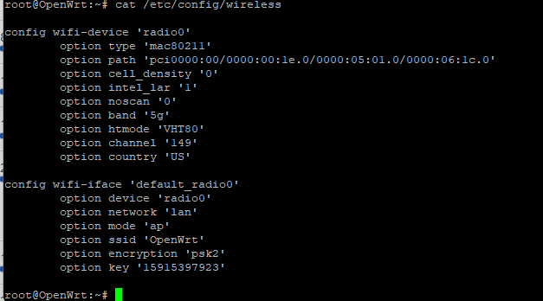

Step3:reboot check reg , however reg is CN

