# Tyler Williams

Anderson College of Business and Computing, Regis University

MSSE 670

Week 2

Professor Randall Granier

# October 29, 2023

# Application Description

The application that will be built in this course is a business insights system that can consume unstructured or differently-structure inputs (from CSV input, JSON exports, events) and run a set of predefined analytics on them to generate reports based on those inputs. The inputs will be modeled as entities in a relational database and consumed through a variety of input mechanisms. Outputs will also be modeled as relational database entities.

# User Stories

1. A user should be able to import subscription events from a JSON source and have them parsed into the database
2. A user should be able to import single subscription events from a GUI, command line, or other user interface and store them in the database.
3. A user should be able to edit subscription events from the existing database
4. A user should be able to query the subscription events using SQL or some object-relational mapping system to find matching events that have been imported
5. A user should be able to generate reports about the lifetime value of users globally
6. A user should be able to generate reports about the lifetime value of users, segmented by event types
7. A user should be able to generate reports that segment users by event types and attributes
8. A user should be able to import ad spend data from CSV data sources and have them parsed into the database
9. A user should be able to import ad spend data from individual interfaces and have them stored in the database
10. A user should be able to join ad spend data on subscription events and run queries on both of those tables
11. A user should be able to generate return on ad spend data by attributing subscription events to specific ad spend information
12. A user should be able to return rolling statistics about return on ad spend based on cumulative or segmented subscription and ad spend data

# UML Models

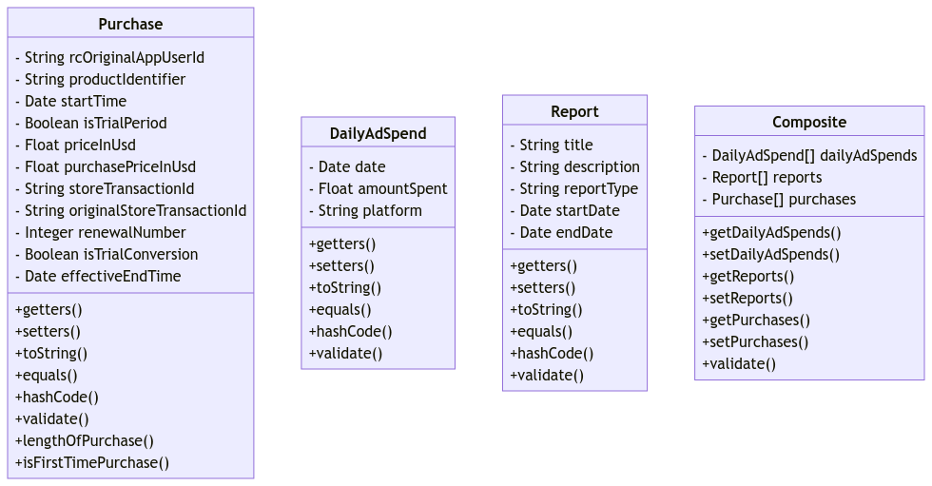

# DDD Bounded Context Diagram

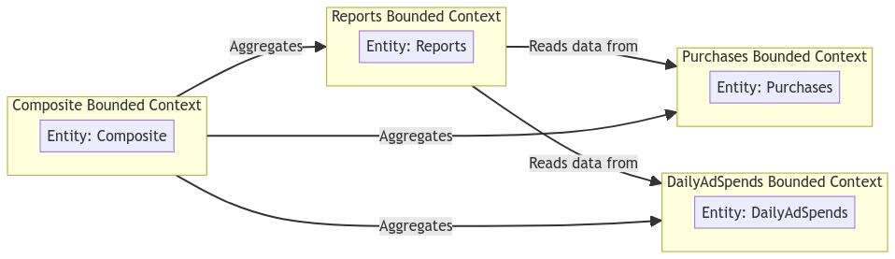

# Sequence Diagram

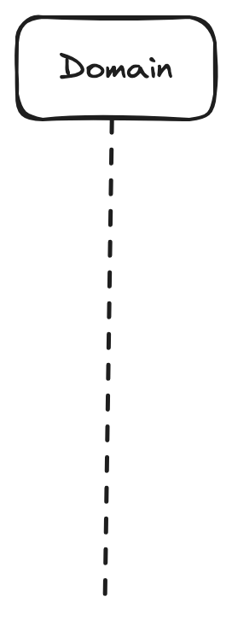

# Screenshot of All Tests Running

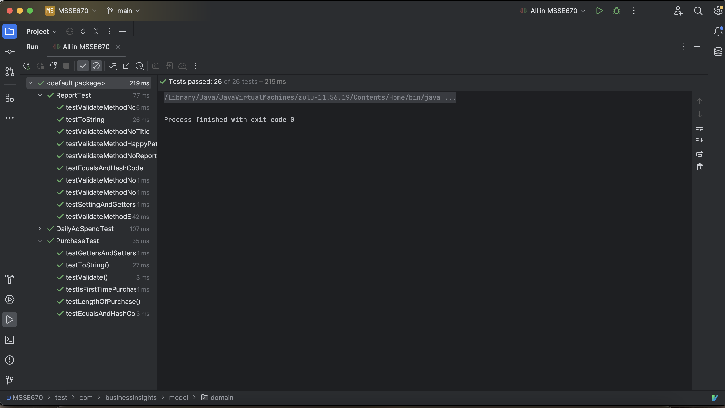

# Screenshot of Program Running

# GitHub Repository

<https://github.com/coolsoftwaretyler/msse670>