스프링 배치 실무

[회사 이름] | [회사 주소]

Spring boot & spring batch & mybatis

zero

2020

1. 프로젝트 생성

1) maven 프로젝트 생성

new > project > Maven > Maven Project

- Create a simple project (skip archetype selection)

- Group id : com.zero

- Artifact id : batch (프로젝트명)

- Version 0.0.1-SNAPSHOT

- Packaging : jar

- Name : batch (??)

- Description : Spring Boot And Spring Batch And Mybatis

(기존 프로젝트 복사 - batch)

2. pom.xml

기존 프로젝트의 pom.xml 복사 -> 오른쪽 마우스 -> Maven -> Update Project

- pom.xml : artifactId "새 프로젝트 명"으로 수정

<?xml version=*"1.0"* encoding=*"UTF-8"*?>

<project xmlns=*"http://maven.apache.org/POM/4.0.0"*

xmlns:xsi=*"http://www.w3.org/2001/XMLSchema-instance"*

xsi:schemaLocation=*"http://maven.apache.org/POM/4.0.0 https://maven.apache.org/xsd/maven-4.0.0.xsd"*>

<!-- ############################ info ############################ -->

<modelVersion>4.0.0</modelVersion>

<groupId>com.euclid</groupId>

<artifactId>batch3</artifactId>

<version>0.0.1-SNAPSHOT</version>

<packaging>jar</packaging>

<name>batch</name>

<description>Spring boot, batch</description>

<!-- ############################ parent ############################ -->

<parent>

<groupId>org.springframework.boot</groupId>

<artifactId>spring-boot-starter-parent</artifactId>

<version>2.2.2.RELEASE</version>

<relativePath/><!-- lookup parent from repository -->

</parent>

<!-- ############################ properties ############################ -->

<properties>

<project.build.sourceEncoding>UTF-8</project.build.sourceEncoding>

<project.reporting.outputEncoding>UTF-8</project.reporting.outputEncoding>

<java.version>1.8</java.version>

</properties>

<!-- ############################ dependencies ############################ -->

<dependencies>

<dependency>

<groupId>org.springframework.boot</groupId>

<artifactId>spring-boot-starter-batch</artifactId>

</dependency>

<dependency>

<groupId>org.mybatis.spring.boot</groupId>

<artifactId>mybatis-spring-boot-starter</artifactId>

<version>2.1.1</version>

</dependency>

<dependency>

<groupId>org.springframework.boot</groupId>

<artifactId>spring-boot-starter-jdbc</artifactId>

</dependency>

<dependency>

<groupId>org.springframework.boot</groupId>

<artifactId>spring-boot-configuration-processor</artifactId>

<optional>true</optional>

</dependency>

<!-- lombok -->

<dependency>

<groupId>org.projectlombok</groupId>

<artifactId>lombok</artifactId>

</dependency>

<!-- persistance -->

<dependency>

<groupId>org.mybatis</groupId>

<artifactId>mybatis</artifactId>

<version>3.5.3</version>

</dependency>

<dependency>

<groupId>org.mybatis</groupId>

<artifactId>mybatis-spring</artifactId>

<version>2.0.3</version>

</dependency>

<!-- driver -->

<dependency>

<groupId>com.microsoft.sqlserver</groupId>

<artifactId>mssql-jdbc</artifactId>

<!-- <scope>runtime</scope> -->

</dependency>

<dependency>

<groupId>com.oracle.ojdbc</groupId>

<artifactId>ojdbc8</artifactId>

<!-- <scope>runtime</scope> -->

</dependency>

<dependency>

<groupId>mysql</groupId>

<artifactId>mysql-connector-java</artifactId>

<!-- <scope>runtime</scope> -->

</dependency>

<!-- tomcat-jdbc for log4jdbc-remix query logging -->

<dependency>

<groupId>org.apache.tomcat</groupId>

<artifactId>tomcat-jdbc</artifactId>

</dependency>

<!-- logback -->

<dependency>

<groupId>ch.qos.logback</groupId>

<artifactId>logback-core</artifactId>

</dependency>

<dependency>

<groupId>ch.qos.logback</groupId>

<artifactId>logback-classic</artifactId>

</dependency>

<!-- logging -->

<dependency>

<groupId>org.slf4j</groupId>

<artifactId>slf4j-api</artifactId>

</dependency>

<dependency>

<groupId>org.slf4j</groupId>

<artifactId>jcl-over-slf4j</artifactId>

</dependency>

<dependency>

<groupId>org.slf4j</groupId>

<artifactId>jul-to-slf4j</artifactId>

</dependency>

<dependency>

<groupId>org.slf4j</groupId>

<artifactId>log4j-over-slf4j</artifactId>

</dependency>

<dependency>

<groupId>org.logback-extensions</groupId>

<artifactId>logback-ext-spring</artifactId>

<version>0.1.5</version>

</dependency>

<dependency>

<groupId>org.lazyluke</groupId>

<artifactId>log4jdbc-remix</artifactId>

<version>0.2.7</version>

</dependency>

<!-- common -->

<dependency>

<groupId>commons-io</groupId>

<artifactId>commons-io</artifactId>

<version>2.6</version>

</dependency>

<dependency>

<groupId>commons-lang</groupId>

<artifactId>commons-lang</artifactId>

<version>2.6</version>

</dependency>

<dependency>

<groupId>org.apache.commons</groupId>

<artifactId>commons-lang3</artifactId>

</dependency>

<dependency>

<groupId>commons-logging</groupId>

<artifactId>commons-logging</artifactId>

<version>1.2</version>

</dependency>

<dependency>

<groupId>commons-codec</groupId>

<artifactId>commons-codec</artifactId>

</dependency>

<dependency>

<groupId>commons-beanutils</groupId>

<artifactId>commons-beanutils</artifactId>

<version>1.9.4</version>

</dependency>

<dependency>

<groupId>commons-collections</groupId>

<artifactId>commons-collections</artifactId>

<version>3.2.2</version>

</dependency>

<dependency>

<groupId>org.apache.commons</groupId>

<artifactId>commons-collections4</artifactId>

<version>4.4</version>

</dependency>

<dependency>

<groupId>org.apache.xmlbeans</groupId>

<artifactId>xmlbeans</artifactId>

<version>3.1.0</version>

</dependency>

<!-- testing -->

<dependency>

<groupId>org.springframework.boot</groupId>

<artifactId>spring-boot-starter-test</artifactId>

<scope>test</scope>

<exclusions>

<exclusion>

<groupId>org.junit.vintage</groupId>

<artifactId>junit-vintage-engine</artifactId>

</exclusion>

</exclusions>

</dependency>

<dependency>

<groupId>org.springframework.batch</groupId>

<artifactId>spring-batch-test</artifactId>

<scope>test</scope>

</dependency>

</dependencies>

<!-- ############################ build ############################ -->

<build>

<plugins>

<plugin>

<groupId>org.springframework.boot</groupId>

<artifactId>spring-boot-maven-plugin</artifactId>

</plugin>

</plugins>

</build>

</project>

3. 개발 및 배포

- 프로젝트(오른쪽마우스) > Run As > Maven build

- 프로젝트 수정 (신규 Job)

- hikari 연결 : spring batch 관리(로그) 연결

- first 연결 : reader 용 연결

- second 연결 : writer 용 연결

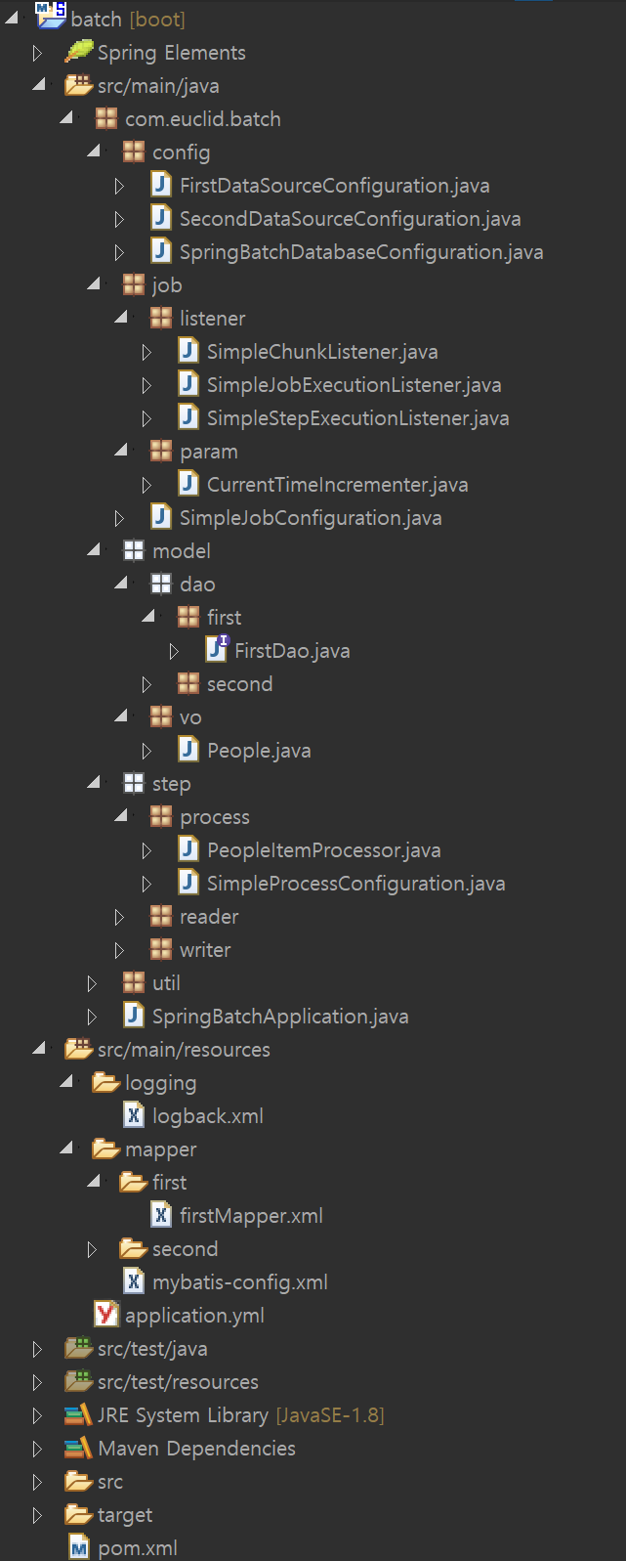

프로젝트 설정

Mybatis설정

로깅설정

3) Step : writer

1) Step : reader

2) Step : process

Job 설정

Job 파라미터

Job, Step, Chunk 리스너

DB연결

- 프로젝트(오른쪽마우스) > Run As > Maven install

: jar 파일 (target폴더) 생성

> java -jar batch.jar

실행...