Globalisation and the development of Capitalism in Russia

Simon Clarke

Mikhail Gorbachev was elected General Secretary of the CPSU in 1985 with the mission to reform an economic system which had progressively lost its dynamism during the ‘years of stagnation’. Gorbachev’s programme of ‘perestroika’ aimed to introduce market elements into the soviet administrative-command system of economic management and eventually developed into a programme for the development of a market economy. The transition to a market economy was completed under Yeltsin, who abandoned the administrative-command system and freed most wages and prices from government control at the end of 1991.
The neo-liberal Russian and western economists who were the ideologues of Yeltsin’s programme of radical reform expected that the abandonment of administrative methods and the transition to a market economy would lead to the rapid transformation of the soviet into a capitalist economy as investors took advantage of the highly skilled labour force and advanced science and technology that had built up the soviet military machine. In fact the outcome has been a disaster: the longest and deepest economic recession in recorded human history, including a decline in industrial production twice as deep as that provoked by Hitler’s invasion of the Soviet Union and living standards which have fallen back to the level of the 1960s, when Krushchev was dismissed for his economic failures.
The following charts show the extent of the collapse of the Russian economy between 1990 and 1998. Chart One shows clearly the depth of Russia’s economic decline. Although there is considerable debate about the figures, these are the official figures and are the best that are available. We can see that GDP at constant prices was halved between 1990 and 1998, while both agricultural and industrial production fell by slightly more than half. Even those sectors which should have flourished with the transition to a market economy declined: the production of fuels, with the world market at its feet, fell by one-third. Retail trade turnover fell by almost 20%, food processing fell in line with the rest of industry, while light industry, the cinderella of the soviet system, was decimated by falling living standards and foreign competition, its output declining by more than 80%.
Following the crisis of August 1998 there has been a marked recovery in the main economic indicators, which most commentators attribute to devaluation and to the increase in world oil and gas prices, which account for half Russia’s exports and around three-quarters of the revenue of the state, but since the beginning of 2001 there has been a marked slowdown in the recovery, and wages and living standards remain well below their pre-crisis levels.

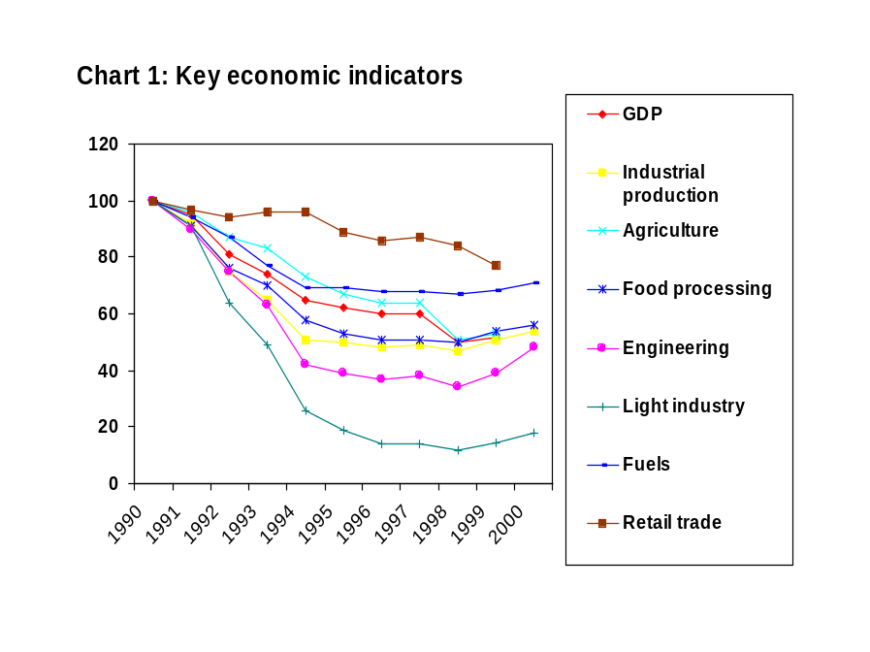
The collapse of production has been accompanied by the collapse of investment, which was most dramatic in the years of disintegration of the soviet system, but which continued to decline steadily over the period, as can be seen in Chart Two. The result is reflected in the ageing of industrial plant. The average age of industrial plant and equipment in the soviet period was about 9 years, but by 1999 it had increased to over 18 years, with less than 4% being less than five years old and about two-thirds having been installed before the beginning of perestroika. Far from being regenerated by the transition to a market economy, the Russian economy was still capitalising on the deteriorating legacy of the past.
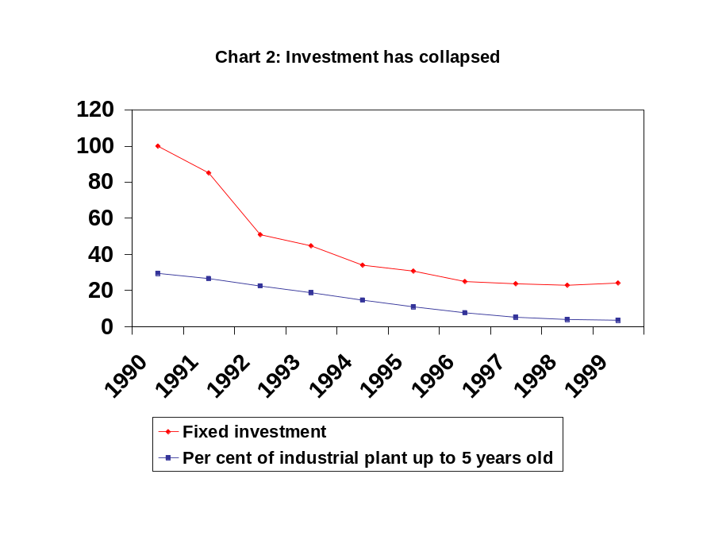
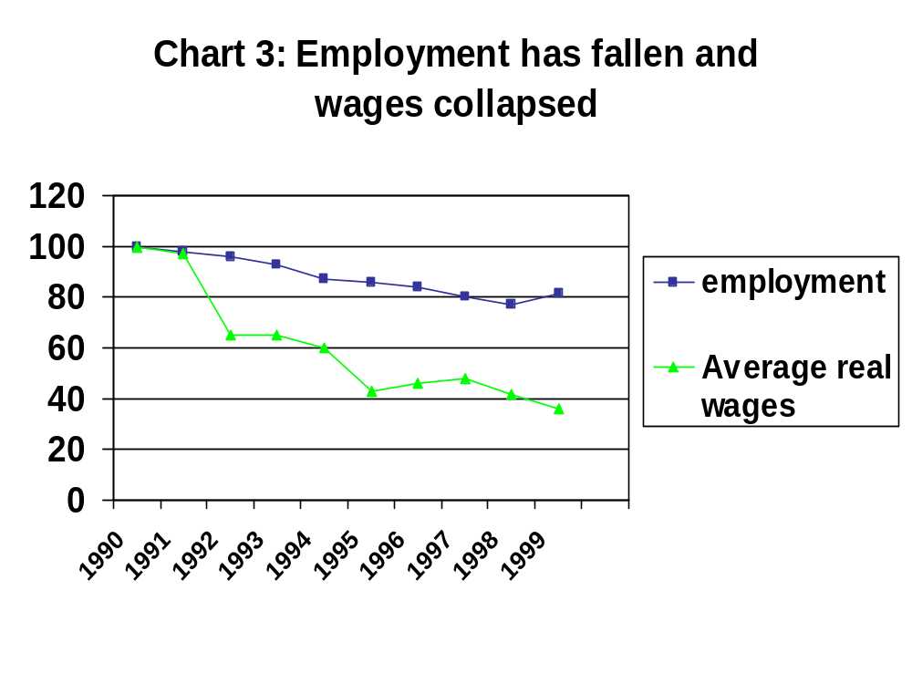
The collapse of the economy is reflected in the decline in employment and wages. Total employment has fallen by over 20%, with employment in industry falling by 40%, construction by 44%, and science by 54%, while employment in credit and finance has increased by 80%, from a very small base. Employment in public administration has increased by the same proportion, creating five times as many new jobs as credit and finance – so much for the transition to a market economy – while employment in trade and catering, the one branch dominated by new private enterprises, has increased by two-thirds (despite the decline in the turnover of retail trade).
Real wages collapsed in the three bursts of inflation in 1992, 1995 and again in the wake of the August 1998 crisis. By the end of 1998 average real wages had fallen to one-third of their 1990 level, although this gives a slightly misleading impression, since the increased money wages of the late Gorbachev period could not be realised as there was so little to buy. However, the most recent wages survey, in October 1999, showed that 41% of wage earners earned less than the adult subsistence minimum, while only one-third earned more than twice the subsistence minimum, enough to support one dependent. Over a third of all households live in poverty and about 10% live in extreme poverty, while the virtual eradication of poverty had been one of the achievements of which the Soviet Union could legitimately be proud.
The fall in wages has been associated with a dramatic increase in wage inequality, from a Gini coefficient of 0.24 in the soviet period to a coefficient of 0.48 since 1992, generating Latin American levels of inequality. Moreover, this increase in inequality does not primarily reflect an increase in class inequality, although that is very striking in every large Russian city. Half the inequality is accounted for by differences in wages between different workplaces, so that a cleaner in a prosperous bank can earn more than the director of a declining industrial enterprise.
The impact of falling living standards and social dislocation on the life expectancy of the Russian population has been dramatic. Male life expectancy at birth in 1999 had fallen to 59.9 years, below not only that of China and Brazil, but even below that of India. The fall in the birth rate to 8 per thousand in 1999 has led to a natural rate of decline of population of 6 per thousand per annum. These catastrophic figures are matched in the world only by the other former soviet republics. 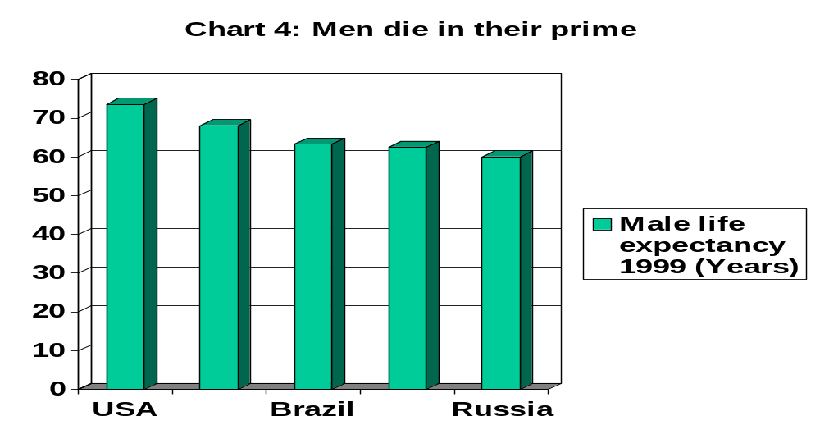
The emergence of ‘crony capitalism’

What has emerged in Russia is not a dynamic capitalist economy but a particularly malevolent form of ‘crony capitalism’, more accurately described as ‘mafia capitalism’, based on the expropriation of state assets by a small group of people who are well-connected with powerful state officials and integrated into criminal clans. The notorious oligarchs make their money primarily through trade and banking, siphoning off enormous profits which are transferred abroad to offshore accounts. It is estimated that this capital flight is currently running at the rate of $20-25 billion per year, which is five times as much as gross inward foreign direct investment.
The bulk of the profits of the oligarchs derive from the sale of Russian fuel and metals on world markets, but they make almost no investment even in the oil and gas and metallurgical companies which supply them so that, as we have seen, the production of fuels is declining, existing reserves are rapidly being depleted and the exploitation of new reserves is postponed because of the lack of investment. Oil extraction fell by a third between 1990 and 1998, although the number employed in the industry more than doubled. In 1998 the rate of fixed investment as a proportion of output in the oil industry was only one-third of the 1985 level.
New capitalist enterprises are almost entirely concentrated in trade, catering and services, with much less penetration of construction, transport and communications and minimal penetration of industry and agriculture. New capitalist enterprises are mostly small unincorporated private companies, paying low wages and making small profits. The October 1999 wages survey found that wages in the private companies which dominate trade and catering were only two-thirds of the wages paid in the remaining state enterprises, half the wages paid by incorporated companies and one-fifth of the wages paid by foreign companies. Low wages, however, were not associated with high profits: almost half the companies in trade and catering were loss-making in 1998.
Meanwhile, the traditional state enterprises, the majority of which have been privatised, have struggled to survive by any means that they can with the limited resources at their disposal: seeking out new markets, deferring payments to the government, their suppliers and their employees, looking for subsidies from local and federal government, and looking for profitable connections with criminal organisations or foreign companies.
But why has this happened? The most common explanations explain the collapse of the Russian economy as the result of the adoption of inappropriate policies by the Russian government. While the government’s domestic critics argue that the collapse has been the result of the adoption of neo-liberal reforms, neo-liberals argue to the contrary, that the collapse has occurred because reforms have not been sufficiently radical.

Neo-Liberalism and its Critics
For the critics of neo-liberalism the explanation for the collapse of the Russian economy is so obvious as barely to require discussion. The collapse has been the result of the application of neo-liberal shock therapy, which has been all shock and no therapy. The inflation unleashed by price liberalisation destroyed the working capital of Russian enterprises, the dismantling of the administrative-command system deprived them of investment finance, restrictive financial policies drove up the cost of credit and led to an over-valued exchange rate, the freeing of international trade swamped the Russian market with cheap imports, unregulated privatisation allowed criminal elements to expropriate the most valuable state assets.
The critics of neo-liberalism contrast the fate of Russia with that of China, Vietnam and even the former Soviet Republic of Uzbekistan, where a strong state has retained control of the transition to a market economy and presided over dynamic growth based on investment in the real economy. They conclude that Russia needs to adopt a state-regulated corporatist programme of industrial regeneration, with protection of the domestic market, a state investment programme and state support for Russian science and technology.
The neo-liberal response to such critics is to insist that neo-liberalism has not failed because it has not even been tried. The Russian government has not implemented the reform programme proposed by the neo-liberals, constantly giving in to the pressure of vested interests.
According to the neo-liberals the collapse of the Russian economy is the result of the failure to carry through the full programme of neo-liberal reforms. The government has failed to impose hard budget constraints on traditional enterprises and has continued to provide direct and indirect credits and subsidies to loss-making enterprises. State bodies, particularly at the local and regional level, have placed endless bureaucratic obstacles to the establishment of new private enterprises. The government has failed to carry through necessary reforms of the tax system or to introduce legislation permitting such things as the private ownership of land or production-sharing agreements for the exploitation of natural resources. The government has done little to encourage the establishment of the rule of law, so that property rights are not secure, contracts cannot be enforced in the courts, rampant corruption is unpunished and transparent corporate governance is absent.
In short, the neo-liberals explain the collapse of the Russian economy in terms of the perverse incentives provided by the policies and practices of the Russian government: failure, corruption and criminality is rewarded, while legitimate business activity is penalised. The collapse of production and investment is the result of the absence of the ‘order and good government’ that is the necessary foundation of liberal capitalism.
In this paper I want to argue that the debate between neo-liberals and their critics is really a false debate. What has happened in Russia has not been the result of policy choices, because policy makers have been severely constrained in the choices that they could make and in their ability to implement the policies which they have chosen to adopt. In general, policy makers have only a limited power to mould the economy according to their ideological predilections. Without a mass concerted revolutionary mobilisation, backed up by the concentrated use of force or the threat of force, the ability of policy makers to mould the economy is constrained by the instruments at their disposal and the structural characteristics of the economy which they seek to manipulate.
What has happened in Russia cannot be put down to the errors of policy makers, as if a different policy could have led to very different results. What has happened in Russia has its roots in the soviet period, and is a result of the path of reform undertaken by Gorbachev. But Gorbachev’s perestroika was in turn not so much a policy decision, as a result of the unfolding of the contradictions of the soviet economic system in the context of the global capitalist economy. Gorbachev sought to introduce a dynamic into the soviet system by abandoning the autarchic administered economy to seek its integration into the world market. Before looking a bit more closely at this process, however, I will touch on the key theoretical issues underlying the analysis of transition.

Theorising Transition: Smith and Marx
Most commentary on the transition in Russia has focused on the role of the ‘Market Bolshevik’ young reformers, who assumed a pivotal position in successive Moscow governments under Yeltsin, and their western allies, who set the agenda for the involvement of the International Financial Institutions which provided and financed the blueprint for reform. This leads to a dualistic interpretation of the transition in terms of the interaction of liberalising reforms and state socialist legacies, the latter being seen as barriers to and distortions of the former, and a voluntaristic interpretation of transition as the outcome of political conflicts between reformers and conservatives. Recognition that the path of liberal reform is not necessarily strewn with roses has been accommodated within a vulgarised notion of ‘path dependence’, according to which the path is littered with obstacles inherited from the past which condition the path of development, but which have to be assimilated or removed. However, a voluntaristic and dualistic approach which analyses the emerging forms of capitalism as a synthesis of an ideal model and an alien legacy fails to identify the indigenous roots of the dynamic of the transition from a state socialist to a market economy and so fails to grasp the process of transformation as an historically developing social reality.
Many commentators have compared the soviet system to that of feudalism in being based on the appropriation of a surplus by the exercise of political power. For Adam Smith and Friedrich Hayek the central feature of feudalism was the distortion of the natural order of the market economy by the superimposition of political rule, and the transition from feudalism to capitalism depended on sweeping away the political institutions of the old regime in order to establish the freedom and security of property – what Smith referred to as ‘order and good government’ – which would allow the market economy to flourish. This was the ideology that informed the liberal project of the transition to a capitalist market economy in the former state socialist economies, although in retrospect even the most ardent liberal reformers in the Former Soviet Union came to recognise that they had put too much emphasis on destroying the old regime and too little on establishing ‘order and good government’. The ideal liberal model of a capitalist economy provides the theoretical foundations for a dualistic model of the transition. According to this model the transition is not theorised as an evolutionary development of the existing system under the impact of its integration into the structures of the world market. For this model the existing system has no dynamic of its own. It is defined purely negatively as a barrier to change which must be destroyed, so that a new system can be created out of the fragments set free by its destruction.
Adam Smith believed that the liberal project of liberating the individual from the fetters of state regulation was hopeless because of the strength of vested interest backing the latter. Yet, within a generation of the publication of his Wealth of Nations the mercantile system had collapsed and the system of regulation had been dismantled by the state itself, not on the basis of the triumph of an enlightened individualism but on the basis of a social transformation which had transformed the balance of class forces and undermined the old regime ([Clarke, 1988 #629]). In the same way, the liberal theorists of totalitarianism were taken completely by surprise when the apparently all-powerful soviet state disintegrated, not as a result of any liberal critique but under the weight of its own contradictions ([Clarke, 1990 #744]). It is not to Adam Smith or Friedrich Hayek that we should look to understand the development of capitalism, but to Smith’s most cogent critic, Karl Marx.
For Marx the development of capitalism was not the realisation of individual reason but an expression of the development of commodity production within the feudal order, which was massively accelerated by the dispossession of the mass of the rural population, who became the wage labourers for capital and the consumers of the products of capitalist production. The dispossession of the rural population provided an ample reserve of cheap wage labour which could be profitably employed by the capitals accumulated through trade and plunder. At this first stage of capitalist development, however, capitalists did not change the handicraft methods of production which they had inherited, so the subsumption of labour under capital was purely formal. Merchant capitalists made huge profits by exploiting their commercial monopolies. Capitalist producers cut their costs not by transforming methods of production but by forcing down wages and extending the working day. Capital only penetrated the sphere of production when competition between capitalists induced and compelled them to revolutionise the methods of production in order to earn an additional profit, or resist the competition of those who had already done so. It was only with the ‘real subsumption’ of labour under capital that the characteristic dynamic of the capitalist mode of production got under way. Nevertheless, in the peripheral regions of the emerging global capitalist economy, where capital swept away traditional handicrafts and subsistence agriculture, the subsumption of production under capital remained purely formal, based on the intensified exploitation of pre-capitalist social forms, with the ‘second serfdom’ in Eastern Europe and the reinforcement of slavery and quasi-feudal forms of exploitation in the colonial world.
The process described by Marx as that of ‘primitive accumulation’ was largely achieved in Russia in the soviet period when the peasants were dispossessed and transformed into wage labourers, not for capital but for the state. The soviet state launched a programme of industrialisation, based on the introduction of the most advanced capitalist technology, not as a means of reducing production costs in order to increase profits but as the means of building up the military and political might of the Soviet state. The social form of the production and appropriation of a surplus in the soviet system was quite different from that characteristic of the capitalist mode of production, and the dynamics of the system were correspondingly different.

The Soviet mode of production
The soviet system had many features in common with the capitalist system of production. It was based on advanced technology and a high degree of socialisation of production, which was the social and material basis of the separation of the direct producers from the ownership and control of the means of production. As in the capitalist system, labour was employed by enterprises and organisations in the form of wage labour and the production of goods and services for individual and social need was subordinated to the production and appropriation of a surplus. However, the two systems differed fundamentally in the form of the surplus and correspondingly in the social organisation of the production and appropriation of that surplus.
The soviet system was not based on the maximisation of profit, nor was it based on planned provision for social need. It was a system of surplus appropriation and redistribution subordinated to the material needs of the state and, above all, of its military apparatus. This subordination of the entire socio-economic system to the demands of the military for men, materials and machines dictated that it was essentially a non-monetary system. The development of the system was not subordinated to the expansion of the gross or net product in the abstract, an abstraction which can only be expressed in a monetary form, but to expanding the production of specific materials and equipment — tanks, guns, aircraft, explosives, missiles — and to supporting the huge military machine. The strategic isolation of the Soviet Union meant that no amount of money could buy these military commodities, so the Soviet state had to ensure that they were produced in appropriate numbers and appropriate proportions, and correspondingly that all the means of production required to produce them were available at the right time and the right place.
The system of ‘central planning’ was developed in Stalin’s industrialisation drive of the 1930s in a framework of generalised shortage, including an acute shortage of experienced (and politically reliable) managers and administrators. The system was driven by the demands of the state for a growing physical surplus with scant regard for the material constraints of skills, resources and capacities on production. The strategic demands of the five-year plan would be determined by the priorities of the regime, and ultimately by the demands of the military apparatus, which would then be converted into requirements for all the various branches of production. These requirements came to be determined in a process of negotiation between the central planning authorities, ministries and industrial enterprises.
The bureaucratisation of the planning system from the 1950s represented a significant and progressive shift in the balance of power from the centre to the periphery as the negotiated element in plan determination increased, at the expense of its exhortatory power and repressive reinforcement. Alongside this, the single-minded orientation to production for military needs was tempered by a growing concern for the material needs of the mass of the population: the expansion of housing and social consumption from the 1950s and of individual consumption from the 1960s, which was linked to the increasing role of material incentives in stimulating the energy and initiative of the direct producers.
Soviet social relations of production were supposed to overcome the contradictions inherent in the capitalist mode of production in being based on the centralised control of the planned distribution and redistribution of productive resources. However, the soviet system was marked by its own system of surplus appropriation. Enterprises and organisations negotiated the allocation of means of production and subsistence with the centre in exchange for the delivery of defined production targets, the surplus taking the form of the net product appropriated by the military-Party-state to secure its own expanded reproduction.

Contradictions of the Soviet System
The fundamental contradiction of the soviet system lay in the separation of production and distribution which led to a contradiction between the production and appropriation of the surplus. The development of the forces of production was constrained by the exploitative social relations of production, and it was this specific contradiction that underpinned the collapse of the administrative-command system. The central planning agencies sought to maximise the surplus in their negotiations with ministries and departments, enterprises and organisations over the allocation of resources and determination of production plans. However, the enterprises and organisations which were the units of production had an interest in minimising the surplus by inflating the resources allocated to them and reducing their planned output targets. The softer the plan that they could negotiate, the easier it was for the enterprise director and his or her line managers to induce or compel the labour force to meet the plan targets ([Clarke, 1996 #672]). Since neither the worker, nor the enterprise, nor even the ministry, had any rights to the surplus produced they could only reliably expand the resources at their disposal by inflating their production costs, and could only protect themselves from the exactions of the ruling stratum by concealing their productive potential. Resistance to the demands of the military-state-Party apparatus for an expanding surplus product ran through the system from top to bottom and was impervious to all attempts at bureaucratic reform. The resulting rigidities of the system determined its extensive form of development, the expansion of the surplus depending on the mobilisation of additional resources. When the reserves, particularly of labour, had been exhausted the rate of growth of production and of surplus appropriation slowed down.
The fundamental contradiction of the Soviet system was between the system of production and the system of surplus appropriation. The centralised control and allocation of the surplus product in the hands of an unproductive ruling stratum meant that the producers had an interest not in maximising but in minimising the surplus that they produced. The contradiction between the forces and relations of production was also expressed in chronic shortages. Enterprises were oriented to meeting their formal plan targets, not to meeting the needs of their customers. Thus, while the centre could allocate rights to supplies, it could not ensure that those supplies were delivered to the place, at the time and of the quality desired. The endemic problems of shortages and of poor quality of supplies were not an inherent feature of a system of economic planning, but of a system based on the centralised allocation of supplies as the means of securing the centralised appropriation of a surplus.

Market Elements in the Soviet System
Market relations played an increasing role in the soviet system. As in the case of feudalism, the contradictions inherent in the soviet system meant that money, the market and quasi-market relations developed spontaneously out of attempts to overcome the contradictions of the system and were tolerated, however reluctantly, by the authorities.
First, even if the supplies allocated in the plan were adequate, securing these supplies was a major problem, for the resolution of which enterprises used informal personal connections with their suppliers, often backed up by local Party apparatchiki, and came increasingly to draw on the services of unofficial intermediaries, the so-called tolchaki (pushers), who were the pioneers of market relations within the soviet economy. The central directives which nominally regulated inter-enterprise transactions within the soviet system were therefore only realised in practice through exchanges within networks of personal, political and commercial connections.
Second, Trotsky’s early attempts at the ‘militarisation of labour’ were unsuccessful and, although wages were regulated centrally, workers were always in practice free to change jobs in search of higher wages. Labour shortages put increasing pressure on the centralised regulation of wages as employers sought to attract the scarcest categories of labour, so that wage-setting had to take account of labour market conditions.
Third, although social reproduction was as far as possible subordinated to the imperatives of production, with housing, items of collective consumption, a wide range of social and welfare benefits and the right to buy goods and services which were not on free sale being provided through the workplace, labour power was partially commodified and workers were paid a money wage with which they bought their heavily subsidised means of subsistence and which they saved in the hope of acquiring the right to buy consumer durables, to take a vacation or to provide for retirement. Money in the hands of workers lubricated the black market for consumer goods and for the private production of agricultural produce for the market which was tolerated and even encouraged, with rural producers being allowed to sell their own products on the kolkhoz markets, which provided a basis for more extensive market transactions.
Fourth, the need to acquire advanced means of production from the west meant that the Soviet Union had to export its natural resources in order to finance its essential imports of machinery. Although the state retained a monopoly of foreign trade, this made it very vulnerable to fluctuations in world market prices. The 1930s industrialisation drive was made possible by the massive export of grain forcibly expropriated from the peasantry, which led to the devastating famines of the 1930s. By the Brezhnev period the Soviet Union had become dependent on its exports of oil and gas to finance its imports of machinery and even of food. In 1985 fuel accounted for more than half the Soviet Union’s exports, with another quarter being accounted for by raw and semi-processed raw materials, while machinery accounted for a third of imports and food for one-fifth. The share of world trade in the net material product of the Soviet Union increased from 3.7% in 1970 to almost 10% in 1980 and a high of 11% in 1985, while oil and gas production doubled between 1970 and 1980. At the same time, the Soviet Union saw a sharp improvement in its terms of trade, the net barter terms of trade improving by an average of 5% per annum over the period 1976-80 and 3% per annum between 1980 and 1985 (IMF, I, pp. 86, 105), helping to offset the decline in productivity growth and allowing the Soviet Union to increase its import volume by one-third, while export volume increased by only 10%. The improved terms of trade also made a substantial contribution to the buoyancy of government revenues through the price equalisation system, according to which the state appropriated the difference between domestic and world market prices. This opening of the Soviet economy to the world market, and the corresponding political processes of detente, were by no means a sign of fundamental change in the Soviet system, but were rather the means by which change was constantly postponed. However, such favourable circumstances could not last: production of gas and oil peaked in 1980, so that the Soviet Union was increasingly dependent on improvement in the terms of trade to sustain its economy. When the terms of trade turned sharply against the Soviet Union from 1985, reforms could be postponed no longer.

The Dilemmas of Soviet Reform.
Proposals for reform of the soviet system always centred on increasing the role of market relations to provide direct producers with the incentive to increase production and to make suppliers more responsive to the needs of consumers. Such reforms necessarily implied giving more independence to enterprises and allowing them to retain a portion of the revenue received from the sale of their output.
The dilemma that all such reforms soon presented to the centre was that the reforms necessarily eroded centralised control, so encouraging the development of the forces of production at the expense of the erosion of the system of surplus appropriation. Moreover, once reform was set under way it tended to acquire a dynamic of its own, as enterprises which had received a taste of independence demanded more. For these reasons, every reform initiative prior to Gorbachev had been reversed in order to preserve the system. In the same way, Gorbachev also came under pressure to reverse his reforms, but Gorbachev’s reforms soon acquired an unstoppable momentum, particularly as the erosion of the administrative-command system of economic management undermined the authoritarian political system with which it was enmeshed.

Gorbachev’s Market Reforms
The ‘transition to a market economy’ was not an alien project imposed on the soviet system by liberal economists, but in the first instance was an expression of the fundamental contradiction of the soviet system. The first stage of market reforms sought to improve the balance of external trade by ending the state monopoly of foreign trade, licensing enterprises and organisations to engage in export operations and to retain a portion of the hard currency earned. The idea was that this would give industrial enterprises an incentive to compete in world markets and to use the foreign exchange earned to acquire modern equipment. In practice it provided a windfall for exporting enterprises, at the expense of the state, and opportunities for those with the right connections to make huge profits by acting as intermediaries.
Once the precedent had been set, other enterprises sought the right to sell above-plan output on export or domestic markets, and to retain a growing proportion of the proceeds. This aspiration was met with the proposed replacement of plan deliveries by state orders at fixed state prices, with the control of prices replacing the control of quantities and taxation of profits replacing exactions in kind. But the emergence of new structures of distribution undermined the centralised control of the system. Allowing enterprises to sell on the market provided an alternative source of supply to the centralised allocations which the state could not guarantee, and if the state could not guarantee supplies, why should enterprises continue to deliver their state orders when they could sell more profitably at market prices? Thus the development of market relations undermined the control of the centre, created a space for the development of capitalist commercial and financial enterprise and precipitated the collapse of the administrative-command system. Rather than resolving the contradictions inherent in the soviet system, the transition to a market economy brought those contradictions to a head. While market reforms might provide an incentive for enterprises to develop the forces of production, the loss of centralised control undermined the system of surplus appropriation in removing the state control of supply which was the basis on which the state extracted the surplus. The surplus which had been appropriated by the state was now retained by enterprises and/or appropriated by the new financial and commercial intermediaries which arose to handle the emerging market relations.

Yeltsin’s Transition to a Market Economy
The collapse of the administrative-command system of economic management under the pressure of growing demands for economic independence also undermined the centralised political system of which it was an integral part as national and regional authorities asserted their independence of the centre. Yeltsin ruthlessly exploited these tendencies in his struggle with Gorbachev, but once he had seized power in Russia his priority was to strengthen rather than to undermine a centralised Russian state. If the Russian Federation was to survive it was essential to give free reign to the market relations and market actors which had emerged but to detach the state from the economy. Yeltsin’s decision to free wages and prices from state control was no more than a recognition that the state had already lost control of wages and prices, since by the end of 1991 nothing was available to buy at state prices.
Corporatisation and privatisation of state enterprises was an equally inevitable consequence of the development of a market economy, merely a juridical recognition of what had already become a fact, that these enterprises had already detached themselves from the administrative-command system of management which no longer had any levers of control over them. Privatisation did not give enterprises any more rights than they already had, while it allowed the state to abdicate all the responsibilities to them which it no longer had the means to fulfil. Thus, the rhetoric of neo-liberalism and radical reform was little more than an ideological cover for what was essentially a bowing to the inevitable.

Russia’s Capitalist Transition: New Forms of Surplus Appropriation
The development of a market economy in Russia and the emergence of private commercial and financial capitalist enterprises represented a change in the form of surplus appropriation, or at least a change in the identity of those appropriating the surplus. The new capitals were formed out of the commercial and financial intermediaries which had been rooted in the soviet system and been given free rein by perestroika. They appropriated their profits by establishing the monopoly control of supplies which had formerly been the prerogative of the state. They acquired this control on the basis of rights assigned to them by state bodies, including property rights acquired on the basis of the privatisation of state enterprises, and they maintained their control, where necessary, by the corruption of state officials and enterprise directors, backed up by the threat and use of force. However, the change in the form of surplus appropriation was not matched by any change in the social relations of production.
The surplus was not appropriated on the basis of the transformation of the social organisation of production or the investment of capital in production. It was appropriated on the basis of trading monopolies, above all in the export of fuels and raw and processed raw materials, which make up 80% of Russian exports, and in domestic trade. It was appropriated through the banking system, which appropriated huge profits through currency speculation and speculation and investment in government debt, debt service now amounting to 3.6% of GDP. The 1998 crisis weakened the banking system, and gave much greater significance to the monopolistic energy complex, whose profits in 1999 amounted to about 1.3% of GDP, but whose significance is the power it derives from the leverage which debts for electricity supply give it over enterprises and even regional governments.
Meanwhile, the bulk of enterprise profits are annihilated by taxation, leaving little or nothing to pay out as dividends to shareholders. While the taxation of enterprise profits amounted to 4.9% of GDP in 1999, dividends amounted to only 0.5% of GDP, up from 0.3% in 1998. The windfall profits which enterprises could make in the late eighties when they could buy at state prices and sell at market prices were annihilated by the liberalisation of prices at the end of 1991. With the collapse of the soviet system enterprises inherited the land and premises, their capital stock and their stocks of parts and raw materials, which substantially reduced their costs and enabled many to remain in profit by trading on their inherited assets. But by 1996 the majority of enterprises were loss-making, the figure falling to 41% with the recovery of 1999. There is little or no scope for profiting by investment in productive activity in Russia. As noted above, investment has slumped even in the oil and gas industry, despite the huge profits realised from the exports of oil and gas.

The Soviet Enterprise in Transition
Russian capitalism was formed by the diversion of the surplus which had been appropriated by the state. The transition to a market economy had a radical impact on the external relations of Russian enterprises, but it had no immediate impact on their internal social organisation.
The soviet enterprise was responsible not only for production, but also for a large part of the social reproduction of the labour force and often of the local community as well. Workers could buy their basic means of subsistence with their wages, but housing, health care, child care, social, cultural, sporting and welfare facilities were all provided by the enterprise. Shortage items such as consumer durables could not be purchased freely, but were allocated for purchase through the workplace. As shortages intensified in the late soviet period even basic foodstuffs were distributed through the workplace, while those enterprises which could profit from foreign trade were able to offer their employees imported consumer goods. The soviet enterprise had a much wider range of responsibilities, and correspondingly had to support a much larger labour force and, at a given level of wages, had much higher costs than its capitalist competitor. But more fundamentally, it was not only an economic unit but also a social organisation which embraced the whole life of the local community. The enterprise director was responsible not for making a profit, but for achieving his plan targets and securing the social reproduction of his enterprise and the surrounding community.
Soviet enterprises were adapted to the fulfilment of the plan, with the resources allocated by the planning authorities, regardless of cost. The plan was extracted by the use of authoritarian management methods, with severe financial and disciplinary penalties for those responsible for failure to make the plan. However, production took place in extremely unpredictable conditions, with irregular supplies of uneven quality and with shortages of spare parts to repair ageing plant and equipment, so that authoritarianism had to be tempered by flexibility, expressed in informal bargaining at all levels to ensure that production tasks were achieved.
The soviet enterprise was marked by an anarchic system of production management, in which the primary responsibility of managers was to secure supplies, while workers were largely left to get on with the job on their own. This workers’ control of production was not, as some have suggested, an expression of the power of workers, but of the abdication of management responsibility that was made possible by the fact that the workers’ efforts, and corresponding penalties and rewards, could be easily monitored by the achievement of plan indicators.
The priority of enterprise directors in the transition to a market economy has not been the maximisation of profits, which only attract the interest of the tax authorities and criminal structures, but has continued to be the reproduction of the enterprise as a social organisation, the ‘preservation of the labour collective’, which is the basis of the power and status of the director. This priority is reinforced by the expectations of the labour force carried over from the soviet period, for whom the legitimacy of the director’s position does not derive from any property rights, but from the director’s ability to preserve the jobs and wages of the labour force. This priority was further reinforced by privatisation, which in the first instance usually put a majority of shares into the hands of the labour force and management, and by pressure from local authorities, which depend on a functioning enterprise to provide jobs for the local population, to provide tax revenues for the local authority and, in many cases, to contribute the maintenance of the local social and welfare infrastructure.
Although the priority of the director was to maintain production, rather than to maximise profits, this now had to be achieved within a market environment in which the revenues to cover costs had to be acquired through sales of the product. The priority of directors in the wake of the breakdown of the soviet system was to continue trading with traditional partners and to find new markets and new sources of supply, the latter often requiring the intervention of new commercial intermediaries. The priority in the piecemeal investments made from enterprise funds was not to reduce production costs but to produce new products and to improve product quality. Finally, directors would appeal to local, regional and federal authorities for financial support to sustain the labour collective.
Enterprises did not undertake any radical reorganisation of their management structures in the face of the transition to a market economy. The authoritarianism of directors was no longer constrained by higher state or Party authorities, but the loss of party-state control also undermined the security of their position so that they were very attentive to threats to their position posed by outsiders or by an opposition faction within management. The traditional domination of production management over finance and marketing persisted. The job of the finance department was not to determine the financial constraints within which the enterprise should operate, but to find the money to allow it to continue in operation. The job of the marketing department was not to identify new products or to dictate production costs but to sell whatever the production managers had decided to produce. The anarchic system of production management was also reinforced, since the lack of funds for investment meant that the enterprise depended on the skills and initiative of the workforce to keep archaic machinery in operation and to identify new products which could be made with the existing equipment.
In the face of tightening financial constraints there was rarely any money for new investment, while declining markets meant that enterprises worked at reduced capacity, which resulted in declining productivity. Enterprises were forced to cut costs by the threat of insolvency, but cost-cutting was not achieved by any planned reorganisation or re-equipment but by deterioration in the living standards and working conditions of employees. Enterprise directors under financial pressure were only too happy to divest themselves of the bulk of their responsibilities for the provision of housing and health, social and welfare facilities, which were transferred to municipal authorities which had neither the financial nor the administrative capacity to maintain them. Wages were only increased in the face of inflation within the limits of financial possibilities and, increasingly from 1994, enterprises which faced a cash-flow crisis left wages unpaid, a phenomenon which was endemic between 1996 and 1998. As the best workers left for jobs elsewhere, those who remained were required to fill the gaps leading to an intensification of labour and increased flexibility in the use of labour, often in defiance of labour legislation. In general such measures were accepted by the workers as the price of keeping their jobs, at least so long as they could be persuaded that management had no alternative. When the workers lost confidence in their director, their response was the traditional one of demanding his or her replacement, the great hope being to attract a new wealthy owner who would pay wages and make the investments necessary to secure their future prosperity.
Although enterprises have responded to the pressures and opportunities presented by the development of the market economy on the basis of their existing soviet form, this is not to say that the Russian enterprise is not undergoing changes in its managerial structure and social organisation. Increasing unemployment has certainly enabled the directors of more successful enterprises, which are able to pay reasonable wages, to tighten labour discipline and to extend managerial authority to the shop-floor. Many enterprises have responded to the pressure of competition by developing new products and improving product quality, even if cost reductions are still achieved primarily by the reduction of wages and staffing levels rather than by investing in advanced technology and introducing modern management methods, but all of these changes are slow and gradual, and are inhibited by the lack of investment finance and by the instability of the market environment.
Of course, as the neo-liberals argue, the absence of hard budget constraints relieves outdated enterprises of the pressure to reform, while it is not possible to sustain loss-making enterprises indefinitely when the state budget itself is squeezed by declining revenues and the burden of foreign debt. On the other hand, as the critics of neo-liberalism argue, it is not realistic to expect loss-making enterprises to turn themselves around by their own efforts, when the banking system provides almost no investment finance, while it is not possible to close down loss-makers when they account for the majority of all enterprises. While it would seem obvious that Russia needs a state-sponsored investment programme to underpin its economic recovery, the state has neither the administrative nor the technical nor the financial resources to undertake such a programme. It remains to be seen whether President Putin will be able to deliver on his recently declared intention of taxing the super-profits of the oil and gas exporters to provide the funds for investing in the domestic economy.

Russia in the Global Economy: Comparative Perspectives
I have focused on the internal dynamics of the transition to a market economy, but it should be apparent that the transition has been driven by internal forces unleashed by the integration of the soviet system into global capitalism as a classic neo-colony, producing cheap fuels and raw materials for global capitalism and importing foodstuffs and manufactured goods while domestic production languished, unable to compete with an archaic production technology and an inappropriate social organisation of production in the face of unfavourable market conditions. As in the classic case of neo-colonialism, the surplus is appropriated by multinational corporations and their comprador capitalist agents. Foreign Direct Investment between 1994 and 1999 amounted to only $3billion per annum. In 1999 23% of foreign investment went into oil and metallurgy, 20% into trade and catering, commerce and finance and 15% into the food processing industry with only a trivial amount in the remaining industrial branches.
Meanwhile, the subsumption of labour under capital within Russia remains overwhelmingly purely formal. The vast majority of Russian enterprises struggle to survive in the face of intense domestic and foreign competition, with minimal investment and earning little or no profits, using inherited plant and equipment and retaining the traditional soviet social organisation of production, while the bulk of the surplus is appropriated by monopolistic and at best semi-criminal commercial intermediaries. Enterprises cut costs not by revolutionising production methods, but by reducing real wages and intensifying labour and they stay in business by defaulting on their payments to suppliers and to their own employees.
The fate of Russia has not been determined exclusively by its own historical legacy. While the other soviet republics, as well as Romania and Bulgaria, have suffered as badly or worse than Russia from the collapse of the soviet system, most of the former soviet satellites in Eastern Europe soon recovered from the transition crisis and the experience of China, of course, presents almost a mirror image of the fate of Russia in its transition to a market economy. While Russian GDP per head fell by almost half over the 1990s, in China it doubled. While industrial production in Russia fell by more than half, in China it increased more than three times. While agricultural production Russia fell by almost half, in China it increased by 50%.
Many commentators attribute these differences to the different policies pursued by different national governments. The International Financial Institutions contrast the fate of Russia with the success of Poland, Hungary and the Czech Republic. Critics of neo-liberalism contrast the fate of Russia with the success of China. But policy makers in all these countries have been severely constrained by the circumstances in which they have found themselves and restricted by the opportunities that they confront. Russia has not pursued radically different policies from those in her former satellites, while much of the programme of perestroika was similar to the reforms being introduced at the same time in China. It is not so much the policy packages which have differed, as the outcomes.
In all of these countries the ‘transition to a market economy’ has not so much been a feature of a particular set of policies, as a strategy of integration into global capitalism. The specificity of Russia lies not in the policies pursued by its government but in the mode of its integration into global capitalism dictated by the dynamics of the latter. Against many of the other Former Soviet Republics, Russia at least had the advantage of having stupendous natural resources, in the form of oil, gas, metals and minerals. But the former Eastern European satellites had the advantages of a highly skilled and relatively low-paid industrial labour force and of location on the fringes of the European Union, giving them ready access to a booming market and making the economies very attractive to foreign investors. China, on the other hand, had the advantages of location, on the Pacific rim, of political stability and, above all, of abundant reserves of cheap labour. The latter allowed China to pursue a dualistic strategy, of continuing to subsidise the strategically important traditional state industries while encouraging private and foreign investment in local and foreign-owned enterprises. Nevertheless, the unevenness of the Chinese pattern of development creates its own problems which raise the question of how long such a dualistic strategy can be sustained. But that is another question.

